Social Media For Researchers
D: Researcher profiling services

D2: Using ResearchGate
What is it? ResearchGate is a researcher profiling service.
Why bother? Having a ResearchGate account can help your peers to find your research publications and can help you connect with fellow researchers.
Risks: Low risk. Can be deleted if not wanted. However you should think carefully before uploading papers to the service due to issues such as copyright infringement and fragmentation of access to your papers. Also ResearchGate may send out alerts to co-authors without your permission

Exercise 1: Familiarisation
D2.1 View the ResearchGate profile for an early adopter at https://www.researchgate.net/profile/Brian_Kelly/ (shown in Figure 1)

Exercise 2: Registering
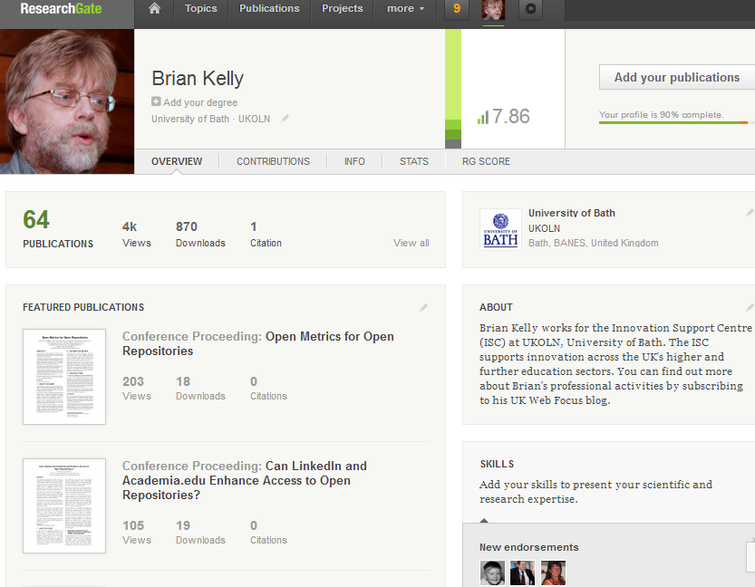Figure 1: ResearchGate profile
D2.2 Go to http://www.researchgate.
net/ and sign up for a ResearchGate account.

Exercise 3: Populating
D2.3 Click on the Add Your Publications option to view papers which appear to be yours. Select any relevant papers.
D2.4 Select Manual entry if you wish to manually add details of papers.
D2.5 If you wish to make the full text of your papers available via ResearchGate upload a copy of relevant papers.

Exercise 4: Searching
D2.6 Use the search facility to search for colleagues at your own institution.
D2.7 Use the search facility to search for researchers with similar research interests.
D2.8 View the blog post about use of ResearchGate in the 24 UK Russell Group Universities at http://ukwebfocus.wordpress.com/2012/08/01/.

Social Media For Researchers
D: Researcher profiling services

D2: Using ResearchGate
What is it? ResearchGate is a researcher profiling service.
Why bother? Having a ResearchGate account can help your peers to find your research publications and can help you connect with fellow researchers.
Risks: Low risk. Can be deleted if not wanted. However you should think carefully before uploading papers to the service due to issues such as copyright infringement and fragmentation of access to your papers. Also ResearchGate may send out alerts to co-authors without your permission

Exercise 1: Familiarisation
D2.1 View the ResearchGate profile for an early adopter at https://www.researchgate.net/profile/Brian_Kelly/ (shown in Figure 1)

Exercise 2: Registering
Figure 1: ResearchGate profile
D2.2 Go to http://www.researchgate.
net/ and sign up for a ResearchGate account.

Exercise 3: Populating
D2.3 Click on the Add Your Publications option to view papers which appear to be yours. Select any relevant papers.
D2.4 Select Manual entry if you wish to manually add details of papers.
D2.5 If you wish to make the full text of your papers available via ResearchGate upload a copy of relevant papers.

Exercise 4: Searching
D2.6 Use the search facility to search for colleagues at your own institution.
D2.7 Use the search facility to search for researchers with similar research interests.
D2.8 View the blog post about use of ResearchGate in the 24 UK Russell Group Universities at http://ukwebfocus.wordpress.com/2012/08/01/.

Creating a ResearchGate Account
How easy was it to create a ResearchGate account? Why would you wish to create and use ResearchGate?

Limitations
What limitations do you feel ResearchGate has?

Questions and Comments
Make a note of any questions and comments you have about ResearchGate .

Further Information and Useful Links
For further information on ResearchGate see:
- ResearchGate, Wikipedia, https://en.wikipedia.org/wiki/ResearchGate
- Why I’m Evaluating ResearchGate, B. Kelly, UK Web Focus blog, 6 Feb 2013, http://ukwebfocus.wordpress.com/2013/02/06/why-im-evaluating-researchgate/
- Profiling Use of Third-Party Research Repository Services, B. Kelly, UK Web Focus blog, 12 Feb 2013, http://ukwebfocus.wordpress.com/2013/02/12/
profiling-use-of-third-party-research-repository-services/

Creating a ResearchGate Account
How easy was it to create a ResearchGate account? Why would you wish to create and use ResearchGate?

Limitations
What limitations do you feel ResearchGate has?

Questions and Comments
Make a note of any questions and comments you have about ResearchGate .

Further Information and Useful Links
For further information on ResearchGate see:
- ResearchGate, Wikipedia, https://en.wikipedia.org/wiki/ResearchGate
- Why I’m Evaluating ResearchGate, B. Kelly, UK Web Focus blog, 6 Feb 2013, http://ukwebfocus.wordpress.com/2013/02/06/why-im-evaluating-researchgate/
- Profiling Use of Third-Party Research Repository Services, B. Kelly, UK Web Focus blog, 12 Feb 2013, http://ukwebfocus.wordpress.com/2013/02/12/
profiling-use-of-third-party-research-repository-services/

