Social Media For Researchers
I: Citation analysis

I2: Using Microsoft Academic Search
What is it? Microsoft Academic Search provides a search facility for research papers, together with a self-claim mechanism for authors.
Why bother? The service can provide metrics on citations. However there is a need to remove false hits on automatically-claimed papers.

Exercise 1: Familiarisation
I2.1 Go to the Microsoft Academic Search home page at http://academic.research.microsoft.com/ Then use the search facility to explore areas of interest.

Exercise 2: A Profile in Microsoft Academic Search
I2.2 Search for “Brian Kelly UKOLN” and then click on the author’s name in one of the search results to view his profile. A profile as shown in Figure 1 will be displayed.
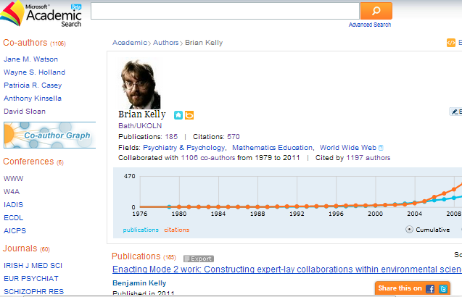Figure 1: Profile in Microsoft Academic Search
I2.3 Click on the links to the numbers of Publications and Citations to see the details for the author.
I2.4 Click on the W4A conference in the Conference link in the sidebar to see paper published in this conference. Select the Sort by Citation option to view the most highly cited papers at the conference.
I2.5 Click on the Co-author link in the profile sidebar. How useful is this display?

Exercise 3: Reality Check
I2.6 Return to the author’s profile page. Look at the list of apparent publications. Do these publications appear to reflect the author’s expertise in Web accessibility?
I2.7 What reasons might there be for incorrect papers being attributed to an author?

Social Media For Researchers
I: Citation analysis

I2: Using Microsoft Academic Search
What is it? Microsoft Academic Search provides a search facility for research papers, together with a self-claim mechanism for authors.
Why bother? The service can provide metrics on citations. However there is a need to remove false hits on automatically-claimed papers.

Exercise 1: Familiarisation
I2.1 Go to the Microsoft Academic Search home page at http://academic.research.microsoft.com/ Then use the search facility to explore areas of interest.

Exercise 2: A Profile in Microsoft Academic Search
I2.2 Search for “Brian Kelly UKOLN” and then click on the author’s name in one of the search results to view his profile. A profile as shown in Figure 1 will be displayed.
Figure 1: Profile in Microsoft Academic Search
I2.3 Click on the links to the numbers of Publications and Citations to see the details for the author.
I2.4 Click on the W4A conference in the Conference link in the sidebar to see paper published in this conference. Select the Sort by Citation option to view the most highly cited papers at the conference.
I2.5 Click on the Co-author link in the profile sidebar. How useful is this display?

Exercise 3: Reality Check
I2.6 Return to the author’s profile page. Look at the list of apparent publications. Do these publications appear to reflect the author’s expertise in Web accessibility?
I2.7 What reasons might there be for incorrect papers being attributed to an author?

Strengths and Limitations of Microsoft Academic Search
What are the strengths and limitations of services such as Microsoft Academic Search?

Managing Content
How would you / should you go about ensuring that papers assigned to you are actually yours??

Questions and Comments
Make a note of any questions and comments you have about services such as Microsoft Academic Search?

Further Information and Useful Links
For further information see:
- Will the Real Scott Wilson Please Stand Up, Please Stand Up, UK Web Focus blog, 20 Sep 2011, http://ukwebfocus.wordpress.com/2011/09/20/will-the-real-scott-wilson-please-stand-up-please-stand-up/

Strengths and Limitations of Microsoft Academic Search
What are the strengths and limitations of services such as Microsoft Academic Search?

Managing Content
How would you / should you go about ensuring that papers assigned to you are actually yours??

Questions and Comments
Make a note of any questions and comments you have about services such as Microsoft Academic Search?

Further Information and Useful Links
For further information see:
- Will the Real Scott Wilson Please Stand Up, Please Stand Up, UK Web Focus blog, 20 Sep 2011, http://ukwebfocus.wordpress.com/2011/09/20/will-the-real-scott-wilson-please-stand-up-please-stand-up/

