Social Media For Researchers
D: Researcher profiling services

D3: Using Mendeley
What is it? Mendeley is a researcher profiling service.
Why bother? Having a Mendeley account can help your peers to find your research publications and can help you connect with fellow researchers.
Risks: Low risk. Can be deleted if not wanted. However you should think carefully before uploading papers to the service due to issues such as copyright infringement and fragmentation of access to your papers.

Exercise 1: Familiarisation
D3.1 View the Mendely home page at http://www.mendeley.com/ Then search for papers in an area of interest to you.
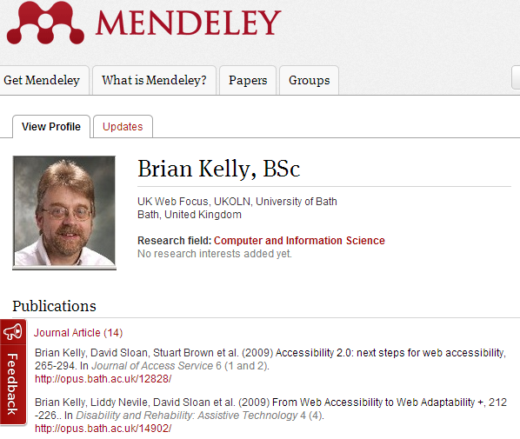Figure 1: Mendeley profile
D3.2 View the Mendeley profile such as the one at http://www.mendeley.com/
profiles/brian-kelly/ (as shown in Figure 1)

Exercise 2: Registering
D3.3 Click on the Sign up link at the top of the page and sign up for a Mendeley account.

Exercise 3: Learning More
D3.4 Go to the Mendeley tutorial at http://gettingstarted.mendeley.com/ Read some of the pages which describe how to get started with Mendeley.

Exercise 4: Searching
D3.5 Use the search facility to search for a paper on “The Role of the LinkedIn Social Media in Building the Personal Image”.

Exercise 5: Using Mendeley Groups
D3.6 Use a search term such as “social networks” and search for relevant groups on this topic which are available in Mendeley.
D3.7 Find a popular group and observe the nature of the discussions.

Social Media For Researchers
D: Researcher profiling services

D3: Using Mendeley
What is it? Mendeley is a researcher profiling service.
Why bother? Having a Mendeley account can help your peers to find your research publications and can help you connect with fellow researchers.
Risks: Low risk. Can be deleted if not wanted. However you should think carefully before uploading papers to the service due to issues such as copyright infringement and fragmentation of access to your papers.

Exercise 1: Familiarisation
D3.1 View the Mendely home page at http://www.mendeley.com/ Then search for papers in an area of interest to you.
Figure 1: Mendeley profile
D3.2 View the Mendeley profile such as the one at http://www.mendeley.com/
profiles/brian-kelly/ (as shown in Figure 1)

Exercise 2: Registering
D3.3 Click on the Sign up link at the top of the page and sign up for a Mendeley account.

Exercise 3: Learning More
D3.4 Go to the Mendeley tutorial at http://gettingstarted.mendeley.com/ Read some of the pages which describe how to get started with Mendeley.

Exercise 4: Searching
D3.5 Use the search facility to search for a paper on “The Role of the LinkedIn Social Media in Building the Personal Image”.

Exercise 5: Using Mendeley Groups
D3.6 Use a search term such as “social networks” and search for relevant groups on this topic which are available in Mendeley.
D3.7 Find a popular group and observe the nature of the discussions.

Creating an Mendeley Account
How easy was it to create a Mendeley account? Why would you wish to create and use Mendeley?

Limitations
What limitations do you feel Mendeley has?

Questions and Comments
Make a note of any questions and comments you have about Mendeley.

Further Information and Useful Links
For further information on Mendeley see:
- Mendeley, Wikipedia, https://en.wikipedia.org/wiki/Mendeley
- Altmetrics posts, Mendeley blog, http://blog.mendeley.com/tag/altmetrics/
- Research Intelligence - Alt-metrics: fairer, faster impact data?, THE blog, 23 Aug 2012, http://www.timeshighereducation.co.uk/420926.article

Creating an Mendeley Account
How easy was it to create a Mendeley account? Why would you wish to create and use Mendeley?

Limitations
What limitations do you feel Mendeley has?

Questions and Comments
Make a note of any questions and comments you have about Mendeley.

Further Information and Useful Links
For further information on Mendeley see:
- Mendeley, Wikipedia, https://en.wikipedia.org/wiki/Mendeley
- Altmetrics posts, Mendeley blog, http://blog.mendeley.com/tag/altmetrics/
- Research Intelligence - Alt-metrics: fairer, faster impact data?, THE blog, 23 Aug 2012, http://www.timeshighereducation.co.uk/420926.article

