Social Media For Researchers
Core services: CVs

A3: Using LinkedIn
What is it? LinkedIn provides an online CV.
Why bother? Having a LinkedIn account raise the visibility of your professional activities, research publications, etc. Note LinkedIn profiles are easily found on Google.

Exercise 1: Familiarisation
A3.1 View an example of a LinkedIn profile at http://uk.linkedin.com/in/ukwebfocus (shown in Figure 1).
A3.2 Use Google to search for individuals and include the name of an institution e.g. ‘John Smith University of Edinburgh’. Notice how LinkedIn profiles often occur in the first page of search results.
A3.3 Click on a LinkedIn profile. How comprehensive is the information? Does it give an indication of the creator’s professional activities, responsibilities and profile?

Exercise 2: Registering
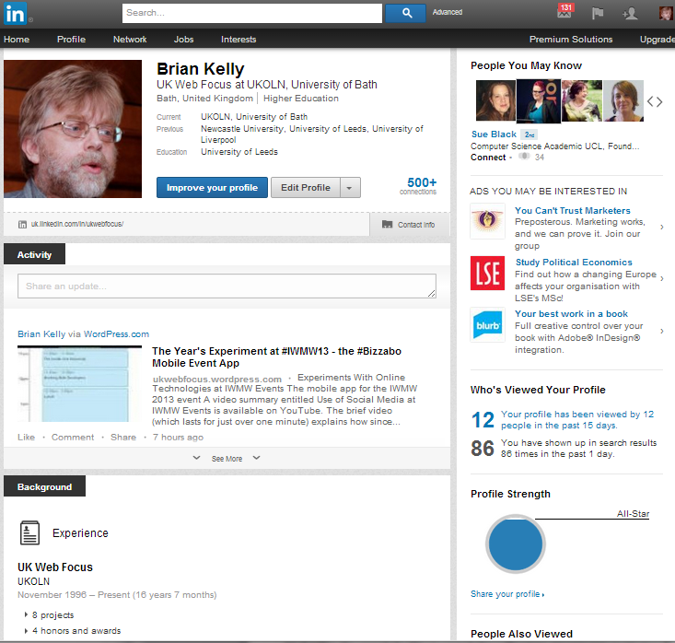Figure 1: LinkedIn profile
A3.4 Go to http://www.linkedin.com/ and sign up for a LinkedIn account.

Exercise 3: Populating
A3.5 Click on the Edit Profile option to create your LinkedIn profile. You can provide details of your current and previous positions, publications, projects, honours and awards, etc.

Exercise 4: Browsing
A3.6 Use the search facility to search for your own institution. How many colleagues have a profile?
A3.7 View the endorsements for Skills and Expertise and Testimonials for a number of LinkedIn profiles. Is such feedback useful? Would you welcome such feedback from your LinkedIn contacts?
A3.8 See a visualisation of your network using the visualisation service at http://inmaps.linkedinlabs.com/

Social Media For Researchers
Core services: CVs

A3: Using LinkedIn
What is it? LinkedIn provides an online CV.
Why bother? Having a LinkedIn account raise the visibility of your professional activities, research publications, etc. Note LinkedIn profiles are easily found on Google.

Exercise 1: Familiarisation
A3.1 View an example of a LinkedIn profile at http://uk.linkedin.com/in/ukwebfocus (shown in Figure 1).
A3.2 Use Google to search for individuals and include the name of an institution e.g. ‘John Smith University of Edinburgh’. Notice how LinkedIn profiles often occur in the first page of search results.
A3.3 Click on a LinkedIn profile. How comprehensive is the information? Does it give an indication of the creator’s professional activities, responsibilities and profile?

Exercise 2: Registering
Figure 1: LinkedIn profile
A3.4 Go to http://www.linkedin.com/ and sign up for a LinkedIn account.

Exercise 3: Populating
A3.5 Click on the Edit Profile option to create your LinkedIn profile. You can provide details of your current and previous positions, publications, projects, honours and awards, etc.

Exercise 4: Browsing
A3.6 Use the search facility to search for your own institution. How many colleagues have a profile?
A3.7 View the endorsements for Skills and Expertise and Testimonials for a number of LinkedIn profiles. Is such feedback useful? Would you welcome such feedback from your LinkedIn contacts?
A3.8 See a visualisation of your network using the visualisation service at http://inmaps.linkedinlabs.com/

Creating a LinkedIn Account
How easy was it to create a LinkedIn account? Why would you wish to create and use LinkedIn?

Limitations
What limitations do you feel LinkedIn has?

Questions and Comments
Make a note of any questions and comments you have about LinkedIn.

Further Information and Useful Links
For further information on LinkedIn see:
- LinkedIn, Wikipedia, https://en.wikipedia.org/wiki/LinkedIn
- Paper Accepted for OR12: Can LinkedIn and Academia.edu Enhance Access to Open Repositories?, B. Kelly, UK Web Focus blog, 3 Jul 2012, http://ukwebfocus.wordpress.com/2012/07/03/paper-accepted-for-or12/
- Visualize Your Network, LinkedIn, http://inmaps.linkedinlabs.com/

Creating a LinkedIn Account
How easy was it to create a LinkedIn account? Why would you wish to create and use LinkedIn?

Limitations
What limitations do you feel LinkedIn has?

Questions and Comments
Make a note of any questions and comments you have about LinkedIn.

Further Information and Useful Links
For further information on LinkedIn see:
- LinkedIn, Wikipedia, https://en.wikipedia.org/wiki/LinkedIn
- Paper Accepted for OR12: Can LinkedIn and Academia.edu Enhance Access to Open Repositories?, B. Kelly, UK Web Focus blog, 3 Jul 2012, http://ukwebfocus.wordpress.com/2012/07/03/paper-accepted-for-or12/
- Visualize Your Network, LinkedIn, http://inmaps.linkedinlabs.com/

