Social Media For Researchers
Using altmetrics

H1: Using Impactstory
What is it? Impactstory is a service which reports on altmetrics from a variety of services.
Why bother? Being able to observe and monitor engagement with tweets can help identify successful engagement strategies.

Exercise 1: Familiarisation
H2.1 Go to the Impactstory home page at http://impactstory.org/ as shown in Figure 1
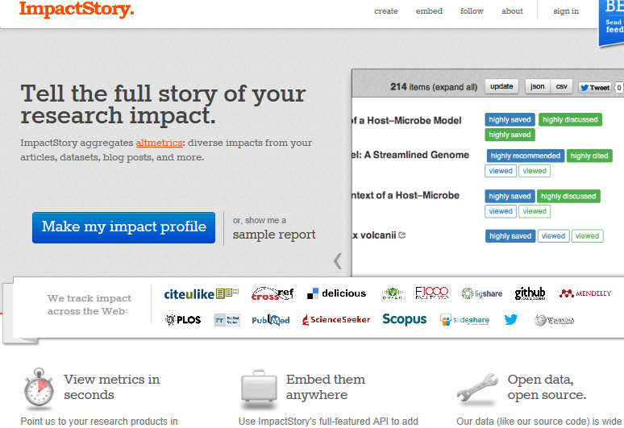Figure 1: The Impactstory home page
Read the information on the home page and the FAQ to familiarise yourself with the service.

Exercise 2: Registering
H2.2 If you are willing to do so, sign in to the service using either your Twitter ID or by creating an account on the service.

Exercise 3: Using Impactstory
H2.3 Select the Add products options and retrieve the altmetrics for a service you use, such as Slideshare, ORCID, etc.
H2.4 What do you find from the results?

Exercise 4: Finding Out More
H2.6 Read the FAQ available from the About menu option. Familiarise yourself with :
- The aims of the service.
- The target audiences.
- How the service should and shouldn’t be used.
- The metrics which are measured and the services used.

Social Media For Researchers
Using altmetric

H1: Using Impactstory
What is it? Impactstory is a service which reports on altmetrics from a variety of services.
Why bother? Being able to observe and monitor engagement with tweets can help identify successful engagement strategies.

Exercise 1: Familiarisation
H2.1 Go to the Impactstory home page at http://impactstory.org/ as shown in Figure 1
Figure 1: The Impactstory home page
Read the information on the home page and the FAQ to familiarise yourself with the service.

Exercise 2: Registering
H2.2 If you are willing to do so, sign in to the service using either your Twitter ID or by creating an account on the service.

Exercise 3: Using Impactstory
H2.3 Select the Add products options and retrieve the altmetrics for a service you use, such as Slideshare, ORCID, etc.
H2.4 What do you find from the results?

Exercise 4: Finding Out More
H2.6 Read the FAQ available from the About menu option. Familiarise yourself with :
- The aims of the service.
- The target audiences.
- How the service should and shouldn’t be used.
- The metrics which are measured and the services used.

Strengths and Limitations of Impactstory
What are the strengths and limitations of services such as Impactstory?

Using Impactstory
If you feel Impactstory has value, how would you go about using it?

Questions and Comments
Make a note of any questions and comments you have about services such as Impactstory.

Strengths and Limitations of Impactstory
What are the strengths and limitations of services such as Impactstory?

Using Impactstory
If you feel Impactstory has value, how would you go about using it?

Questions and Comments
Make a note of any questions and comments you have about services such as Impactstory.

