Social Media For Researchers
A: Google services

A2: Google Scholar
What is it? Google Scholar is Google’s search interface for research papers.
Why bother? Google’s expertise in search can provide valuable searching and alerting mechanisms for researchers.

Exercise 1: Familiarisation
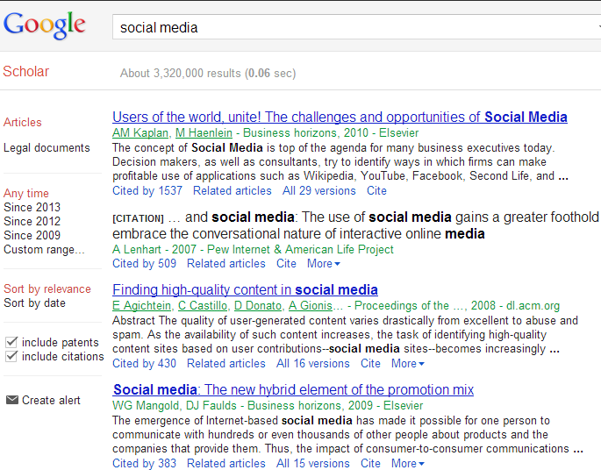Figure 1: A Google Scholar Search
A2.1 Visit the Google Scholar Web site at http://scholar.google.co.uk/
A2.2 Search for research articles on topics such as “social media”. Results similar to those shown in Figure 1 will be displayed.
A2.3 Examine the Google Scholar options including (a) searches by date and (b) citations information.

Exercise 2: Personalised Searches
A2.4 Login to Google Scholar using your Google+ account. If you have claimed ownership of any research papers you should see a set of alerts based on the citations given in your papers.

Exercise 3: Personal Citation Information
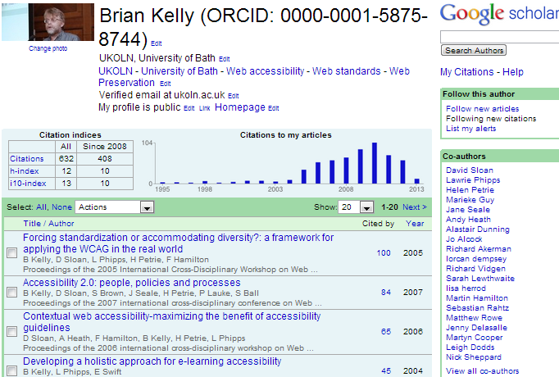Figure 2: A Google Scholar Profile
A2.5 Go to a Google Scholar profile. For example use Google Scholar to search for “Brian Kelly UKOLN”.
As shown in Figure 2 notice how the profile contains (a) citation metrics; (b) links to co-authors and (c) alerts for relevant new articles.

Social Media For Researchers
A: Google services

A2: Google Scholar
What is it? Google Scholar is Google’s search interface for research papers.
Why bother? Google’s expertise in search can provide valuable searching and alerting mechanisms for researchers.

Exercise 1: Familiarisation
Figure 1: A Google Scholar Search
A2.1 Visit the Google Scholar Web site at http://scholar.google.co.uk/
A2.2 Search for research articles on topics such as “social media”. Results similar to those shown in Figure 1 will be displayed.
A2.3 Examine the Google Scholar options including (a) searches by date and (b) citations information.

Exercise 2: Personalised Searches
A2.4 Login to Google Scholar using your Google+ account. If you have claimed ownership of any research papers you should see a set of alerts based on the citations given in your papers.

Exercise 3: Personal Citation Information
Figure 2: A Google Scholar Profile
A2.5 Go to a Google Scholar profile. For example use Google Scholar to search for “Brian Kelly UKOLN”.
As shown in Figure 2 notice how the profile contains (a) citation metrics; (b) links to co-authors and (c) alerts for relevant new articles.

Using Google Scholar
Did you find research papers using Google Scholar which may be of interest to you?

Making Your Research Papers Available in Google Scholar
Would you want to create a Google Scholar profile which contains details of your research publications? What advantages and disadvantages might the service have?

Questions and Comments
Make a note of any questions and comments you have about Google Scholar.

Further Information and Useful Links
For further information on Google Scholar see:
- Google Scholar, Wikipedia, https://en.wikipedia.org/wiki/Google_Scholar
- Thoughts on Google Scholar Citations, B. Kelly, UK Web Focus blog, 22 Nov 2011, http://ukwebfocus.wordpress.com/2011/11/22/thoughts-on-google-scholar-citations/
- Surveying Russell Group University Use of Google Scholar Citations, B. Kelly, UK Web Focus blog, 24 Nov 2011, http://ukwebfocus.wordpress.com/2011/
11/24/surveying-russell-group-university-use-of-google-scholar-citations/

Using Google Scholar
Did you find research papers using Google Scholar which may be of interest to you?

Making Your Research Papers Available in Google Scholar
Would you want to create a Google Scholar profile which contains details of your research publications? What advantages and disadvantages might the service have?

Questions and Comments
Make a note of any questions and comments you have about Google Scholar.

Further Information and Useful Links
For further information on Google Scholar see:
- Google Scholar, Wikipedia, https://en.wikipedia.org/wiki/Google_Scholar
- Thoughts on Google Scholar Citations, B. Kelly, UK Web Focus blog, 22 Nov 2011, http://ukwebfocus.wordpress.com/2011/11/22/thoughts-on-google-scholar-citations/
- Surveying Russell Group University Use of Google Scholar Citations, B. Kelly, UK Web Focus blog, 24 Nov 2011, http://ukwebfocus.wordpress.com/2011/
11/24/surveying-russell-group-university-use-of-google-scholar-citations/

