Social Media For Researchers
I: Citation analysis

I1: Using Google Scholar Citations
What is it? Microsoft Academic Search provides a search facility for research papers, together with a self-claim mechanism for authors.
Why bother? The service can provide metrics on citations. However there is a need to remove false hits on automatically-claimed papers.

Exercise 1: Familiarisation
I1.1 Visit a Google Scholar Citations profile at http://scholar.google.com/citations?
user=ixey0RkAAAAJ (or search for “brian kelly ukoln google scholar citations”). The profile shown in Figure 1 should be displayed.
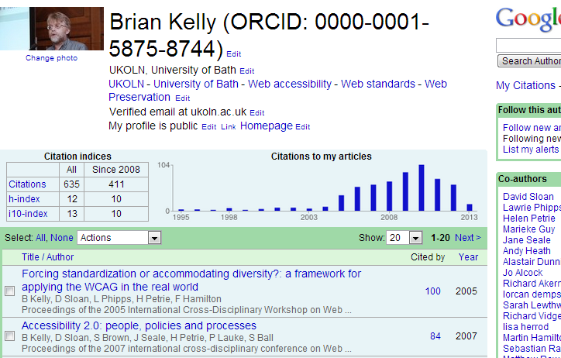Figure 1: Profile in Microsoft Academic Search
I1.2 Click on the Citations, h-index and 10-index names in order to read about how these scores area measures
I1.3 Click on one of the numbers of citations in order to view the citations for a paper.

Exercise 2: Viewing Co-authors
I1.4 View the information for co-authors. How reliable do you think the numbers of citations are?

Exercise 3: Searching
I1.5 Search for your colleagues. Do your fellow researchers a Google Scholar Profile?
I1.6 Search for your own name. Do you have a Google Scholar Profile?
I1.7 Read the blog post on use of Google Scholar Citations across Russell Group Universities at http://ukwebfocus.wordpress.com/2011/11/24/
surveying-russell-group-university-use-of-google-scholar-citations/
I1.8 Make a note of the number of profiles for your institution (if included). Then view the search results for your institution and go to the end of the research. Have the numbers grown significantly?

Social Media For Researchers
I: Citation analysis

I1: Using Google Scholar Citations
What is it? Microsoft Academic Search provides a search facility for research papers, together with a self-claim mechanism for authors.
Why bother? The service can provide metrics on citations. However there is a need to remove false hits on automatically-claimed papers.

Exercise 1: Familiarisation
I1.1 Visit a Google Scholar Citations profile at http://scholar.google.com/citations?
user=ixey0RkAAAAJ (or search for “brian kelly ukoln google scholar citations”). The profile shown in Figure 1 should be displayed.
Figure 1: Profile in Microsoft Academic Search
I1.2 Click on the Citations, h-index and 10-index names in order to read about how these scores area measures
I1.3 Click on one of the numbers of citations in order to view the citations for a paper.

Exercise 2: Viewing Co-authors
I1.4 View the information for co-authors. How reliable do you think the numbers of citations are?

Exercise 3: Searching
I1.5 Search for your colleagues. Do your fellow researchers a Google Scholar Profile?
I1.6 Search for your own name. Do you have a Google Scholar Profile?
I1.7 Read the blog post on use of Google Scholar Citations across Russell Group Universities at http://ukwebfocus.wordpress.com/2011/11/24/
surveying-russell-group-university-use-of-google-scholar-citations/
I1.8 Make a note of the number of profiles for your institution (if included). Then view the search results for your institution and go to the end of the research. Have the numbers grown significantly?

Strengths and Limitations of Google Scholar Citations
What are the strengths and limitations of services such as Google Scholar Citations?

Managing Content
How would you / should you go about ensuring that papers assigned to you are actually yours?

Questions and Comments
Make a note of any questions and comments you have about services such as Google Scholar Citations?

Further Information and Useful Links
For further information see:
- Thoughts on Google Scholar Citations, UK Web Focus blog, 22 Nov 2011, http://ukwebfocus.wordpress.com/2011/11/22/thoughts-on-google-scholar-citations/
- Surveying Russell Group University Use of Google Scholar Citations, UK Web Focus blog, 24 Nov 2011, http://ukwebfocus.wordpress.com/2011/11/24/
surveying-russell-group-university-use-of-google-scholar-citations/

Strengths and Limitations of Google Scholar Citations
What are the strengths and limitations of services such as Google Scholar Citations?

Managing Content
How would you / should you go about ensuring that papers assigned to you are actually yours?

Questions and Comments
Make a note of any questions and comments you have about services such as Google Scholar Citations?

Further Information and Useful Links
For further information see:
- Thoughts on Google Scholar Citations, UK Web Focus blog, 22 Nov 2011, http://ukwebfocus.wordpress.com/2011/11/22/thoughts-on-google-scholar-citations/
- Surveying Russell Group University Use of Google Scholar Citations, UK Web Focus blog, 24 Nov 2011, http://ukwebfocus.wordpress.com/2011/11/24/
surveying-russell-group-university-use-of-google-scholar-citations/

