Social Media For Researchers
A: Google Services

A1: Using Google+
What is it? Google+ is Google’s social networking environment and identify provider.
Why bother? Having a Google+ account is needed to make use of a range of Google services.

Exercise 1: Familiarisation
A1.1 Visit a Google+ profile such as the one at http://gplus.to/ukwebfocus You should see a profile similar to the one shown in Figure 1.
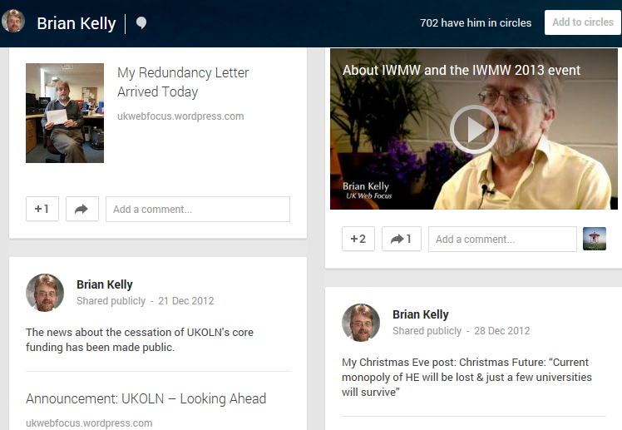Figure 1: A Google+ Profile

Exercise 2: Registering
A1.2 If you do not have a Google+ account and are willing to sign up for one go to http://plus.google.com/ and complete the registration details.

Exercise 3: Viewing Google Circles
A1.3 Near the top of a Google + profile click on the link to In his (her) circles and view the Google+ profile information for other users. View users’ posts and photos .

Exercise 4: Browsing
A1.4 Click on the Profile (or G+ icon if you are not logged in) link near the top of the screen and then select the Communities link. If you have used Google + previously there may be recommended communities for you to join.
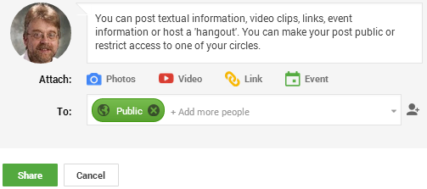Figure 2: Posting content in Google+

Exercise 5: Posting Information
A1.5 Go to your Google + profile page and select the option to “Share what’s new”. Notice how you can share textual information, images, video clips and links. You can also create a ‘Hangout’ – a video-conference.

Social Media For Researchers
A: Google Services

A1: Google+
What is it? Google+ is Google’s social networking environment and identify provider.
Why bother? Having a Google+ account is needed to make use of a range of Google services.

Exercise 1: Familiarisation
A1.1 Visit a Google+ profile such as the one at http://gplus.to/ukwebfocus You should see a profile similar to the one shown in Figure 1.
Figure 1: A Google+ Profile

Exercise 2: Registering
A1.2 If you do not have a Google+ account and are willing to sign up for one go to http://plus.google.com/ and complete the registration details.

Exercise 3: Viewing Google Circles
A1.3 Near the top of a Google + profile click on the link to In his (her) circles and view the Google+ profile information for other users. View users’ posts and photos .

Exercise 4: Browsing
A1.4 Click on the Profile (or G+ icon if you are not logged in) link near the top of the screen and then select the Communities link. If you have used Google + previously there may be recommended communities for you to join.
Figure 2: Posting content in Google+

Exercise 5: Posting Information
A1.5 Go to your Google + profile page and select the option to “Share what’s new”. Notice how you can share textual information, images, video clips and links. You can also create a ‘Hangout’ – a video-conference.

Using Google+
Did you find information or services in Google+ which may be of interest to you?

Limitations
What limitations do you feel Google+ has?

Questions and Comments
Make a note of any questions and comments you have about Google+.

Further Information and Useful Links
For further information on Google+ see:
- Google+, Wikipedia, https://en.wikipedia.org/wiki/Google%2B
- Is It Now Time to Embed Use of Google+?, B. Kelly, UK Web Focus blog, 21 Sept 2011, http://ukwebfocus.wordpress.com/2011/09/21/is-it-now-time-to-embed-use-of-google/
- Google+ isn't a social network; it's The Matrix, Guardian technology blog, 4 June 2013, http://www.guardian.co.uk/technology/blog/2013/jun/04/google-plus-the-matrix

Using Google+
Did you find information or services in Google+ which may be of interest to you?

Limitations
What limitations do you feel Google+ has?

Questions and Comments
Make a note of any questions and comments you have about Google+.

Further Information and Useful Links
For further information on Google+ see:
- Google+, Wikipedia, https://en.wikipedia.org/wiki/Google%2B
- Is It Now Time to Embed Use of Google+?, B. Kelly, UK Web Focus blog, 21 Sept 2011, http://ukwebfocus.wordpress.com/2011/09/21/is-it-now-time-to-embed-use-of-google/
- Google+ isn't a social network; it's The Matrix, Guardian technology blog, 4 June 2013, http://www.guardian.co.uk/technology/blog/2013/jun/04/google-plus-the-matrix

