Social Media For Researchers
B: Resource sharing

B2: Using Delicious
What is it? Slideshare is service which enables slides to be shared widely.
Why bother? Having an Slideshare account can help you share presentations given at conferences with fellow researchers.

Exercise 1: Familiarisation
B2.1 View a Delicious social bookmark service profile at https://delicious.com/lisbk as shown in Figure 1.
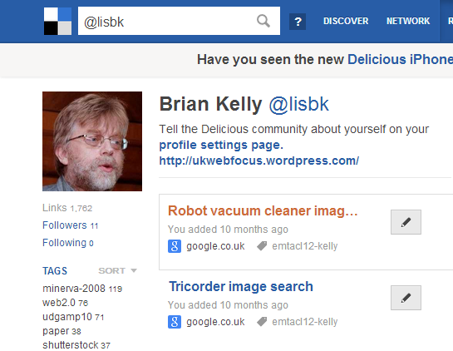Figure 1: A Delicious profile
B2.2 Look at the tags which have been used? What purposes do you think they have served?
B2.3 In the Followers list (shown below the image) see the resources which have been bookmarked by Mike Nolan.

Exercise 2: Searching
B2.4 Use the search box to search for an area relevant to your research interests. Did you find any useful resources?
B2.5 Look at Mike Nolan’s list of Tag bundles, such as Blogging.

Exercise 3: Additional Functionality
B2.6 Read the blog post on “Tweet a Link, Save a Link” at http://blog.delicious.com/2012/03/tweet-a-link-save-a-link/. How useful might this functionality be?

Exercise 4: Sustainability
B2.7 Revisit the bookmarks you have found. When were the most recent bookmarks added?
B2.8 Visit the Wikipedia entry for Delicious at https://en.wikipedia.org/wiki/Delicious_(website). Read the information about the history of the service and the takeover in 2011.

Social Media For Researchers
B: Resource sharing

B2: Using Delicious
What is it? Slideshare is service which enables slides to be shared widely.
Why bother? Having an Slideshare account can help you share presentations given at conferences with fellow researchers.

Exercise 1: Familiarisation
B2.1 View a Delicious social bookmark service profile at https://delicious.com/lisbk as shown in Figure 1.
Figure 1: A Delicious profile
B2.2 Look at the tags which have been used? What purposes do you think they have served?
B2.3 In the Followers list (shown below the image) see the resources which have been bookmarked by Mike Nolan.

Exercise 2: Searching
B2.4 Use the search box to search for an area relevant to your research interests. Did you find any useful resources?
B2.5 Look at Mike Nolan’s list of Tag bundles, such as Blogging.

Exercise 3: Additional Functionality
B2.6 Read the blog post on “Tweet a Link, Save a Link” at http://blog.delicious.com/2012/03/tweet-a-link-save-a-link/. How useful might this functionality be?

Exercise 4: Sustainability
B2.7 Revisit the bookmarks you have found. When were the most recent bookmarks added?
B2.8 Visit the Wikipedia entry for Delicious at https://en.wikipedia.org/wiki/Delicious_(website). Read the information about the history of the service and the takeover in 2011.

Using Delicious
What benefits do you feel Delicious can provide?

Limitations
What limitations do you feel Delicious has?

Questions and Comments
Make a note of any questions and comments you have about Delicious.

Further Information and Useful Links
For further information on Delicious see:
- Delicious (web site), Wikipedia, https://en.wikipedia.org/wiki/Delicious_(website)
- Tweet a Link, Save a Link, Delicious blog, 2 Mar 2012, http://blog.delicious.com/2012/03/tweet-a-link-save-a-link/
- Delicious posts, Techcrunch, http://techcrunch.com/tag/delicious/

Using Delicious
What benefits do you feel Delicious can provide?

Limitations
What limitations do you feel Delicious has?

Questions and Comments
Make a note of any questions and comments you have about Delicious.

Further Information and Useful Links
For further information on Delicious see:
- Delicious (web site), Wikipedia, https://en.wikipedia.org/wiki/Delicious_(website)
- Tweet a Link, Save a Link, Delicious blog, 2 Mar 2012, http://blog.delicious.com/2012/03/tweet-a-link-save-a-link/
- Delicious posts, Techcrunch, http://techcrunch.com/tag/delicious/

