Social Media For Researchers
E: Using blogs

E2: Finding Content Posted In Blogs
What is it? A blog can be used to highlight new peer-reviewed papers and provide links to papers which have been published previously.
Why bother? Using a blog can help you to (a) get feedback and comments on your papers and (b) raised the visibility of your work.

Exercise 1: Finding Pages About Peer-Reviewed Papers
E2.1 Go to the home page for the UK Web Focus blog at http://ukwebfocus.wordpress.com/ Then click on the link to Papers which is available in the top navigation bar.
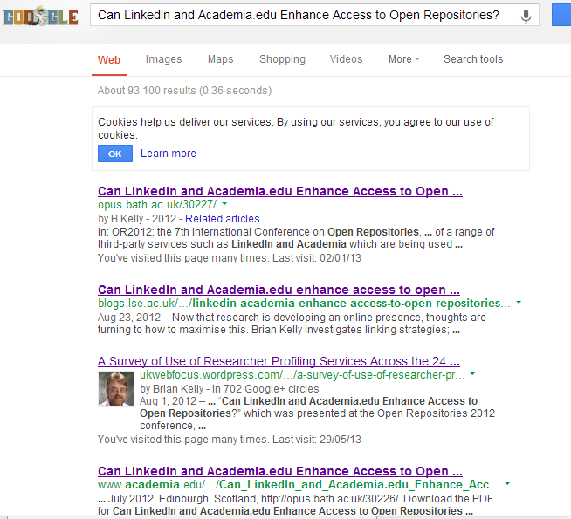Figure 1: Google search for peer-reviewed paper
E2.2 Select the title of a paper and search for it in Google. The results for the paper on “Can LinkedIn and Academia.edu Enhance Access to Open Repositories?” are shown in Figure 1.
E2.3 What type of services are found on the first page of Google’s results?

Exercise 2: Anonymised Browsing
E2.4 Check to see if your browser supports anonymised browsing. If it does, repeat the search using the option. Do the results differ?
E2.5 Go to http://www.duckduckgo.com/ and search for a paper using a search tool which does not remember your previous searches. Do the findings differ from those found when you used Google.

Exercise 3: Blogs For Researchers
E2.6 Read the post at http://researchblogging.org/static/index/page/about If you would like to publish a blog would you (a) set up a blog on a hosted service such as Wordpress.com; (b) use an institutional blog or (c) use a blog aimed at researchers?

Social Media For Researchers
E: Using blogs

E2: Finding Content Posted In Blogs
What is it? A blog can be used to highlight new peer-reviewed papers and provide links to papers which have been published previously.
Why bother? Using a blog can help you to (a) get feedback and comments on your papers and (b) raised the visibility of your work.

Exercise 1: Finding Pages About Peer-Reviewed Papers
E2.1 Go to the home page for the UK Web Focus blog at http://ukwebfocus.wordpress.com/ Then click on the link to Papers which is available in the top navigation bar.
Figure 1: Google search for peer-reviewed paper
E2.2 Select the title of a paper and search for it in Google. The results for the paper on “Can LinkedIn and Academia.edu Enhance Access to Open Repositories?” are shown in Figure 1.
E2.3 What type of services are found on the first page of Google’s results?

Exercise 2: Anonymised Browsing
E2.4 Check to see if your browser supports anonymised browsing. If it does, repeat the search using the option. Do the results differ?
E2.5 Go to http://www.duckduckgo.com/ and search for a paper using a search tool which does not remember your previous searches. Do the findings differ from those found when you used Google.

Exercise 3: Blogs For Researchers
E2.6 Read the post at http://researchblogging.org/static/index/page/about If you would like to publish a blog would you (a) set up a blog on a hosted service such as Wordprerss.com; (b) use an institutional blog or (c) use a blog aimed at researchers?

Finding Papers
Which services are displayed in the first page of search results? Suggest possible reasons for the high visibility of these services/

Hidden Dangers in Reproducing Search Findings
Google can tailor its findings for searchers based on your previous searches and your environment. What are the risks of this?

Questions and Comments
Make a note of any questions and comments you have about searching for content.

Further Information and Useful Links
For further information see:
- Research Blogs, Guardian, 10 Oct 2010, http://www.guardian.co.uk/higher-education-network/higher-education-network-blog/2012/oct/10/higher-education-blog-directory-research
- Top Qualitative Research Blogs, Qualitative, http://www.qual360.com/news-and-blogs/11-editor-s-pick-top-qualitative-research-blogs
- Impact of Social Sciences blog, LSE, http://blogs.lse.ac.uk/impactofsocialsciences/

Finding Papers
Which services are displayed in the first page of search results? Suggest possible reasons for the high visibility of these services/

Hidden Dangers in Reproducing Search Findings
Google can tailor its findings for searchers based on your previous searches and your environment. What are the risks of this?

Questions and Comments
Make a note of any questions and comments you have about searching for content.

Further Information and Useful Links
For further information see:
- Research Blogs, Guardian, 10 Oct 2010, http://www.guardian.co.uk/higher-education-network/higher-education-network-blog/2012/oct/10/higher-education-blog-directory-research
- Top Qualitative Research Blogs, Qualitative, http://www.qual360.com/news-and-blogs/11-editor-s-pick-top-qualitative-research-blogs
- Impact of Social Sciences blog, LSE, http://blogs.lse.ac.uk/impactofsocialsciences/

