Social Media For Researchers
E: Using blogs

E1: Blogs To Support Research Activities
What is it? A blog can be used to highlight new peer-reviewed papers and provide links to papers which have been published previously.
Why bother? Using a blog can help you to (a) get feedback and comments on your papers and (b) raised the visibility of your work.

Exercise 1: Post About a New Paper
E.1 Go to the home page for the UK Web Focus blog at http://ukwebfocus.wordpress.com/ Then search for a blog post using the search term “w4a 2013”. View the post at http://ukwebfocus.wordpress.com/2012/
03/07/paper-accepted-for-w4a2012-conference/ shown in Figure 1.
E1.2 Notice how the post helped to raise the profile of the paper.
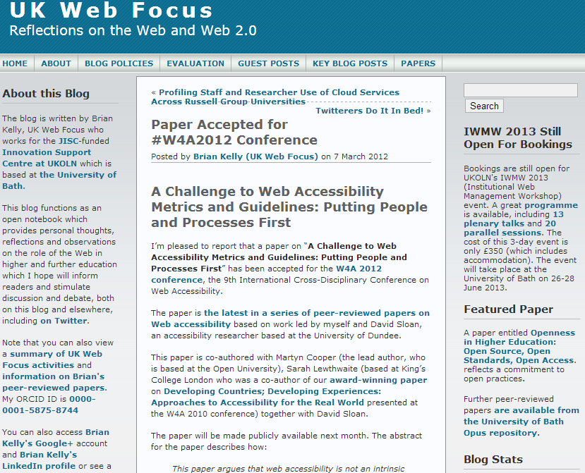Figure 1: Post on UK Web Focus blog

Exercise 2: Promoting Old Papers
E1.3 Notice the link to the Featured Paper in the right hand sidebar.
E1.4 Click on the link to Papers which is available in the top navigation bar.
E1.5 View the information about the peer-reviewed papers which is available from this page on the blog.

Exercise 4: Other Content on the Blog
E1.6 Notice the information about the researcher’s ORCID ID.
E1.7 Notice the other information about the researcher’s profile, including the link to the Google+, LinkedIn and ResearchGate profiles.

Exercise 4: Promoting Research Papers
E1.8 Go to the blog post which can be found at http://ukwebfocus.wordpress.com/2012/
04/13/ Complete the survey form which invites researchers to give their views on promotion of research publications .

Social Media For Researchers
E: Using blogs

E1: Blogs To Support Research Activities
What is it? A blog can be used to highlight new peer-reviewed papers and provide links to papers which have been published previously.
Why bother? Using a blog can help you to (a) get feedback and comments on your papers and (b) raised the visibility of your work.

Exercise 1: Post About a New Paper
E.1 Go to the home page for the UK Web Focus blog at http://ukwebfocus.wordpress.com/ Then search for a blog post using the search term “w4a 2013”. View the post at http://ukwebfocus.wordpress.com/2012/
03/07/paper-accepted-for-w4a2012-conference/ shown in Figure 1.
E1.2 Notice how the post helped to raise the profile of the paper.
Figure 1: Post on UK Web Focus blog

Exercise 2: Promoting Old Papers
E1.3 Notice the link to the Featured Paper in the right hand sidebar.
E1.4 Click on the link to Papers which is available in the top navigation bar.
E1.5 View the information about the peer-reviewed papers which is available from this page on the blog.

Exercise 4: Other Content on the Blog
E1.6 Notice the information about the researcher’s ORCID ID.
E1.7 Notice the other information about the researcher’s profile, including the link to the Google+, LinkedIn and ResearchGate profiles.

Exercise 4: Promoting Research Papers
E1.8 Go to the blog post which can be found at http://ukwebfocus.wordpress.com/2012/
04/13/ Complete the survey form which invites researchers to give their views on promotion of research publications .

Promoting New Papers
Do you feel it is appropriate to promote papers after they have been accepted for publication?

Providing Links and Commentable Papers for to Old Papers
Do you feel it is appropriate to promote papers which have previously been published? What advantages does it give to provide links and commentable pages?

Questions and Comments
Make a note of any questions and comments you have about using blogs to support your research.

Promoting New Papers
Do you feel it is appropriate to promote papers after they have been accepted for publication?

Providing Links and Commentable Papers for to Old Papers
Do you feel it is appropriate to promote papers which have previously been published? What advantages does it give to provide links and commentable pages?

Questions and Comments
Make a note of any questions and comments you have about using blogs to support your research.

