Social Media For Researchers
D: Researcher profiling services

D1: Using Academia.edu
What is it? Academia.edu is a researcher profiling service.
Why bother? Having an Academia.edu account can help your peers to find your research publications and can help you connect with fellow researchers.
Risks: Low risk. Can be deleted if not wanted. However you should think carefully before uploading papers to the service due to issues such as copyright infringement and fragmentation of access to your papers.

Exercise 1: Familiarisation
D1.1 View the Academia.edu profile for an early adopter at http://bath.academia.edu/
BrianKelly (shown in Figure 1)

Exercise 2: Registering
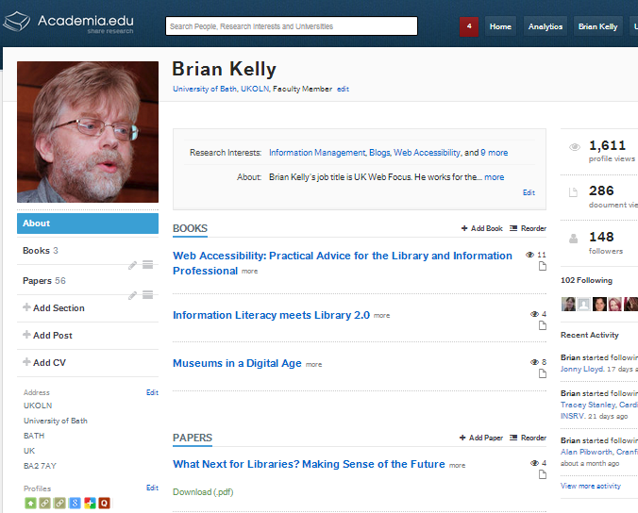Figure 1: Academia.edu profile
D1.2 Go to http://www.academia.edu/
and sign up for an Academia.edu account.

Exercise 3: Populating
D1.3 Click on the Upload papers option and add details of your papers. You should include a link to the paper if this is available online.
D1.4 If you wish to make the full text of your papers available via Academia.edu upload a copy of relevant papers.

Exercise 4: Searching
D1.5 Use the search facility to search for colleagues at your own institution.
D1.6 Use the search facility to search for papers in your area of expertise.
D1.7 View the blog post about use of Academia.edu in the 24 UK Russell Group Universities at http://ukwebfocus.wordpress.com/2012/08/01/.

Social Media For Researchers
D: Researcher profiling services

D1: Using Academia.edu
What is it? Academia.edu is a researcher profiling service.
Why bother? Having an Academia.edu account can help your peers to find your research publications and can help you connect with fellow researchers.
Risks: Low risk. Can be deleted if not wanted. However you should think carefully before uploading papers to the service due to issues such as copyright infringement and fragmentation of access to your papers.

Exercise 1: Familiarisation
D1.1 View the Academia.edu profile for an early adopter at http://bath.academia.edu/
BrianKelly (shown in Figure 1)

Exercise 2: Registering
Figure 1: Academia.edu profile
D1.2 Go to http://www.academia.edu/
and sign up for an Academia.edu account.

Exercise 3: Populating
D1.3 Click on the Upload papers option and add details of your papers. You should include a link to the paper if this is available online.
D1.4 If you wish to make the full text of your papers available via Academia.edu upload a copy of relevant papers.

Exercise 4: Searching
D1.5 Use the search facility to search for colleagues at your own institution.
D1.6 Use the search facility to search for papers in your area of expertise.
D1.7 View the blog post about use of Academia.edu in the 24 UK Russell Group Universities at http://ukwebfocus.wordpress.com/2012/08/01/

Using Academia.edu
How easy was it to create an Academia.edu account? Why would you wish to create and use Academia.edu?

Limitations
What limitations do you feel Academia.edu has?

Questions and Comments
Make a note of any questions and comments you have about Academia.edu.

Further Information and Useful Links
For further information on Academia.edu see:
- Academia.edu, Wikipedia, https://en.wikipedia.org/wiki/Academia.edu
- Paper Accepted for OR12: Can LinkedIn and Academia.edu Enhance Access to Open Repositories?, B. Kelly, UK Web Focus blog, 3 July 2012, http://ukwebfocus.wordpress.com/2012/07/03/paper-accepted-for-or12/
- Profiling Use of Third-Party Research Repository Services, B. Kelly, UK Web Focus blog, 12 Feb 2013, http://ukwebfocus.wordpress.com/2013/02/12/
profiling-use-of-third-party-research-repository-services/

Using Academia.edu
How easy was it to create an Academia.edu account? Why would you wish to create and use Academia.edu?

Limitations
What limitations do you feel Academia.edu has?

Questions and Comments
Make a note of any questions and comments you have about Academia.edu.

Further Information and Useful Links
For further information on Academia.edu see:
- Academia.edu, Wikipedia, https://en.wikipedia.org/wiki/Academia.edu
- Paper Accepted for OR12: Can LinkedIn and Academia.edu Enhance Access to Open Repositories?, B. Kelly, UK Web Focus blog, 3 July 2012, http://ukwebfocus.wordpress.com/2012/07/03/paper-accepted-for-or12/
- Profiling Use of Third-Party Research Repository Services, B. Kelly, UK Web Focus blog, 12 Feb 2013, http://ukwebfocus.wordpress.com/2013/02/12/
profiling-use-of-third-party-research-repository-services/

