Forcing Standardization or Accommodating Diversity?
A Framework for Applying the WCAG in the Real World

Brian Kelly
UKOLN
University of Bath
Bath, UK
+44 1225 383943
b.kelly@ukoln.ac.uk
Lawrie Phipps
The Network Centre
York Science Park
York, UK
+44 1904 754533
lawrie.phipps@heacademy.ac.uk

David Sloan
Digital Media Access Group
University of Dundee
Dundee, UK
+44 1382 385598
dsloan@computing.dundee.ac.uk
Helen Petrie, Fraser Hamilton
School of Informatics
City University
London, UK
+44 1904 754533
{h.l.petrie, f.m.hamilton}@city.ac.uk

ABSTRACT
Since 1999 the W3C’s Web Content Accessibility Guidelines (WCAG) have provided a solid basis for implementation of accessible Web design. However it is argued that in the context of evaluation and policymaking, inappropriate reference to the WCAG may lead to serious practical difficulties in implementation and monitoring of an effective accessibility policy. There is a pressing need for a framework that guides appropriate application of the WCAG in a holistic way, taking into account the diversity – or homogeneity – of factors such as context of use, audience and audience capability, and access environment. In particular, the current promotion of W3C technologies at the expense of widely used and accessible proprietary technologies may be problematic, as is the apparent reliance of the WCAG on compliant browsing technology.
In this paper, a holistic application of the WCAG is proposed by the authors, whereby the context of the Web resource in question and other factors surrounding its use are used to shape an approach to accessible design. Its potential application in a real world environment is discussed.
Categories and Subject Descriptors
H.5.2 [User Interfaces - Evaluation]; K.4.2 [Social Issues - Assistive technologies for persons with disabilities]
General Terms
Measurement, Documentation, Human Factors, Standardization, Legal Aspects, Verification.
Keywords
Web accessibility, WAI, WCAG, guidelines, methodologies.

INTRODUCTION
In many countries legislation now exists – or is in the process of being introduced – that places a responsibility on Web site providers to ensure that they do not unjustifiably discriminate against disabled people through the provision of a Web site with accessibility barriers. Yet, despite the presence of highly-regarded design guidelines, supported by an increasing volume of published and on-line literature, and growing support networks and communities devoted to Web accessibility, surveys consistently find that levels of Web accessibility remain disappointing.
We suggest that, while in the past this may have almost exclusively been a result of ignorance amongst Web content providers of the issue of Web accessibility, this is now a symptom of the complex relationship between:
- Web content accessibility;
- context and intended use of the Web content in question;
- interpretation and validation of accessibility guidelines;
- understanding of Web accessibility issues by owners and commissioners of Web sites
- capability of browsing and access technology to optimize accessibility;
- end user awareness of browsing and access technology
As organizations seek to define and implement policies for accessible Web design, whether for internal use or in outsourcing development work, so there is a pressing need to establish a practical framework for ensuring that on the one hand, unlawful discrimination does not take place, yet at the same time design can take place such that issues relating to accessibility as well as usability and user experience can equally be addressed.
Permission to make digital or hard copies of all or part of this work for personal or classroom use is granted without fee provided that copies are not made or distributed for profit or commercial advantage and that copies bear this notice and the full citation on the first page. To copy otherwise, or republish, to post on servers or to redistribute to lists, requires prior specific permission and/or a fee.
W4A at WWW2005, 10th May 2005, Chiba, Japan
Copyright 2005 ACM 1-59593-036-1/05/05…$5.00.
The incorporation of acknowledged best practice in the form of standards and guidelines would seem an important step in the definition of any policy relating to Web accessibility. What is challenging, however, is the nature of current guidance and standards on Web accessibility, and its compatibility with real world Web browsing situations and real world Web development environments, making difficult the formation of workable, definitive requirements that may be enshrined in formal policy or legislation.
There is a need for a framework with which to apply Web accessibility guidelines in real-world situations. This paper proposes such a framework, based on the authors’ extensive experiences of promoting accessibility within the UK educational, cultural, business and public sectors. First, though, we consider the nature of existing guidelines and challenges in their practical implementation, focusing initially on the World Wide Web Consortium’s Web Content Accessibility Guidelines.

THE WEB CONTENT ACCESSIBILITY GUIDELINES

Scope and Nature
The pre-eminent reference when considering Web accessibility is the Web Content Accessibility Guidelines (WCAG), Version 1.0 of which was published by the World Wide Web Consortium in 1999 [30]. The WCAG is one of three sets of guidelines which have been developed by the Web Accessibility Initiative (WAI); the other two guidelines being the User Agent Accessibility Guidelines (UAAG) [27] and the Authoring Tools Accessibility Guidelines (ATAG). [26]
The approach which has been developed by WAI assumes that universal Web accessibility can be provided by full conformance with these three components, as illustrated in Figure 1.
Figure 1: The WAI Approach to Accessibility
ATAG
UAAG
WCAG
The simplicity of this approach has helped WAI in raising the profile of Web accessibility. The WAI guidelines are now widely acknowledged as the main approach for providing accessible Web resources. Indeed, the success in which Web accessibility has been adopted as part of the increasingly popular “Web standards” movement [35] has been remarked upon by a number of commentators, for example Regan [19].
However, as this paper argues, there are limitations with this approach: the WAI model does not truly reflect the diverse uses made of Web technologies and the diversity of the end user environment. In addition the model is reliant on developments in user agents (browsers) and authoring tools. Since Web authors have no control over developments in these areas, and must wait for market forces and user awareness to propel end users towards using UAAG-conformant Web browsers, the WAI model fails to provide a practical implementation approach for Web authors.
As well as the limitations of the model, implementation of the WCAG guidelines can be problematic, as is discussed below.

Challenges in Implementation
Several surveys have been carried out which seek to measure WCAG conformance across a number of communities. Due to the resource implications and subjectivity of seeking to measure full WCAG conformance, surveys typically make use of automated accessibility auditing tools such as Bobby [32] in order to measure conformance with WCAG features which can be checked automatically. Although this approach will not be able to measure full conformance, it can be used to give an upper bound on WCAG conformance (for example, a tool can report on resources which appear to comply with WCAG through the presence, say, of ALT attributes for images but will not be able to say if appropriate alternative text for images are provided, which is needed for WCAG conformance). Despite such limitations, such surveys can prove useful as they can help to give a broad picture across communities, help to spot common problems and inform the development of appropriate strategies for developing solutions.
A survey of more than 160 UK University online entry points carried out in 2002 [20] showed that 43% of these entry points appeared conformant with WCAG A and less than 2% with WCAG AA. A repeat of the survey in 2004 [17] showed a small increase to 58% for WCAG A conformance and less than 6% for WCAG AA conformance. A more comprehensive survey of 1,000 UK Web sites was carried out for the Disability Rights Commission in 2004, which reported that only 19% of the pages appeared to comply with WCAG A [4]. A survey of 325 English and international sites in the cultural sector (museums, libraries and archives) also conducted in 2004 found that 40% passed the automated Level A checks, and 3% passed the automated Level AA checks [17] Links to a wider range of automated surveys which have been carried out within several countries is available have been collected by Schmetzke [20] which appear to show similar findings.
An initial reaction to such a low level of conformance (note that this was an upper bound on the conformance level, and given limitations of the capabilities of automated validation tools, manual testing may show that resources that may appear conformant using automated tools, would fail to comply using manual testing) would be to call for increased awareness raising and education and training, and possibly for punitive measures to be taken against high-profile non-conformant sites in order to make an example. However the authors have all been involved in a wide range of Web accessibility awareness-raising events and led training programmes in accessible Web design. Increasingly we have found that user communities have a genuine willingness and desire to provide accessible Web resources, but are beginning to raise questions concerning the challenges in implementing – and indeed the relevance of - all aspects of WCAG.
Discussions within the Web development community within the higher and further education within the UK on mailing lists, Web forums and events have taken place and a number of reservations concerning WCAG have been raised. This can be summarized as:
Theoretical nature of the guidelines: There is a feeling that the guidelines are too theoretical and are based on a W3C perspective rather than real world experiences. For example WCAG supporting documentation makes no mention of widely used Web formats such as PDF and Flash, yet concentrates on open, W3C technologies such as such as RDF, PNG and SVG which are far from ubiquitous and for which very little practical experiences are available.
Dependencies on other WAI guidelines: As mentioned, the WAI model of complementary accessibility guidelines rightly presents accessibility as a tripartite responsibility of users, browser and assistive technology developers, and Web content providers, in practice this model is inappropriate for Web authors, since developments to Web browsers and HTML authoring tools are outside of their control. The target audience of a particular resource may be quite unable or unwilling to use a user agent that supports the User Agent Accessibility Guidelines. Much as the existence of UAAG-conformant browsers in widespread use is a desirable scenario, until it happens, a model that depends on user agents taking responsibility for accessibility is flawed when put into practice. It may frequently require authors to consider extending browser functionality by adding features within page content – for example by providing features such as style sheet switchers to enable customization of page appearance – with clear implications on usability.
Ambiguity of the guidelines: The guidelines themselves are very ambiguous. Phrases such as ‘until user agents’ and ‘if appropriate’ are used which can be difficult to define. In an attempt to clarify the diversity of interpretations of WCAG a brief questionnaire was distributed at an annual UK Web management conference in 2003. The responses, from an audience with much knowledge of Web accessibility issues, showed a diverse set of answers to questions such as “Testing of accessibility can be fully achieved through the use of automated accessibility checking tools” and “Fully accessible Web sites should contain no pictures or multimedia features” [10].
Complexity of the guidelines: Note only are the WCAG guidelines ambiguous but they are also complex. This has led to many documents being written which seek to explain and interpret the guidelines (e.g. [14]). However this then leads to further confusion as such explanatory documents may perpetuate confusions.
Closed nature of the guidelines: The guidelines require use of W3C formats. Thus they implicitly fail to recognise the increasing emphasis placed on accessibility by vendors of proprietary file formats such as Shockwave Flash and PDF. The guidelines do not allow Web developers to embrace a diversity of solutions in order to provide effective Web services for a diverse set of requirements, but may be perceived as imposing a W3C-approved solution. The guidelines also fail to acknowledge the accessibility benefits which may be provided within an operating system environment (which can also help to provide an accessible environment for a range of desktop applications and not just a Web browser).
Logical flaws of the guidelines: The wording of the WCAG guidelines could be seen to lead to a number of logical absurdities. For example a strict interpretation of the priority 2 guidelines which states “... use the latest versions [of W3C technologies] when supported” would mean that a WCAG AA conformant HTML 4 Web site would be degraded to WCAG A conformance overnight when XHTML 1.0 was officially released! There are similar flaws when one considers use of GIF (a widely used, but proprietary graphical format) and PNG (an open and rich, but comparatively rarely-used W3C graphical format). Use of a closed graphical format such as GIF would appear to break the WCAG priority 2 guideline which requires Web developers to “Use W3C technologies when they are available and appropriate for a task”. But is there any evidence that use of GIF rather than PNG is a significant accessibility barrier?
Level of understanding of accessibility issues required: It needs to be remembered that the vast majority of individuals working to make Web sites accessible, both developers and managers, are not experts in accessibility or access technologies and never will be. Accessibility is one aspect of developing a Web site that they are seeking to understand. Thus expecting them to understand not only WCAG and something of how access technologies deal – perhaps inappropriately - with Web code, but also how WCAG interacts with the other WAI recommendations (e.g. those on user agents and authoring tools) [29] is a considerable undertaking. The Disability Rights Commission 2004 investigation [4] found that Web developers are asking for clear, straightforward guidance on how to produce accessible Web sites.
Case Study
As an example of how WCAG limitations can cause difficulties, consider the Allerdale Borough Council Web site. The Web site contains a WAI AAA logo on its home page and states that the home page is WCAG AAA conformant and the rest of the Web site is AA conformant. However a page on the accessibility of the site [2] states that
“Based upon advice from Nomensa, recognised Web Accessibility experts, we have decided to no longer provide Access keys on this Website.”
A quote from them:
Access keys are not used by the people who are supposed to use them, and could even hinder people if poorly implemented. The time would be better spent on a technique that is known to work, such as skip links.
Although access keys are intended to improve site navigation, it is shown they actually can interfere with web accessibility. In terms of implementing a common standard, it would require a universal understanding of access keys to be applied to every site.”
This is a clear example of a WCAG priority 3 requirement to “Provide keyboard shortcuts to important links” being purposefully disregarded due to its failure to provide accessibility benefits.
It should also be noted that, despite the clear evidence of the considered approach to accessibility taken by this Web site, many pages on the Web site are not HTML conformant and GIF images are used widely. However the authors of this paper would argue that such minor limitations (the HTML errors, for example, are mainly due to use of invalid punctuation characters and use of </br> instead of <br />) are not a barrier to the accessibility of the Web site.
At this point, we must acknowledge the ongoing efforts of WAI to develop and publish WCAG 2.0 [31], a clear opportunity to address these issues. It is a highly admirable undertaking in many respects, but we fear that the level of understanding required by non-experts in accessibility will be even greater than for WCAG 1.0.
It is acknowledged that our concerns could be regarded as ‘nit-picking’, and that there is a legitimate concern that raising such issues may be considered counter-productive and could lead to a reluctance by Web authors to seek to develop accessible Web sites until these confusions have been resolved. It is also acknowledged by the authors that WAI has been tremendously successful in raising the importance of Web accessibility and the WCAG guidelines have been a very useful tool.
However, so long as the Web publishing community is aware of WCAG 1.0 as the current stable reference to Web accessibility, and so long as WCAG 2.0 remains in draft and non-referencable form, we feel there is a need to address now the concerns over the nature of the guidelines and the potential problems of an uninformed application of the guidelines by content providers and policymakers alike, since we are all seeking to build a robust and achievable framework to support accessibility in today’s world.

Other Guidelines
There is a need to recognize that other guidelines, focusing partially or completely on Web accessibility also exist; some of which may be similar to or even based on the WCAG yet which may be more prominent to specific communities. These include the Section 508 Electronic and Information Technology Standards [21], the IMS Accessibility Guidelines for e-learning resources [6], guidelines based on user-focused research programmes, such as the usability guidelines for disabled people developed by Coyne and Nielsen [3], and Theofanos and Redish’s guidelines for Web design for screen reader users [25].
The US Department of Health and Human Services has also produced research-based Web design and usability guidelines [13]. This set of guidelines is interesting for a number of reasons. It has a very transparent methodology for how the guidelines were developed, the rating of each guideline for ‘relative importance’ and ‘strength of evidence’, and the listing of sources of evidence for each guideline, all give confidence in the validity and usefulness of the guidelines. One chapter provides 13 guidelines on accessibility and two other accessibility related guidelines are included in other chapters.

LIMITATIONS OF GUIDELINES - THE HUMAN ASPECT OF ACCESSIBILITY
The presence of a set of guidelines may lead Web developers to assume that some goal of ‘accessibility’ can be reached by self-validation against each and every checkpoint. Indeed, this can be extended to the reliance of automated checking tools for reporting levels of accessibility, when these tools can only check against those guidelines that directly refer to easily machine-testable conditions, such as the presence or absence of specific HTML code (or strings of text).
Indeed, accessibility is often defined as conformance to WCAG 1.0 (e.g. [5]). However, the WAI’s definition of accessibility makes it much closer to usability: content is accessible when it may be used by someone with a disability [28] (emphasis added). Therefore the appropriate test for where a Web site is accessible is whether disabled people can use it, not whether it conforms to WCAG or other guidelines. Thatcher [24] expresses this nicely when he states that accessibility is not “in” a Web site, it is experiential and environmental, it depends on the interaction of the content with the user agent, the assistive technology and the user. Obviously, one would hope there would be a high correlation between user performance and usability measures on the one hand and conformance to WCAG on the other hand. But as yet there are few studies that have produced the evidence base for this relationship. The DRC investigation [4] produced Web sites that rated very well on user performance and acceptance measures yet did not conform to WCAG. Conversely the investigation of museum Web sites [9, 18] showed that Web sites which have a high level of conformance to WCAG were unusable by disabled people and rated as “accessibility catastrophes”. Clearly more research on this topic is urgently called for. Part of the problem is that designing Web sites to be easy to use is not a straightforward undertaking, whether for mainstream users or disabled users.
This also leads to a rather strange legal anomaly. Usability of Web sites may be a commercial imperative as well as plain common sense, but is not a legal requirement for mainstream users, yet in many countries Web sites must be accessible, i.e. usable, by disabled users (see Section 4). So the requirement is higher for disabled than ‘mainstream’ users. Perhaps Web developers can use this anomaly in a positive way and drive usability of sites from the legal requirement for accessibility – so if Web sites become more usable in the future, we may have disabled people to thank.
User evaluation is widely recommended as a crucial aspect of inclusive and usable design. It does, though, require organization and time, and recruitment of appropriate subjects. Coyne and Nielsen noted the difficulties in recruiting a suitable number of disabled subjects when they carried out their investigation of Web site accessibility [3].
Even when considering a group of users who may appear to be specific disability, there may be significant diversity in members of that group in, for example, available browsing and assistive technologies, knowledge and confidence in using those technologies, knowledge of and attitude towards Web browsing in general, and severity, combination and impact of other disabilities. So, despite recommendations from the usability community of the benefits of involving even a small number of disabled people in evaluation [15], some have argued that, given the existence of comprehensive guidelines such as the WCAG, this diversity of disabled users is such that user evaluation may produce inappropriate or incomplete results (see the thread on the WAI-IG mailing list at http://lists.w3.org/Archives/Public/w3c-wai-ig/2004AprJun/0100.html for discussion on this).
This tension can lead to conflict between those who seek to report accessibility based solely on automated guideline evaluation, and those who promote a human-based evaluation strategy. Recently in the UK, a public argument broke out between Sitemorse, a Web monitoring and evaluation company which develops solutions for automated testing of Web site metrics including accessibility, and the Disability Rights Commission over the relative merits of automated and user evaluation in assessing accessibility. The Sitemorse position [22] has been critiqued [7], although the critique, which outlines the limitations of automated testing, does not reconcile the tensions between these two approaches. Similarly, as noted earlier, when the findings of the DRC Investigation into Web site accessibility were published, the apparent iniquity between those Web sites that were found by the investigation to perform well in evaluation with disabled people, and the level of conformance of these Web sites with the WCAG led some commentators to make disapproving remarks about the outcomes of the research [34].
This scenario may lead Web developers to conclude that either:
- The WCAG is flawed and should not be relied upon, or
- The use of automated tools testing against WCAG is a more reliable and robust way of identifying accessibility barriers than involving disabled people in evaluation- a particularly illogical scenario given the intended beneficiaries of accessible Web design!
Clearly both these scenarios are undesirable and unhelpful in a drive towards an optimally accessible – and usable -Web.

LEGISLATION
We now briefly examine examples of legislation that may directly apply to Web site accessibility for disabled people, or at least be generally regarded as applying to Web sites, and consider the relationship of the terms of each instance of legislation to the WCAG.

Australia: Disability Discrimination Act
In Australia, the Disability Discrimination Act 1992 (DDA) was demonstrated in a court of law to apply to Web site accessibility when in 2000 the Human Rights and Equal Opportunities Commission (HREOC) ruled that the Sydney Organizing Committee of the Olympic Games (SOCOG) was in breach of the DDA in providing a Web site (the 2000 Olympic Games Web site) containing accessibility barriers. While the terms of the DDA legislation do not specifically mention acceptable levels of Web accessibility – or even Web sites themselves, Sloan [23] noted that in summing up the case, the view of HREOC was that unlawful discrimination would not have occurred had the WCAG been followed by the site developers.

US – Section 508 of the Rehabilitation Act
The amended Section 508 of the Rehabilitation Act [1] sets out obligations for federal agencies in that the technology they procure and provide, for the use of employees and for provision of information and services to members of the public, is accessible to disabled people. In simple terms, the legislation requires conformance with the Section 508 Standards [21] – not part of the legislation itself, but a set of technical requirements, some of which specifically relate to Web accessibility. These requirements are very similar to – but not identical to, and not as extensive as – the WCAG.

US – Americans with Disabilities Act
The Americans with Disabilities Act is the pre-eminent legislation in the US addressing the rights of disabled US citizens not to encounter unjustified discrimination on account of their disability. The terms of the ADA do not directly reference the Web or Internet, nor to the WCAG, and this has led to a number of seemingly contradictory rulings in cases where the ADA has been applied in a court of law to a case concerning Web accessibility [33].

Italy - Provisions to Support the Access to Information Technologies for the Disabled
In January 2004, legislation was introduced in Italy that set out requirements for accessibility of computer systems, with specific provision for Web sites [16]. The legislation, like Section 508, provides for the establishment of a set of technical requirements which - while not part of the legislation - will serve as a standard to be adhered to by Web site developers in order to ensure legal compliance. At the time of writing, though, it does not appear that this standard has been formalised.

UK – Disability Discrimination Act
In the UK, the Disability Discrimination Act sets out the rights of disabled people not to encounter unjustified discrimination. Web sites are not mentioned in the legislation itself, although do appear in supporting Codes of Practice. At the time of writing no case law exists, although most commentators agree that the DDA would likely apply to a Web site with accessibility barriers [23]. No consensus exists, though, in terms of what might be deemed an acceptable level of accessibility. As mentioned previously, though, the terms of the DDA do appear to extend to the need to make services accessible to – and usable by – disabled people.

WCAG, Law and Policymaking
The above examples show the diversity of approaches across the globe to the issue of Web accessibility and legislation protecting the rights of disabled people not to encounter unjustified discrimination. What seems clear is that, as a stable and referencable document, WCAG is widely seen as a standard to which legislation and policy can refer, directly or indirectly.
Yet, given the challenges outlined in Section 2.2 in applying the WCAG in today’s diverse Web browsing environment, establishing WCAG conformance as a legislative obligation or enforceable policy requirement may lead to serious problems for many Web developers, who may find that a failure to meet one WCAG checkpoint will see them breaking the law. There may be cases when conformance with certain WCAG checkpoints may be legally required, despite there being no obvious situation where failing to conform would lead specifically to discrimination against disabled people.
It is beyond the expertise of the authors to discuss how – indeed if – a satisfactory relationship between WCAG and law can exist, but for both policymakers and Web content providers, some form of framework that supports effective application of the WCAG in a given context, such that optimal accessibility of online resources can be reached.

SUPPORTING DIVERSITY – AN ALTERNATIVE APPROACH TO WEB ACCESSIBILITY

A Holistic Approach to e-Learning Accessibility
A holistic approach to e-learning accessibility has been developed by Kelly, Phipps and Swift [12]. This framework, (illustrated in Figure 2) puts the user at the centre. It has been developed recognising that the Web (indeed technologies themselves) are not necessary critical in themselves but in what they can provide. Within the context of e-learning the important aspect are the learning outcomes. An approach based on blended learning, for example, seeks to provide a rich learning environment based on both use of learning technologies and traditional approaches to learning. With this approach the emphasis is placed on the provision of accessible learning outcomes, and not necessarily on accessibility e-learning resources.
Figure 2: TechDis/UKOLN Approach For Holistic E-Learning Accessibility
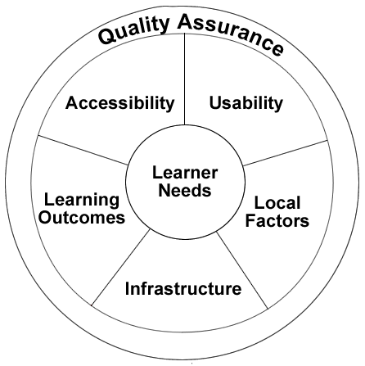
This approach is based on current consensus approaches to learning within the UK higher and further educational communities in which there is a recognition of the need to support a diversity of learning styles through the provision of a diversity of learning approaches. The richness and diversity of blended learning is illustrated in Figure 3.
Figure 3: A Blended Approach To Learning
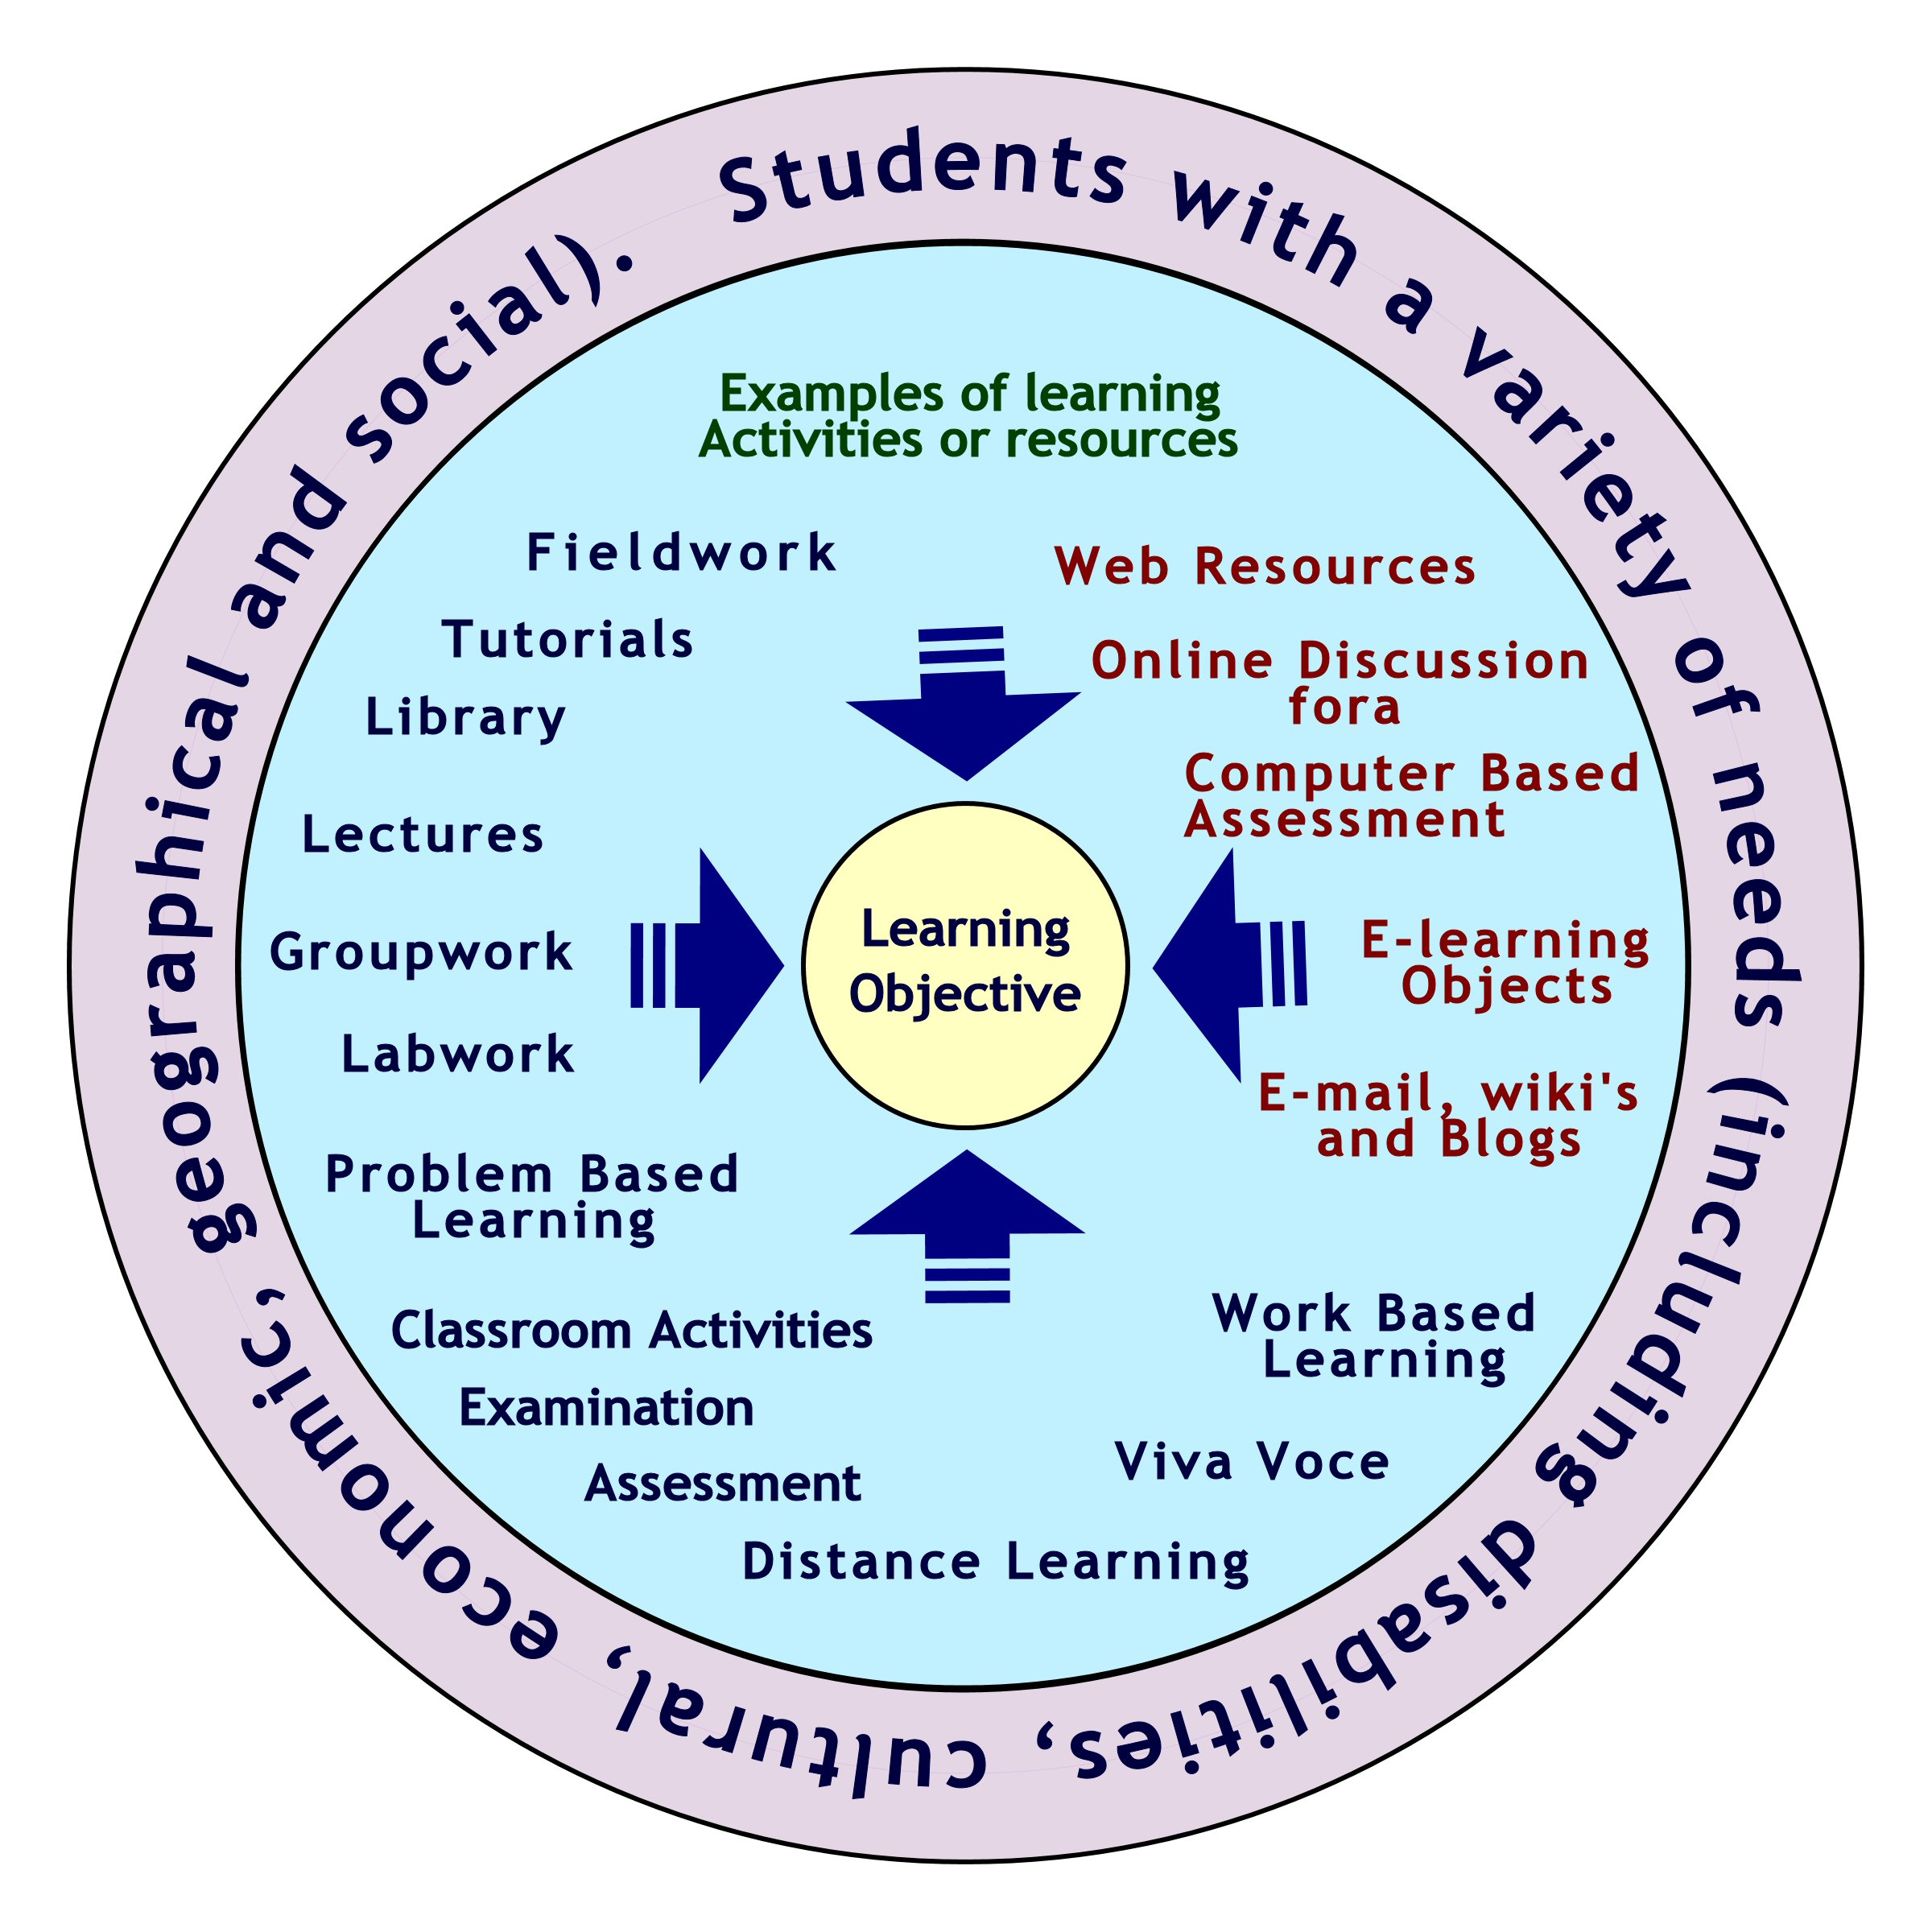

Extending the Approach
The holistic approach to e-learning discussed in Section 5.1 shows that accessibility cannot be treated in isolation from other factors that combine to determine the success or otherwise of an e-learning resource in the wider context of the learning environment. In this section we outline a more general holistic approach to accessibility.
We thus argue that the WCAG cannot be applied to a specific resource – whether an e-learning resource or a publicly accessible Web site - without taking into account a number of factors, and that only when the following have been established, can an effective strategy for applying the WCAG be implemented:
- The intended purpose of the Web site or resource (what are the typical tasks that user groups might be expected to perform when using the site? What is the intended user experience?)
- The intended audience – their level of knowledge both of the subject(s) addressed by the resource, and of Web browsing and, assistive technology
- The intended usage environment (e.g. what is the range of browsers and assistive technologies that the target audience is likely to be using?)
- The role in overall delivery of services and information (are there pre-existing non-Web means of delivering the same services?)
- The intended lifecycle of resource (e.g. when will it be upgraded/redesigned? Is it expected to be evolvable?)
Once these parameters have been established, there is a need to define, and document justifications for the definition made, the following:
- The extent of bespoke accessibility features to be provided within the site (for example an accessibility statement, a custom style sheet switcher, large text option(s), the provision of an audio output feature on each page)
- Acceptable (X)HTML validation target
- Acceptable use of proprietary technologies
- Level of involvement of disabled users in evaluation, including an indication of the degree to which they represent the target audience in terms of available technology and subject knowledge
- Any instance of a WCAG checkpoint found not to be implementable or applicable given the defined context of the resource in question given must also be documented and justified. Consideration of how those who may remain affected by the barrier can access the information or functionality in another way should, of course, also be documented, even though the process described above should ensure that a failure to meet a guideline has a minimal impact on the target audience’s ability to use the resource as required.
This process should create a framework for effective application of the WCAG without fear that conformance with specific checkpoints may be unachievable or inappropriate.
As it provides a way of applying ALL of the WCAG checkpoints effectively, in the context of the resource as opposed to a set of priorities, it may also help to reduce or avoid the current dilemma facing both Web content providers and the W3C WCAG Working Group, whereby the presence of three rigid priority levels may discourage Web authors going beyond a specific conformance level to a seemingly unrewarded point short of the next conformance level, despite the obvious accessibility benefits these ‘extra steps’ would offer users.
There is also an issue in that a checkpoint’s WCAG priority may not necessarily be a true indicator of its impact on disabled users. Consider the usability impact of a frequent and high-profile Priority Three checkpoint failure – such as the failure to provide a way of bypassing groups of links. This may be more serious than a failure to provide alternative text for a spacer image somewhere towards the bottom of a rarely-visited page – yet classified as a Priority One failure. In such a case WCAG conformance levels thus cease to be an effective way of assessing accessibility for disabled people. So we argue that moving emphasis from designing and assessing according to priority of checkpoints, towards making accessible the purpose of the site to the target audience, is a more user-centered and more effective way of ensuring optimal accessibility.

APPLYING OUR HOLISTIC APPROACH
We have argued the need for a holistic approach to Web accessibility which takes into account factors such as usability, IT accessibility, proprietary solutions, resource implications and local and regional cultural factors. There is also a need for a wider framework which addresses other important issues such as selection of standards, application environments, project management, financial and funding issues, etc.
As part of work to support digital library development programmes with the UK, funded by bodies such as the JISC (Joint Information Systems Committee) we are in the process of developing a framework covering the standards, file formats, etc. which can be used for JISC’s development and service activities. Following consultation work across the community the JISC-funded QA Focus project felt there was a need to promote an open standards culture but felt that, in many cases, mandating open standards failed to reflect the diversity of our community, including the disparity of skills and resources, and also the potential for open standards to be accepted within the marketplace [11]. We therefore feel there is a need to have a layered approach to the deployment or standards and best practices which recognises that a one-size-fits-all approach is inappropriate and yet supports the development of appropriate solutions: The framework which is currently being developed takes into account the following factors:
Context: There is no “one size-fits all” solution; instead there is a need to take into account the nature of the development activity (e.g. innovative work which is evaluating new technologies and methodologies versus mainstream development work for which mature and well-tested solutions exist); the remit of the work (e.g. end-user service; middleware component; closed service such as an Intranet; simple report; etc.); the organizations context (e.g. well-funded research-led institution or poorly-funded college with limited technical expertise); whether the work is part of new development activities or established service provision; etc.
Within this contextual layer, invitations to tender for new work and service level agreements for existing services will refer to the policies which are appropriate for the context.
Policies: A layered set of policies will cover areas such as technical standards, open source software, usability, accessibility, project management finances, etc. In the case of technical standards, usability and accessibility, the policies may be an annotated catalogue of appropriate standards and best practices, containing brief descriptions of their maturity, deployment challenges, etc.
Selection: The section layer can allow projects to choose the standards and best practices which are applicable to their particular context, subject to any requirements mandated within the contextual layer.
Figure 4: Wider Context For Selection Of Standards and Best Practices
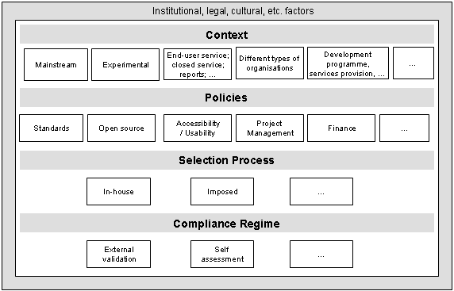
Conformance: The conformance layer will ensure that the selected standards and best practices are being implemented correctly.
External factors (e.g. legislation, organizational, etc.): A framework digital library development cannot be developed independently of a variety of external factors. Legal factors are a clear example, but in addition there may be organizational issues which could potentially cause conflicts.
This framework is illustrated in Figure 4.
It should be noted that an instantiation of this framework could mandate use of W3C technologies and the WCAG within a digital library programme and implement a strict conformance regime which ensures that such policies were correctly implemented. However the framework will also allow a more liberal approach to be taken.
An implication of this framework from the perspective of Web accessibility guidelines is the need for accessibility policies to be capable of being integrated within this framework. This layered approach will mean, for example, that Web accessibility guidelines should be neutral on file format issues; the Web accessibility should describe how particular formats should be used in order to be accessible, but should not mandate usage of the formats.

Revisiting the Role of WAI and WCAG
This paper has argued for a more open approach to accessibility than is currently provided by the WCAG. This approach will inevitably lead to the question of the future role of WAI and WCAG. One approach would be to argue that WAI should include usability within its remit and that future versions of WCAG should include guidelines on best practices for usability. However an alternative point of view is to argue that since WAI is a part of W3C, it will be difficult for WAI to provide neutral and objective advice on non-W3C formats, even given representation on WCAG of those organizations producing ‘rival’ proprietary technologies and formats. Similarly WAI will not be in a position to address wider approaches to accessibility using non-Web protocols, as such issues are not within W3C’s remit. Such arguments would lead to WAI having a remit to address the accessibility of new W3C formats.
Clearly such issues will be very contentious. It would be a mistake to regard raising such issues as a criticism on the work which has been carried out by WAI. Rather, this debate reflects the success of WAI in raising awareness of the importance of accessibility across a much wider community than may have originally been envisaged.

CONCLUSION
The WCAG – whether the current version 1, or the as yet in-draft version 2 – remains an important and valuable resource on which to base accessible Web design. What is essential, though, is that the diversity of the context, purpose and target audience in which current Web development takes place is considered in any policy or approach to web accessibility, and that a logical approach to defining this context is taken before implementing the WCAG. The approach suggested in this paper takes a holistic approach to Web accessibility, and may be an appropriate means by which appropriate strategies can be applied to create optimally accessible – and usable – Web content.

ACKNOWLEDGMENTS
We are grateful to Andy Judson and Lorna Gibson for their advice and comments in the writing of this paper.

REFERENCES
- 1998 Amendment to Section 508 of the Rehabilitation Act Retrieved March 15 2005 from Section 508.gov web site http://www.section508.gov/index.cfm?FuseAction=Content&ID=14
- Allerdale Borough Council: Accessibility. Retrieved March 10, 2005, from Allerdale Borough Council Web site: http://www.allerdale.gov.uk/main.asp?page=166
- Coyne, K. and Nielsen, J. Beyond ALT text: making the web easy to use for users with disabilities. Fremont, CA: Nielsen Norman Group 2001.
- Disability Rights Commission. Formal Investigation report: web accessibility. Retrieved March 10, 2005, from DRC Web site: http://www.drc-gb.org/publicationsandreports/report.asp
- HTML Writers Guild. HTML Writers Guild Web Accessibility Standards. Retrieved March 10, 2005, from Web site: http://www.hwq.org/opcenter/policy/access.htm
- IMS Global Learning Consortium. Guidelines for Developing Accessible Learning Applications, version 1.0. Retrieved March 10 2005 from NCAM Web site http://ncam.wgbh.org/salt/guidelines/
- Isolani. Sitemorse gets nasty, accessibility is the victim. Retrieved March 16 2005 from http://www.isolani.co.uk/blog/access/SiteMorseGetsNastyAccessibilityIsTheVictim
- Kelly, B. Accessibility Survey of UK University Entry Points, June 2004. Retrieved March 10, 2005, from UKOLN Web site: http://www.ukoln.ac.uk/web-focus/events/
workshops/webmaster-2004/talks/phipps-kelly/survey/
- Kelly, B. An Accessibility Analysis Of UK University Entry Points. Ariadne issue 33, Sept 2002. Retrieved March 10, 2005 from http://www.ariadne.ac.uk/issue33/web-watch/
- Kelly, B. Institutional Web Management Workshop 2003: Accessibility Questionnaire. Retrieved March 10, 2005, from UKOLN Web site: http://www.ukoln.ac.uk/web-focus/events/workshops/webmaster-2003/accessibility-questionnaire/
- Kelly, B, Dunning, A, Guy, M and Phipps, L. Ideology Or Pragmatism? Open Standards And Cultural Heritage Web Sites. ichim03 Proceedings (CDROM). Retrieved March 10 2005, from: http://www.ukoln.ac.uk/qa-focus/documents/papers/ichim03/
- Kelly, B., Phipps, L. and Swift, E. Developing A Holistic Approach For E-Learning Accessibility. Canadian Journal of Learning and Technology, 2004, Vol. 30, Issue 3. Retrieved March 10, 2005, from: http://www.ukoln.ac.uk/web-focus/papers/cjtl-2004/
- Koyani, S.J., Bailey, R.W.. Nall, J.R., Allison, S., Mulligan, C., Bailey, K. and Tolson, M. Research-based Web design and usability guidelines. Retrieved March 10, 2005, from Usability.gov Web site: http://www.usability.gov/guidelines/guidelines_notice.html
- National Disability Authority of Ireland. Accessibility Guidelines for Web. Retrieved March 10, 2005, from NDA Web site: http://accessit.nda.ie/technologyindex_1.html
- Nielsen J. Why you only need to Test with 5 Users. Alertbox March 2000. Retrieved March 16, 2005 from http://www.useit.com/alertbox/20000319.html
- Parlamento Italiano - Disposizioni per favorire l’accesso dei soggetti disabili agli strumenti informatici. Retrieved March 15 2005 from http://www.camera.it/parlam/leggi/04004l.htm (Unofficial English translation retrieved March 15, 2005 from http://www.pubbliaccesso.it/normative/
law_20040109_n4.htm)
- Petrie, H., King, N. and Hamilton, F. Accessibility of Museum, Library and Archive Web Sites: the MLA audit. London: Council for Museums, Libraries and Archives. 2005.
- Petrie, H., King, N., Hamilton, F. and Weisen, M. The accessibility of museum websites: results from an English investigation and international comparison. Proceedings of HCI International 2005. Mahwah, NJ: Lawrence Erlbaum. In press.
- Regan B Web Accessibility and Design: A Failure of the Imagination. Conference Proceedings – Designing for the 21st century III, December 7-12 2004, Rio de Janeiro. Retrieved March 15 2005 from http://www.designfor21st.org/proceedings/proceedings/
plenary_regan.html
- Schmetzke, A. Web Accessibility Survey Site, Retrieved March 10, 2005, from University of Wisconsin Web site: http://library.uwsp.edu/aschmetz/Accessible/websurveys.htm
- Section 508 Standards. Retrieved March 15 2005 from Section 508.gov Web site: http://www.section508.gov/index.cfm?FuseAction=Content&ID=12
- Sitemorse. Confusion Reigns Over Website Accessibility Compliance. Retrieved March 16 2005 from http://www.business2www.com/news.html?id=1217547344
- Sloan, M. Web Accessibility and the DDA. In: Paliwala, A. and Moreton, J (eds) The Journal of Information, Law and Technology (JILT) 2001 (2). Retrieved March 10 from http://elj.warwick.ac.uk/jilt/01-2/sloan.html
- Thatcher, J. Prioritizing Web Accessibility Evaluation Data. Proceedings of CSUN 2004:
- Theofanos M. and Redish J. Guidelines for Accessible and Usable Web Sites: Observing Users Who Work With Screen Readers. Retrieved March 16 2005 from http://redish.net/content/papers/interactions.html
- W3C. Authoring Tool Accessibility Guidelines 1.0. February 2000. Retrieved March 10, 2005 from W3C site: http://www.w3.org/TR/WAI-AUTOOLS/
- W3C. User Agent Accessibility Guidelines 1.0. December 2002. Retrieved March 10, 2005 from W3C site: http://www.w3.org/TR/WAI-USERAGENT/
- W3C. Web Accessibility Initiative Glossary. Retrieved March 10, 2005, from Web site: http://www.w3.org/TR/1999/WAI-WEBCONTENT-19990505/#glossary
- W3C. Web Accessibility Initiative Statement on Web Access Report from UK Disability Rights Commission. Retrieved March 10, 2005, from W3C Web site: http://www.w3.org/2004/04/wai-drc-statement.html
- W3C. Web Content Accessibility Guidelines 1.0. May 1999. Retrieved March 10, 2005 from W3C site: http://www.w3.org/TR/WAI-WEBCONTENT/
- W3C. Web Content Accessibility Guidelines 2.0. November 2004. Retrieved March 10, 2005, from W3C Web site: http://www.w3.org/TR/WCAG20/
- Watchfire. Welcome to Bobby Worldwide. Retrieved March 10, 2005 from Watchfire site: http://bobby.watchfire.com/bobby/html/en/
- WebAIM. Americans with Disabilities Act (1990), Retrieved March 15 2005 from http://www.webaim.org/coordination/law/us/ada/
- WebCredible. The DRC Blew it. May 2004. Retrieved March 16 2005 from http://www.webcredible.co.uk/user-friendly-resources/web-accessibility/drc-blew-it.shtml
- Zeldman J. Designing with Web Standards. New Riders, 2003.

