Experiences with XML:
beyond the hype
James Currall
University of Glasgow
Institutional Web Conference
Goldsmith's College
8th September 1999

Where is XML right now?

- A definition
- Why do we need a diversity of tagsets?
- Modes of XML use
- The current state of browser support
- Conclusions

What is XML?

Extensible Markup Language is a language in which you can define your own tagset, with tags to define the concepts and data or information structures which are important:
- to you
- to your 'community'
- for a particular activity
(these slides are written in an XML tagset created for the production of slides)

XML essentials

- Not just HTML on steroids
- A syntax for information transfer
- application to application
- person to person
- server to client
- Is a recognition that documents contain information not just words and layout I

Three categories of use

- International standards for information transfer
- Organisational needs
- Personal Applications

Farewell to Greek bearing GIFs

- The problem
- Pictures in Web Pages
- Mathematical information content
- MathML

The problem

People who have a need to communicate things like this:
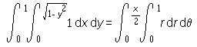

GIFs in Web Pages

In the past equations generally had to be converted to pictures to put them on the web, this has a number of serious drawbacks:
- You have to manage a number of image (GIF or PNG) files as well as the HTML page they belong to,
- The pages look terrible when printed out,
- The font size for expressions is fixed,
- There is no effective answer for people who can't see the images,
- The expressions can't be moved to a mathematical manipulation package.

Transferring mathematical meaning

The problem of transferring mathematics notation between packages is one of transferring the meaning of the mathematics and not just the visual look of the equations.
This is also true of the web in that people want to be able to lift an equation out of a document and have their symbolic algebra package able to 'understand' it.

MathML

Is two XML tagsets for mathematical representation:
- a visual presentation tagset
- a content tagset
It is designed for program to program interchange of mathematical expressions (not for hand-coding) and for representation on the web.
The W3C developments have close collaboration with the ISO standards activities in this area.

Committee document system

- The problem
- Generating documents in Word
- The XML information repository
- 'Products' produced by XSLT stylesheets
- 'Products' using the XML corpus

The problem

To generate and store 'self-aware documents' which contain database-like information 'fields'.
These documents should be able to survive changes in 'technologies' and provide a long-term archive of the decisions of the University.
The document creation process should use familiar tools in a familiar environment.

Word as an XML editor?

Documents are generated in Word with the assistance of a wizard, templates and elaborate stylesheets. 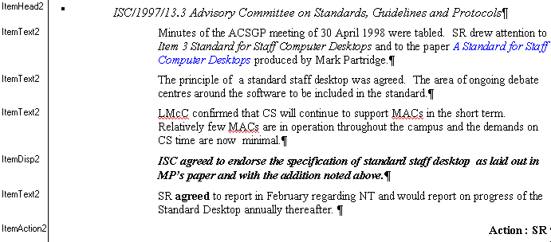

Conversion to XML for storage

- Rich text format (RTF)
- rtftohtml
- Standard generalised markup language (SGML)
- sx
- Extensible markup language (XML)
- the basis for long-term storage

XSLT stylesheet 'products'

- Committee document in HTML
- Metadata page in HTML
- Format choice page in HTML
- RTF
- PDF, etc.
- future formats?

Downstream uses of the XML

- Context aware searching tools
- people
- topics
- departments
- decisions
- Action notification and follow-up
- Decision index

Slide maker

- The problem
- The show XML DTD and tagset
- Outputs produced by XSLT stylesheets

The problem

Creation of hierarchical sets of HTML slides including a wide range of elements and featuring:-
- uniform layout and background
- resolving all the linkages between slides
- list builds

The show XML DTD and tagset

The show slide production system consists of the following components:-
- The show DTD defining the structure of show documents
- An emacs mode which helps to produce a document which conforms to the DTD (optional)
- XSLT stylesheets which turn the XML document into various outputs
The XML for this slide

The XML for the previous slide

<slideset>
<slidetitle>The show XML DTD and tagset</slidetitle>
<toctitle>The show XML DTD and tagset</toctitle>
<main>
<text1>The show slide production system consists of the
following components:-</text1>
<ulist1 type="" compact="no" build="no">
<item>The show DTD defining the structure of show
documents</item>
<item>An emacs mode which helps to produce a document
which conforms to the DTD (optional)</item>
<item>XSLT stylesheets which turn the XML document into
various outputs</item>
</ulist1>
<text1><digress num="1"/></text1>
</main>
...
</slideset>

XSLT stylesheet outputs

- Slides in HTML
- Handouts in RTF
- Speakers notes in RTF
- Tree diagram in plain text

Deployment of XML

- XML as an information repository
conversion to other forms for display, printing, etc.
- XML for application to application transfer
e.g. banking, e-commerce, MathML, etc.
- Display XML natively in browser
using CSS to determines styles for rendering

Browser support

The browser requires good support for both XML (information content) and CSS (element rendering)
- IE4 has a little XML (channels) and reasonable CSS support
- IE5 has good support for both XML and CSS
- Netscape 4 has no XML and moderate CSS support
- Netscape 5 will have good support for both XML and CSS

Conclusions

- XML is well established in information transfer and in some specialist areas (MathML, ChemML, etc.).
- Version 5 browsers are not yet sufficiently widespread for 'Native' XML deployment directly from web sites or databases.
- We still need to convert from XML to HTML for delivery to the average punter.

Acknowledgement

Much of the development work on the document system and slide system has been carried out by Pete Johnston without whom my understanding of markup and XML in particular would have been much the poorer.

