
Discussion
What is your impression of the tools you have read about?

What are the financial and managerial implications of deploying such products?

Do you feel that your institution should make use of sophisticated publishing systems rather than desktop HTML authoring tools for managing corporate pages?

Do you feel that your institution should make use of sophisticated publishing systems rather than desktop HTML authoring tools for managing corporate pages?

Would you be interested in evaluating Publishing Systems?

Institutional Web Management Workshop

Web Publishing Tools

Introduction
This document provides access to web resources about sophisticated web publishing systems. The document has been produced for use by participants on the Web Tools session at the Institutional Web Management workshop held at Newcastle University on 15-17 September 1998.

Aims of This Exercise
This document provides access to web resources about sophisticated web publishing systems. The aim of the exercises is to get an appreciation of the range of sophisticated web publishing systems which are available and to discuss their suitability for use within the UK Higher Education community.

Eprise

Task 1 Getting Started
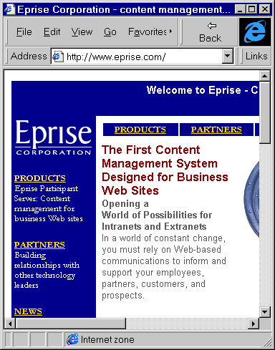
Figure 1 The Eprise Home Page
In your web browser enter the address <URL: http://www.eprise.com/>.
The web page shown in Figure 1 will be displayed.

Task 2 Finding Out More
Explore the information on the Eprise website.
What companies use the software?

Is the software relevant to the requirements of a University website?

See if you can find a price for the software.

StoryServer

Task 3 Getting Started
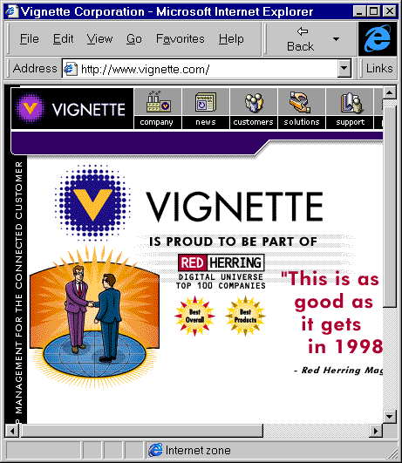Figure 2 The Vignette Home Page
In your browser enter the address <URL: http://www.vignette.com/>. The web page shown in Figure 2 will be displayed.
Follow the link to StoryServer 4.

Task 4 Finding Out More
Explore the information on the Vignette website.
What companies use the software?
Is the software relevant to the requirements of a University website?
See if you can find a price for the software.

Oracle

Task 5 Getting Started
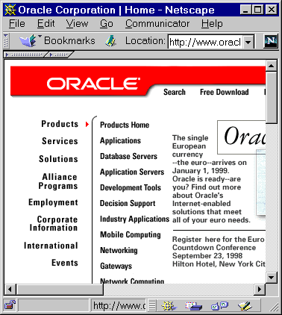Figure 3 The Oracle Home Page
In your web browser enter the address <URL: http://www.oracle.com/>.
The web page shown in Figure 3 will be displayed.
Follow the link to Products and Application Servers. Then follow the link to Application Server.
Read about the Oracle Application Server, including the Product Information.
Find the customers of the software. Is the software used in HE institutions?

Lotus Domino

Task 7 Getting Started
In your web browser enter the address <URL: : http://www.lotus.com/>.
Follow the links to Products and then to the Domino Home page. View the Demos.
Find out how much the software costs.

The C|Net Story

Task 7 Getting Started
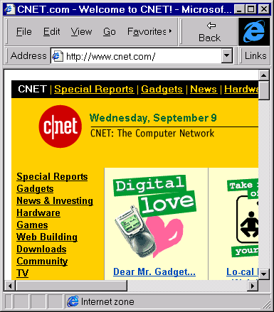Figure 4 The C|Net home page
In your web browser enter the address <URL: http://ipw.internet.com/>.
The screen shown in Figure 4 will be displayed.
Explore the C|Net website.

Task 8 How It’s Done
In your web browser enter the address <URL: http://builder.cnet.com/Business/Archive/>.
Follow the link to Under the hood at C|Net.com.
Read how the C|Net web site is managed.

Lists of Publishing Systems

Task 9 Internet ProductWatch
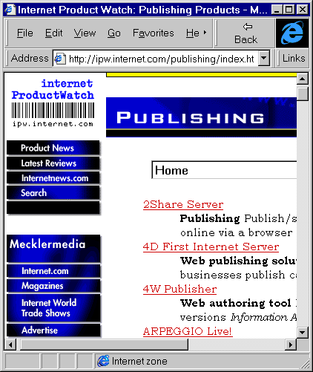Figure 5 Internet ProductWatch home page
In your web browser enter the address <URL: http://ipw.internet.com/>.
Under Product Categories select Publishing Products and then click on the Go button.
The screen shown in Figure 5 will be displayed.
Read the list of products. Follow the links to any publishing products which may be of interest.

Task 10 Shopper.COM
In your web browser enter the address <URL: http://www.shopper.com/
idx/SOFTWARE/INTERNET/>.
Follow the links to software available on NT and Unix systems.
Follow the links to products such as Microsoft’s SiteServer and Netscape’s SuiteSpot software.

