
Discussion
What is your overall opion of the service?

What are the benefits of using technologies such as Access and Active Service Pages?

What disadvantages may there be in using technologies such as Access and Active Service Pages?

Acknowledgements
The Manchester University Module and Tutorial (MATS) system was developed by Nick Gould, Information Systems Development Officer in the Faculty of Economic and Social Studies at the University of Manchester.
Nick Gould is also author of this handout.
Institutional Web Management Workshop

Using Manchester’s Module and Tutorial System

Introduction
This document describes use of the Module and Tutorial System (MATS) developed by Nick Gould, Information Systems Development Officer in the Faculty of Economic and Social Studies at the University of Manchester. The document has been produced for use by participants on the Web Tools session at the Institutional Web Management workshop held at Newcastle University on 15-17 September 1998.

Aims of This Exercise
These exercises describe use of the Module and Tutorial System (MATS). The aim is to gain experience in the use of a system driven by an Access database and Active Service Pages.
Note that the system is dynamic so some of the options described below may not appear. Feel free to browse the system but for the sake of others viewing the system don't actually change anything!

Using MATS

Task 1 Getting Started
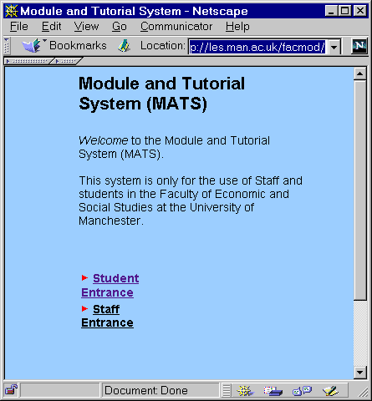
Figure 1 MATS Home Page
In your web browser enter the address <URL: http://les.man.ac.uk/facmod/>.
The web page shown in Figure 1 will be displayed.
This is the only static page in the system. All other pages are generated dynamically using Active Server Pages (ASP) which interface with an Access database. The system can be used by staff and students.
The information hierarchy in both cases is:
Module > Tutorial group > Meeting

Student Use

Task 2 Student Use
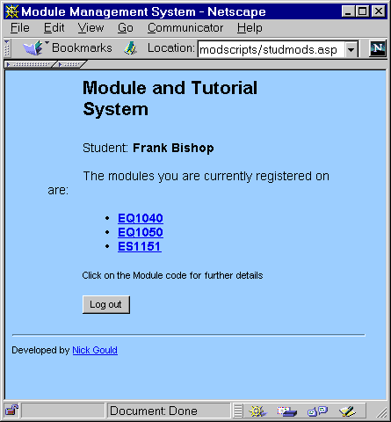Figure 2 The Student Entrance
Click the Student Entrance link.
A dummy library card number and password have been set-up for this exercise.
Give the Library card number 981234 and password pgtips to login.
Click on the Continue link.
The screen shown in Figure 2 will be displayed.

Task 3 Accessing Resources
After you have logged in you will be presented with a list of the modules you are registered on. Click on the module code EQ1040 for further details on the module.
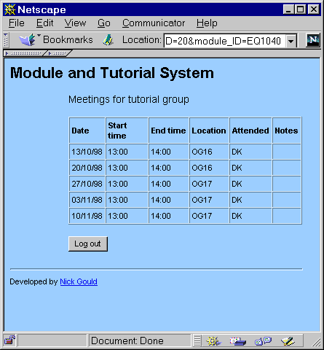
Figure 4 Viewing Module Information
If you are in a tutorial group for a particular module you will be told which one. Select the link, 2 - 1040. You will get a page of information about that tutorial (dates, times etc) as shown in Figure 4.
Click Back to return to the module information screen.
Select Return to Module List and from the list of modules select ES1151. On this module you have not been assigned a tutorial group and you will be given the option to join a tutorial group.
Click this option and you will be presented with a list of tutorial groups for this module. You will not be able to join some tutorial groups. Some may be full and/or have their Self Register flag disabled.

Staff Use

Task 4 Getting Started
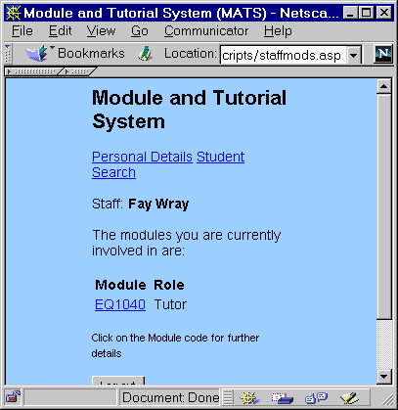Figure 5 Staff Use
Return to the home page at <URL: http://les.man.ac.uk/facmod/> and click the Staff Entrance link.
Use the library card number 7654321 and password kingkong.
Click on the Continue link. The screen shown in Figure 5 will be displayed.

Note: Most of the staff usage of the system will be done via a Visual Basic front-end. The web interface has been developed for tutors, many of whom are off-campus, part-time staff.

Task 5 Viewing Module Details
You will be presented with a list of modules and your role on that module (e.g. tutor, module administrator. Currently you are a tutor for one module. Click on the link EQ1040.
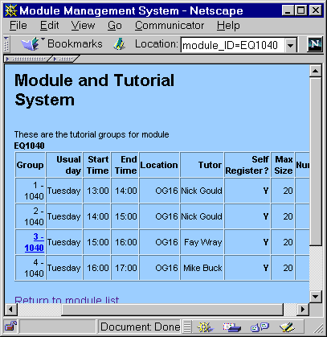Figure 6 Staff Use
You will get a list of tutorials for this particular module, as shown in Figure 6. Select the tutorial for which you are tutor, 3-1040. (Note that this is the only one you can select). This will give you a list of meetings for your tutorial group.
Click on the first meeting date - 13/10/98. Since this meeting has already been held and the attendance recorded you will be presented with the attendance record. Click Back to the list of meetings and select the second meeting 20/10/98. Here you will be given a list of students and to buttons - one to Display Sheet, which produces a list of students which can be printed and taken to the tutorial and one to Mark Attendance. Click the latter to view the attendance form. Without clicking the Save marks button click back to the meetings list.
Select one of the Update links. From this screen the tutor can modify the meeting's details.

