
Other Approaches

Task 8 Finding Out More
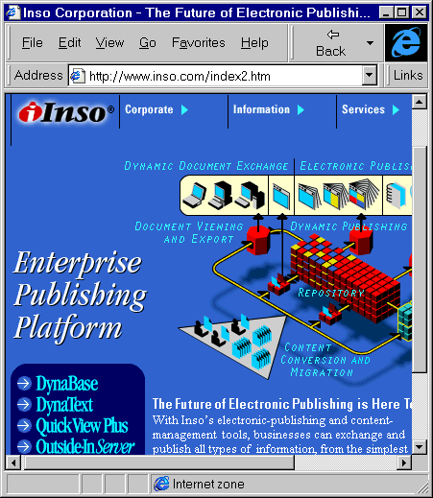 Figure 4 Inso Home Page
Go to the address <URL: http://www.inso.com/>.
Follow the link to the Outside In Server.
Read about what the software does.
How much does the software cost?

Lists of Conversion Tools

Task 9 Finding Out More
Further useful information is available at:
<URL: http://www.ed.ac.uk/~helper/editors/>.
<URL: http://www.w3.org/Tools/Word_proc_filters.html>.

Discussion
Should the UK HE community be evaluating sophisticated conversion tools (e.g. providing bulk conversion or on-the-fly conversion)?

Should the UK HE community host a web-based document conversion service?

Institutional Web Management Workshop

Document Conversion Tools

Introduction
This document describes various document conversion tools and models. The document has been produced for use by participants on the Web Tools session at the Institutional Web Management workshop held at Newcastle University on 15-17 September 1998.

Aims of This Exercise
This document describes various document conversion tools and models. The aim is to gain experience of the various document conversion tools which are available and to discuss which tools may be most suitable for use within the UK HE community.

Widely Used Tools

Task 1 Listing Tools
Make a note of document conversion tools you are familiar with which can be used to convert files from proprietary formats, such as MS Word and PowerPoint into HTML.

List the advantages of these tools.

List the disadvantages of these tools.

The rtftohtml Conversion Tool

Task 2 Finding Out More
Enter the address <URL: http://www.sunpack.com/RTF/rtftohtml_overview.html>.
Read the information about the Rrtftohtml conversion program.
What are the advantages of a tool such as this?

What are the disadvantages of a tool such as this?

Using HTML Authoring Tools

Task 3 HoTMetaL
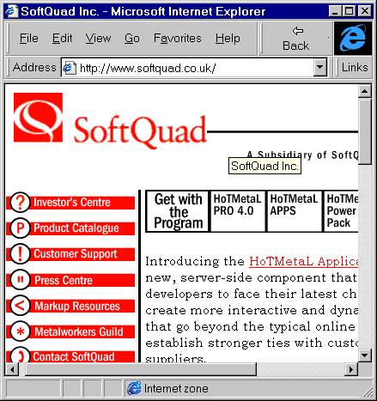
Figure 1 HoTMetaL Home Page
Enter the address <URL: http://www.softquad.co.uk/>.
The screen shown in Figure 1 will be displayed.
Follow the links to the HoTMetaL HTML authoring tool.
Read about HoTMetaL’s document import features.
What are the advantages of using import features in an authoring tool?

What are the disadvantages of using import features in an authoring tool?

Using Dedicated Conversion Packages

Task 4 HTML Transit
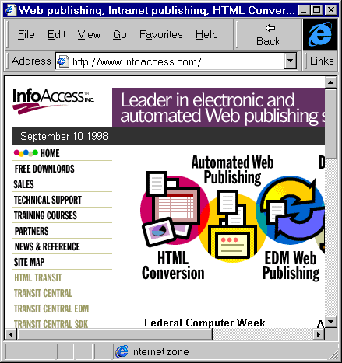Figure 2 InfoAccess Home Page
Go to the address <URL: http://www.infoaccess.com/>. The screen shown in Figure 2 will be displayed.
Follow the link to document conversion and read the information about HTML Transit.

Task 5 Transit Central
Return to the InfoAccess home page.
Follow the link to Transit Central.
Read about this software.
How does Transit Central differ from HTML Transit?

What is the full commercial cost for Transit Central?
Would Transit Central be a cost-effective solution?

Document Conversion Services

Task 6 Getting Started
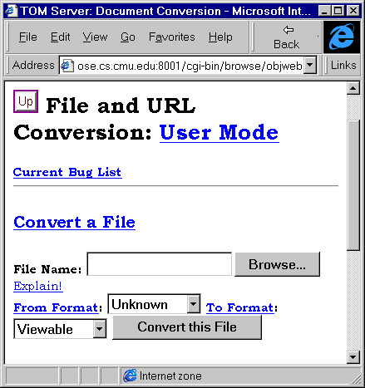Figure 3 Document Conversion Service
Go to the address <URL: http://wheel.compose.cs.cmu.edu:8001/cgi-bin/browse/objweb>. The screen shown in Figure 3 will be displayed.

Task 7 Using The Service
Explore the options provided by the service.
Convert a document using the service.
How effective was the service?

What are the advantages of a service like this?

