
Task 7 Maintaining Records
Return to the initial entry point at <URL:http://www.bris.ac.uk/ISC/wiwm98/pgp.htm>.
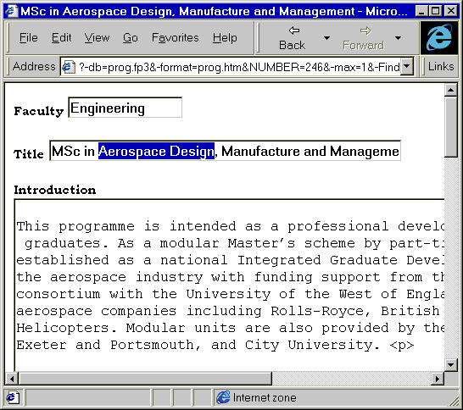
Figure 3 Editing A Record
Select the Editor’s Pages link and then select one of the Taught Programmes.
The screen like the one shown in Figure 3 will be displayed.
Scroll through the page. Compare the information with the information you viewed initially (i.e. see Figure 2).
Amend some of the information and then scroll to the bottom of the screen to find the Update Record button. Commit your changes by clicking the Update Record button.
Now re-visit the relevant page (as in Task 2) to see the updated entry.

Task 8 Review
The pages you have accessed are stored on a database. The web pages are created dynamically.
Give up to 3 advantages of this model.

Give up to 3 disadvantages of this model.

Commentary
The University of Bristol Prospectus is stored in a FileMaker Pro database. The information is stored as plain text. The HTML pages are created dynamically.
Institutional Web Management

Bristol’s Prospectus Database

Introduction
This document gives instuctions on accessing the University of Bristol Online Prospectus. The document has been produced for use by participants on the Institutional Web Management workshop held at Newcastle University on 15-17 September 1998.
Paul Browning, Bristol University will give a presentation on Publishing And Devolving Maintenance of a Prospectus at the Institutional Web Management workshop.
This is a new service which will be released shortly. The Prospectus is stored in a database. The HTML pages are created dynamically.
For further information please contact Paul Browning at the email address paul.browning@bris.ac.uk

Accessing the Prospectus

Task 1 Getting Started
In your web browser enter the address
<URL: http://www.bris.ac.uk/ISC/wiwm98/pgp.htm >.
Note that when you follow links from the page you will be asked for a username and password (until the service is released). You should give the following:
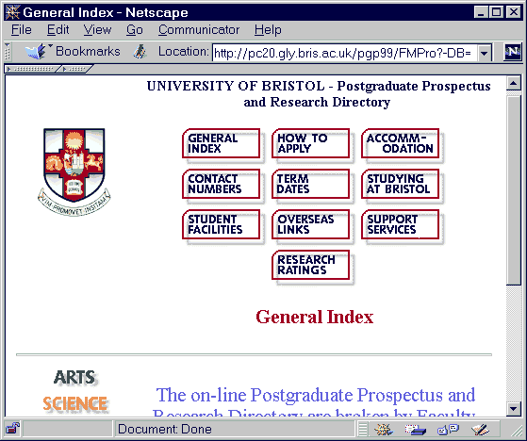
Figure 1 Entry Page For Prospectus
Username: editor
Password: wiwm98
Then select the link to the General Index.
The screen shown in Figure 1 will be displayed.

Task 2 Accessing Prospectus Details
Click on a link to a Faculty. Remember to give the username and password given previously, if requested.
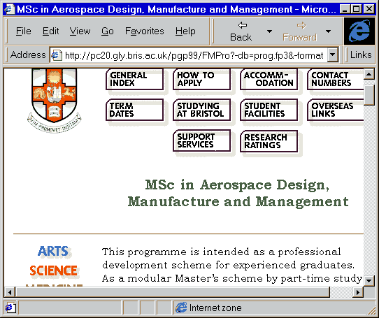
Figure 2 Course Details
Follow the link to Taught Programmes and then to one of the courses.
You should see a screen similar to the one shown in Figure 2.
Click on the Back button in the web browser and examine the details for another course.

Task 3 Examining The Addresses of the Web Resource
Look at the URL in the browser’s address box. Make a note of the URL.

Continue to browse the prospectus. What do you notice about the URLs?

Task 4 Viewing the HTML Source of the Web Resource
View the HTML source of the web page using the browser’s View Source option.
Do you notice anything unusual? Look especially at the <A> hyperlink elements.

Task 5 Accessing Other Resources
Click on one of the icons near the top of the screen, such as Studying At Bristol.
Notice the URL of the resource.
Move the cursor over the link to the Message From The Vice Chancellor. What do you notice about the destination.

Exploring The Technology

Task 6 Deconstructing The URL
Examine the URL of the resource you are viewing. Note that you may have to increase the size of the browser in order to see more of the URL. If you wish you can copy the URL and paste it into an editor such as WordPad.
The URL should look something like this:
http://pc29.gly.bris.ac.uk/pgp99/FMPro?-db=uni.fp3&-format=uni.htm&-Token=The+University+and+the+City+-+An+Introduction&SectionHeadingNoSpaces=StudyingatBristol&-max=1&-find
What do you think the following parts signify:
http://pc29.gly.bris.ac.uk/
/pgp99
/FMPro?-db=uni.fp3
&-format=uni.htm
&-Token=The+University+and+
the+City+-+An+Introduction
&SectionHeadingNoSpaces=StudyingatBristol
&-max=1
&-find

