Institutional Web Management Workshop 2005:
Whose Web Is It Anyway?

6-8th July 2005 at the University of Manchester

Exhibition And Poster Displays

About The Workshop
The ninth in the series of Institutional Web Management Workshops will be held at the University of Manchester on 6-8th July 2005. This annual workshop, organised by UKOLN, is aimed at members of Web management teams and others involved in Web development in the UK higher and further education and related communities.
The workshop consists of a mixture of plenary presentations, discussion groups and hands-on sessions, etc. In addition there will be a social programme which will provide an opportunity for informal networking.
The workshop will address strategic, managerial, resourcing and technical issues relevant to the management of institutional Web services. Topics to be covered include Web strategies, Web site management, information management, portals, VLEs, accessibility and usability, legal issues, standards, emerging technologies, etc.

Who Will Attend?
The workshop is intended for those involved in the management of institutional Web services. This can include members of institutional Web teams, policy makers, managers, development and support staff.
Although aimed primarily at the HE and FE communities, the workshop may be of interest to related public sector organisations and other bodies with links to HE /FE.

Where And When?
The workshop takes place from lunchtime on noon 6th July to lunchtime on Friday 8th July 2005 at the Manchester Conference Centre, University of Manchester.

Exhibition And Poster Displays
There will be an accompanying exhibition and poster display at the workshop. Further details are provided overleaf.

Further Information
Further information, including online bookings is available at the Web site
<http://www.ukoln.ac.uk/web-focus/events/workshops/webmaster-2005/>.
Institutional Web Management Workshop 2005:
Whose Web Is It Anyway?

6-8th July 2005 at the University of Manchester

Exhibition And Poster Displays

About The Workshop
The ninth in the series of Institutional Web Management Workshops will be held at the University of Manchester on 6-8th July 2005. This annual workshop, organised by UKOLN, is aimed at members of Web management teams and others involved in Web development in the UK higher and further education and related communities.
The workshop consists of a mixture of plenary presentations, discussion groups and hands-on sessions, etc. In addition there will be a social programme which will provide an opportunity for informal networking.
The workshop will address strategic, managerial, resourcing and technical issues relevant to the management of institutional Web services. Topics to be covered include Web strategies, Web site management, information management, portals, VLEs, accessibility and usability, evaluation, standards, emerging technologies, etc.

Who Should Attend?
The workshop is intended for those involved in the management of institutional Web services. This can include members of institutional Web teams, policy makers, managers, development and support staff.
Although aimed primarily at the HE and FE communities, the workshop may be of interest to related public sector organisations and other bodies with links to HE /FE.

Where And When?
The workshop take places from noon on Wednesday 6th July to lunchtime on Friday 8th July 2005 at the Manchester Conference Centre, University of Manchester.

Exhibition And Poster Displays
There will be an accompanying exhibition and poster display at the workshop. Further details are provided overleaf.

Further Information
Further information, including online bookings is available at the Web site
<http://www.ukoln.ac.uk/web-focus/events/workshops/webmaster-2005/>.

Exhibition And Poster Display
An Exhibition and Poster Display will be provided during the workshop. It will be located in the Weston Rooms 2 and 3, conveniently located near the area used for refreshments and lunch. In addition to providing an opportunity for casual browsing during these times, there will be a dedicated slot to allow delegates to view the Exhibition and Poster Display from 09:15-10:30 on Friday 8th July.

Location
The Exhibition and Poster Display will be located in Weston Rooms 2 and 3. Details of these rooms is available at <http://www.conference.manchester.ac.uk/
manchesterconferencecentre/meetingfacilities/conferencerooms/>. The room plans are illustrated (the rooms are approximately 11m.x 8m and 9m x 6m).
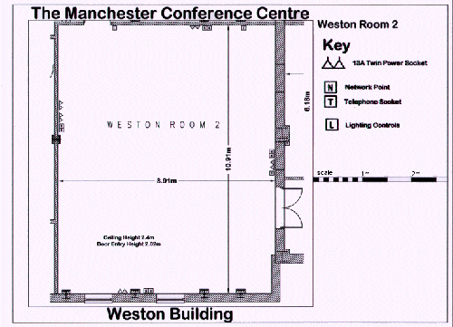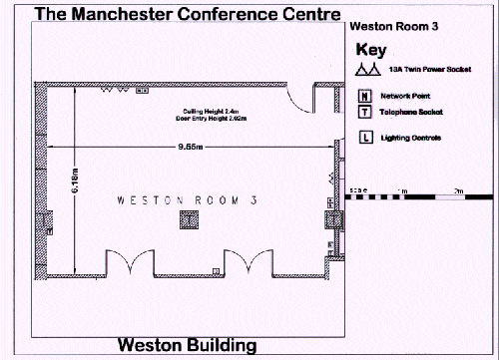

Information For Exhibitors
The Exhibition provides a valuable opportunity for commercial vendors, JISC services, etc. to inform the University Web management community about the services they provide to this sector. If you are interested in exhibiting please contact Natasha Bishop (phone 01225 386256 or email <N.Bishop@ukoln.ac.uk>) or Matt Jukes (phone 0117 954 5080 or email <Matt.Jukes@bristol.ac.uk>). Further details are available at <http://www.ukoln.ac.uk/web-focus/events/workshops/webmaster-2005/exhibition/>.

Information For Poster Displays
The Poster Display provides an opportunity for members of the Web management community to describe areas of their work and solutions they have been involved in by providing poster displays. If you would like take part in the poster display please contact Matt Jukes (phone 0117 954 5080 or email <Matt.Jukes@bristol.ac.uk>) or Brian Kelly Jukes (phone 01225 383943 or email <B.Kelly@ukoln.ac.uk>).
Further details are available at <http://www.ukoln.ac.uk/web-focus/events/workshops/
webmaster-2005/exhibition/>.

Exhibition And Poster Display
An Exhibition and Poster Display will be provided during the workshop. It will be located in the Weston Rooms 2 and 3, conveniently located near the area which delegates will use for refreshments and lunch. In addition to providing an opportunity for casual browsing during these times, there will be a dedicated slot to allow delegates to view the Exhibition and Poster Display from 09:15-10:30 on Friday 8th July.

Location
The Exhibition and Poster Display will be located in Weston Rooms 2 and 3. Details of these rooms is available at <http://www.conference.manchester.ac.uk/
manchesterconferencecentre/meetingfacilities/conferencerooms/>. The room plans are illustrated (the rooms are approximately 11m.x 8m and 9m x 6m).

Information For Exhibitors
The Exhibition provides a valuable opportunity for commercial vendors, JISC services, etc. to inform the University Web management community about the services they provide to this sector. If you are interested in exhibiting please contact Natasha Bishop (phone 01225 386256 or email <N.Bishop@ukoln.ac.uk>) or Matt Jukes (phone 0117 954 5080 or email <Matt.Jukes@bristol.ac.uk>). Further details are available at <http://www.ukoln.ac.uk/web-focus/events/workshops/webmaster-2005/exhibition/>.

Information For Poster Displays
The Poster Display provides an opportunity for members of the Web management community to describe areas of their work and solutions they have been involved in by providing poster displays. If you would like take part in the poster display please contact Matt Jukes (phone 0117 954 5080 or email <Matt.Jukes@bristol.ac.uk>) or Brian Kelly Jukes (phone 01225 383943 or email <B.Kelly@ukoln.ac.uk>).
Further details are available at <http://www.ukoln.ac.uk/web-focus/events/workshops/
webmaster-2005/exhibition/>.

