
An Introduction To Wikis

A UKOLN Briefing Document

Background
This document has been written to support the workshop on “Beyond Email - Strategies For Collaborative Working In The 21st Century”. The document aims to give a brief description of Wikis and to summarise the main challenges to be faced when considering the deployment of Wiki technologies within an institution.

What Is A Wiki?
A Wiki or wiki (pronounced "wicky" or "weekee") is a Web site (or other hypertext document collection) that allows a user to add content. The term Wiki can also refer to the collaborative software used to create such a Web site. [1].
The key characteristics of typical Wikis are:
- The ability to create and edit content within a Web environment without the need to download any special software.
- The use of a simple markup language which is designed to simplify the process of creating and editing documents.
- The ability to easily create and edit content, often without the need for special privileges.

Wikipedia – The Largest Wiki
The Wikipedia is the largest and best-known Wiki – see <http://www.wikipedia.org/>.
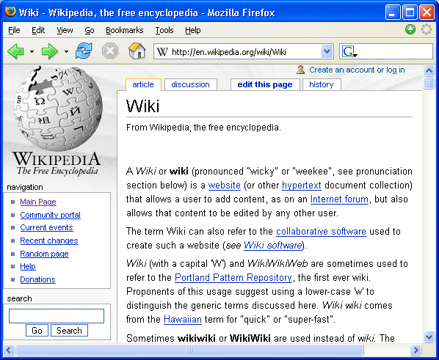
The Wikipedia provides a good example of a community Wiki in which content is provided by contributors around the world.
The Wikipedia appears to have succeeded in providing an environment and culture which has minimised the dangers of misuse. Details of the approaches taken on the Wikipedia are given on the Wikimedia Web site [2].

An Introduction To Wikis

A UKOLN Briefing Document

Background
This document has been written to support the workshop on “Beyond Email - Strategies For Collaborative Working In The 21st Century”. The document aims to give a brief description of Wikis and to summarise the main challenges to be faced when considering the deployment of Wiki technologies within an institution.

What Is A Wiki?
A Wiki or wiki (pronounced "wicky" or "weekee") is a Web site (or other hypertext document collection) that allows a user to add content. The term Wiki can also refer to the collaborative software used to create such a Web site. [1].
The key characteristics of typical Wikis are:
- The ability to create and edit content within a Web environment without the need to download any special software.
- The use of a simple markup language which is designed to simplify the process of creating and editing documents.
- The ability to easily create and edit content, often without the need for special privileges.

Wikipedia – The Largest Wiki
The Wikipedia is the largest and best-known Wiki – see <http://www.wikipedia.org/>.
The Wikipedia provides a good example of a community Wiki in which content is provided by contributors around the world.
The Wikipedia appears to have succeeded in providing an environment and culture which has minimised the dangers of misuse. Details of the approaches taken on the Wikipedia are given on the Wikimedia Web site [2].

What Can Wikis Be Used For?
Wikis can be used for a number of purposes:
- On public Web sites to enable end users to easily contribute information.
- In teaching. In addition to making it easier to contribute, use of Wikis can also help in provide an oppeortunity to learn about team working, trust, etc. A good example is provided by Queen’s University Belfast [3].
- By the research community. Many Wikis were used inially by the Web research community to make it easier for a group of distributed researchers to develop collaborative documents. For example see the FOAF Wiki [4].
- On Intranets, where departmental administrators with minimal HTML experience may be able to manage departmental content.

Wikis – The Pros And Cons
Advantages of Wikis include:
- No need to install HTML authoring tools.
- Minimal training may be needed.
- Can help develop a culture of sharing and working together (cf. open source).
Disadvantages of Wikis include:
- The success of the Wikipedia may not necessarily be replicated in other fully open Wikis.
- There is not (yet) a standard lightweight Wiki markup language.
- A collaborative Wiki may suffer from a lack of a strong vision or leadership.
- There may be copyright and other legal issues regarding collaborative content.

Further Information
- Wiki, Wikipedia, <http://en.wikipedia.org/wiki/Wiki>
- Wikimedia principles, Wikimedia, <http://meta.wikimedia.org/wiki/Wikimedia_principles>
- IT and Society Wiki, Queen’s University Belfast, <http://itsoc.mgt.qub.ac.uk/ITandSociety>
- FOAF Wiki, FoafProject, <http://rdfweb.org/topic/FoafProject>
Details of Wiki software are available at <http://en.wikipedia.org/wiki/Wiki_software>.

Note: This is a draft document. Please email b.kelly@ukoln.ac.uk if you have any comments or suggestions about the document.

What Can Wikis Be Used For?
Wikis can be used for a number of purposes:
- On public Web sites to enable end users to easily contribute information.
- In teaching. In addition to making it easier to contribute, use of Wikis can also help in provide an oppeortunity to learn about team working, trust, etc. A good example is provided by Queen’s University Belfast [3].
- By the research community. Many Wikis were used inially by the Web research community to make it easier for a group of distributed researchers to develop collaborative documents. For example see the FOAF Wiki [4].
- On Intranets, where departmental administrators with minimal HTML experience may be able to manage departmental content.

Wikis – The Pros And Cons
Advantages of Wikis include:
- No need to install HTML authoring tools.
- Minimal training may be needed.
- Can help develop a culture of sharing and working together (cf. open source).
Disadvantages of Wikis include:
- The success of the Wikipedia may not necessarily be replicated in other fully open Wikis.
- There is not (yet) a standard lightweight Wiki markup language.
- A collaborative Wiki may suffer from a lack of a strong vision or leadership.
- There may be copyright and other legal issues regarding collaborative content.

Further Information
- Wiki, Wikipedia, <http://en.wikipedia.org/wiki/Wiki>
- Wikimedia principles, Wikimedia, <http://meta.wikimedia.org/wiki/Wikimedia_principles>
- IT and Society Wiki, Queen’s University Belfast, <http://itsoc.mgt.qub.ac.uk/ITandSociety>
- FOAF Wiki, FoafProject, <http://rdfweb.org/topic/FoafProject>
Details of Wiki software are available at <http://en.wikipedia.org/wiki/Wiki_software>.

Note: This is a draft document. Please email b.kelly@ukoln.ac.uk if you have any comments or suggestions about the document.

