Exercise 1

Using An Online Tutorial

Aims of this Exercise
In the following exercises you will use a number of online tutorials. You should make a note of anything that strikes you about the tutorials, including aspects you like or find useful and areas which could be improved.
Note Go to the page <http://www.ukoln.ac.uk/web-focus/events/workshops/
trieste-2004/#urls> and bookmark the page. This page contains URLs used in the exercises.

1.1 The VTS Online Tutorial
Go to the VTS Online Tutorial Web site at the address: <http://www.vts.rdn.ac.uk/>.
Make a note of any tutorials which may be of interest to you or your colleagues when you return to work.

1.2 Choosing A Tutorial
Choose a tutorial such as the Internet Instructor tutorial at <http://www.vts.rdn.ac.uk/tutorial/instructor> which lets you practise your Internet Information Skills.

1.3 Explore The Navigation
Explore the navigational aspects of the tutorial.
How easy is it to navigate around the tutorial?

1.4 Tutorial’s Writing Style
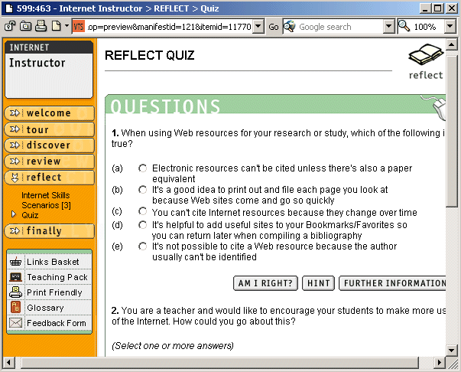
Consider on the writing style used in the tutorial.
What do you notice about the writing style?

1.5 Using A Quiz
Find the tutorial’s quiz and use it.
What is the purpose of the quiz?

DISCUSSION
What did you like about the online tutorial?

What aspects of the online tutorial do you think could be improved?

Could the tutorials have a role in your institution?
Exercise 2

Using An Instant Messaging Tool

Aims Of This Exercise
In the following exercises you will create an Instant Messaging (IM) account and install and use an IM client.

2.1 Getting An MSN ID
Go to the MSN Web site at the address: <http://www.msn.com/>. If you do not have an existing MSN account follow the steps to create an account. Then make a note of your MSN ID and the ID of your neighbours.
You: Neighbour: Neighbour:
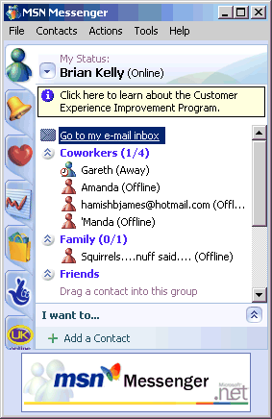

2.2 Installing The MSN Messenger Client
Ask the workshop facilitator if the MSN Messenger client is available on the local PC. If it is go to step 2.3. If not, go to the address: <http://www.msnmessenger-download.com/> and install the MSN messenger client on your PC.
Note You will need a .NET passport before you can download the software.

2.3 Using The MSN Chat Client
Run the MSN Messenger client. A window similar to that illustrated should be displayed.

2.4 Adding Contacts
Click on the add contacts link and add the MSN ID of your neighbours.
You should also add the MSN ID of the workshop facilitator: ictp2004_bkelly

2.5 Contacting Your Neighbours
Double click on the MSM ID of your neighbour. Send a message to your neighbour.
You should also send a message to the workshop facilitator: ictp2004_bkelly

NOTE
You will be able to use the MSN Chat tool during your stay at the workshop and when you return home.

DISCUSSION
How do you think a IM tool such as MSN Chat could be used in an e-learning context.

What problems or limitations in the use of such tools can you imagine.
Exercise 3

Using Other MSN Messenger Facilities

Aims Of This Exercise
In the following exercises you will learn about other facilities provided by the MSN Messenger tool.

3.1 Using Online Games
Go to the MSN Messenger application and chose the Actions menu. Chose an online game and invite a neighbour to play a game. Please spend no more that 1 minute playing the game!
What are the benefits of such games?

What are the disadvantages of such games?

3.2 Using The WebCam Facility
Go to the MSN Chat application and choose the Webcam option (please note this option is only available in a Webcam is connected to your PC). If you wish to use a Webcam ask if you can use the lecturer’s PC.
What are threw advantages of use of a Webcam?

What are the disadvantages?

3.3 Using NetMeeting
Go to the the MSN Messenger application and choose the NetMeeting option. Have a NetMeeting with a colleague (note this may involve additional software being installed).
What are threw advantages of NetMeeting?

What are the disadvantages?

DISCUSSION
How useful do you think these extra tools are run use in an e-learning environment?

What problems or limitations in the use of such tools can you envisage?

Exercise 4

Using Other Instant Messaging Tools

Aims Of This Exercise
In the following exercises you will learn about other instant messaging tools.

4.1 Learning About Jabber
Go to the Jabber Web site at the address: <http://www.jabber.org/>. Read about Jabber.

4.2 Learning About Jabber IM Clients
Go to the Jabber Clients Web site at the address: <http://www.jabber.org/user/clientlist.php>. Choose one of the clients and read about its functionality.

4.3 Learning About XMPP
Read about XMPP (a) From the Jabber home page and (b) at <http://networking.webopedia.com/TERM/X/XMPP.html>.

4.4 Learning About Jabber Developments
Go to the Jabber Buddyspace Web site at <http://kmi.open.ac.uk/projects/buddyspace/>. Read about the Buddyspace application which is being developed by the Open University in the UK.
What advantages does this type of application provide?

DISCUSSION
What are the advantages of open source software applications such as Jabber and open standards such as XMPP? What are the disadvantages?

What are the advantages of closed applications such as MSN Chat? What are the disadvantages?

What approaches would you take in the selection of IM software?

Exercise 5

Using A Bulletin Board

Aims Of This Exercise
In the following exercises you will learn about online bulletin boards.

5.1 The phpBB Software
Go to the phpBB Web site at the address: <http://www.phpbb.com/>. Read about the phpBB software.

5.2 Using the phpBB Bulletin Board
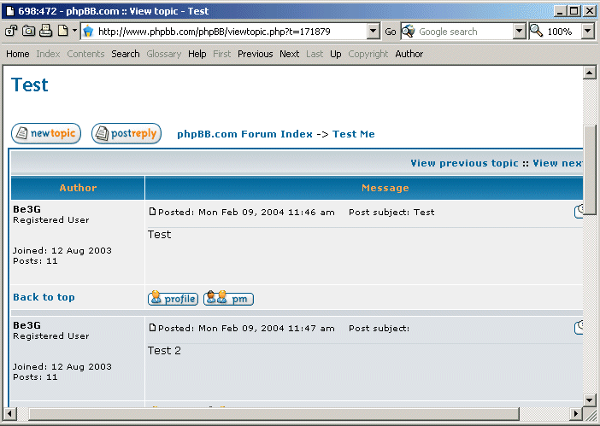
Select the phpBB Community. Then scroll to the bottom and choose the Test Me option. Enter a topic, such as “ICTP test from your name”. If someone from the workshop has already entered a topic, reply to it.

5.3 Finding Out More
Select the Demo option at the address <http://www.phpbb.com/demo.php>. Get a feel for the administrator’s interface to phpBB.

5.4 Other phpBB Forums
Go to the address <http://www.accessifyforum.com />. Select the Building and Testing forum and read the postings about Accessibility and Flash.

NOTE
The phpBB software is available as open source.

DISCUSSION
How do you think bulletin board software such as phpBB could be used in an e-learning context?

What problems or limitations in the use of such tools can you imagine?

How does bulletin board software compare with instant messaging software and email software?

Exercise 6

Using A Blog

Aims Of This Exercise
In the following exercises you will learn about Web logging (Blogging) tools.

6.1 Viewing A Blog
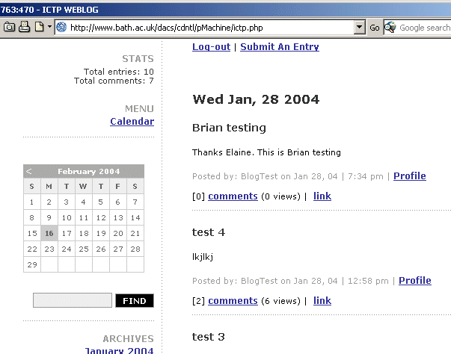
Go to the Blog at the address: <http://ictp2004-kelly.blogspot.com/>. Read the postings.

6.2 Creating Your Own Blog
Go to the Blogger Web site at the address: <http://www.blogger.com/>. Create your own Blog, with a name of the form ictp2004-name. Add your first entry giving your name and details.
Give the address of your Blog to a fellow workshop participant and find the address of their Blog, if they have one.
Submit a posting which gives a link to their Blog.

6.3 Blogs About e-Learning
Go to the Web site at the address: <http://www.elearnspace.org/edutechblogs.htm>. Chose a Blog and read discussions about e-learning.
Then read the Blog at <http://www.bath.ac.uk/dacs/cdntl/pMachine/morriblog.php>. Read the article about “The weblog as the model for a new type of VLE?” (dated 6 April 20-04).

6.4 Blogs For e-Learning
Go to the Web site at the address: <http://itsoc.mgt.qub.ac.uk/>. Select the Blog option in the menu of the left hand side of the window and read some of the Blogs which are created by students on the course.

DISCUSSION
How do you think a Blog could be used in an e-learning context?

What problems or limitations in the use of such tools can you envisage?

Note
If you wish you can use your Blog to keep a record of your time at the workshop. You can also continue to use the Blog when you return home.

Other Blogs
Exercise 7

Aims Of This Exercise
In the following exercises you will look at other examples of Blog software and related tools.

7.1 pMachine
Go to the pMachine Web site at the address: <http://www.pmachine.com/>. Read about the pMachine Pro software. What does pMachine provide?

7.2 Movabletype
Go to the Movabletype Web site at the address: <http://www.movabletype.org/> and read the Frequently Asked Questions page. What does this software provide?

7.3 Review of Blog Software
Go to the Google directory of Weblog software at the address: <http://directory.google.com/Top/Computers/Internet/On_the_Web/Weblogs/Tools/Publishers>. How many Blog applications are mentioned? How would you go about selecting a Blog tool for your own use?

7.4 More About Blogs
In your own time go to the Wikipedia entry about Blogs at the address: <http://en.wikipedia.org/wiki/Weblog>.

DISCUSSION
Do you think Blogging software applications have a role to play in e-learning?

If so, what are the issues you should consider in choosing a Blogging application?

Exercise 8

Using A Wiki

Aims Of This Exercise
In the following exercises you will make use of Wiki software.

8.1 Accessing the Main Wiki Web Site
Read about Wikis from reviews such as <http://www.contentpeople.co.uk/issue4/whatthehellisawiki.php>.
Go to the WikiWikiWeb page at <http://c2.com/cgi/wiki>. Read about the WikiWikeWeb.

8.2 Testing a Wiki
Go to the Wiki Wiki Sandbox page at the address: <http://c2.com/cgi/wiki?WikiWikiSandbox>.
Scroll to the bottom of the page and select the Edit this Page option. Then add some text as shown below:
------------------------------------
This is a test by BrianKelly.
Test Wiki features by replacing BrianKelly by your name (use mixed case and no spaces as illustrated here).
Also type ItcpBrianKelly which will create a link to a page created by the workshop facilitator..
Brian Kelly, 15 Feb 2004
------------------------------------
Save the page. Then return to the Wiki Wiki Sandbox page at <http://c2.com/cgi/wiki?WikiWikiSandbox>.
Scroll to the text your have entered. Click on the links to the pages, including the empty page about you. Add personal details to this page.

8.3 Finding Our More About Wikis
Go to the Wikipedia Web site at the address: <http://en.wikipedia.org/> and read the entries about Wiki.

8.4 Contributing To A WIki
Go to the SeedWiki Web site at <http://www.seedwiki.com/>. Then add the account name ictp-2004 and follow the link to My accounts. Add your own contribution to the information already provided.

8.5 Wikis and E-Learning
Use Google to find out about use of Wikis in an e-learning context, such as <http://www.openconcept.ca/webofchange/index.php/ElearningLunch> and <http://careo.elearning.ubc.ca/cgi-bin/wiki.pl?HomePage>.

DISCUSSION
How do you think Wiki software applications could be used in an e-learning context?

Exercise 9

Social Networks

Aims of this Exercise
In the following exercises you will take join a social network.

9.1 What Are Social Networks?
Go to the Wiki at <http://www.iawiki.net/wiki.pl?SocialInformatics>.
What relevance do you think social networks have to e-learning?

9.2 About Social Networks
Go to the article on Social Network Analysis at <http://semanticstudios.com/publications/semantics/000006.php>. Skim-read the article and go to the comments (from the link at the top of the page).
Do you have any thoughts on the comments on the original article?
http://www.orkut.com/

9.3 About Orkut
Use Google to find out about the Orkut social network which is available at <http://www.orkut.com/>.

9.4 Joining Orkut
In order to use Orkut you have to be invited by an existing member. This will help to ensure that there will be at least one person who is part of your community. You will be able to follow this person’s friends and interests which can help you develop further links.
The workshop facilitator is a member of Orkut. If you would like to join Orkut, inform the workshop facilitator and give him your email details.

9.5 Using Orkut
Once you have subscribed login to Orkut and follow the links to people you know. Explore the communities and join any of interest.
Exercise 10

Flash, SVG And SMIL

Aims of this Exercise
In the following exercises you will make use of learning tools developed in Flash, SVG and SMIL.

10.1 Flash Example (1)
Go to <http://ferl.becta.org.uk/display.cfm?resID=6577>. Use the “Instructive demonstration movie viewlet” to view the tutorial which describes use of the Blackboard VLE (Virtual Learning Environment.
What are the advantages and disadvantages of this as an e-learning tool?

What are the advantages and disadvantages of this from a technical perspective?

10.2 Flash Example (2)
Go to <http://www.flashking.com/>. Access the “Educational/Medical” menu. Scroll down the list of options to see the available resources. Select the Medical Procedures option and view the resources.
Do you have any comments on the user interface?

Do you have any comments on the educational merits of this approach?

10.3 SVG Demonstration
Go to the address <http://www.w3.org/2003/Talks/www2003-svg/>. Follow the link to the demo.
Note You will need to use a browser which has an SVG plugin in order to carry out this exercise.

10.4 CWI’s SMIL Tutorial
Go to <http://homepages.cwi.nl/~media/SMIL/Tutorial/>. View the one hour tutorial.
Note You will need to use a browser which support SMIL, such as Internet Explorer. Also make a note of the commands needed to move to the next page.

10.5 Other SMIL Tutorials
Go to the address <http://www.empirenet.com/~joseram/>. View the Freedom Example tutorial.
Go to the address <http://smw.internet.com/smil/tutor/> and view one of the examples.

Exercise 11

Using Video

Aims Of This Exercise
In the following exercises you will make use of video tools.

11.1 Box Mind
Go to the Boxmind Web site at the address <http://www.boxmind.co.uk/>.
From the Products menu select the E-lectures Collections option. Read about the e-lectures and then view a demonstration.

11.2 Video On “Open Source Software in Libraries”
Go to the address <http://www.horizonlive.com/eventreg/participant/registration.php?eventid=212>.
Register to view the video clip. Note that while waiting for the registration details to be emailed to you continue working on the other exercises and return to this later.
Did you have any problems viewing the video?

What are the advantages of such use of videos?

What are the disadvantages?

11.3 Other Videos
Go to the address <http://www.horizonlive.com/eventreg/>.
What other video clips are available which may be of interest to you?

MIT Open Courseware
Exercise 12

Aims Of This Exercise
In the following exercises you will make use of the open courseware provided by MIT.

12.1 Accessing The MIT Open Courseware
Go to the address <http://ocw.mit.edu/>.

12.2 Using The MIT Open Courseware
Choose a subject of interest to you and then select a course module, such as the Computer System Architecture course module at <http://ocw.mit.edu/OcwWeb/Electrical-Engineering-and-Computer-Science/6-823Computer-System-ArchitectureSpring2002/CourseHome/>.
Read the information about this course, including the syllabus, lecture notes, assignments, exams, etc.

12.3 Use Of MIT Open Courseware
What are the advantages of using freely available resources such as the MIT Open Courseware?

What are the disadvantages of using freely available resources such as the MIT Open Courseware?

Would you consider making use of resources such as the MIT Open Courseware?

Would you consider making your e-learning resources available in an open format similar to the MIT Open Courseware? Give reasons for your answer.

Exercise 13

Choosing A VLE

Aims of this Exercise
In the following exercises you will learn about the criteria needed to choose a VLE (Virtual Learning Environment) / MLE (Managed Learning Environment).

13.1 Reading a VLE/MLE Comparison Chart
Go to the page <http://www.eduserv.org/chest/datasets/vle/checklist.html>. Briefly read the information provided in the chart.

13.2 Evaluation Criteria
Read the list of evaluation criteria given at the top of the chart.
Make a note of any additional evaluation criteria which would be relevant to use of a VLE / MLE in your organisation.

Make a note of any additional evaluation criteria which may not be relevant to your organization.

13.3 Approaches To Selection
If you were to choose from the list of products given in the chart what procedures and approaches would you take within your organization in selecting the most appropriate product.

13.4 Open Source VLEs
Use Google to find out about the Moodle and Boddington VLEs (or go to <http://moodle.org/> and <http://bodington.org/index.html>). Do open source VLEs have a role to play in your institution?

13.5 Do You Need a VLE?
Do you need a VLE system or should you consider developing an e-learning environment through use of appropriate applications such as Blogs, Wikis, etc?

Exercise 14

Using An MLE

Aims Of This Exercise
In the following exercises you will give some thought to the management aspects of e-learning environments.

14.1 The “Masters in Healthcare Informatics” Online Course
Go to the address <http://www.healthcare-informatics.info/msc.asp>.
Read the information about the Learning Outcomes, Programme Structures, Course Delivery and Student Support.

14.2 The Application Process For The “Masters in Healthcare Informatics” Online Course
Read the information about applying to enroll for the online course.
What type of information and support will be needed for students wishing to apply for the course?

14.3 Using The “Masters in Healthcare Informatics” Online Course
What type of information and support would you expect students to require as they take the online course?

14.4 Administering The “Masters in Healthcare Informatics” Online Course
What type of tools would you expect administrators of the course require to support students on the course?

