Understanding & Using Web 2.0:
Hands-on Exercises: Using Web 2.0 Applications

Document Details
This document contains a series of exercises in use of Web 2.0 applications. The exercises are intended for use in a workshop session at the STIMULATE 2006” to be held at the VUB university, Brussels on 30-31st October 2006.

Table Of Contents
Using The Gabbly Chat Service 1
Using A Wiki - Wikalong 2
Using The Webpaint Wiki 3
Using del.icio.us 4
Searching And Web 2.0 5
Using An RSS Aggregator 6
Using Flickr 7
Using Frappr 8
Using Location-Based Services 9
Web 2.0 And Openness 10

Using The Gabbly Chat Service
Exercise 1

Aims of this Exercise
In this exercise you will make use of a simple Web-based chat tool. You will also see how easy it can be to set up such a tool. You will be asked to consider the strengths and weakness of the tool
Note Go to the page <http://www.ukoln.ac.uk/web-focus/events/workshops/stimulate-2006/technologies/> and bookmark the page. This page contains URLs used in the exercises.

1.1 The Gabbly Chat Service
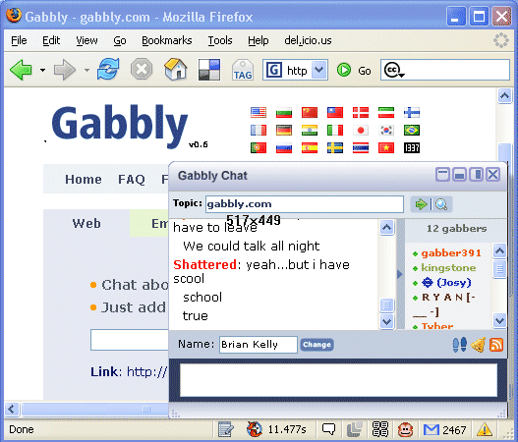
Go to the Gabbly Web site at the address: <http://www.gabbly.com/>.
In the Gabbly Chat window give your name, with the prefix VUB- (e.g. VUB-john-smith). This will allow you to identify fellow participants on the course. Please note, however, that names are limited to 16 characters.

1.2 Chat With Your Colleagues
Introduce yourself to your colleagues. Then try and agree on three strengths and weaknesses of the Gabbly service.
Strengths:

Weaknesses

1.3 Creating A Gabbly Service Elsewhere
When you have completed the first exercise, use the chat box to tell your colleagues that you are moving on to the next exercise. Then go to the Gabbly Web site at the address: <http://www.gabbly.com/>.
Add a Gabbly page on UKOLN Web site : <http://www.ukoln.ac.uk/> by entering www.ukoln.ac.uk into the box. Note that if you have difficulties doing this then go to the address <http://gabbly.com/www.ukoln.ac.uk/web-focus/ >.

1.4 Reviewing This Service
Say hello to your colleagues again (when they arrive in the chat area). Then try and agree on three strengths and three weaknesses of use of this service on another Web site.
Strengths:

Weaknesses

1.5 Embedding The Service In A Web Page
When you have completed the second exercise, use the chat room to tell your colleagues that you are moving on to the next exercise. Then go to the address: <http://www.ukoln.ac.uk/web-focus/events/
workshops/stimulate-2006/chat/>.
Say hello to your colleagues again (when they arrive in the chat area). Then try and agree on the strengths and weaknesses of use of this service on another Web site.

Using A Wiki - Wikalong
Exercise 2

Aims Of This Exercise
In the following exercises you will use a simple Wiki tool called Wikalong.

2.1 Viewing Pages Annotated By Wikalong
Go to the Wiki page at the address: <http://www.ukoln.ac.uk/web-focus/events/
workshops/stimulate-2006/talk-using-web2.0/#wikalong >.
Click on the Annotate This Page link to the Wikalong Wiki and read the information provided.
Feel free to add your own comments.

2.2 Using Wikalong
Go to the Wiki page at the address: <http://www.ukoln.ac.uk/web-focus/events/workshops/stimulate-2006/group-n/> where n is 1 to 5.
Choose up to four colleagues who will make use of a Wiki page called group-1, group-2, group-3, group-4 and group-5. Then click on the link to the Wikalong service for your group.
Write your name in the text box and then press the Save button.. Then try and agree on the strengths and weaknesses of use of this service on another Web site.
Strengths:

Weaknesses

2.3 Wikalong Plugin
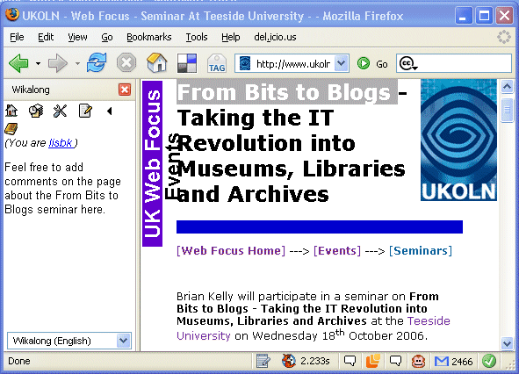
The Wikalong plugin is designed for use with a plugin for the FireFox or Internet Explorer browser. Go to the Wikalong home page at <http://www.wikalong.org/> and view the screenshots.
What are the strengths and weaknesses of this tool?

Comments
Wikalong is an example of a browser extension which was designed to allow users to make comments on Web pages.
It is also possible to provide a simple link from a Web page to the annotaion for a page, so that it can be used if the browser extension is not available.

Exercise 3

Using The Webpaint Wiki

Aims Of This Exercise
In the following exercises you will use a simple Wiki tool called Wetpaint.

3.1 The Wetpaint Wiki
Go to the Wiki page at the address: <http://stimulate-2006.wetpaint.com/>.
Read the information which is available.

3.2 Using Wetpaint
In your Wetpaint Wiki space make a note of possible applications of this of Wiki could be used in your organisation
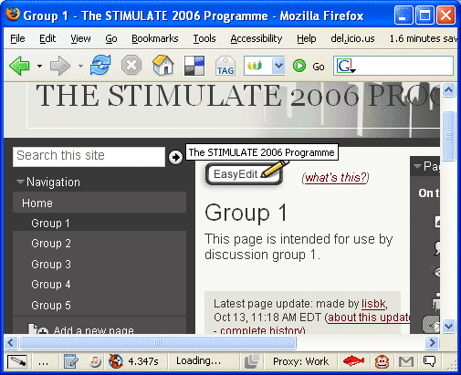
Then try and agree on the strengths and weaknesses of use of this Wiki service.

3.3 Review
Try and agree on the strengths and weaknesses of use of this Wiki service.
Strengths:

Weaknesses

Discussion
What are the benefits of this Wiki compared with other Wiki tools? What are the advantages and disadvantages of using an externally hosted Wiki service such as Wetpaint?

Comments
Wetpaint is an example of an externally hosted Wiki service. It is very easy to set up a Wetpaint Wiki and use requires no specialist skills. In addition access to the Wiki can be restricted to authorised users.
However if you arre considering making use of externally hosted services you will need to address certain potential risks, such as the persistency, performance and interoperability of the service.
Exercise 4

Using del.icio.us

Aims Of This Exercise
In the following exercises you will learn about the del.icio.us social bookmarking tool.

4.1 The del.icio.us Social Bookmarking Service
Go to the del.icio.us Web site at the address: <http://del.icio.us/>. What do you think this service will provide?

4.2 Using the del.icio.us Service
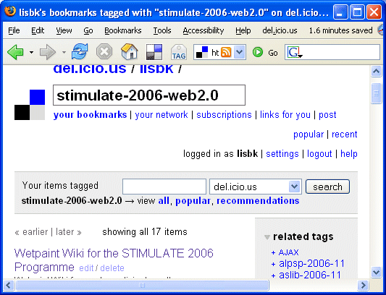
Go to the address <http://del.icio.us/lisbk/
stimulate-2006-web2.0>. What information is provided?

4.4 Embedding del.icio.us Bookmarks
Go to the address <http://www.ukoln.ac.uk/web-focus/events/workshops/stimulate-2006/talk-web2.0/>. Look at the list of bookmarks? How do you think this information was provided? What are the advantages of this approach?

4.5 Using Your del.icio.us Resource From Your Deskop
Read about the Delwin application at the address <http://www.bafio.it/projects/deliwin/>.
What benefits could this tool provide?

DISCUSSION
How could del.icio.us be used within your context?

What problems or limitations in the use of such tools can you imagine?

Exercise 5

Searching And Web 2.0

Aims Of This Exercise
In the following exercises you will learn about search tools related to Web 2.0 technologies such as Bloggs and RSS which can help find resources.

5.1 Using Google Blog Search
Go to the Google Blog Search Web site at the address: <http://blogsearch.google.com/>. Search for information of interest to you.
Howe recent is the latest search result.

Search for information about your Web site by giving the search term link:URL e.g. link:ukoln.ac.uk/web-focus/

5.2 Adding Google Blog Search To Your Browser
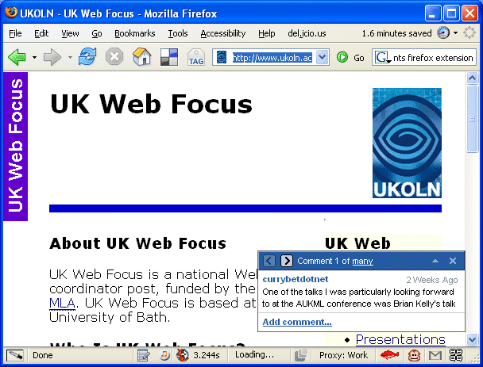
Go to the page <http://www.google.com/tools/firefox/webcomments/index.html>. Read how you can install an interface to this search tool to the Firefox browser. If you are using Firefox, install the software.

5.3 Using Technorati
Go to the Technorati Web site at the address: <http://www.technorati.com/>. Search for information of interest, such as UKOLN.
Howe recent is the latest search result.

5.4 Adding Technorati To Your Browser
Go to the page <https://addons.mozilla.org/search-engines.php>. Read how you can install a Technorati search box into the Firefox browser. If you are using Firefox, install the software.

DISCUSSION
What are the advantages of these search engines over better known search engines such as Google?

Exercise 6

Using An RSS Aggregator

Aims Of This Exercise
In the following exercises you will learn about Blogs.

6.1 Finding Blogs Of Interest
Use Google to find examples of Blogs about your area of interest, your organisation., etc..
What type of articles do you find?

6.2 Blogs And RSS
Find the RSS feed for one of the Blogs you have lokied at. View the RSS file and notice that it is not (normally) available in a format which is easy to understand.

6.3 RSS Readers: Netvibes
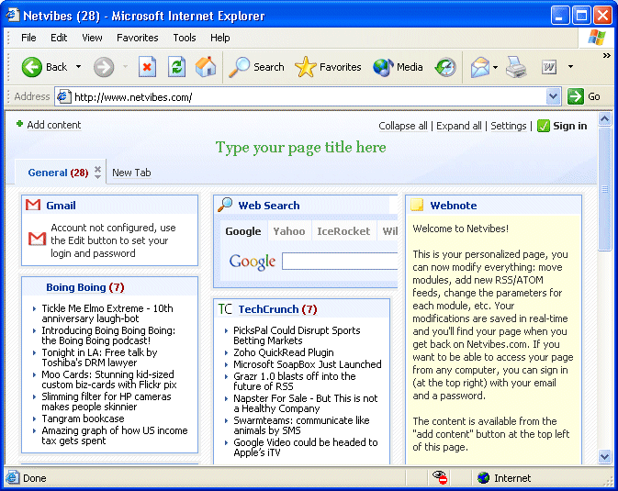
Copy the URL of the RSS file you have been looking at. The go to the Netvibes personalized RSS viewer at <http://www.netvibes.com/>.

6.4 Adding An RSS Feed To Netvibes
Click on the Add Content link on the top left hand corner.
Then click on Add Feed and paste the URL of the RSS file.
Notice how the feed is added to the page.

6.5 Using Netvibes
Add a title to the page by clicking on “Type your page title here”.
Create a new tab for organizing your RSS feeds.

6.6 Getting A Netvibes Account
If you wish to continue using Netvibes, click on the Sign In option and sign up for a Netvibes account.

DISCUSSION
What are the advantages of services such as Netvibes?
Exercise 7

Using Flickr

Aims Of This Exercise
In the following exercises you will learn about the Flickr photo-sharing service.

7.1 The Flickr Photo Sharing Service
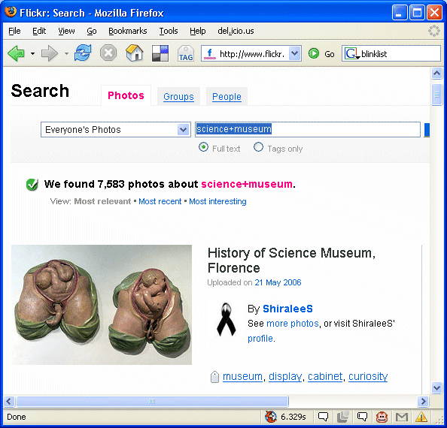
Go to the Flickr at the address: <http://www.flickr.com/>.

7.2 Using Flickr
Use Flickr to search for photographs of your museum or a popular museum such as the Science Museum (use the search string science+museum).
What advantages can services such as Flickr provide?

7.3 Adding Flickr
Read the Flickr help pages and find out how content from Flickr can be embedded within your Web site.
What benefits can thisprovide?

DISCUSSION
How do you think photo sharing services such as Flickr could be used to support your professional interests?

What concerns may you have over use of such services?

Using Frappr
Exercise 8

Aims Of This Exercise
In the following exercises you will look at a social networking service called Frappr.

8.1 Frappr Web SIte
Go to the Frappr Web site at the address: <http://www.frappr.com/>.
What do you think Frappr will provide?

8.2 IWMW 2006 Frappr Group
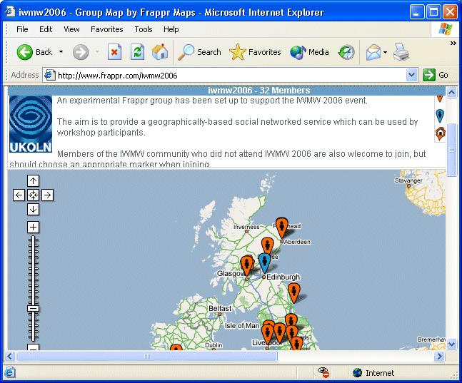
Go to the IWMW 2006 Frappr group Web site at the address: <http://www.frappr.com/iwmw2006/>.

What does this service seek to provide provide?

Discussion
Do you think social networking service have a role to play in your environment?

If so, what are the issues you should consider in choosing the social networking service and how it will be used?

Exercise 9

Using Location-Based Services

Aims Of This Exercise
In the following exercises you will make use of a location-based service.

9.1 Accessing a Location Based Mashup Service
Go to the list of forthcoming Web Focus events at <http://www.ukoln.ac.uk/web-focus/events/>.
Then click on the link to the Acme.com mapping service.

9.2 Using a Location Based Mashup Service
Click on the icons representing forthcoming events.
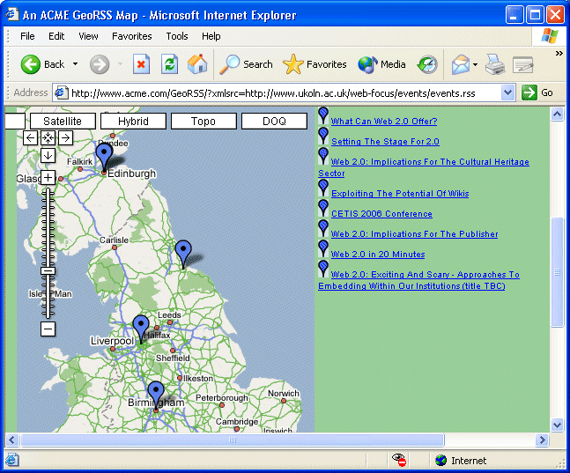

Zoom in on the map as far as you can.

Click on the Satellite button to get a satellite view of the location

Discussion
How do you location-based service could be used in your area?

What benefits might you gain from making use of Creative Commons within your organisation? What potential difficulties might you expect to encounter?

Exercise 10

Web 2.0 And Openness

Aims Of This Exercise
In the following exercises you will make use of search engines which can be used to search for resources which are licensed with a Creative Commons licence software.

10.1 Creative Commons Search Engine
Go to the Creative Commons search page at <http://search.creativecommons.org/>.
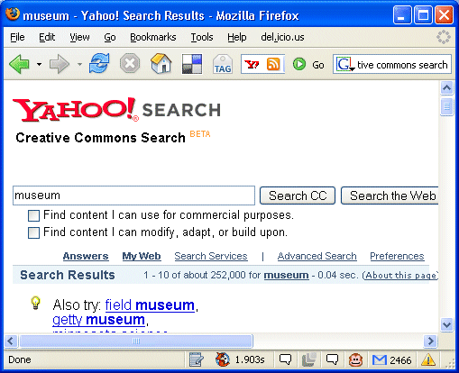

Search for topics of interest to you.

Discussion
What are the potential benefits of use of Creative Commons licences for use in an educational context?

What benefits would you gain from using Creative Commons licences with your resources? What may be the possible disadvantages?

