
Publishing An E-Journal:
Managing Metadata

Metadata – What Is It?
Metadata can be regarded as data about data. The term metadata is not a new one – in a library and publishing context catalogue records are an example of metadata.
Metadata provides structured information about a resource. So Title=“The Bible” clearly defines the title of a publication, so in a search by title the user will not be confused by documents about The Bible.

Use Of Metadata
Metadata can be used for a number of purposes:
Enhanced local search facilities: Metadata can be used to provide enhanced local search facilities, such as searching the author of an article or its title, as shown below.
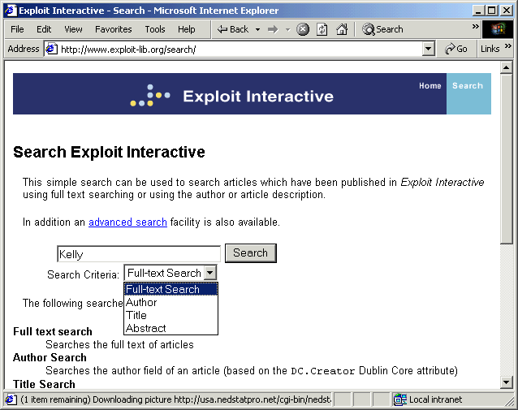
Enhanced remote search facilities: If the metadata is provided in a standard format it can be used to support enhanced remote search facilities.
Publishing An E-Journal:
Managing Metadata

Metadata – What Is It?
Metadata can be regarded as data about data. The term metadata is not a new one – in a library and publishing context catalogue records are an example of metadata.
Metadata provides structured information about a resource. So Title=“The Bible” clearly defines the title of a publication, so in a search by title the user will not be confused by documents about The Bible.

Use Of Metadata
Metadata can be used for a number of purposes:
Enhanced local search facilities: Metadata can be used to provide enhanced local search facilities, such as searching the author of an article or its title, as shown below.
Enhanced remote search facilities: If the metadata is provided in a standard format it can be used to support enhanced remote search facilities.

Metadata In HTML
Metadata can be defined in the <META> HTML element. As an example view the source of a Cultivate Interactive article (e.g. see < http://www.cultivate-int.org/issue5/
buildings/>). You will see a number of <META> statements as shown below.
<meta name="DC.Title" content="The search for the most fascinating library buildings in the world">
<meta name="DC.Creator" content="Oswald, G.">
<meta name="DC.Description" content="Godfrey Oswald reports on the Search for the most fascinating library buildings in the world ">
<meta name="DC.Relation.IsPartOf" content="http://www.cultivate-int.org/issue5/">
<meta name="DC.Type" content="text.article.misc" scheme="Cultivate-categories">

Note that this is an example of metadata which uses the Dublin Core standard.

Managing Metadata
You could add your metadata to HTML pages manually. However this approach has several disadvantages:
- It is difficult to reuse the metadata.
- It is difficult to maintain the metadata or the format in which the metadata is represented.
To overcome these problems it is suggested that metadata is managed in some way.

Using SSIs to Include Metadata
Server-side includes (SSIs) can be used to manage metadata. For example, metadata could be held as variables in a server-side scripting languages (such as JavaScript or VBScript if using Active Server Pages [ASP] in a Windows NT environment or as PHP variables if using a Unix environment).
An SSI fragment can then transform the variables into the appropriate format – e.g. <META> elements. If, at a later date, it is felt desirable to make use of an alternative format (such as RDF) this will simply require updating the single scripting fragment.

Metadata Repositories
Although use of SSIs helps with the maintenance of the scripting fragments, it does not help with the management of the metadata content itself. A better approach is to store the metadata in a backend database (sometimes called a metadata repository). The metadata can then be accessed, either by exporting as a batch process or by providing dynamic access to the database.

Metadata In HTML
Metadata can be defined in the <META> HTML element. As an example view the source of a Cultivate Interactive article (e.g. see < http://www.cultivate-int.org/issue5/
buildings/>). You will see a number of <META> statements as shown below.
<meta name="DC.Title" content="The search for the most fascinating library buildings in the world">
<meta name="DC.Creator" content="Oswald, G.">
<meta name="DC.Description" content="Godfrey Oswald reports on the Search for the most fascinating library buildings in the world ">
<meta name="DC.Relation.IsPartOf" content="http://www.cultivate-int.org/issue5/">
<meta name="DC.Type" content="text.article.misc" scheme="Cultivate-categories">

Note that this is an example of metadata which uses the Dublin Core standard.

Managing Metadata
You could add your metadata to HTML pages manually. However this approach has several disadvantages:
- It is difficult to reuse the metadata.
- It is difficult to maintain the metadata or the format in which the metadata is represented.
To overcome these problems it is suggested that metadata is managed in some way.

Using SSIs to Include Metadata
Server-side includes (SSIs) can be used to manage metadata. For example, metadata could be held as variables in a server-side scripting languages (such as JavaScript or VBScript if using Active Server Pages [ASP] in a Windows NT environment or as PHP variables if using a Unix environment).
An SSI fragment can then transform the variables into the appropriate format – e.g. <META> elements. If, at a later date, it is felt desirable to make use of an alternative format (such as RDF) this will simply require updating the single scripting fragment.

Metadata Repositories
Although use of SSIs helps with the maintenance of the scripting fragments, it does not help with the management of the metadata content itself. A better approach is to store the metadata in a backend database (sometimes called a metadata repository). The metadata can then be accessed, either by exporting as a batch process or by providing dynamic access to the database.

