
Publishing An E-Journal:
Providing Extra Functionality
For Your E-Journal

About This Document
This document describes how to provide extra functionality to an e-journal. It is based on the approach taken by the Cultivate Interactive and Exploit Interactive e-journals.
This document assumes that server-side includes (SSIs) are used to include article fragments.
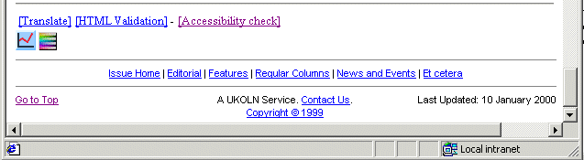

Print Entire Issue
It can be useful to provide a mechanism for printing the entire contents of an issue of an e-journal. This can be useful for, say, users who prefer reading articles in paper form.
It can be time-consuming for readers to visit every page and print articles individually. The approach taken in Cultivate Interactive is to make use of SSIs to include article fragments into a single page (see <http://www.cultivate-int.org/issue5/print-all/>).
It should be noted that before including each article it is necessary to include the article metadata (author details) as they are used in the citation information at the bottom of articles.
It should also be noted that it is necessary to ensure that images are uniquely identified. If images for each article are to be copied into a central area, you must ensure that image file names are unique (e.g. biblink-figure-1.gif rather than figure-1.gif for an article on the BIBLINK project. An alternative approach is to use absolute rather than relative links to images.
Note that this approach can also be used to automatically provide a table of contents and a site map of the e-journal.
Publishing An E-Journal:
Providing Extra Functionality
For Your E-Journal

About This Document
This document describes how to provide extra functionality to an e-journal. It is based on the approach taken by the Cultivate Interactive and Exploit Interactive e-journals.
This document assumes that server-side includes (SSIs) are used to include article fragments.

Print Entire Issue
It can be useful to provide a mechanism for printing the entire contents of an issue of an e-journal. This can be useful for, say, users who prefer reading articles in paper form.
It can be time-consuming for readers to visit every page and print articles individually. The approach taken in Cultivate Interactive is to make use of SSIs to include article fragments into a single page (see <http://www.cultivate-int.org/issue5/print-all/>).
It should be noted that before including each article it is necessary to include the article metadata (author details) as they are used in the citation information at the bottom of articles.
It should also be noted that it is necessary to ensure that images are uniquely identified. If images for each article are to be copied into a central area, you must ensure that image file names are unique (e.g. biblink-figure-1.gif rather than figure-1.gif for an article on the BIBLINK project. An alternative approach is to use absolute rather than relative links to images.
Note that this approach can also be used to automatically provide a table of contents and a site map of the e-journal

Translation Of Articles
Since Cultivate Interactive has a European readership it was felt that it would be useful to provide a facility for providing translations of articles. Since no funding was available for manual translation use was made of machine translation software. A number of Web-based translation services have been used including AltaVista’s Babelfish and World Lingo.
The URL of each article to be translated is defined by an SSI. The translation service itself is included as an SSI. This means that if it is necessary to use a new translation service, comments on the initial service need to be made, or, indeed, if the translation service needs to be removed this can be done by changing a single file.
Note see <http://www.cultivate-int.org/issue2/mt/> for an article on machine translation.

Citation Of Articles
If author and article details were manually maintained there is a danger that discrepancies will be introduced. In addition it would be very time-consuming to change the format of citations.
In Cultivate Interactive the author and article details are defined in SSIs and the format information itself is also an SSI (see image below).
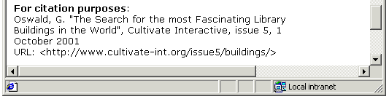

What Else Can Be Done?
The use of SSIs makes it relatively easy to deploy new functionality to an e-journal. Some additional areas of functionality which can be deployed include:
Appearance: If the e-journal makes use of style sheets (CSS) it would be possible to allow the user to choose alternative style sheets. This may be useful as an accessibility aid. Note that in addition, cookies could be used to remember the user’s preferred settings.
Technical Quality: It would be possible to include links to Web page checking tools, to check for, say, HTML compliance, validate links, etc. Note that in addition, cookies could be used to include such links only for, say, members of the editorial board and not end users.

Translation Of Articles
Since Cultivate Interactive has a European readership it was felt that it would be useful to provide a facility for providing translations of articles. Since no funding was available for manual translation use was made of machine translation software. A number of Web-based translation services have been used including AltaVista’s Babelfish and World Lingo.
The URL of each article to be translated is defined by an SSI. The translation service itself is included as an SSI. This means that if it is necessary to use a new translation service, comments on the initial service need to be made, or, indeed, if the translation service needs to be removed this can be done by changing a single file.
Note see <http://www.cultivate-int.org/issue2/mt/> for an article on machine translation.

Citation Of Articles
If author and article details were manually maintained there is a danger that discrepencies will be introduced. In addition it would be very time-consuming to change the format of citations.
In Cultivate Interactive the author and artilce details are defined in SSIs and the format information itself is also an SSI (see image below).

What Else Can Be Done?
The use of SSIs makes it reletively easy to deploy new functionality to an e-journal. Some additional areas of functionality which can be deployed include:
Appearance: If the e-journal makes use of style sheets (CSS) it would be possible to allow the user to choose alternative style sheets. This may be useful as an accessibility aid. Note that in addition, cookies could be used to remember the user’s preferred settings.
Technical Quality: It would be possible to include links to Web page checking tools, to check for, say, HTML compliance, validate links, etc. Note that in addition, cookies could be used to include such links only for, say, members of the editorial board and not end users.

