
Publishing An E-Journal:
Usage Statistics

Analysis Of Web Server Log Files
Many publishers of Web sites will make use of Web statistical analysis software to provide details of usage of their Web site. Many tools which will analyse server log files are available, as can be seen from the list at <http://directory.google.com/Top/
Computers/Software/Internet/Site_Management/Log_Analysis/>.
It should be noted that care must be taken in interpreting the output from such software. It is possible to confuse terms such as hits and page impressions. Also trends shown in graphs and histograms may not reflect reality: for example, on the one hand, usage could be greater than shown because of the effect of caching, offline browsers, etc. but usage could be less than that shown due to visits by robots and other automated user agents.

Use Of Externally-Hosted Usage Analysis Services
The use of Web log analysis software requires a Web site administrator to purchase and configure the software and to develop a process for managing the server log files. This may be a time-consuming process, and require the purchase of, possibly expensive, software (although some software analysis software tools are available for free).
An alternative approach is to make use of an externally-hosted usage analysis service. This approach involves adding a small image which is hosted by a external company on pages for which usage statistics is required. When the page is accessed, the image is retrieved from the external company, who record the usage details. Summaries of the usage statistics can then be obtained by accessing the external companies Web site.

Example
Use of externally-hosted usage analysis service has been evaluated for the Exploit Interactive and Cultivate Interactive e-journals.
In these e-journals the Nedstats <http://www.nedstat.com/> and Sitemeter <http://www.sitemeter.com/> services have been used. Nedstats is used to provide information on usage of individual articles and Sitemeter or usage of the entire e-journal.
Publishing An E-Journal:
Usage Statistics

Analysis Of Web Server Log Files
Many publishers of Web sites will make use of Web statistical analysis software to provide details of usage of their Web site. Many tools which will analyse server log files are available, as can be seen from the list at <http://directory.google.com/Top/
Computers/Software/Internet/Site_Management/Log_Analysis/>.
It should be noted that care must be taken in interpreting the output from such software. It is possible to confuse terms such as hits and page impressions. Also trends shown in graphs and histograms may not reflect reality: for example, on the one hand, usage could be greater than shown because of the effect of caching, offline browsers, etc. but usage could be less than that shown due to visits by robots and other automated user agents.

Use Of Externally-Hosted Usage Analysis Services
The use of Web log analysis software requires a Web site administrator to purchase and configure the software and to develop a process for managing the server log files. This may be a time-consuming process, and require the purchase of, possibly expensive, software (although some software analysis software tools are available for free).
An alternative approach is to make use of an externally-hosted usage analysis service. This approach involves adding a small image which is hosted by a external company on pages for which usage statistics is required. When the page is accessed, the image is retrieved from the external company, who record the usage details. Summaries of the usage statistics can then be obtained by accessing the external companies Web site.

Example
Use of externally-hosted usage analysis service has been evaluated for the Exploit Interactive and Cultivate Interactive e-journals.
In these e-journals the Nedstats <http://www.nedstat.com/> and Sitemeter <http://www.sitemeter.com/> services have been used. Nedstats is used to provide information on usage of individual articles and Sitemeter or usage of the entire e-journal.
An example of the output from Sitemeter is shown. As well as showing usage trends over various periods, it also provides details of the end user’s environment (e.g. machine type and operating system, browser type, etc.). This information is available to everyone, by simply following a link.
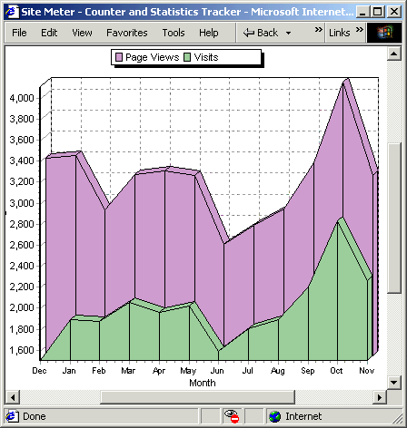
An article on “Software in Use: Externally-Hosted Web Statistics Services” is available at <http://www.exploit-lib.org/
issue5/software-used/> and one on “Comparing Externally-Hosted Web Statistics and Purchased Statistics Services” at <http://www.exploit-lib.org/issue7/statistics/>.

Advantages And Disadvantages
Externally-hosted Web statistics services can be easy to set up and use – all you have to do is to go to the Web site and register your details. You will then be given the HTML fragment to be included in your Web page. No extra effort is needed in order to provide access to the usage statistics. However there are several disadvantages to this approach:
Reliance on a remote service and network: Usage will only be recorded if the request is sent to the remote service. This may not happen if the remote service is overloaded or the network is not available.
Reliance on a third party: You are reliant on the business policies of the remote service. If they go out of business or change their conditions of use it will affect access to usage statistics. If they go out of business and their domain name is acquired by another company, this could potentially be of course, as it could mean that an inappropriate image is hosted on your Web site.
If you do make use of externally-hosted statistical (or other) services you are strongly advise to consider the management of the services, so they can easily be replaced.

Further Information
For further information on usage statistics see the article on “Performance Indicators For Web Sites” at <http://www.exploit-lib.org/issue5/indicators/>.
An example of the output from Sitemeter is shown. As well as showing usage trends over various periods, it also provides details of the end user’s environment (e.g. machine type and operating system, browser type, etc.). This information is available to everyone, by simply following a link.
An article on “Software in Use: Externally-Hosted Web Statistics Services” is available at <http://www.exploit-lib.org/
issue5/software-used/> and one on “Comparing Externally-Hosted Web Statistics and Purchased Statistics Services” at <http://www.exploit-lib.org/
issue7statistics/>.

Advantages And Disadvantages
Externally-hosted Web statistics services can be easy to set up and use – all you have to do is to go to the Web site and register your details. You will then be given the HTML fragment to be included in your Web page. No extra effort is needed in order to provide access to the usage statistics. However there are several disadvantages to this approach:
Reliance on a remote service and network: Usage will only be recorded if the request is sent to the remote service. This may not happen if the remote service is overloaded or the network is not available.
Reliance on a third party: You are reliant on the business policies of the remote service. If they go out of business or change their conditions of use it will affect access to usage statistics. If they go out of business and their domain name is acquired by another company, this could potentially be of course, as it could mean that an inappropriate image is hosted on your Web site.
If you do make use of externally-hosted statistical (or other) services you are strongly advise to consider the management of the services, so they can easily be replaced.

Further Information
For further information on usage statistics see the article on “Performance Indicators For Web Sites” at <http://www.exploit-lib.org/issue5/indicators/>.

