Social Media For Researchers
B: Resource sharing

B1: Using Slideshare
What is it? Slideshare is service which enables slides to be shared widely.
Why bother? Having an Slideshare account can help you share presentations given at conferences with fellow researchers.

Exercise 1: Familiarisation
B1.1 View the Slideshare profile for an early adopter at http://slidehshare/lisbk as shown in Figure 1.
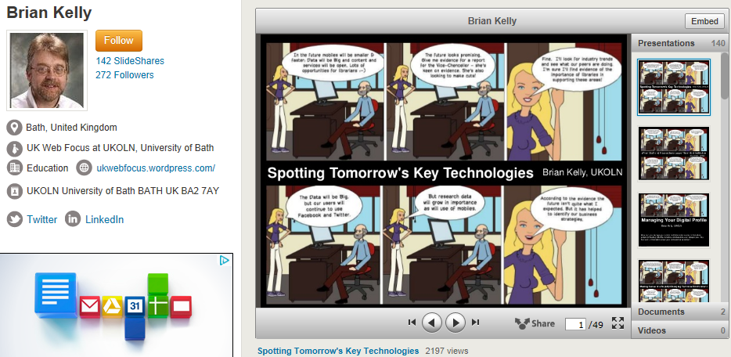Figure 1: Slideshare account
B1.2 View popular slides by clicking on the Slideshare link and view by popularity (or go directly to <http://www.slideshare.net/lisbk/presentations?order=popular>). How many views have the top three slides have? Click on the More link at the bottom of a slide to view further metrics information.

Exercise 2: Registering (optional)
B1.3 Go to <http://www.slideshare.net/> and sign up for an account.

Exercise 3: Finding and Embedding Slides of Interest
B1.4 Go to the search interface and search for “altmetrics”. You should find a slideshow on “Overview of the altmetrics landscape”at <http://www.slideshare.net/rcave/
overview-of-the-altmetrics-landscape?from_search=1>.
B1.5 Explore the speaker’s other slides. Then click on the Embed link at the top of a slideshow to discover how slides can be embedded elsewhere.

Social Media For Researchers
B: Resource sharing

A1: Using Slideshare
What is it? Slideshare is service which enables slides to be shared widely.
Why bother? Having an Slideshare account can help you share presentations given at conferences with fellow researchers.

Exercise 1: Familiarisation
B1.1 View the Slideshare profile for an early adopter at http://slidehshare/lisbk as shown in Figure 1.
Figure 1: Slideshare account
B1.2 View popular slides by clicking on the Slideshare link and view by popularity (or go directly to <http://www.slideshare.net/lisbk/presentations?order=popular>). How many views have the top three slides have? Click on the More link at the bottom of a slide to view further metrics information.

Exercise 2: Registering (optional)
B1.3 Go to <http://www.slideshare.net/> and sign up for an account.

Exercise 3: Finding and Embedding Slides of Interest
B1.4 Go to the search interface and search for “altmetrics”. You should find a slideshow on “Overview of the altmetrics landscape”at <http://www.slideshare.net/rcave/
overview-of-the-altmetrics-landscape?from_search=1>.
B1.5 Explore the speaker’s other slides. Then click on the Embed link at the top of a slideshow to discover how slides can be embedded elsewhere.

Learning From Slides
How useful do you think it would be to learn from the content of slideshows? Would you slides be of use to your peers?

Limitations
What limitations do you feel Slideshare has?

Questions and Comments
Make a note of any questions and comments you have about Slideshare.

Further Information and Useful Links
For further information on Slideshare see:
- Slideshare, Wikipedia, https://en.wikipedia.org/wiki/Slideshare
- The Value of Statistics: Guest Blog Post by Brian Kelly, B. Kelly, UK Web Focus blog, 13 Feb 2012, http://www.jorum.ac.uk/blog/post/27/the-value-of-statistics-guest-blog-post-by-brian-kelly
- Using Slideshare as a Tool to Help Identify Impact, B. Kelly, UK Web Focus blog, 6 May 2011, http://ukwebfocus.wordpress.com/2011/05/06/using-slideshare-as-a-tool-to-help-identify-impact/
- How Plenary Speakers Are Maximising Their Impact, B. Kelly, UK Web Focus blog, 18 June 2008, http://ukwebfocus.wordpress.com/2008/06/18/how-plenary-speakers-are-maximising-their-impact/

Learning From Slides
How useful do you think it would be to learn from the content of slideshows? Would you slides be of use to your peers?

Limitations
What limitations do you feel Slideshare has?

Questions and Comments
Make a note of any questions and comments you have about Slideshare.

Further Information and Useful Links
For further information on Slideshare see:
- Slideshare, Wikipedia, https://en.wikipedia.org/wiki/Slideshare
- The Value of Statistics: Guest Blog Post by Brian Kelly, B. Kelly, UK Web Focus blog, 13 Feb 2012, http://www.jorum.ac.uk/blog/post/27/the-value-of-statistics-guest-blog-post-by-brian-kelly
- Using Slideshare as a Tool to Help Identify Impact, B. Kelly, UK Web Focus blog, 6 May 2011, http://ukwebfocus.wordpress.com/2011/05/06/using-slideshare-as-a-tool-to-help-identify-impact/
- How Plenary Speakers Are Maximising Their Impact, B. Kelly, UK Web Focus blog, 18 June 2008, http://ukwebfocus.wordpress.com/2008/06/18/how-plenary-speakers-are-maximising-their-impact/

