Social Media For Researchers
C: Research Identifiers

C1: Using Researcher ID Services
What are they? AuthorCalim and RePEc are services which can be used by researchers to claim their researcher identifier and associated publications.
Why bother? Having a unique researcher identifiers differentiates you from others.
Risks: These services may be discipline specific or being obsoleted by alternatives.

Exercise 1: Exploring Authorcalim
C1.1 View the Authorcalim home page at http://authorclaim.org/
C1.2 Make a note of the frequency of updates to the service.
C1.3 Try to find a Authorcalim Wikipedia entry.

Exercise 2: Exploring RePEc
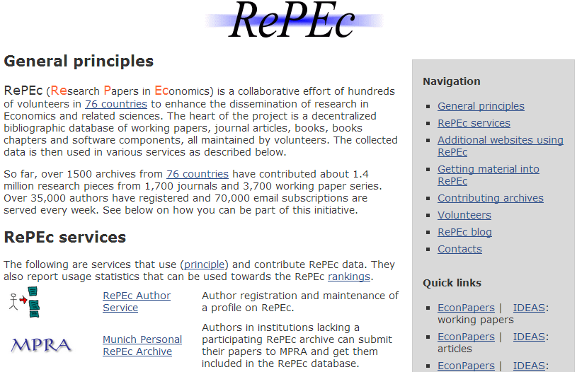Figure 1: RePEc Home Page
C1.4 Go to the RePEc home page at http://repec.org/ (see Figure 1).
C1.5 Read about the RePEc service. Then click on the link to RePEc Author service. Make a note of the number of recent changes to the service.

Exercise 3: Issues Prior To Registration
C1.6 Click on the Register Now option. Then read the further information about the service.
C1.7 How useful is the service for you, in your area of research?

Exercise 4: Identification of Researcher ID Requirements
C1.8 Make a note overleaf of the requirements you have of a researcher ID service and the potential limitations such services may have which could prevent you from using them.

Social Media For Researchers
C: Research Identifiers

C1: Using Researcher ID Services
What are they? AuthorCalim and RePEc are services which can be used by researchers to claim their researcher identifier and associated publications.
Why bother? Having a unique researcher identifiers differentiates you from others.
Risks: These services may be discipline specific or being obsoleted by alternatives.

Exercise 1: Exploring Authorcalim
C1.1 View the Authorcalim home page at http://authorclaim.org/
C1.2 Make a note of the frequency of updates to the service.
C1.3 Try to find a Authorcalim Wikipedia entry.

Exercise 2: Exploring RePEc
Figure 1: RePEc Home Page
C1.4 Go to the RePEc home page at http://repec.org/ (see Figure 1).
C1.5 Read about the RePEc service. Then click on the link to RePEc Author service. Make a note of the number of recent changes to the service.

Exercise 3: Issues Prior To Registration
C1.6 Click on the Register Now option. Then read the further information about the service.
C1.7 How useful is the service for you, in your area of research?

Exercise 4: Identification of Researcher ID Requirements
C1.8 Make a note overleaf of the requirements you have of a researcher ID service and the potential limitations such services may have which could prevent you from using them..

Requirements of Researcher ID Services
What requirements do you have for a researcher ID service?

Barriers to Use of Researcher ID Services
Why would you not sign up for a researcher ID services?

Questions and Comments
Make a note of any questions and comments you have about researcher ID services.

Requirements of Researcher ID Services
What requirements do you have for a researcher ID service?

Barriers to Use of a Researcher ID Services
Why would you not sign up for a researcher ID services?

Questions and Comments
Make a note of any questions and comments you have about researcher ID services.

