Social Media For Researchers
G: Social media analytics

G2: Using PeerIndex
What is it? PeerIndex is a social media analytics service.
Why bother? Having a PeerIndex account can provide an indication of your engagement with others on Twitter and how your use compares with your peers.
Risks: Low risk. Can be deleted if not wanted. However you should think carefully before uploading papers to the service due to issues such as copyright infringement and fragmentation of access to your papers.

Exercise 1: Familiarisation
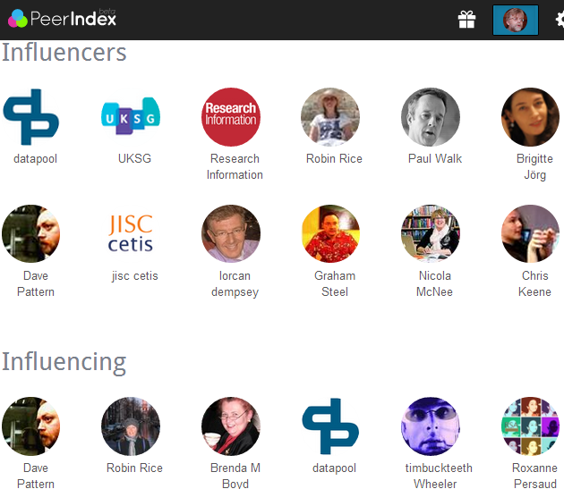Figure 1: A PeerIndex profile
G2.1 View a PeerIndex profile such as the one available at http://www.peerindex.com/
briankelly.
G2.2 Scroll down and see details of influencers influencing as shown in Figure 1.

Exercise 2: Registering
G2.3 Go to the PeerIndex home page Then sign in using your Twitter ID.

Exercise 3: Finding Our More
G2.4 Go to PeerIndex’s Twitter account at http://twitter.com/peerindex Read the biographical details which summarises the service’s role.
G2.5 Read more about PeerIndex on Wikipedia.

Exercise 4: Changes to the Service
G2.6 Read the blog post at http://ukwebfocus.wordpress.com/2011/06/28/ about how PeerIndex was used to compare Twitter rankings for Russell Group universities.
G2.7 Click on the links to PeerIndex scores. Notice how these findings are no longer available.

Social Media For Researchers
G: Social media analytics

G2: Using PeerIndex
What is it? PeerIndex is a social media analytics service.
Why bother? Having a PeerIndex account can provide an indication of your engagement with others on Twitter and how your use compares with your peers.
Risks: Low risk. Can be deleted if not wanted. However you should think carefully before uploading papers to the service due to issues such as copyright infringement and fragmentation of access to your papers.

Exercise 1: Familiarisation
Figure 1: A PeerIndex profile
G2.1 View a PeerIndex profile such as the one available at http://www.peerindex.com/
briankelly.
G2.2 Scroll down and see details of influencers influencing as shown in Figure 1.

Exercise 2: Registering
G2.3 Go to the PeerIndex home page Then sign in using your Twitter ID.

Exercise 3: Finding Our More
G2.4 Go to PeerIndex’s Twitter account at http://twitter.com/peerindex Read the biographical details which summarises the service’s role.
G2.5 Read more about PeerIndex on Wikipedia.

Exercise 4: Changes to the Service
G2.6 Read the blog post at http://ukwebfocus.wordpress.com/2011/06/28/ about how PeerIndex was used to compare Twitter rankings for Russell Group universities.
G2.7 Click on the links to PeerIndex scores. Notice how these findings are no longer available.

Using PeerIndex
How easy was it to create a PeerIndex account? Why would you wish to create and use PeerIndex?

Limitations
What limitations do you feel PeerIndex has?

Questions and Comments
Make a note of any questions and comments you have about PeerIndex.

Further Information and Useful Links
For further information on PeerIndex see:
- PeerIndex, Wikipedia, https://en.wikipedia.org/wiki/PeerIndex
- Social Analytics for Institutional Twitter Accounts Provided by the 24 Russell Group Universities, B. Kelly, UK Web Focus blog, 3 Aug 2012, http://ukwebfocus.wordpress.com/2012/08/03/social-analytics-for-institutional-twitter-accounts-provided-by-the-24-russell-group-universities/
- Social Analytics for Russell Group University Twitter Accounts, B. Kelly, UK Web Focus blog, 28 Jun 2011, http://ukwebfocus.wordpress.com/2011/06/28/
social-analytics-for-russell-group-university-twitter-accounts/

Using PeerIndex
How easy was it to create a PeerIndex account? Why would you wish to create and use PeerIndex?

Limitations
What limitations do you feel PeerIndex has?

Questions and Comments
Make a note of any questions and comments you have about PeerIndex.

Further Information and Useful Links
For further information on PeerIndex see:
- PeerIndex, Wikipedia, https://en.wikipedia.org/wiki/PeerIndex
- Social Analytics for Institutional Twitter Accounts Provided by the 24 Russell Group Universities, B. Kelly, UK Web Focus blog, 3 Aug 2012, http://ukwebfocus.wordpress.com/2012/08/03/social-analytics-for-institutional-twitter-accounts-provided-by-the-24-russell-group-universities/
- Social Analytics for Russell Group University Twitter Accounts, B. Kelly, UK Web Focus blog, 28 Jun 2011, http://ukwebfocus.wordpress.com/2011/06/28/
social-analytics-for-russell-group-university-twitter-accounts/

