Social Media For Researchers
C: Researcher Identifiers

C2: Using ORCID
What is it? ORCID is a standard for researcher identifiers.
Why bother? Having a unique researcher identifier differentiates you from others. As organisations make greater use of ORCID it will save time in admin processes.
Risks: Low risk. Can be deleted if not wanted.

Exercise 1: Familiarisation
C2.1 View the ORCID record of an early adopter at http://bit.ly/orcid-briankelly

Exercise 2: Registering
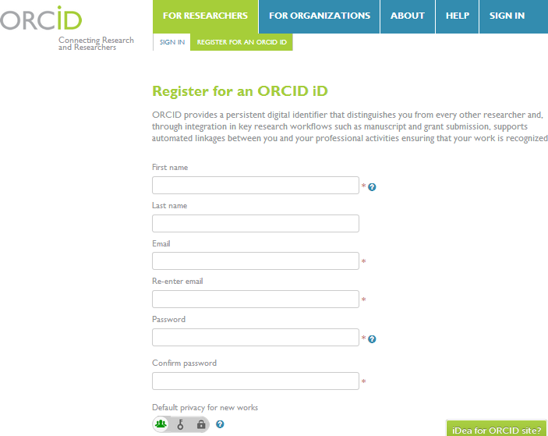Figure 1: ORCID Registation Form
C2.2 Go to http://orcid.org/ and click on the Register for an ORCID ID under the For Researchers menu. Sign up for an ORCID ID (see Figure 1).

Exercise 3: Populating
C2.3 If you have a Scopus account, retrieve your publications from Scopus.
C2.4 If you do not have a Scopus account, feel free to add details of one of your research publications.

Exercise 4 Using ORCID (optional)
C2.5 Go to the ImpactStory service at http://impactstory.org/. Sign up for the service if you do not have an account.
C2.6 Select Add articles and add an Impact Story article based on your ORCID ID.

Social Media For Researchers
C: Researcher Identifiers

C2: Using ORCID
What is it? ORCID is a standard for researcher identifiers.
Why bother? Having a unique researcher identifier differentiates you from others. As organisations make greater use of ORCID it will save time in admin processes.
Risks: Low risk. Can be deleted if not wanted.

Exercise 1: Familiarisation
C2.1 View the ORCID record of an early adopter at http://bit.ly/orcid-briankelly

Exercise 2: Registering
C2.2 Go to http://orcid.org/ and click on the Register for an ORCID ID under the For Researchers menu. Sign up for an ORCID ID (see Figure 1).
Figure 1: ORCID Registation Form

Exercise 3: Populating
C2.3 If you have a Scopus account, retrieve your publications from Scopus.
C2.4 If you do not have a Scopus account, feel free to add details of one of your research publications.

Exercise 4 Using ORCID (optional)
C2.5 Go to the ImpactStory service at http://impactstory.org/. Sign up for the service if you do not have an account.
C2.6 Select and add an Impact Story article based on your ORCID ID.

Creating an ORCID Account
How easy was it to create an ORCID? Why would you not sign up for an ORCID ID?

Making Use of an ORCID ID
How easy was it to create an ORCID ID and use it with the ImpactStory service?

Questions and Comments
Make a note of any questions and comments you have about ORCID.

Further Information and Useful Links
For further information on ORCID see:
- ORCID, Wikipedia, https://en.wikipedia.org/wiki/Slideshare
- Why Every Researcher Should Sign Up For Their ORCID ID, B. Kelly, UK Web Focus blog, 9 Jan 2013, http://ukwebfocus.wordpress.com/2013/01/09/why-every-researcher-should-sign-up-for-their-orcid-id/
- Why You Should Do More Than Simply Claiming Your ORCID ID, B. Kelly, UK Web Focus blog, 19 Nov 2012, http://ukwebfocus.wordpress.com/2012/11/19/
why-you-should-do-more-than-simply-claiming-your-orcid-id/

Creating an ORCID Account
How easy was it to create an ORCID? Why would you not sign up for an ORCID ID?

Making Use of an ORCID ID
How easy was it to create an ORCID ID and use it with the ImpactStory service?

Questions and Comments
Make a note of any questions and comments you have about ORCID.

Further Information and Useful Links
For further information on ORCID see:
- ORCID, Wikipedia, https://en.wikipedia.org/wiki/Slideshare
- Why Every Researcher Should Sign Up For Their ORCID ID, B. Kelly, UK Web Focus blog, 9 Jan 2013, http://ukwebfocus.wordpress.com/2013/01/09/why-every-researcher-should-sign-up-for-their-orcid-id/
- Why You Should Do More Than Simply Claiming Your ORCID ID, B. Kelly, UK Web Focus blog, 19 Nov 2012, http://ukwebfocus.wordpress.com/2012/11/19/
why-you-should-do-more-than-simply-claiming-your-orcid-id/

