Social Media For Researchers
G: Social media analytics

G1: Using Klout
What is it? Klout is a social media analytics service.
Why bother? Having a Klout account can provide an indication of your engagement with others on Twitter and how your use compares with your peers.

Exercise 1: Familiarisation
G1.1 View a Klout profile such as the one available at http://klout.com/#/briankelly (as shown in Figure 1).
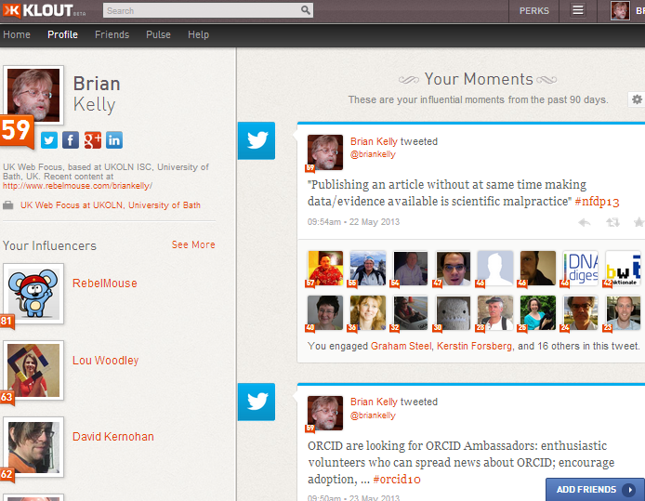Figure 1: Klout profile
G1.2 What type of tweets are listed which appear to have been influential?

Exercise 2: Registering
G1.3 Go to the Klout home page at http://www.klout.com/ Then sign in using your Twitter ID.

Exercise 3: Klout Lists
G1.4 Go to a Klout list such as the list which gives Klout scores for institutional Twitter accounts for the Russell group universities at http://klout.com/#/briankelly/list/3986/ Click on the link for a highly ranked account. What might the reasons be for the high ranking?

Exercise 4: Klout Dashboard
G1.6 Visit the Klout dashboard, as illustrated in Figure 2.
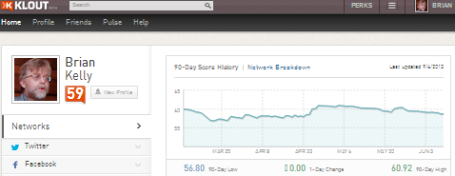Figure 2: Klout Dashboard
G1.7 What might the reasons for fluctuations in your Klout ranking be?

Social Media For Researchers
E: Social media analytics

G1: Using Klout
What is it? Klout is a social media analytics service.
Why bother? Having a Klout account can provide an indication of your engagement with others on Twitter and how your use compares with your peers.

Exercise 1: Familiarisation
G1.1 View a Klout profile such as the one available at http://klout.com/#/briankelly (as shown in Figure 1).
Figure 1: Klout profile
G1.2 What type of tweets are listed which appear to have been influential?

Exercise 2: Registering
G1.3 Go to the Klout home page at http://www.klout.com/ Then sign in using your Twitter ID.

Exercise 3: Klout Lists
G1.4 Go to a Klout list such as the list which gives Klout scores for institutional Twitter accounts for the Russell group universities at http://klout.com/#/briankelly/list/3986/ Click on the link for a highly ranked account. What might the reasons be for the high ranking?

Exercise 4: Klout Dashboard
G1.6 Visit the Klout dashboard, as illustrated in Figure 2.
Figure 2: Klout Dashboard
G1.7 What might the reasons for fluctuations in your Klout ranking be?

Using Klout
How easy was it to create a Klout account? Why would you wish to create and use Klout?

Limitations
What limitations do you feel Klout has?

Questions and Comments
Make a note of any questions and comments you have about Klout.

Further Information and Useful Links
For further information on LinkedIn see:
- Klout, Wikipedia, https://en.wikipedia.org/wiki/Klout
- Social Analytics for Russell Group University Twitter Accounts, B. Kelly, UK Web Focus blog, 28 Jun 2011, http://ukwebfocus.wordpress.com/2011/06/28/
social-analytics-for-russell-group-university-twitter-accounts/
- Klout: Here Is How You Can Game Klout, RocketMill blog, 22 Sep 2011, http://www.rocketmill.co.uk/here-is-how-you-can-game-klout

Using Klout
How easy was it to create a Klout account? Why would you wish to create and use Klout?

Limitations
What limitations do you feel Klout has?

Questions and Comments
Make a note of any questions and comments you have about Klout.

Further Information and Useful Links
For further information on LinkedIn see:
- Klout, Wikipedia, https://en.wikipedia.org/wiki/Klout
- Social Analytics for Russell Group University Twitter Accounts, B. Kelly, UK Web Focus blog, 28 Jun 2011, http://ukwebfocus.wordpress.com/2011/06/28/
social-analytics-for-russell-group-university-twitter-accounts/
- Klout: Here Is How You Can Game Klout, RocketMill blog, 22 Sep 2011, http://www.rocketmill.co.uk/here-is-how-you-can-game-klout

