Exercise 1

Accessibility And E-Learning:
Accessibility Doubts And Concerns

1.1 A Sceptical Perspective
“Although it may be politically incorrect to raise such issues, how relevant is Web accessibility to e-learning? Addressing Web accessibility is expensive and detracts from the development of e-learning resources.”
To what extent can such sentiments be justified? Identify concerns which you feel need to be addressed.

1.2 Resources Implications
What are the costs in providing accessibility?
What, if any, dangers can seeking to provide accessibility e-learning resources provide?

1.3 Addressing The Sceptics
There is a danger that doubts concerning Web accessibility will be hidden, due to worries about being politically incorrect. What approaches can be taken in order to ensure that concerns can be brought into the open and properly addressed.

Exercise 2

Accessibility And E-Learning:
Defining Accessibility

2.1 What Is Meant By ‘Accessible’?
How do you (and your group/institution) define what makes a site “accessible”? Is the emphasis on adhering to a known benchmark, or on providing solutions that work with assistive technology?

2.2 The Checklist Approach
Do you make use of a ‘checklist’ approach to identifying if resources are accessible?
If so, what areas are covered by the checklist?

What are the advantages and disadvantages of this type of approach?

2.3 W3C WAI Guidelines
The W3C WAI guidelines have great authority, but are not always useful or helpful within the context in which we are working, therefore, to what extent should the W3C Web Accessibility guidelines be regarded as gospel?

2.4 Other Guidelines
Does anybody use guidelines other than those provided by the W3C such as the TechDis Seven Precepts, or home grown guidelines?

Exercise 3

Accessibility And E-Learning:
Accessibility And The End User Experience
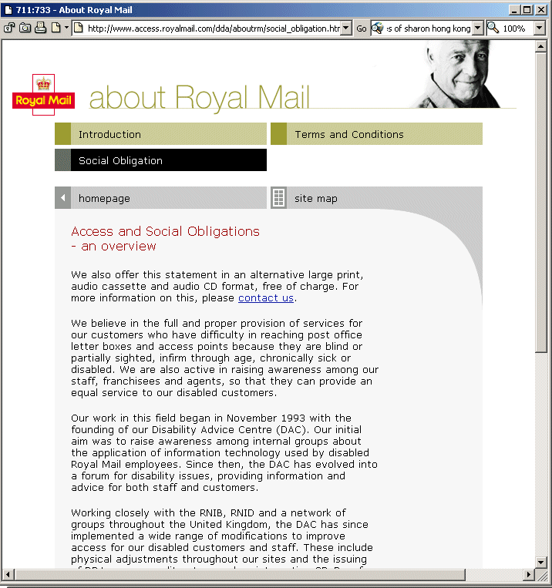

3.1 Royal Mail Access Web Site
The Royal Mail Access Web site – see <http://www.access.royalmail.com/> – was voted by visually impaired viewers as a very usable Web site.
Why do you think this is the case?

3.2 Is Accessibility Always A Good Thing?
Is accessibility a “good thing”? For example does it always enhance the overall user experience, or can it contribute to a less “effective” site overall?

3.3 Is Accessibility Always A Good Thing? (2)
Are there other areas in which accessibility may be in conflict with other best practices?

3.4 Checking Usability
Do you treat usability on equal footing with accessibility?

What processes do you have / should you have for checking the usability of e-learning resources?

Exercise 4

Accessibility And E-Learning:
Tools and Technology

4.1 Use Of Automated Tools
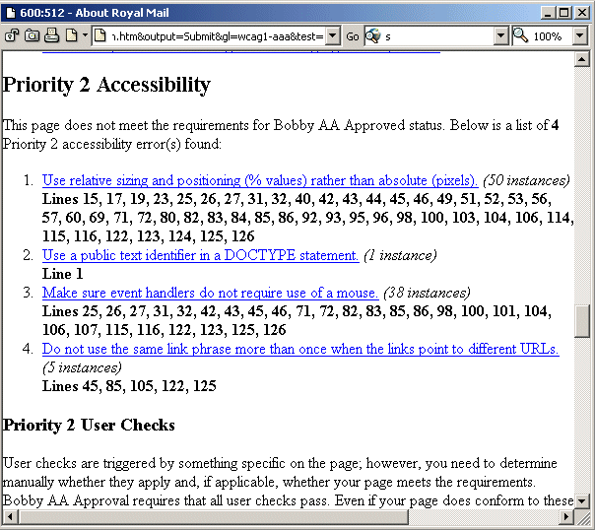
Although highly regarded by visually impaired users the Royal Mail Access Web site fails WAI guidelines according to Bobby.
Do you think this:
- Indicates a failure in Bobby?
- Illustrates the limitations of automated tools?
- Shows that end users can make mistakes?

4.2 Automated Testing Tools
What are the strengths and weaknesses of automated checking tools such as Bobby, The WAVE and LIFT. Are we making use of the LIFT licences made available by the EduServ Grants Programme. What do we think of these tools?

4.3 Authoring Tools
What software do you use to assist you in developing accessible resources? Do these tools help with the development of accessible resources?

4.4 Browsers
What browsers are used to access your e-learning resources? What barriers to accessibility do such browsers have? How can such barriers be addressed?

4.5 XML and CSS
What relevance to formats such as XML have for accessibility? What limitations do they have?

Is CSS ready for mainstream deployment? Can CSS replace tables for layout of Web pages?
Exercise 5

Accessibility And E-Learning:
Education and Involvement

5.1 Reasonable Efforts
SENDA legislation expects organisations to take ‘reasonable efforts’ to ensure people with disabilities are not discriminated against unfairly. How would you define ‘reasonable effort?

5.2 Involvement Of People With Disabilities
Should we as developers be involving disabled end users in our development procedure, and if so how can we best go about this?

5.3 Our Understanding Of Disabilities
Do we as developers fully understand the range of disabilities which we need to consider and the implications of each?

5.4 Education For Academics
How can we best educate and persuade our academic collaborators about the importance of accessibility (particularly when it is often something that means more work for them!)?

Exercise 6

Accessibility And E-Learning:
Accessibility Policies

6.1 Current Use Of Accessibility Policies
Do you use accessibility statements on your Web sites? If so, what do they contain?

6.2 Do You Need An Accessibility Policy?
Should you provide an accessibility policy? If so, why? If not, why not?

6.3 Types Of Accessibility Policies
What should accessibility policies cover?

6.4 Development Processes
Who should be responsible for developing an organisational Web accessibility policy? How should your organisation proceed in developing a policy?

