Exercise 7 Staff Development To Support Use Of Web 2.0 Technologies


A UKOLN Document

Aims Of This Exercise
In this exercise you find out how Web 2.0 technologies, such as Blogs, Podcasts, etc. are being use to provide training and staff development for users and developers of Web 2.0 tools and services.

7.1 Tame The Web
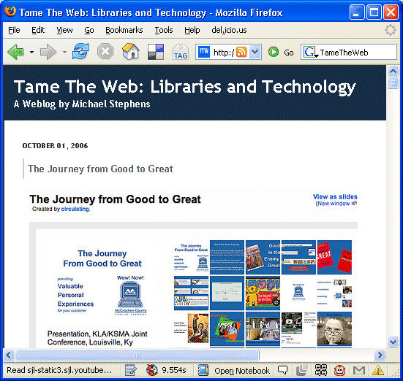
Go to the Tame TheWeb Blog at the address: <http://tametheweb.com/>.
Read some of Michael Stephens’ postings about Web 2.0 technologies and their potential in the Library world.

7.2 Tame The Web Postings On Training And Top Trends
Scroll through the menu of the right hand side of the window until your find the list of categories for thew Blog postings.
Read some of the postings which have been categorised under “Training” and “Top Tech Trends”.

Exercise 7 Staff Development To Support Use Of Web 2.0 Technologies

A UKOLN Document

Aims Of This Exercise
In this exercise you find out how Web 2.0 technologies, such as Blogs, Podcasts, etc. are being use to provide training and staff development for users and developers of Web 2.0 tools and services.

7.1 Tame The Web
Go to the Tame TheWeb Blog at the address: <http://tametheweb.com/>.
Read some of Michael Stephens’ postings about Web 2.0 technologies and their potential in the Library world.

7.2 Tame The Web Postings On Training And Top Trends
Scroll through the menu of the right hand side of the window until your find the list of categories for thew Blog postings.
Read some of the postings which have been categorised under “Training” and “Top Tech Trends”.

7.3 Podcasts
Go to the Library 2.0 Podcasts Blog at <http://podcasts.alablog.org/blog/>.
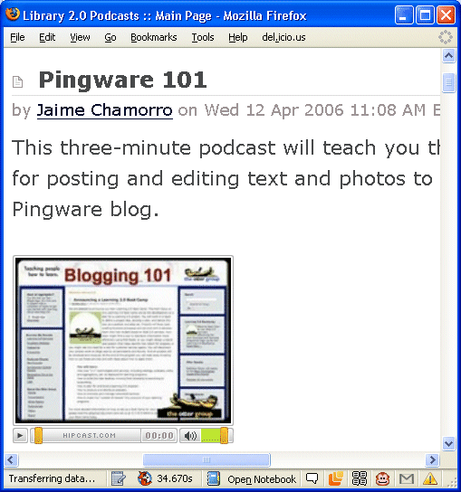
Read about the Podcasts, the typical length and the topics they cover.
What are the advantages of such Podcasts?

What are the limitations?

How could the Podcasts be used to support learning and professional development?

7.4 Creative Commons
Go to the the page providing access to materials used in this session at <http://www.ukoln.ac.uk/web-focus/events/workshops/mla-yorkshire-2008-05/>.
Notice how the page states that a Creative Commons licence is available for the resources used in the seminar.
What are the potential advantages and limitations in Creative Commons licences to support staff development and training?

7.3 Podcasts
Go to the Library 2.0 Podcasts Blog at <http://podcasts.alablog.org/blog/>.
Read about the Podcasts, the typical length and the topics they cover.
What are the advantages of such Podcasts?

What are the limitations?

How could the Podcasts be used to support learning and professional development?

7.4 Creative Commons
Go to the the page providing access to materials used in the seminar at <http://www.ukoln.ac.uk/web-focus/events/workshops/mla-yorkshire-2008-05/>.
Notice how the page states that a Creative Commons licence is available for the resources used in the seminar.
What are the potential advantages and limitations in Creative Commons licences to support staff development and training?

