Exercise 5: Using The Facebook
Social Networking Service



A UKOLN Document

Aims Of This Exercise
In this exercise you will explore how Facebook can be used in a cultural heritage context. Please note that you will need a Facebook ID to complete this exercise.

5.1 Using Facebook
Go to the Facebook social network service at the address: <http://www.facebook.com/>.

5.2 Accessing Information About Cultural Heritage
Search for resources about “museum”, “library” or “archives”.
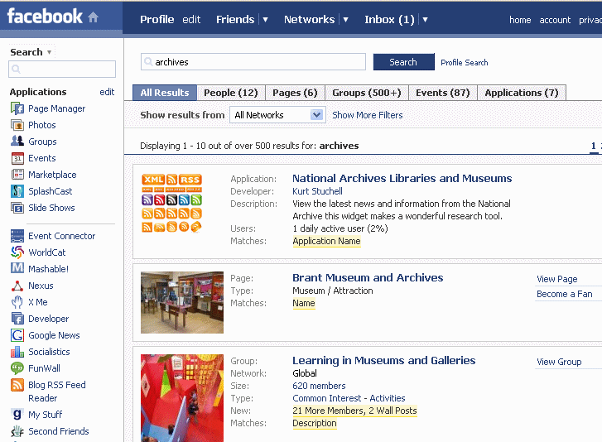
Select the ‘People’ option to find information about people who have used the serach term in their descriptions. Might this be a useful tool for (a) finding people or (b) eastablishing contact with professionals you may already know?
How does this service compare with existing networking tools you may use (such as JISCMail discussion lists)?

5.3 Accessing Information About Archives
Search for resources about ‘archives’. Then select the ‘Pages’ option to find information about archives organisations. How many archives are making use of this facility? What information are they providing?
Select the ‘Applications’ option to find information about Facebook applications, such as the National Archives Libraries and Museums application. Install this application. How useful might this application be?

Exercise 5: Using The Facebook
Social Networking Service

A UKOLN Document

Aims Of This Exercise
In this exercise you will explore how Facebook can be used in a cultural heritage context. Please note that you will need a Facebook ID to complete this exercise.

5.1 Using Facebook
Go to the Facebook social network service at the address: <http://www.facebook.com/>.

5.2 Accessing Information About Archives
Search for resources about “museum”, “library” or “archives”.
Select the ‘People’ option to find information about people who have used the serach term in their descriptions. Might this be a useful tool for (a) finding people or (b) eastablishing contact with professionals you may already know?
How does this service compare with existing networking tools you may use (such as JISCMail discussion lists)?

5.3 Accessing Information About Archives
Search for resources about ‘archives’. Then select the ‘Pages’ option to find information about archives organisations. How many archives are making use of this facility? What information are they providing?
Select the ‘Applications’ option to find information about Facebook applications, such as the National Archives Libraries and Museums application. Install this application. How useful might this application be?

5.4 Potential Of Facebook
What benefits might Facebook provide for your organisation?

What are the obstacles to making use of Facebook?

What could such obstacles be overcome?

5.4 Potential Of Facebook
What benefits might Facebook provide for your organisation?

What are the obstacles to making use of Facebook?

What could such obstacles be overcome?

