Exercise 2: Using Wikipedia To Read About Library, Museum & Archive Resources


A UKOLN Document

Aims Of This Exercise
In the following exercises you will make use of Wikipedia.

2.1 The Wikipedia Service
Go to the Wikipedia home page at the address: <http://en.wikipedia.org/>.
Read a few of the Wikipedia entries in order to familiarise yourself with the approach taken by Wikipedia.
Search for entries opn museums and libraries.

2.2 The MLA Entry on Wikipedia
Search for an entry on “MLA” (Museums, Libraries and Archives Council) in Wikipedia.

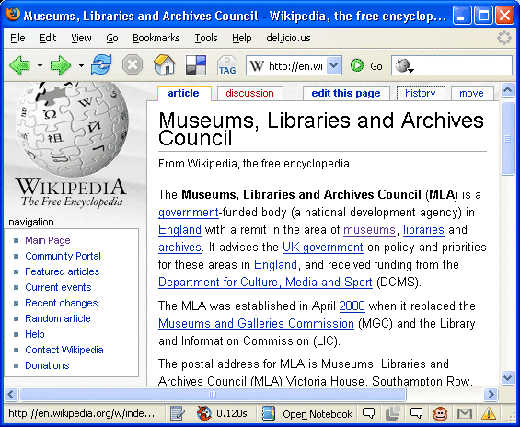
How accurate do you think the entry is?

How useful do you think the entry is?

Look at the History details for the entry. Who created the page originally? Who has updated the page?

Exercise 2: Using Wikipedia To Read About Library, Museum & Archive Resources

A UKOLN Document

Aims Of This Exercise
In the following exercises you will make use of Wikipedia.

2.1 The Wikipedia Service
Go to the Wikipedia home page at the address: <http://en.wikipedia.org/>.
Read a few of the Wikipedia entries in order to familiarise yourself with the approach taken by Wikipedia.

2.2 The MLA Entry on Wikipedia
Search for an entry on “MLA” (Museums, Libraries and Archives Council) in Wikipedia.
How accurate do you think the entry is?

How useful do you think the entry is?

Look at the History details for the entry. Who created the page originally? Who has updated the page?

2.3 Museum Entries on Wikipedia
From the entry for MLA, click on the History tab and then click on the link for Jpbowen, the original creator of the entry.
Scroll though his list of areas in Wikipedia in order to discover more about entries relatred to museums.

2.4 Museum Entries on Wikipedia
From the page on Jpbowen follow the link to “See the paper Museums and Wikipedia at the 2006 Museums and the Web conference.”
Briefly skim through this paper.

2.5 Adding Entries About Your Museum Or Library on Wikipedia
Do you think it would be useful for Wikipedia to contain an entry about your service?

What possible dangers do you forse if you are considering adding an entry to Wikipedia?

What benefits could having an entry in Wikipedia provide?

Comments
Wikepedia is a global encyclopedia which can be edited by anyone. A wide range of materials are included in Wikipedia.This is helped by Wikipedia’s open policy. However the lack of a formal publication policy can result in errors creeping in or entries being vandalised, or either deliberate or inadvertant miseleading entries being published.
Because of its open approach, some people feel Wikipedia should not be used. Others, however, point out that Wikipedia since is a very popular service, it can be benefical to publish orgnanisation detauils on Wikipedia, and take a responsible, professional attuitude towards its use: for example, being proactive in fixing errors.

2.3 Museum Entries on Wikipedia
From the entry for MLA, click on the History tab and then click on the link for Jpbowen, the original creator of the entry.
Scroll though his list of areas in Wikipedia in order to discover more about entries relatred to museums.

2.4 Museum Entries on Wikipedia
From the page on Jpbowen follow the link to “See the paper Museums and Wikipedia at the 2006 Museums and the Web conference.”
Briefly skim through this paper.

2.5 Adding Entries About Your Museum Or Library on Wikipedia
Do you think it would be useful for Wikipedia to contain an entry about your service?

What possible dangers do you forse if you are considering adding an entry to Wikipedia?

What benefits could having an entry in Wikipedia provide?

Comments
Wikepedia is a global encyclopedia which can be edited by anyone. A wide range of materials are included in Wikipedia.This is helped by Wikipedia’s open policy. However the lack of a formal publication policy can result in errors creeping in or entries being vandalised, or either deliberate or inadvertant miseleading entries being published.
Because of its open approach, some people feel Wikipedia should not be used. Others, however, point out that Wikipedia since is a very popular service, it can be benefical to publish orgnanisation detauils on Wikipedia, and take a responsible, professional attuitude towards its use: for example, being proactive in fixing errors.

