Exercise 9: Using YouTube



A UKOLN Document

Aims Of This Exercise
In this exercise you will make use of the YouTube service for finding video clips related to archives.

9.1 YouTube (1)
Go to the YouTube Web site at the address: <http://www.youtube.com/>.
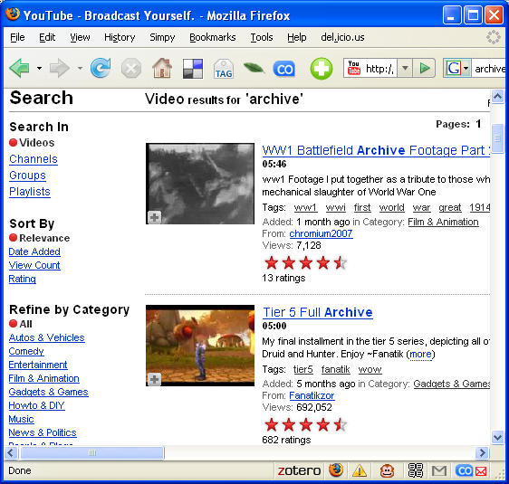
Search for resources using the search term “Archive”.
View any of the resources which seem of interest to you.

9.2 YouTube (2)
Go to the YouTube Web site at the address: <http://www.youtube.com/>.
Search for resources using the search term “The National Archive” – making sure you include the quotation marks (“ and ”).
Do you find any resources about (or published by) The National Archive?
How well-used are the resources you find?
How well rated are the resources you find?

Exercise 9: Using YouTube

A UKOLN Document

Aims Of This Exercise
In this exercise you will make use of the YouTube service for finding video clips related to archives.

9.1 YouTube (1)
Go to the YouTube Web site at the address: <http://www.youtube.com/>.
Search for resources using the search term “Archive”.
View any of the resources which seem of interest to you.

9.2 YouTube (2)
Go to the YouTube Web site at the address: <http://www.youtube.com/>.
Search for resources using the search term “The National Archive” – making sure you include the quotation marks (“ and ”).
Do you find any resources about (or published by) The National Archive?
How well-used are the resources you find?
How well rated are the resources you find?

9.32 BBC Section on YouTube
Go to the BBC area of the YouTube Web site at the address: <http://www.youtube.com/BBC>.
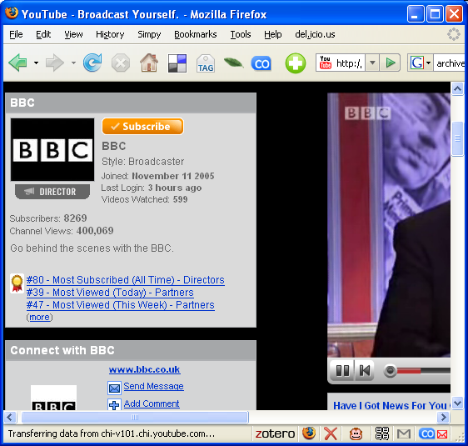
Does the use of a commercial service such as YouTube by an organisation such as the BBC have significance for public sector organisations such as the Archices community?

Discussion
Do you feel that services such as YouTube have a role to play in enhacning the services provided by Archives services?

What barriers do you expect to face in seeking to make use of services such as YouTube?

What approaches might you take in seeking to overcome such barriers?

9.3 BBC Section on YouTube
Go to the BBC area of the YouTube Web site at the address: <http://www.youtube.com/BBC>.
Does the use of a commercial service such as YouTube by an organisation such as the BBC have significance for public sector organisations such as the Archices community?

Discussion
Do you feel that services such as YouTube have a role to play in enhacning the services provided by Archives services?

What barriers do you expect to face in seeking to make use of services such as YouTube?

What approaches might you take in seeking to overcome such barriers?

