Exercise 7: Use Of Social Bookmarking And Social Sharing Services



A UKOLN Document

Aims Of This Exercise
In this exercise you will make use of the del.icio.us social bookmarking tool.

7.1 Using del.icio.us (1)
Go to the del.icio.us social bookmarking service at the address: <http://del.icio.us/>.
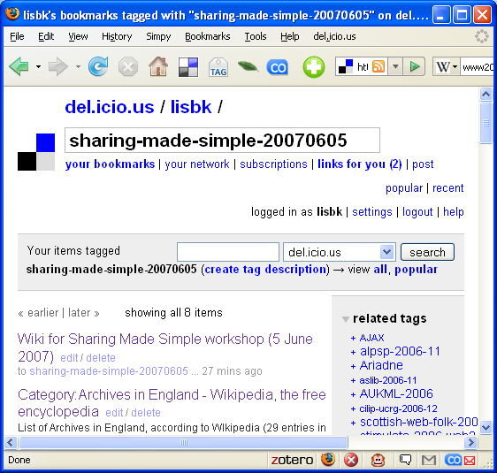
Familiarise yourself with the tool.
Go to the page <http://del.icio.us/lisbk/
sharing-made-simple-200803> and look at the resources which Brian Kelly has bookmarked.
Then click on the View All option near the top of the page to look at other resources bookmarked using the same tag.

7.2 Using del.icio.us (2)
Find the del.icio.us bookmark entry for The Mational Archives Web site.
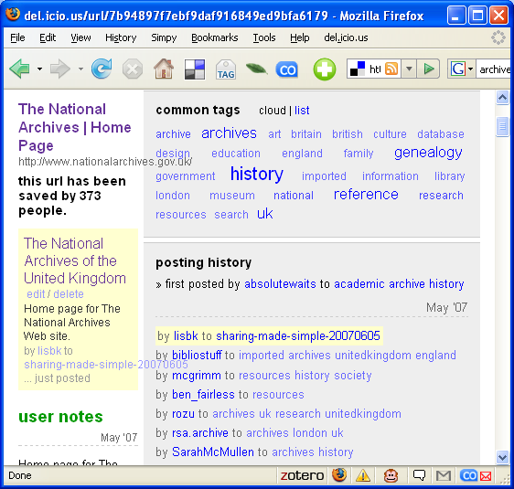
Notice how many others have bookmarked this page.
Click on the Saved by 373 people link.
Explore the resources which have been bookmarked by people who have also bookmarked this entry.

Exercise 7: Use Of Social Bookmarking And Social Sharing Services

A UKOLN Document

Aims Of This Exercise
In this exercise you will make use of the del.icio.us social bookmarking tool.

7.1 Using del.icio.us (1)
Go to the del.icio.us social bookmarking service at the address: <http://del.icio.us/>.
Familiarise yourself with the tool.
Go to the page <http://del.icio.us/lisbk/
sharing-made-simple-200803> and look at the resources which Brian Kelly has bookmarked.
Then click on the View All option near the top of the page to look at other resources bookmarked using the same tag.

7.2 Using del.icio.us (2)
Find the del.icio.us bookmark entry for The Mational Archives Web site.
Notice how many others have bookmarked this page.
Click on the Saved by 373 people link.
Explore the resources which have been bookmarked by people who have also bookmarked this entry.

7.3 Flickr
Go to the Flickr photo sharing service at <http://www.flickr.com/>.
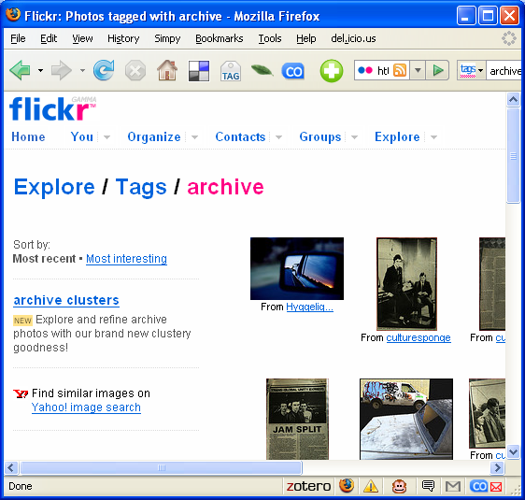
Find photographs which have been tagged with the term “archive”.
How many photographs are available?

Continue searching for photographs which may be of interest to you.

7.4 Use Of Social Networking Services
What, if any, potential do social bookmarking and photographic sharing services services have for your organisation?

What are the limuitations of such service?

7.3 Flickr
Go to the Flickr photo sharing service at <http://www.flickr.com/>.
Find photographs which have been tagged with the term “archive”.
How many photographs are available?

Continue searching for photographs which may be of interest to you.

7.4 Use Of Social Networking Services
What, if any, potential do social bookmarking and photographic sharing services services have for your organisation?

What are the limuitations of such service?

