Exercise 3: Using Wetpaint:
An Externally Hosted Wiki Service



A UKOLN Document

Aims Of This Exercise
In the following exercises you will use a simple wiki tool called Wetpaint.

3.1 The Wetpaint Wiki
Go to the Wiki page at the address:
<http://sharing-made-simple-2008-03.wetpaint.com/>.
Read the information which is available.

3.2 Using Wetpaint
In your Wetpaint wiki space make a note of possible applications of this of Wiki could be used in your organisation
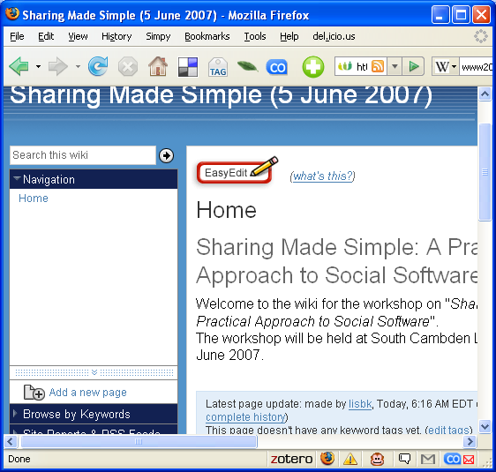
Then try and agree on the strengths and weaknesses of use of this Wiki service.
Strengths

Weaknesses

Exercise 3: Using Wetpaint:
An Externally Hosted Wiki Service

A UKOLN Document

Aims Of This Exercise
In the following exercises you will use a simple wiki tool called Wetpaint.

3.1 The Wetpaint Wiki
Go to the Wiki page at the address:
<http://sharing-made-simple-2008-03.wetpaint.com/>.
Read the information which is available.

3.2 Using Wetpaint
In your Wetpaint wiki space make a note of possible applications of this of Wiki could be used in your organisation
Then try and agree on the strengths and weaknesses of use of this Wiki service.
Strengths

Weaknesses

3.3 Topics For General Discussion
Go to the page on Topics For General Discussion. Contribute to this page with your thoughts on issues you would like to see discussed during the final session of the day.

3.4 Review
Try and agree on the strengths and weaknesses of use of this wiki service.
Strengths:

Weaknesses

Discussion
What are the benefits of this wiki compared with other wiki tools?

What are the advantages and disadvantages of using an externally hosted wiki service such as Wetpaint?

Comments
Wetpaint is an example of an externally hosted wiki service. It is very easy to set up a Wetpaint Wiki and use requires no specialist skills. In addition access to the Wiki can be restricted to authorised users.
However if you arre considering making use of externally hosted services you will need to address certain potential risks, such as the persistency, performance and interoperability of the service.

3.3 Topics For General Discussion
Go to the page on Topics For General Discussion. Contribute to this page with your thoughts on issues you would like to see discussed during the final session of the day.

3.4 Review
Try and agree on the strengths and weaknesses of use of this wiki service.
Strengths:

Weaknesses

Discussion
What are the benefits of this wiki compared with other wiki tools?

What are the advantages and disadvantages of using an externally hosted wiki service such as Wetpaint?

Comments
Wetpaint is an example of an externally hosted wiki service. It is very easy to set up a Wetpaint Wiki and use requires no specialist skills. In addition access to the Wiki can be restricted to authorised users.
However if you arre considering making use of externally hosted services you will need to address certain potential risks, such as the persistency, performance and interoperability of the service.

