Exercise 2: Using Wikipedia To Read About Cultural Heritage Resources



A UKOLN Document

Aims Of This Exercise
In the following exercises you will make use of Wikipedia.

2.1 The Wikipedia Service
Go to the Wikipedia home page at the address: <http://en.wikipedia.org/>.
Read a few of the Wikipedia entries in order to familiarise yourself with the approach taken by Wikipedia.. Then nearch for entries on archives, museums and libraries.

2.2 The MLA Entry on Wikipedia
Search for an entry on “MLA” (Museums, Libraries and Archives Council) in Wikipedia.

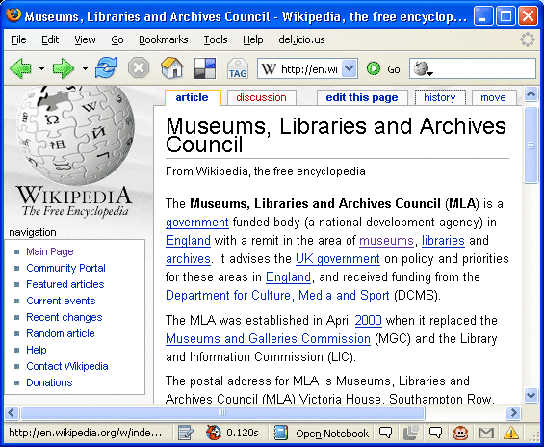
How accurate do you think the entry is? How useful do you think the entry is?
Look at the History for the entry. Who created the page originally? Who has updated the page?

2.3 Archive Entries on Wikipedia
From the entry for MLA, click on the link for “Archive” (or enter “Archive” in the Search box).
How useful is this information? How accurate is it? Could you help to improve this article?

Exercise 2: Using Wikipedia To Read About Cultural Heritage Resources

A UKOLN Document

Aims Of This Exercise
In the following exercises you will make use of Wikipedia.

2.1 The Wikipedia Service
Go to the Wikipedia home page at the address: <http://en.wikipedia.org/>.
Read a few of the Wikipedia entries in order to familiarise yourself with the approach taken by Wikipedia.. Then nearch for entries on archives, museums and libraries.

2.2 The MLA Entry on Wikipedia
Search for an entry on “MLA” (Museums, Libraries and Archives Council) in Wikipedia.
How accurate do you think the entry is? How useful do you think the entry is?
Look at the History for the entry. Who created the page originally? Who has updated the page?

2.3 Archive Entries on Wikipedia
From the entry for MLA, click on the link for “Archive” (or enter “Archive” in the Search box).
How useful is this information? How accurate is it? Could you help to improve this article?

2.4 The National Archive Entry on Wikipedia
On Wikipedia search for “The National Archive”.
When you have retrieved the entry for The National Archive, in the list of Categories near the bottomof the page click on the link to “Archives in England”.
How complete is this list? How useful is this information?

2.5 Museum Entries on Wikipedia
On Wikipedia search for “list of museums in England”.
How complete is this list? How does this compare with the information provided on Archives?

2.5 Adding Entries About YourArchive on Wikipedia
Do you think it would be useful for Wikipedia to contain an entry about your service?

What possible dangers do you forse if you are considering adding an entry to Wikipedia?

What benefits could having an entry in Wikipedia provide?

Comments
Wikepedia is a global encyclopedia which can be edited by anyone. A wide range of materials are included in Wikipedia.This is helped by Wikipedia’s open policy. However the lack of a formal publication policy can result in errors creeping in or entries being vandalised, or either deliberate or inadvertant miseleading entries being published.
Because of its open approach, some people feel Wikipedia should not be used. Others, however, point out that Wikipedia since is a very popular service, it can be benefical to publish orgnanisation detauils on Wikipedia, and take a responsible, professional attuitude towards its use: for example, being proactive in fixing errors.

2.4 The National Archive Entry on Wikipedia
On Wikipedia search for “The National Archive”.
When you have retrieved the entry for The National Archive, in the list of Categories near the bottomof the page click on the link to “Archives in England”.
How complete is this list? How useful is this information?

2.5 Museum Entries on Wikipedia
On Wikipedia search for “list of museums in England”.
How complete is this list? How does this compare with the information provided on Archives?

2.5 Adding Entries About YourArchive on Wikipedia
Do you think it would be useful for Wikipedia to contain an entry about your service?

What possible dangers do you forse if you are considering adding an entry to Wikipedia?

What benefits could having an entry in Wikipedia provide?

Comments
Wikepedia is a global encyclopedia which can be edited by anyone. A wide range of materials are included in Wikipedia.This is helped by Wikipedia’s open policy. However the lack of a formal publication policy can result in errors creeping in or entries being vandalised, or either deliberate or inadvertant miseleading entries being published.
Because of its open approach, some people feel Wikipedia should not be used. Others, however, point out that Wikipedia since is a very popular service, it can be benefical to publish orgnanisation detauils on Wikipedia, and take a responsible, professional attuitude towards its use: for example, being proactive in fixing errors.

