
Exercise 10: Participating In
A Social Networking Service

A UKOLN Document

Aims Of This Exercise
In this exercise you will make investigate the potential of a social networking service to support your professional interests.

10.1 The Ning Social Network Service
Go to the Ning social network service at the address: <http://www.ning.com/>.
Explore social networtking groups which may be of interest to you, use the browse, search and cloud intefaces.
Then click on the View All option near the top of the page to look at me tag.

10.2 The Library 2.0 Social Networking Service at Ning
Go to the Library 2.0 social networking group at the address <http://library20.ning.com/>.
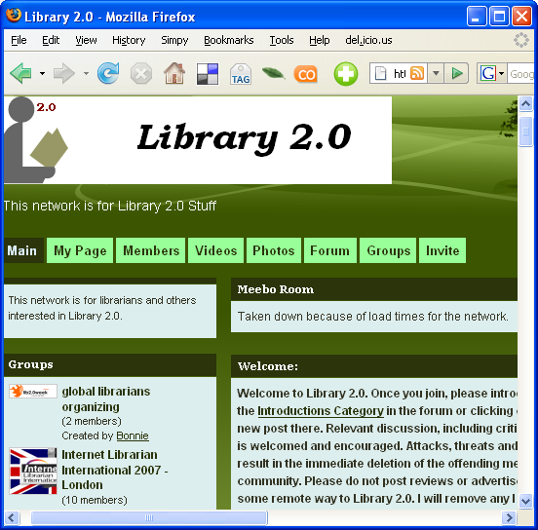
Explore the various menu options to discover what the service provides.
How does this service compare with existing networking tools you may use (such as JISCMail discussion lists).
Advantages:

Weakneses:

Exercise 10: Participating In
A Social Networking Service

A UKOLN Document

Aims Of This Exercise
In this exercise you will make investigate the potential of a social networking service to support your professional interests.

10.1 The Ning Social Network Service
Go to the Ning social network service at the address: <http://www.ning.com/>.
Explore social networtking groups which may be of interest to you, use the browse, search and cloud intefaces.
Then click on the View All option near the top of the page to look at me tag.

10.2 The Library 2.0 Social Networking Service at Ning
Go to the Library 2.0 social networking group at the address <http://library20.ning.com/>.
Explore the various menu options to discover what the service provides.
How does this service compare with existing networking tools you may use (such as JISCMail discussion lists).
Advantages:

Weakneses:

10.3 Use Of Social Networking Services
Go to the group entitled Archives and Web 2.0 (which should be listed on the left hand menu).
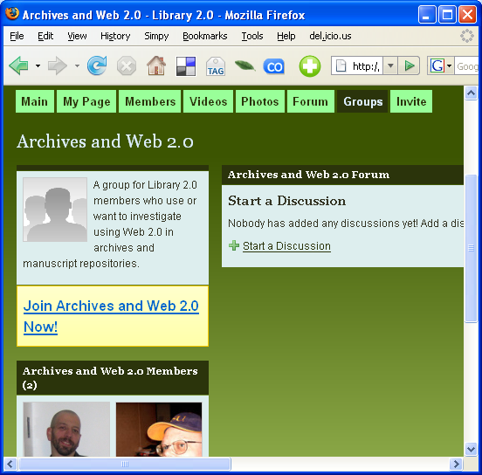
What topics could usefully be discussed in this group?

What barriers are there to this group working effectively?

What could such barriers be overcome?

Do you feel that you and your colleagues (at work and on the course) could make effective use of this group?

10.3 Use Of Social Networking Services
Go to the group entitled Archives and Web 2.0 (which should be listed on the left hand menu).
F What topics could usefully be discussed in this group?

What barriers are there to this group working effectively?

What could such barriers be overcome?

Do you feel that you and your colleagues (at work and on the course) could make effective use of this group?

