
Further Information

RDF Specifications
Resource Description Framework (RDF) Schemas
RDF Schemas working draft. Published by W3C as a Working Draft.
See <URL: http://www.w3.org/TR/WD-rdf-schema/>
Resource Description Framework (RDF) Model and Syntax
RDF model and syntax working draft. Published by W3C as a Working Draft.
See <URL: http://www.w3.org/TR/WD-rdf-syntax/>
Introduction to RDF Metadata
See <URL: http://www.w3.org/TR/NOTE-rdf-simple-intro>
Resource Description Framework (RDF)
W3C pages about RDF including the FAQ. See <URL: http://www.w3.org/RDF/>

RDF Applications
Mozilla
Netscape source code with RDF support. See <URL: http://www.mozilla.org/>
RDF in Mozilla
Information about RDF support in Netscape. See <URL: http://www.mozilla.org/
rdf/doc/>
Java Central Station
A global search engine for information about Java resources which stores information in RDF format. See <URL: http://www.ibm.research.com/java/>
RDF For XML
An RDF toolkit. See <URL: http://www.alphaworks.ibm.com/>

Papers and Presentations
An Introduction To The Resource Description Framework
See <URL: http://www.dlib.org/dlib/may98/miller/05miller.html> or
<URL: http://mirrored.ukoln.ac.uk/lis-journals/dlib/dlib/dlib/
may98/miller/05miller.html> (UK Mirror)
RDF: The Resource Description Framework
Talk given by Ralph Swick at the WWW 7 Conference in Brisbane in April 1998.
See <URL: http://www.w3.org/Talks/1998/0418-WWW7-RDF/>
RDF
Talk given by Josef Dietl at the WWW 7 Conference in Brisbane in April 1998.
See <URL: http://www.w3.org/Talks/1998/0417-WWW7-RDF/>
Evolvability
Keynote talk given by Tim Berners-Lee at the WWW 7 Conference in Brisbane in April 1998. See <URL: http://www.w3.org/Talks/1998/0415-Evolvability/>
UKOLN

RDF Tools

About This Briefing Document
This briefing document has been produced for the eLib / UKOLN seminar on “What is RDF?” held at the Stakis Hotel, Bath on Friday 8th May 1998.
Note that RDF has not been finalised. This document reflects the position in May 1998. There is no guarantee that information in the document will continue to be valid.

What Is RDF?
RDF can be regarded as the missing architectural component of the web. RDF was developed following various work on metadata areas, such as content filtering (PICS), resource discovery (Dublin Core), digital signatures (DSig) and site mapping (MCF and Web Collections). RDF provides a generic framework which could be used to implement these, and various other applications.
RDF uses XML, the Extensible Markup Language as its transfer syntax. RDF offers more than XML could provide by itself, however. RDF incorporates a formal mathematical model which can define relationships between resources. This will enable RDF to provide “knowledge representation”.
RDF also employs XML’s notion of URI-addressable namespaces. These enable a wide variety of metadata vocabularies to be employed within one resource without encountering clashes of the names. Note that a centralised naming authority is not required, enabling new schemas to be deployed rapidly.

RDF Example
An example of representing Dublin Core metadata in RDF is given below.
<?xml:namespace href="http://www.w3c.org/RDF/" as="RDF"?>
<?xml:namespace href="http://purl.oclc.org/RDF/DC/" as="DC"?>
<RDF:RDF>
<RDF:Description RDF:HREF="http://homes.ukoln.ac.uk/~lisap/">
<DC:Title>My personal home page</DC:Title>
<DC:Creator>Andy Powell</DC:Creator>
<DC:Identifier>http://homes.ukoln.ac.uk/~lisap/</DC:Identifier>
</RDF:Description>
</RDF:RDF>
Note that in this example there are two namespaces. The Dublin Core namespace is defined at http://purl.oclc.org/RDF/DC/ and referred to as “DC” and the RDF namespace at http://www.w3.org/RDF/ and referred to as “RDF”.

RDF Tools
Although RDF is relatively new and the specifications are still at a draft stage, there are already a number of tools available which can process RDF applications, make use of RDF as the underlying data format or create RDF.

Browser Support For RDF
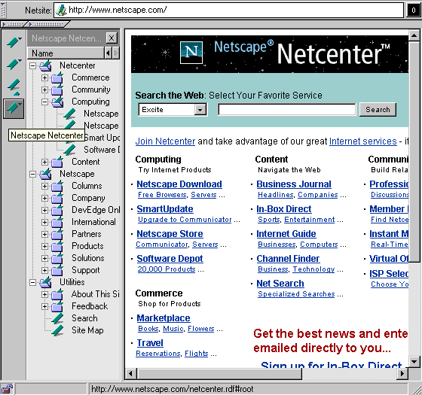
Figure 1 Mozilla Support For A Site Map

Mozilla
Recently Netscape released the source code of their browser. A version of Mozilla is available which supports RDF. Applications include management of site maps, bookrmarks and history lists.
The HotWired and Netscape websites both contain links to the site mapping RDF file from the home page. Examine the HTML source of these pages to find the URL of the RDF file.

Applications Using RDF

Java Central Station
Java Central Station is a searching service which provides access to Java resources from around the world. Java Central Station uses RDF for describing the data collected by the robot.
Java Central Station has been developed by IBM. See <URL: http://www.ibm.com/
java/>.

RDF For XML
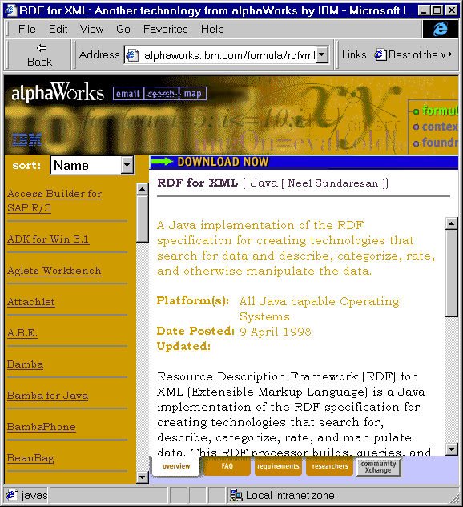Figure 2 IBM’s RDF For XML
RDF for XML is a Java implementation of the RDF specification for creating technologies that search for data and describe, categorize, rate, and otherwise manipulate the data.
RDF for XML has been developed by IBM.
See <URL: http://www.alphaworks.
ibm.com/formula/rdfxml>.
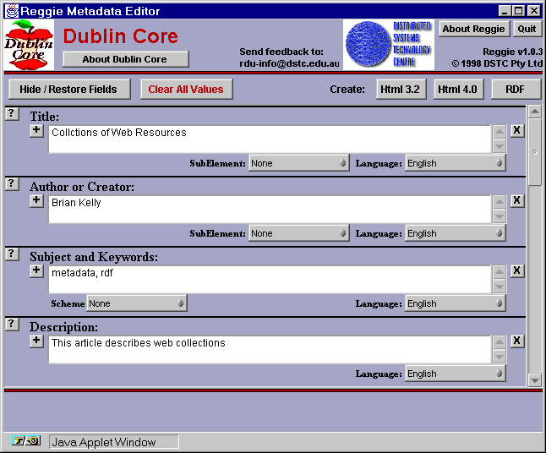Figure 3 Reggie

Creating RDF

Reggie
Reggie is a metadata editor which has been designed to enable a variety of metadata formats to be created using one editor. Reggie is a Java application which been developed by DSTC (Distributed Systems Technology Centre). The interface is illustrated in Figure 3.
See <URL: http://metadata.net/dstc/>.

DC-Dot
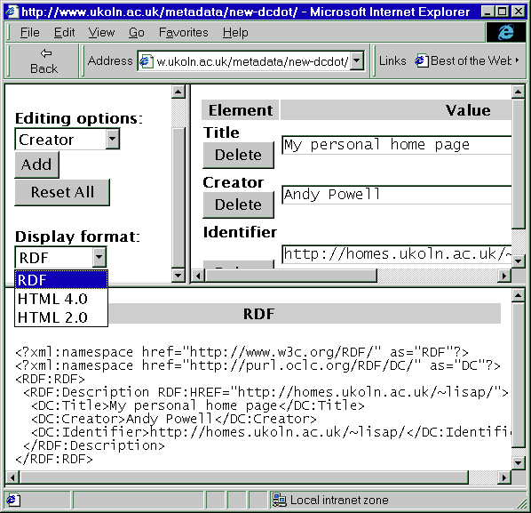Figure 4 DC-Dot
DC-Dot is an editing tool for Dublin Core which has been developed by UKOLN. It currently being updated so that output can be created in RDF format, as well as in HTML 2.0 and HTML 4.0 formats.
Figure 4 shows the interface for DC-Dot.

PrismEd
At the WWW 7 conference held in Brisbane in April 1998 Andrew Waugh gave a paper on “Specifying Metadata Standards for Metadata Tool Configuration”. This paper described the PrismEd generic metadata editor, which is available at <URL: http://www.mel.dit.csiro.au:8080/~ajw/schema/editor.html>.

Issues
Anyone considering making use of RDF will need to address a number of issues including:
- Will RDF take off?
- Is it timely to make use of RDF, as the RDF specifications have not been finalised?
- When will browser support for RDF be widely deployed? Is browser support needed or will backend RDF applications be rdeveloped?
- The cost of creating metadata, as described in Andrew Waugh’s paper (see above).
- If RDF is used how will the metadata be managed?
- What type of RDF tools are needed?
- Should we develop home-grown RDF tools or make use of commerical tools?
- Should priority be given to desktop or backend applications?
- Who will develop RDF schemas?

