
Exercise 6 Use Of Social Bookmarking And Social Sharing Services

A UKOLN Document

Aims Of This Exercise
In this exercise you will make use of the del.icio.us social bookmarking tool.

6.1 del.icio.us
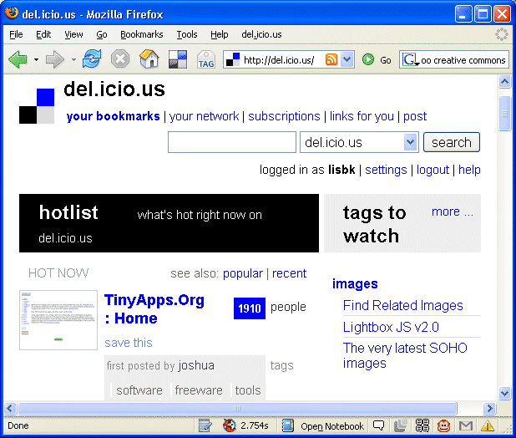
Go to the del.icio.us social bookmarking service at the address: <http://del.icio.us/>.
Familiarise yourself with the tool.

6.2 Using del.icio.us to Find Museum Resources
Search for resopurces which have been labelled with the tag “museum”..
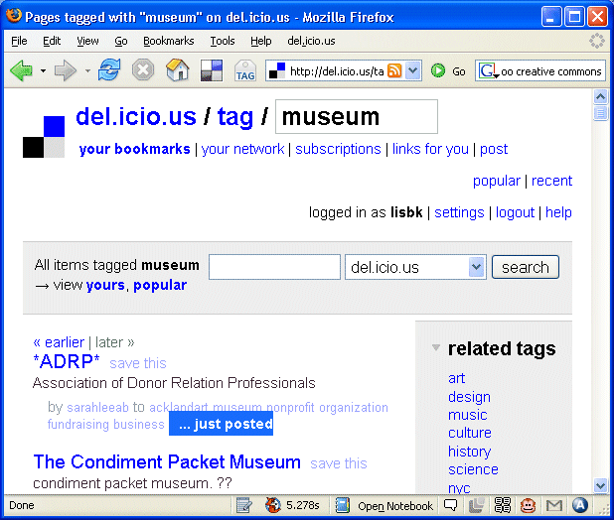
Look at some of the resources which have been bookmarked.
What features do you notice which are not available in conventional bookmarking tools, scuh aas that provided in Web browsers?

Exercise 6 Use Of Social Bookmarking And Social Sharing Services

A UKOLN Document

Aims Of This Exercise
In this exercise you will make use of the del.icio.us social bookmarking tool.

6.1 del.icio.us
Go to the del.icio.us social bookmarking service at the address: <http://del.icio.us/>.
Familiarise yourself with the tool.

6.2 Using del.icio.us to Find Museum Resources
Search for resopurces which have been labelled with the tag “museum”..
Look at some of the resources which have been bookmarked.
What features do you notice which are not available in conventional bookmarking tools, scuh aas that provided in Web browsers?

6.3 Flickr
Go to the Flickr photo sharing service at <http://www.flickr.com/>.
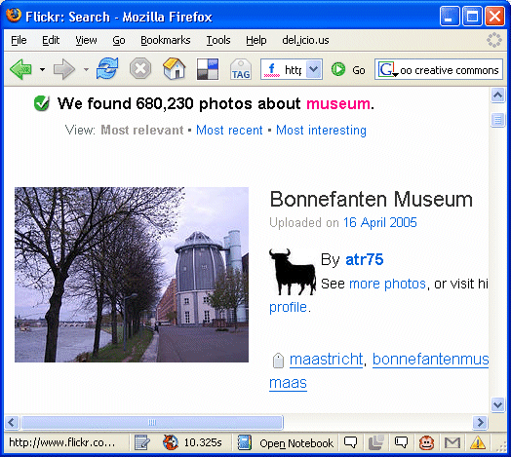
Find photographs which have been tagged with the term “museum”.
How many photographs are available?

Continue searching for photographs which may be of interest to you.

6.4 Use Of Social Networking Services
What, if any, potential do social bookmarking and photographic sharing services services have for your organisation?

What are the limuitations of such service?

6.3 Flickr
Go to the Flickr photo sharing service at <http://www.flickr.com/>.
Find photographs which have been tagged with the term “museum”.
How many photographs are available?

Continue searching for photographs which may be of interest to you.

6.4 Use Of Social Networking Services
What, if any, potential do social bookmarking and photographic sharing services services have for your organisation?

What are the limuitations of such service?

