
Exercise 5: Embedding RSS Feeds Into Web Pages

A UKOLN Document

Aims Of This Exercise
In the following exercises you will use an OPML viewer to view RSS feeds which are embedded in a Web site.

5.1 An RSS Aggregator For The Seminar
Go to the address: <http://www.ukoln.ac.uk/
web-focus/events/seminars/
mla-ne-2006-10/rss/#opml-viewer>.
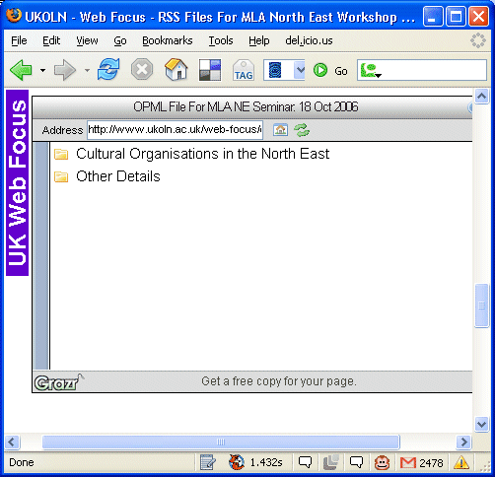
The page has been set up for use at the “From Bits To Bytes” seminar.
Read the information which is available.

5.2 Embedding The Content On Your Own Web Site
You can embedded this content on your own Web site by simply copying a few lines of HTML and JavaScript code.
What are the advantages and disadvantages of doing this?

Exercise 5: Embedding RSS Feeds
Into Web Pages

A UKOLN Document

Aims Of This Exercise
In the following exercises you will use an OPML viewer to view RSS feeds which are embedded in a Web site.

5.1 An RSS Aggregator For The Seminar
Go to the address: <http://www.ukoln.ac.uk/
web-focus/events/seminars/
mla-ne-2006-10/rss/#opml-viewer>.
The page has been set up for use at the “From Bits To Bytes” seminar.
Read the information which is available.

5.2 Embedding The Content On Your Own Web Site
You can embedded this content on your own Web site by simply copying a few lines of HTML and JavaScript code.
What are the advantages and disadvantages of doing this?

Comments
OPML is a format which can be used to group together related RSS feeds.
OPML is used, for example, oon the BBC Web sites. It enables users to import groups of releated RSS feeds (e.g. all RSS feeds about Sport) into an RSS aggregator.
As well as allowing users to add such feeds to their own RSS aggregator, this approach can also be used to allow organisations to embed content from third party Web sites into the organisation’s Web site.

Discussion
Use of simple formats such as RSS and OPML to enable your content to be more widely accessed would appear to have clear benefits.
However some organisations may be concerned that this can mean a loss of control over one’s own data.
What concerns might your organisation have over providing more open access to your resources?

Comments
OPML is a format which can be used to group together related RSS feeds.
OPML is used, for example, oon the BBC Web sites. It enables users to import groups of releated RSS feeds (e.g. all RSS feeds about Sport) into an RSS aggregator.
As well as allowing users to add such feeds to their own RSS aggregator, this approach can also be used to allow organisations to embed content from third party Web sites into the organisation’s Web site.

Discussion
Use of simple formats such as RSS and OPML to enable your content to be more widely accessed would appear to have clear benefits.
However some organisations may be concerned that this can mean a loss of control over one’s own data.
What concerns might your organisation have over providing more open access to your resources?

