
Authoring Issues

Task 6 Viewing CNN.com
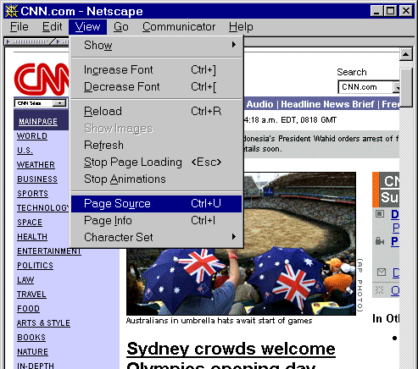
Figure 6 Viewing the Source of CNN
In your Web browser enter the address <http://www.cnn.com/>.
View the HTML source. There are a number of ways of viewing the HTML source, depending on the browser you are using. For example using the Edit menu and select the View Source option, click with the right mouse button on the page and then choose the View Source option, etc.

Discussion
How comprehensible is the HTML source? How big is the file? What are the implications of creating documents like this?

Size Issues

Task 7 The Size of University Web Sites
In your Web browser enter the address <http://www.ariadne.ac.uk/issue24/web-watch/>. How many Web servers do the Universities of Bath, Bath Spa, Bristol and UWE have (currently and previously)? How does this compare with the University of Cambridge?
In your Web browser enter the address <http://www.ariadne.ac.uk/issue23/web-watch/>. How many links are there to resources on Web sites at the Universities of Bath, Bath Spa, Bristol and UWE? How does this compare with the University of Cambridge?
What are the implications of running large-scale Web service?

Other Problems

Task 8 Other Problems
Make a list of other problems which users of the World Wide Web may encounter.
UKOLN

Future Web Trends:
Hands-on Exercises

Introduction
This handout has been prepared for the guest lecture on “Future Web Trends” given on the “Advanced Information Systems” module (Unit 7C) of the MSc in Library and Information Management at the University of Bristol on 19th September 2000.
The handout is also available from <http://www.ukoln.ac.uk/web-focus/events/
seminars/bristol-msc-sep2000/>. This page also contains links to all the Web sites used in this exercise.
The handout contains a series of exercises which aim to identify problem areas encountered by people when using the Web.

Searching

Task 1 Using A Search Engine
In your Web browser enter the address <http://www.altavista.com/>.
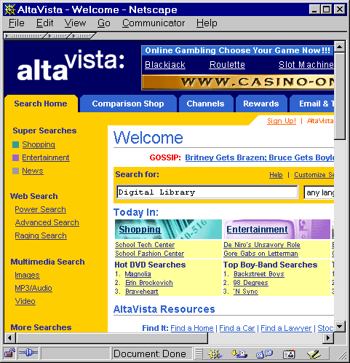
Figure 1 Using AltaVista
Then enter a search term such as Digital Library.
How many hits do you get?

Discussion
What are the limitations of use of this type of search engine?

Would you expect other search engines, such as Infoseek, to give signficantly different results?

Try the same search using the Google search engine at <http://www.google.com/>. How do the results compare?

Technologies and File Formats

Task 2 Exploring Web Technologies
In your Web browser enter the address <http://www.bathspa.ac.uk/>.
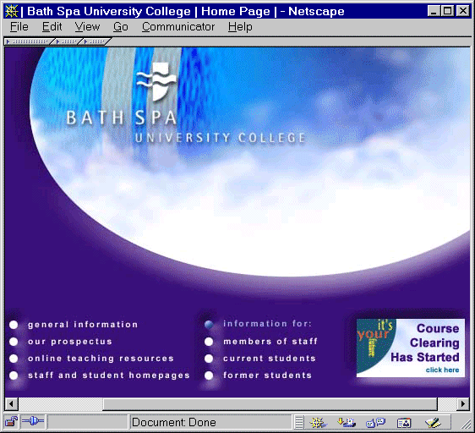
Figure 2 Bath Spa University College Home Page

Discussion
How does the interface on your computer compare with that shown?

What technologies do you think this page uses? View the HTML source for clues.

What are the limitations of using these types of technologies?

Task 3 PDF Files
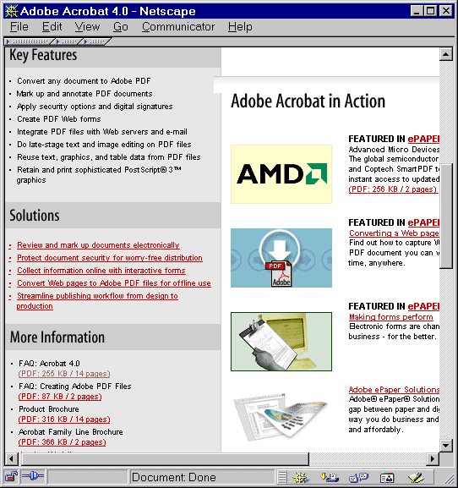
Figure 3 Adobe PDF File Format
In your Web browser enter the address <http://www.adobe.com/
products/acrobat/main.html>.
Select one of the Adobe PDF documents.

Discussion
What happens when you select an Adobe PDF document?
What are the advantages of using a format such as Adobe PDF?

What are the limitations of using Adobe PDF?

Are you aware of any technologies which will address PDF deficiences?

E-Commerce

Task 4 Using An Online Book Store
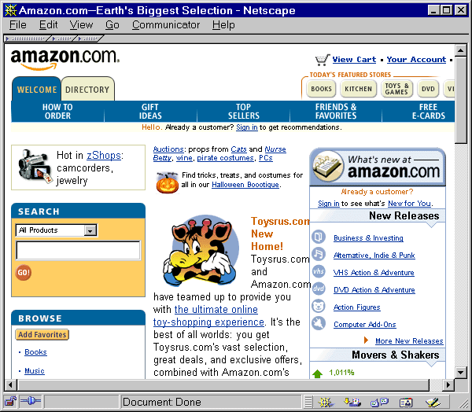
Figure 4 Amazon Online
In your Web browser enter the address <http://www.amazon.com/>. Explore the Web site.
Find a book and then select the option to order it.

Discussion
Have you ever ordered goods or services online? If not, why not?
What are the implications of using e-commerce systems such as Amazon?

The Mobile Web

Task 5 Using A WAP Emulator
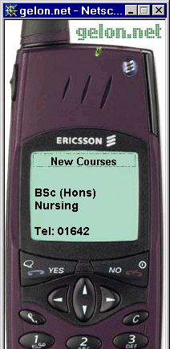
Figure 5 A WAP Emulator
In your Web browser enter the address <http://www.gelon.net/>.
Enter the address http://wap.tees.ac.uk/ into the Wapalizer box.
Click on the Yes button on the mobile phone emulator. Then enter the URL http://wap.tees.ac.uk/news.wml or http://wap.tees.ac.uk/newcourses.wml.
Use the scroll down buttons to view the information.

Discussion
Do you think WAP will take off?
What difficulties do you think there may be in providing a WAP service?

