
ECommerce

Task 6 Using An Online Book Store
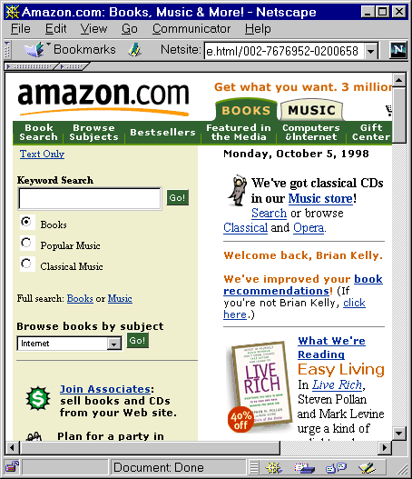
Figure 6 Amazon Online
In your Web browser enter the address <URL: http://www.amazon.com/>. Explore the web site.
Find a book and the select the option to order it.

Discussion
Have you ever ordered goods or services online? If not, why not?

What are the implications of using ecommerce systems, such as Amazon?

Authoring

Task 7 Viewing the CNN Home Page
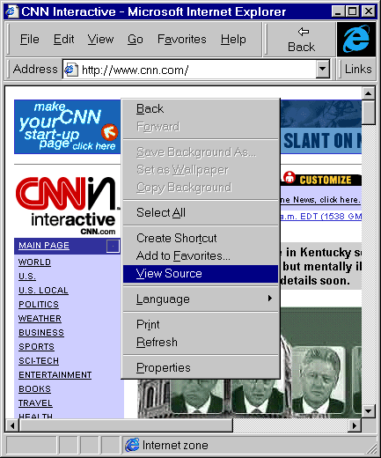
Figure 7 Viewing the Source of CNN
In your Web browser enter the address <URL: http://www.cnn.com/>.
Then view the source of the document in your browser. Note that there are a number of ways of viewing the HTML source, depending on the browser you are using. For example using the Edit menu and select the View Source option, click with the right mouse button on the page and then choose the the View Source option, etc.
Examine the HTML source.

Discussion
How large is the document? What are the implications of creating a document like this?

Other Problems

Task 8 Other Problems
Make a list of other problems which users of the World Wide Web may encounter.
UKOLN

Fixing The Web:
Hands-on Exercises

Introduction
This handout has been prepeared for the guest lecture on “Fixing The Web” given on the “Advanced Information Systems: Towards the Digital Library” module of the MSc in Library and Information Management at the University of Bristol on 13th October 1998.
The handout was written by Brian Kelly, UK Web Focus, UKOLN, University of Bath.
The handout contains a series of exercises which aim to identify problem areas encountered by people when using the Web.

Searching

Task 1 Using A Search Engine
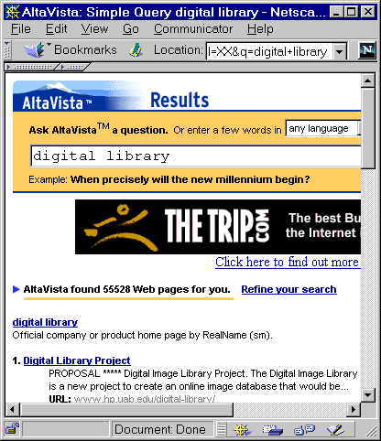
Figure 1 Using AltaVista
In your Web browser enter the address <URL: http://www.altavista.digital.
com/>.
Then enter a search term such as Digital Library.
How many hits do you get?

Discussion
What are the limitations of use of this type of search engine?

Would you expect other search engines, such as Infoseek, to give signficantly different results?

Technologies

Task 2 Exploring Web Technologies
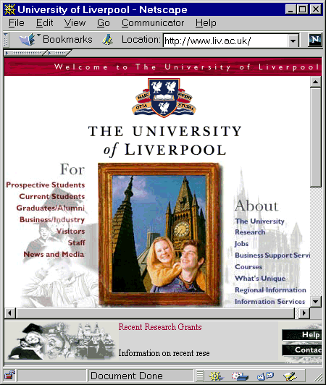
Figure 2 Liverpool University Home Page
In your Web browser enter the address <URL: http://www.liv.ac.uk/>.

Discussion
How does the interface on your computer compare with that shown in Figure 2?

What technologies do you think this page uses?

What are the limitations of using these types of technologies?

File Formats

Task 3 PDF Files
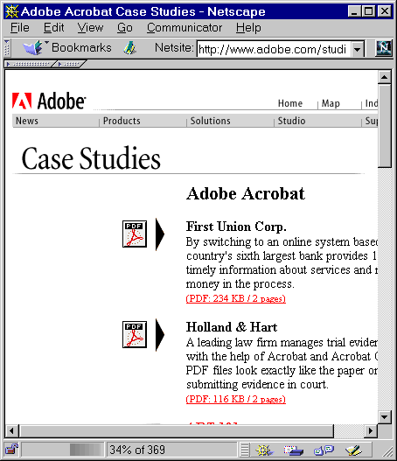
Figure 3 Adobe Acrobat Case Studies
In your Web browser enter the address <URL: http://www.adobe.com/studio/
casestudies/acrobat.html>.
Select one of the Adobe Acrobat documents.

Discussion
What happens when you select an Adobe Acrobat document?
What are the limitations of using Adobe Acrobat?

What are the advantages of using a format such as Adobe Acrobat?

Task 4 Shockwave Files
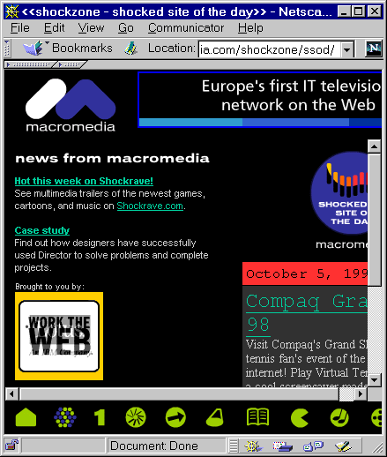
Figure 4 Macromedia Shockwave Site
In your Web browser enter the address <URL: http://www.macromedia.com/>.
Follow the link to Shockwave and then Shocked Site of the Day. Follow a link to a “shocked” site.

Discussion
What happens when you select a page containing a ShockWave document?
What are the limitations of using formats such as ShockWave?

What are the advantages of using formats such as ShockWave?

Accessibility

Task 5 Viewing Without Graphics
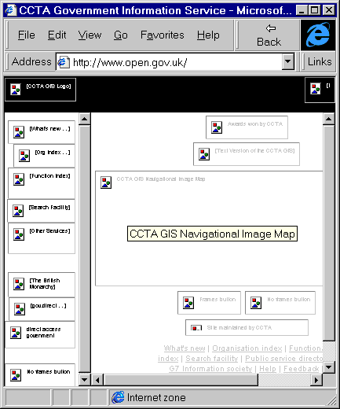
Figure 5 The Open Goverment Web Site
In your Web browser switch off the display of graphical images. This is often done by choosing the Edit menu and selecting the Preferences option and then choosing the appropriate option.
Then enter the address <URL: http://www.open.gov.uk/>.

Discussion
What are the implications of surfing without a graphical display?

Who would use a web browser in this way?

