
Useful URLs
HTML Activity Page
See <URL:http://www.w3.org/MarkUp/Activity.html>
XML Activity Page
See <URL:http://www.w3.org/XML/Activity.html>
HTTP/NG Activity Page
See <URL:http://www.w3.org/Protocols/HTTP-NG/Activity.html>
Metadata Activity Page
See <URL:http://www.w3.org/Metadata/Activity.html>
P3P
See <URL:http://www.w3.org/P3P/>
Intellectual Property Rights Overview
See <URL:http://www.w3.org/IPR/>
W3C Technical Reports & Publications
See <URL:http://www.w3.org/TR/>

For Your Notes

UKOLN

Fixing The Web - Solutions:
Hands-on Exercises

Introduction
This handout has been prepared for the guest lecture on “Fixing The Web” given on the “Advanced Information Systems: Towards the Digital Library” module of the MSc in Library and Information Management at the University of Bristol on 13th October 1998.
The handout was written by Brian Kelly, UK Web Focus, UKOLN, University of Bath.
The handout contains a series of exercises which aim to provide access to solutions top some of the problem areas encountered by people when using the Web.

Searching

Task 1 Searching
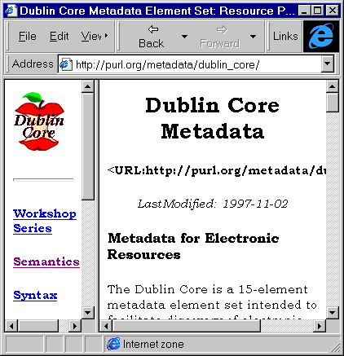
Figure 1 Dublin Core
In your Web browser enter the address <URL: http://purl.org/metadata/
dublin_core/>.
Read about the Dublin Core work.

Authentication

Task 2 Athens
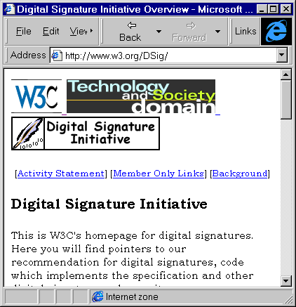
Figure 2 W3C DSig Home Page
In your Web browser enter the address <URL: http://www.athens.ac.uk/>.
Read about the Athens work.

Task 3 Verisign
In your Web browser enter the address <URL: http://www.verisign.com/>.
Read about Verisign’s digital certificates.

Task 4 Digital Signatures
In your Web browser enter the address <URL: http://www.w3.org/DSig/>.
Read about W3C’s Digital Signature Initiative.

Exercise
How do Athens, Verisign’s software and DSig compare?

File Formats

Task 5 HTML
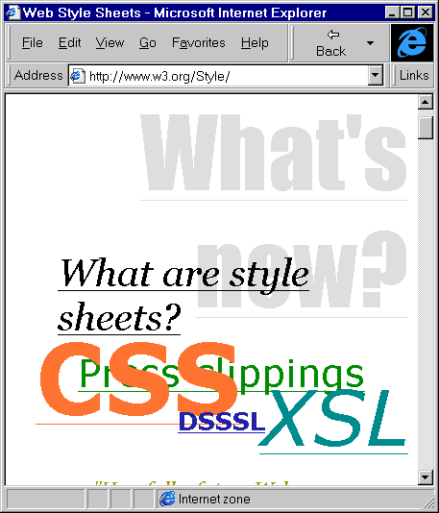
Figure 3 CSS Home Page
In your Web browser enter the address <URL: http://www.w3.org/MarkUp/>.
Read about HTML.

Task 6 CSS
In your Web browser enter the address <URL: http://www.w3.org/Style/>.
Read about Cascading Style Sheets.

Task 7 XML
In your Web browser enter the address <URL: http://www.w3.org/Style/>.
Read about XML.

Exercise
How do you think HTML, CSS and XML will develop in the future?

Technology and Society

Task 7 P3P
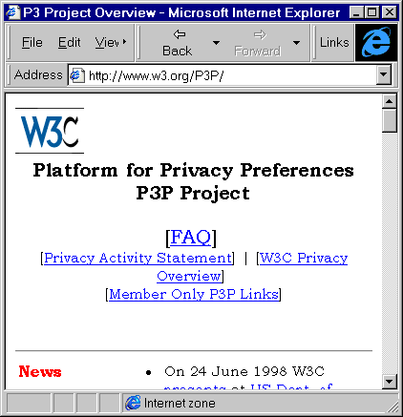
Figure 5 W3C’s P3P Page
In your Web browser enter the address <URL: http://www.w3.org/P3P/>.
Read about W3C’s P3P (Platform for Privacy Preferences) project.

Task 8 PICS
In your Web browser enter the address <URL: http://www.w3.org/PICS/>.
Read about W3C’s PICS (Platform for Internet Content Selection) activity.

Exercise
Are privacy and content filtering issues primarily technical problems or political / ethical problems?

Architecture

Task 9 HTTP
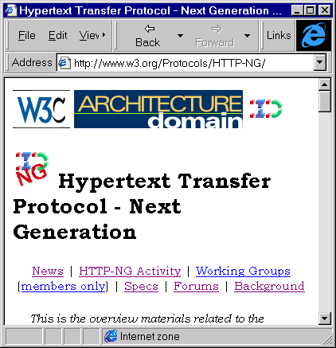
Figure 6 W3C’s HTTP/NG Page
In your Web browser enter the address <URL: http://www.w3.org/Protocols/>.
Read about W3C’s HTTP work.

Task 10 HTTP/NG
In your Web browser enter the address <URL: http://www.w3.org/Protocols/
HTTP-NG/>.
Read about W3C’s HTTP/NG work.

Exercise
What barriers to the deployment of HTTP/NG do you envisage?

