WWW 6 Trip Report:

Report on the Sixth International WWW Conference held in Santa Clara on April 7-11, 1997
Brian Kelly, UKOLN
Contents
WWW 6 Trip Report: 1
About This Document 2
About WWW 6 2
Web Accessibility Day 3
Web Site Mapping Workshop 4
Presentations 4
Demonstrations 5
Discussion 5
XML Tutorial 5
Background 6
XML 7
XML Linking 7
“Beyond HTML” Technical Session 8
Bookmarking Service for Organizing and Sharing URLs 8
Extending HTML in a Principled Way with Displets 8
Index-Based Hyperlinks 9
“Multidimensional Web Search” Technical Session 10
Towards a Multimedia World-Wide Web Information Retrieval Engine 10
Dynamic Reference Sifting: A Case Study in the Homepage Domain 10
ParaSite: Mining Structural Information on the Web 11
“Site Mapping and Syntactic Analysis” Technical Session 11
Syntactic Clustering of the Web 11
“Automatic Interface Generation” Technical Session 12
Transforming Command-Line Driven Systems to Web Applications 12
Responsive Interaction for a Large Web Application: The Meteor Shower Architecture in the WebWriter II Editor 12
The Message Is The Medium 13
Seamless Integration of Interactive Forms Into The Web 13
“Strategies For Resource Location” Technical Session 14
WebQuery: Searching and Visualizing the Web through Connectivity 14
WebCutter: A System for Dynamic and Tailorable Site Mapping 14
“Leading the Evolution of HTML” W3C Session 14
Cougar 14
“Microsoft Internet Explorer 4.0” Industrial Presentation 17
CSS Positioning 18
Good Web Design Panel Session 19
Conclusions 21
Address for Correspondence 21

About This Document
This document gives a report on the WWW 6 conference. Views given in this document are the authors. Every effort has been made to ensure the accuracy of email addresses, URLs and other information within this document. If you find any errors or inaccuracies in this document please contact the author.

About WWW 6
The WWW 6 conference was held at the Santa Clara Convention Centre between 7th –11th April 1997. Workshops and tutorial sessions were held on Monday 7th April, 97. Technical papers were presented from 8-10th April. The Developer's Day and History Day were held on 11th April. In addition various other BOFs (Birds of a Feather) and meetings were held during the conference (including Web Accessibility Initiative day).
The Conference details, which included online booking, were available on Web at the URL http://www6conf.org/
An Online conference known as ICE (Interactive Conference Environment) was available for delegates before, during and after conference (with restricted access for non-delegates) at the URL http://ice.www6conf.org/ as shown in Figure 1.
The Conference proceedings are available online at the URL http://proceedings.www6conf.org/ as shown in Figure 2.
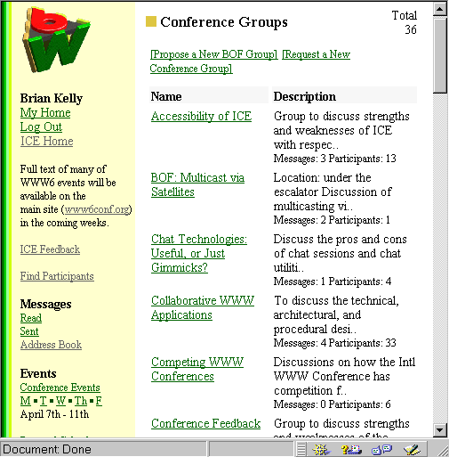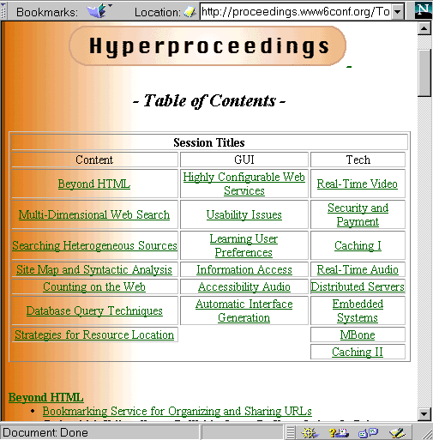
Figure 1 ICE Interface Figure 2 Conference Proceedings
ICE was a new facility for WWW conferences which provided a home page and messaging and conferencing facilities for delegates and online registration for conference events. Although there were a number of usability problems, and the conferences did not seem to be widely used before the conference (with the interesting exception of the social conferences such as the “Trips to the Beach” conference) ICE was a interesting new development for WWW conferences, and worth developing further for future conferences.
Delegates from forty countries attended WWW 6, 50% academic and 50% commercial.
Overall attendance not known at start of conference I understand that the attendance was about 1,800 - this was down on expectations, perhaps due to the JavaOne (8,000) and Microsoft Hardware Developers conference (15,000) held in San Francisco the previous week.

Web Accessibility Day
A Web Accessibility Day was held on Sunday, 6th April. About 80 participants attended the meeting, at which an announcement was made regarding the Web Accessibility Initiative (WAI).
A number of speakers described the importance of make the web accessible:
- The web can provide access to information previously inaccessible or accessible with great difficulties to people with disabilities.
- There are legal reasons for making the web accessible – in the US, for example, there is legislation governing equality of access to resources by people with disabilities.
- There are job-related reasons for making the web accessible – for example the growing importance of corporate intranets means that people with disabilities may be prevented from doing their job if the intranet is not designed to be accessible.
- The are financial reasons for making the web accessible- in the US, for example, there is an aging population which has a higher proportion if disposable income.
- As we grow old we will suffer from disabilities – the term Temporarily Abled Bodied has been coined to express this sentiment.
- Making the web accessible with have spin-offs in other areas. For example, when we drive a car we temporarily have mobility and visual limitations (we can’t look at a screen or use a mouse). Developments with aural browsers will have potential in this area.
Jim Miller (W3C) described the Web Accessibility Initiative (WAI). The initiative had been approved by W3C members. The initiative will cover the development of web protocols, guidelines for software developers, information providers and end users and training. An International Program Office will be established to coordinate the initiative.
Peter Bosher (RNIB, UK) spoke about the tremendous benefits of IT for the visually impaired, but also the pitfalls that blind people face. He mentioned good examples of accessible Web pages, such as the Times job vacancies page is usable with Lynx and speech browsers. On the other had web sites such as the London Broadcasting Company pages are poor since they mainly provide a graphical interface which cannot be interpreted with speech browsers. The LBC pages are also require specific HTML features, such as Frames. A user requesting a page with a browser which does not support frames is displayed a message advising them to upgrade to the latest version of Netscape (see http://www.lbc.co.uk/).
Scott Isaacs (Microsoft) spoke of developments with HTML and related protocols within W3C Working Groups. For example the new Forms draft will have a number of new accessibility features. The Aural Cascading Style Sheet spec will provide support for speaking browsers. The Document Object Model (DOM) will enable software to have control over HTML elements.
Further information on the Web Accessibility Initiative, and on general accessibility resources is available at:
http://www.w3.org/pub/WWW/Disabilities/
http://weber.u.washington.edu/~doit/Other/design.html
http://www.igs.net/~starling/acces.htm
http://trace.wisc.edu/
http://access.adobe.com/
http://cs.cornell.edu/home/raman/
http://www.sun.com/tech/access/

Web Site Mapping Workshop
The half day workshop on Web Site Mapping took place on Monday 6th April. The workshop was led by Yoelle Maarek. About 35 people attended.
The aim of the workshop was to define the protocol requirements for site mapping. The protocols would be used to software developers involved in writing software to create dynamic site maps of both local and remote web sites for use by web masters and end users.

Presentations
The following presentations were given:
Chris Evans, Microsoft
Chris spoke about the draft XML WebCollections specification (see http://www.w3.org/pub/WWW/TR/NOTE-XMLsubmit.html). Web Collections can be used to defined sets of related Web resources which can be used for a wide range of applications such as Web Maps, HTML Email Threading, PIM functions, scheduling, content labeling, and distributed authoring. XML is proposed as the language to define the collections. A simple example is shown below:
<HTML>
<HEAD>
<TITLE>Web Collections Information</TITLE>
<LINK REL=PageInfo HREF="#WebPageInfo">
<XML>
<WEBPAGE ID="WebPageInfo" Profile="http://www.w3.org/WebPage.webc" about="http://www.microsoft.com/WebCollections/">
<Author value="Alex Hopmann">
<LastMod value=="Sun, 09 Feb 1997 10:21:18 GMT">
<Title value="Web Collections Info">
<MaxDLSize value=50000>
<Schedule value=DAILY>
</WEBPAGE>
</XML>
</HEAD>
<BODY>
<H1>HTML Content goes here</H1>
</BODY></HTML>

Dave Beckett, University of Kent
Dave spoke about the Dublin Core metadata attributes. Dublin Core (DC) is a core set of metadata attributes used to describe Internet resources.
R.V. Guha, Apple
R V Guha spoke about Apple’s Meta Content Framework (MCF) and the HotSauce application. Computer users have to deal with several incompatible structures, which have traditionally been developed based on user interface requirements (e.g. email folders, directory structures, web resources). MCF is based on a relational model for describing structures. For further information see the URL http://hotsauce.apple.com/
David Singer, IBM
David, who is IBM’s W3C rep and a member of the W3C HTML working group, reported on W3C activities. Developments involving metadata in the past were forced to use the <META> tag. However now XML is a better mechanism for defining metadata. The Web Site Mapping workshop has related interests to the WebDAV (Web Distributed and Authoring) IETF group and the PICS W3C Working Group. If the Web Site Mapping community wishes to submit a proposal to W3C then it should probably liaise with the PICS Manifest group.

Demonstrations
Following the presentations, the group moved to a larger lecture theatre for a series of presentations:
WebCutter
Yoelle Maarek, IBM gave a demonstration of WebCutter, a tool for providing a personalised map of a site (compared with tools such as Netacarta’s Webmapper which provides a fixed site map). WebCutter uses a dedicated server (currently available for the AIX and NT 4.0 platforms) which can be used to create a site map of any web site. WebCutter’s visualisation is carried out in Java.
For further information see:
http://www.ibm.net.il/ibm_il/ibmhrl/webcutter/
http://www.alphaworks.ibm.com/
HotSauce
R.V. Guha, Apple demonstrated the HotSauce application. As well as providing a fly-through view of a web site, Guha demonstrated how the software can be used to provided multiple views of a website.
For further information see:
http://hotsauce.apple.com/
http://mcf.research.apple.com/slides/
WebMapper
Chris Wilson, Microsoft mentioned WebMapper, now owned by Microsoft following their takeover of Netcarta, which originally developed the software.

Discussion
The workshop concluded with a discussion of the next stages need to define a web sire mapping protocol. It was agreed on the need to separate the protocol into three distinct components:
- A Metadata Model
- A Metadata Manipulation Language
- A File Format Syntax / File Interchange Standard.
It seemed to be agreed that XML was probably the best solution for the File Interchange Standard.
There was more uncertainty as to the metadata manipulation language. There is an argument that we do not require a dedicated metadata manipulation language – instead we need a general document manipulation language. There was also some discussion as to whether we need a new language or if an existing language (such as the Hytime Query Language or SQL) could be used. It was suggested that a way of resolving this would be to define a set of common site related operations and see how this mapped in to existing languages.

XML Tutorial
A tutorial session on “Enriching Document Structure: HTML, CSS and XML” was held on Monday 7th April from 2-5pm. The tutorial speakers were Tim Bray and Lauren Wood. An audience of over 100 attended the workshop, indicating the interest in document structure.
The description of the tutorial “HTML is an effective tool for presenting information, but not for structuring it. CSS allows separating structure and presentation issues, but does not address enriching the structure. XML is the latest technology for enriching HTML structure.” summarised the problem

Background
There is a need to extend HTML because:
- The need to support new Web developments such as Web TV, Digicash, etc.
- HTML is the wrong size – it’s too big (about 120 tags) or too small (no application specific tags such as <PARTUM> <LONGITUDE> etc.)
- Mobile code can’t process Web data (although the Document Object Model will help).
The speakers described the history of markup languages, from presentational markup, procedural markup (such as PostScript) and descriptive markup (in which the structure rather than the appearance of a document is defined).
In HTML it would be desirable to be able to do the following:
- Use meaningful tags (e.g. <HEADING> rather than <H1> or <ABATZ> rather than <P> in German documents)
- Define a grammar for the structure (e.g. a <CHAPTER> must have a <TITLE>, a <LETTER> must have one and only one sender but can have multiple <RECIPIENTS>
- Provide control over formatting (e.g. sub-section numbering)
- Provide reusability (e.g. templates will fixed content that can’t be overridden by the author)
- A mechanism for sharing grammar
- Richer linking mechanisms
- Richer processing (e.g. search only on <PART-NUM>, sort by <ADDRESS>)
There are a number of mechanisms for extending HTML:
- Extending HTML by Fiat: introducing proprietary tags such as <BLINK> or <FONT FACE>. This can only be done by powerful browser vendors such as Netscape or Microsoft. There is an argument that there are benefits to this approach. Market forces will ensure that mistakes (such as <BLINK>) will die. This approach has been used on other areas of computing (e.g. SQL developments); in the area of computer networking OSI standardisation has a bad name. On the other hand this approach is bad for user, authors, 3rd party vendors of authoring products, and, more importantly, this approach is bad the data.
- Extending HTML: the Offical Way: Proposals are submitted to W3C. However with this approach there is no guarantee that browser vendors will implement the proposal.
- Extending HTML Using CSS: This approach uses a W3C Recommendation which is implemented by Microsoft and Netscape browsers. CSS is desirable as it separates content and format.
- Extending HTML Using DSSSL: DSSSL is an ISO standard which contains a general purpose language. Freeware implementations are available (e.g. JADE and YADE [written in Java]). However DSSSL is very complex.
- Mimicking New Tags: Develop applications which make use of the CLASS attribute. However with this approach you can’t (a) change the grammar, (b) add new attributes, (c) define general purpose functions such as intelligent copying, such the intelligence must be implemented in a separate program (such as SoftQuad’s HiP product which makes use of this approach).

XML
XML (Extensible markup language) has been developed by the SGML community. In XML the difficult bits of SGML have been discarded and it has been optimised for use on the Web.
The XML design goals are:
- XML shall be straightforwardly usable over the Internet.
- XML shall support a wide variety of applications.
- XML shall be compatible with SGML.
- It shall be easy to write programs which process XML documents.
- The number of optional features in XML is to be kept to the absolute minimum, ideally zero.
- XML documents should be human-legible and reasonably clear.
- The XML design should be prepared quickly.
- The design of XML shall be formal and concise.
- XML documents shall be easy to create.
- Terseness in XML markup is of minimal importance.
The XML specification is available at http://www.w3.org/pub/WWW/TR/WD-xml-lang/ The specification is only 33 pages long.
Note that XML documents must be either:
- Valid (a DTD is provided)
or
- Well-formed (all start and end tags must be provided and must be nested correctly; all attribute values must be quoted)
Note that the requirement for providing end tags (<P>A paragraph</P>) and quoting (<IMG SRC="logo.gif">) attribute values, as well as defining empty elements thus <IMG SRC=”image.gif”/> are required in order to make XML documents easy to parse.

XML Linking
The XML Linking specification provides a richer mechanism for hyperlinking than that provided in HTML.
The current specification is available at http://www.w3.org/pub/WWW/TR/WD-xml-link-970406.html. However as the spec is liable to change you are advised to access the document using the URL http://www.w3.org/pub/WWW/TR/WD-xml
A simple XML link is shown below:
<A XML-LINK="SIMPLE" HREF="http://www.w3.org/">The W3C</A>
Richer linking can be provided using the SHOW=value attribute
SHOW=REPLACE Equivalent to existing <A> tag
SHOW=EMBED Embed a resource in the existing document
SHOW=NEW Create a new window
Richer linking can also be provided using the ACTUATE=value attribute
ACTUATE=AUTO Linking operation occurs automatically
ACTUATE=USER Linking operation occurs in response to user action
For further information on XML see:
- http://www.textuality.com/xml/
- http://www.sil.org/sgml/related.html#xml

“Beyond HTML” Technical Session
The technical session on "Beyond HTML" took place at 11 am on Tuesday, 8th April. The following papers were presented:
- "Bookmarking Service for Organizing and Sharing URLs" by Richard M. Keller et al
- "Extending HTML in a Principled Way with Displets" by Fabio Vitali et al
- "Index-Based Hyperlinks" by John H. Hartman, Todd A. Proebsting, Rajesh Sundaram
- "Metadata Mediation : Representation and Protocol" by Tsuyoshi Sakata, Hiroyuki Tada, Tomohisa Ohtake

Bookmarking Service for Organizing and Sharing URLs
This paper outlined limitations in bookmarking (monolithic structure, problems in sharing URLs, ranking long lists and navigation).
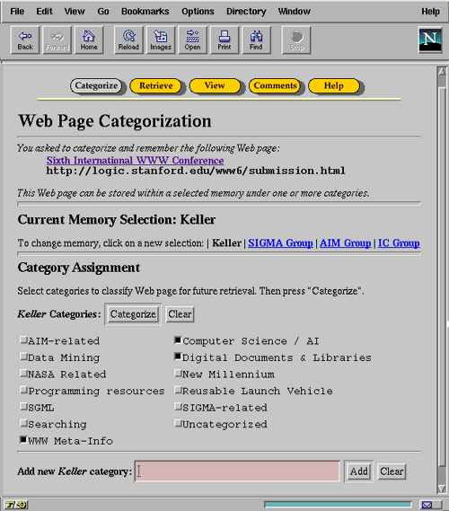
Figure 3 WebTagger
WebTagger uses a proxy service which adds buttons at top of pages. These can be use to provide a richer bookmaking service.
An illustration of WebTagger is shown in Figure 3.
The paper is available at the URL http://www6.nttlabs.com/HyperNews/get/PAPER189.html

Extending HTML in a Principled Way with Displets
This paper describes a Java solution to adding new tags to HTML. The solution works by wrapping new tags around existing HTML tags to add new functionality. For example the following tags:
<TABLE>
<TH>JAN<TR><TH>125…
</TABLE>
will result in a table being displayed. Additional functionality can be added to the table by included new tags, as shown below:
<CHART TYPE=BAR>
<TABLE>
<TH>JAN<TR><TH>125…
</TABLE>
</BAR>
The CHART tag illustrated refers to a Java program, which can be defined as shown:
<TAG NAME=CHART .. SRC=chart.class>…</TAG>
A browser which can parse the new tags can display the table as a bar chart, pie chart, etc.
This solution has been implemented by modifying the HotJava browser.
This solution can add a number of new extensions to HTML, such as graphs, multiway links, maths, etc.
For further information see:
http://proceedings.www6conf.org/HyperNews/get/PAPER155.html
http://pegasus.rutgers.edu/~chchiu/displets.html

Index-Based Hyperlinks
There are a number of problems with the current hyperlinking model of the web:
- Web pages have too many links for authors to manage
- Web pages have too few links for readers (e.g. a language student may want every word to be a link - an author would not want to maintain such a document)
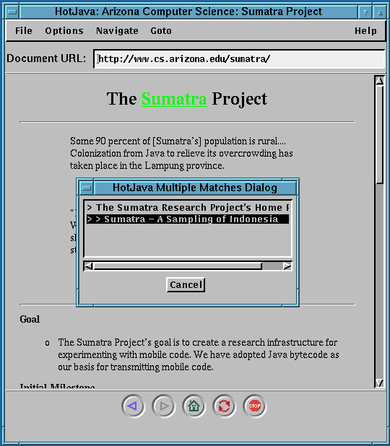
Figure 4 Index Based Hyperlinks

- Only one URL per link allows
- The URL name provides little meaning
- Link can only be created by the author
Possible solutions include:
- Automatically generation of links (can be inaccurate)
- Use Javascript (which is a heavy weight solution)
In Index-based Hyperlinks:
- Indices associate attributes with phrases
- Browsers can implement the linking policy (i.e. link on first occurrence of phrase)
- Indexes are separate from document
A prototype has been developed used a modified version of the HotJava browser.
For further information see:
http://www6.nttlabs.com/HyperNews/get/PAPER248.html
http://www.cs.arizona.edu/sumatra/

“Multidimensional Web Search” Technical Session
The technical session on "Multidimensional Web Search" took place at 4 pm on Tuesday, 8th April. Papers were presented on:
- "Towards a Multimedia World-Wide Web Information Retrieval Engine" by Sougata Mukherjea et al
- "Dynamic Reference Sifting: A Case Study in the Homepage Domain" by Jonathan Shakes et al
- "ParaSite: Mining Structural Information on the Web" by Ellen Spertus

Towards a Multimedia World-Wide Web Information Retrieval Engine
This paper describes software that integrates searching for text with searching for images.
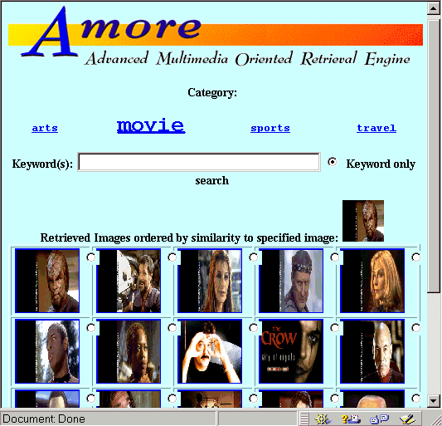
Figure 5 Amore

- Search for the textual keywords "baseball player"
- Select one of the images retrieved, and search for others similar to the one retrieved
- Give schematic drawing and search for a similar image in the image database (e.g. draw an image containing blue in the top half with a yellow circle, and yellow in the bottom half will find images of the seaside.
The software can also be used to provide 3D visualisation of search results using VRML.
The software is called Amore. A prototype available at the URL
http://www.ccrl.neclab.com/amore/
The paper is available at the URL http://www6.nttlabs.com/HyperNews/get/PAPER3.html

Dynamic Reference Sifting: A Case Study in the Homepage Domain
This paper described Ahoy! - a Web application used for finding personal home pages based on recognition of likely hits from directory naming conventions.
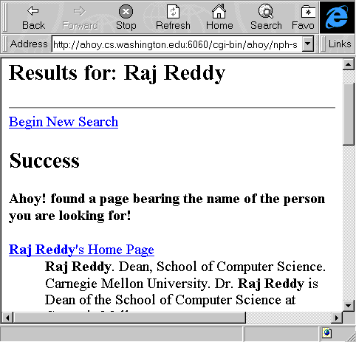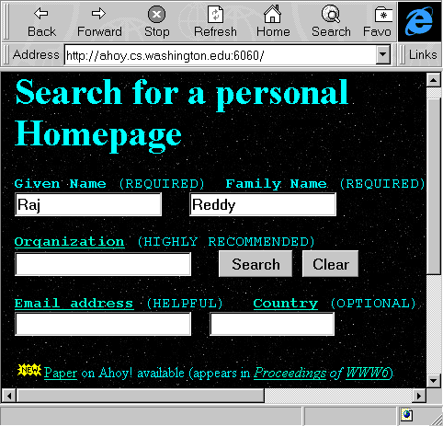
Figure 6 Ahoy!
See http://www6.nttlabs.com/HyperNews/get/PAPER39.html
The paper is available at the URL http://www.cs.washington.edu/research/ahoy

ParaSite: Mining Structural Information on the Web
Based on heuristic assumptions including:
Hypertext Linking
- A linked page is likely to be on the same topic as the original page (esp. for Yahoo type resources)
Directory Structure
- A URL containing a directory below a personal home page (PHP) is likely to be authored by the person identified in the PHP
Page Structure
- Links "near" each other on a page are likely to have similar topics
Used these assumptions to propose applications for finding:
- moved pages
- related pages
- people
Comments
- Brute strength approach
- This and preceding paper (on Ahoy!) show importance of directory naming conventions (directory names provide metadata - what can we guess from the URL www.cs.acme.edu/staff/jsmith)

“Site Mapping and Syntactic Analysis” Technical Session
The technical session on "Site Mapping and Syntactic Analysis" took place at 2 pm on Wednesday, 9th April. Papers were presented on:
- "Finding Salient Features for Personal Web Page Categories" by Marilyn R. Wulfekuhler, William F. Punch
- "Syntactic Clustering of the Web" by Andrei Z. Broder et al
- "Analysis and Design of Web-based Information Systems" by Takahashi and Liang
I saw a presentation of the second paper.

Syntactic Clustering of the Web
Award winning paper.
Using a clustering algorithm to find "similar" documents
Can be used to:
- In response to a 404 not found message, find similar versions of a resource
- Observe how resources change over time (find new and out-of -date versions)
- Find plagarisms
Results
Tested on 30,000,000 documents in Alta Vista
60% of documents are unique
Most clusters of similar documents are small

“Automatic Interface Generation” Technical Session
The technical session on "Automatic Interface Generation" took place at 11 am on Thursday, 10th April. Papers were presented on:
- "Transforming Command-Line Driven Systems to Web Applications" by Phanouriou and Abrams
- "Responsive Interaction for a Large Web Application The Meteor Shower Architecture in the WebWriter II Editor" by Crespo et al
- "The Message Is the Medium" by Seligmann et al
- "Seamless Integration of Interactive Forms into the Web" by Girgensohn and Lee
I attended the first two presentations.

Transforming Command-Line Driven Systems to Web Applications
This paper described work which used Java to provide access to a legacy command line application (a monolithic Fortran 77 program) on the Web. Input to application is provided using a Java form. The output is displayed in a Java applet window. Future work will include sharing the execution load across multiple servers and providing a graphical mechanism for defining applications. A commercial version of the product will be released shortly.
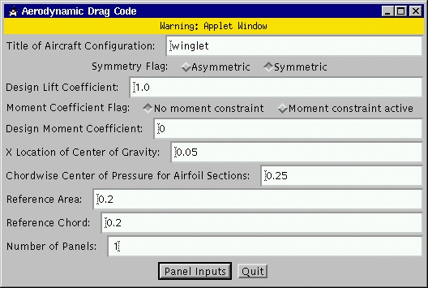
Figure 7 The Java Interface for Inputting Data To A Fortran Application

Responsive Interaction for a Large Web Application:
The Meteor Shower Architecture in the WebWriter II Editor
This paper described the architecture of an HTML authoring tool with server and client side processing. The work is based on WebWriter which was a server-based authoring tool. WebWriter II addresses the performance problems by providing editing functionality on the client using Java. The “Meteor Show Architecture” is used to manage the dialogue between the frames windows and the CGI scripts running on the server.
WebWriter II makes use of frames to provide the user interface. It even finds a use for the <BLINK> tag which is used to define a flashing cursor.
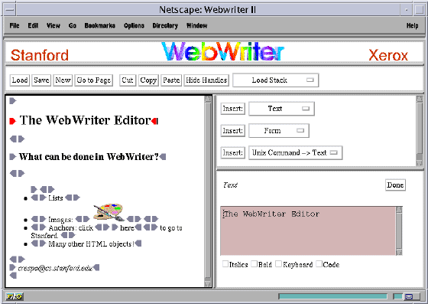
Figure 8 The WebWriterII Interface
Tools such as WebWriter II are likely to become much more popular once the Document Object Model is deployed, as it will provide applications with greater means of control over HTML documents.
http://www6.nttlabs.com/HyperNews/get/PAPER86.html

The Message Is The Medium
This paper described a number of approaches to using visual imagery in Web interfaces. The user interfaces can be accessed in the Metaphorium which is available at the URL http://www.multimedia.bell-labs.com/Metaphorium/
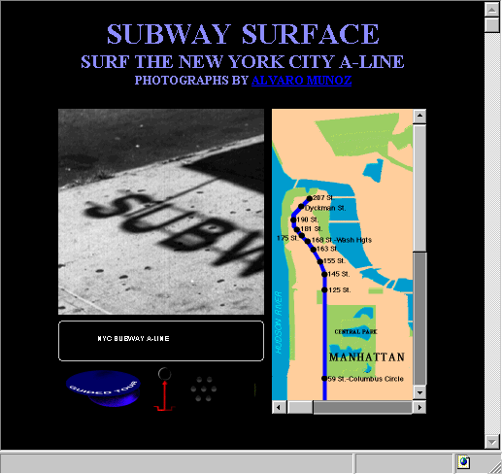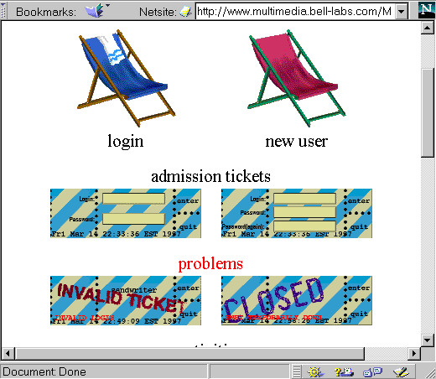
Figure 9 Explorotorium Interfaces

Seamless Integration of Interactive Forms Into The Web
This paper described limitations of existing forms on the Web and described how Dynamic Forms would overcome these limitations. Dynamic Forms is based on Java. Unfortunately the paper did not describe how Dynamic Forms related to other HTML developments such as W3C work on forms and the Document Object Model.
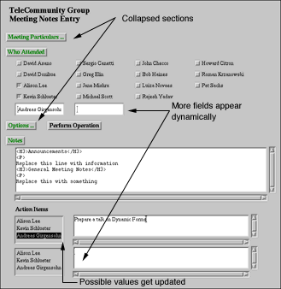
Figure 10 Example of a Dynamic Form

“Strategies For Resource Location” Technical Session
The technical session on " Strategies For Resource Location" took place at 2 pm on Thursday, 10th April. Papers were presented on:
- "SiteHelper: A Localized Agent that Helps Incremental Exploration of the World Wide Web" by Ngu and Wu
- "WebQuery: Searching and Visualizing the Web through Connectivity" by Carrière and Kazman
- "WebCutter: A System for Dynamic and Tailorable Site Mapping" by Maarek et al

WebQuery: Searching and Visualizing the Web through Connectivity
Paper on various visualisation techniques for searching. Based on structural information to find "hot spots".
http://www6.nttlabs.com/HyperNews/get/PAPER96.html

WebCutter: A System for Dynamic and Tailorable Site Mapping
Paper on IBM/Lotus product for website visualisation. WebCutter is implemented in Java. Site Maps are generated on the fly. The map can be edited by end user (to define user's view of web site).
http://www6.nttlabs.com/HyperNews/get/PAPER40.html

“Leading the Evolution of HTML” W3C Session
This W3C session took place at 2 pm on Tuesday, 8th April. Talks were given by Dave Raggett, Arnaud LeHors and Rob Miner which covered HTML developments, Metadata, XML and Maths.
Further technical discussion on HTML should take place on www-html list and feedback should be sent to www-html-editor@w3.org

Cougar
Cougar is the code name for next version of HTML. Cougar is needed as "forces driving evolution of HTML are threatening media independence". The first draft will be available summer 1997, although some parts already released:
WD-htmllink WD-script
WD-frames WD-forms
WD-object WD-entities
WD-fileupload
For further information on Cougar see http://www.w3.org/pub/WWW/MarkUp/Cougar/

WD-htmllink
The WD-htmllink spec, defines hypertext links in HTML.
It defines link relationships (e.g. <LINK REL=Next> could be used to facilitate printing in a single document split into several files)
It is related to Style Sheet work
<LINK REL=Stylesheet MEDIA=print HREF=ukoln-print.css>
It defines TITLE attribute for hints for accessibility e.g.
<A HREF="welcome.html" TITLE="The Welcome page for ACME Ltd">text</A>
In this example a browser could display the text in, say, a pop-up window.
It also defines uses of META tag (e.g. for use with PICS), define language(s) for documents and define pages which can be indexed by robots. For example:
<META NAME="ROBOTS" CONTENT="NOINDEX, NOFOLLOW">
prohibits robots from indexing and following links.

WD-style
The WD-style draft defines relationships between a HTML document and associated style sheet files.
A single style sheet can be defined by the tag:
<LINK REL=stylesheet HREF="corporate.css">
Cascading style sheets can be defined by:
<LINK REL=stylesheet HREF="corporate.css">
<LINK REL=stylesheet HREF="techreport.css">
Can define alternate style sheets for media types:
<LINK REL=stylesheet MEDIA=screen …>
MEDIA types can include Print, Screen, Aural, Braille,...

WD-script
WD-script draft covers the use of client-side scripting in HTML documents. It defines a mechanism for embedding scripting languages in HTML:
<SCRIPT type="text/javascript">
document.write ("<EM>This will work</EM>")
</SCRIPT>
Using the tag <SCRIPT SRC="url"> it is possible to store scripts externally.
A default script language can be defined:
<META HTTP-EQUIV="Content-Script-Type" CONTENT="text/tcl">
Self-modifying documents and event handlers can be written.
<SCRIPT TYPE="text/vbscript">
Sub edit1_changed()
If edit1.value = "abc" Then
button1.enabled = True
Else
button1.enabled = False
End If
End Sub
</SCRIPT>
Events include onLoad, onClick, MouseOver, onSelect, ...

WD-frames
WD-frames defines existing usage of FRAME tag. It includes IFRAME proposal for inclusion of frames inline in body of HTML documents (FRAME tag replaces BODY tag):
<BODY>
<P>This document contains an inline frame <IFRAME src="foo.html" width=400 height=500> that unfortunately your user agent doesn't support. Alternatively you can get the related document <A href="foo.html">here </A>.</IFRAME> That's all folks!
</BODY>
Initial release of FRAMES caused problems, and there are still accessibility concerns.

Dynamic HTML
Dynamic HTML is based on work of the Document Object Model (DOM) working group. It provides an API (applications programming interface) for HTML page structure and style.
Microsoft's Internet Explorer 4.0 implements many features of Dynamic HTML

XML
XML is a clean subset of SGML. It is felt that XML and HTML will coexist for some time.
Further information on XML is given elsewhere in this report.

HTML Math
The HTML Math spec:is due out in May 97. It will be a core standard covering presentation and markup. It will contain 20 presentation tags with 40 attributes, and 50 content tags (roughly equivalent to functions on scientific calculator).
Initially HTML Math will be implemented using embedded elements (ActiveX, Java) enabling 3rd parties to develop the rendering tools (won't need to wait for Netscape or Microsoft).
Software will be available in June 97. Full implementation requires better browser APIs (e.g. DOM).

CSS1
The CSS1 (Cascading Style Sheet) spec. replaces all HTML extensions. It can replace most uses of tables and provides floating text elements and control over background. A CSS logo available for pages using style sheets (see http://www.w3.org/pub/WWW/Style/CSS/Buttons/Menu/)
The history of CSS is interesting. The initial CSS proposal was made in September 1994. Microsoft’s Internet Explorer 3 was released in June 1996 which included some support for CSS. The CSS1 draft finished in December 1996. Netscape was released in October 1994 and since then they have released many formatting tags.
Q How closely matched are the CSS and XML?
A They are a good match
Q Features such as side bars (e.g. <P CLASS=side>) are likely to be widely used. Should such attributes be registered?
A It's likely that a set of standard style sheet definitions will be released, and they'll be widely used
Q Will CSS held to reduce network bandwidth?
A Yes, see http://www.w3.org/pub/WWW/Protocols/NL-PerfNote.html
Q What about headers and footers?
A In next release

CSS Futures
In next version of CSS:
- Multiple media (using @media)
- Improved printing support (headers, footers, margins, etc.)
- Better control over positioning (e.g. out-of-flow elements, navigational bars, layering)
- Better font control (mixed fonts - e.g. helvetica and cyrillic for, say, language dictionaries)
- Aural cascading style sheets (as well as for visually impaired also for in car-use, industrial and medical systems, entertainment, illiterate):
- <STRONG> rendered as loud voice, pause-before
Left column in table spoken in left speaker

“Microsoft Internet Explorer 4.0” Industrial Presentation
The presentation in the Industrial Presentation track was given the day after the first beta version of Internet Explorer 4.0 (IE4) had been made available on the Microsoft Web site. The presentation described IE4s implementation of emerging HTML recommendations (Cougar).
The talk described some of the limitations of HTML:
- It’s not possible to have fine control over positioning using HTML
- Various applications (e.g. resorting output from a search engine) require interaction with the server, which is slow.
- Animated GIFs have limitations
IE4 is based on emerging HTML proposals, such as dynamic styles, dynamic contents, CSS positioning and data binding. Microsoft’s name for it’s implementation is known as Dynamic HTML. For further details see http://www.microsoft.com/workshop/prog/aplatfrm/dynhtml-f.htm

Dynamic HTML
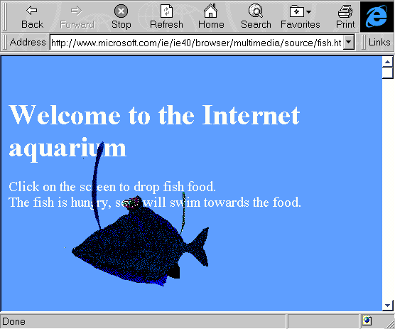
Figure 11 Example of a Dynamic Style Sheet

Dynamic HTML provides control over positioning control (in X, Y and Z planes). The position can be changed at run time (e.g. on mouseOver event).
For example in Figure ? notice how the image of a fish is positioned in front of the text elements.
When the mouse button is clicked, the image of the fish moves towards the position of the mouse click.

Dynamic Style Sheets
Dynamic style sheets enable CSS properties to be changed at run time. For example code such as:
<H1 onMouseOver {color: red;} onMouseOut {color: yellow;}>
could be used to change the colour of a heading as the cursor moved over the heading.
Note in the above example the HTML attributes are given for illustrative purposes – the syntax may be different from that given. In addition a more elegant way to store the Javascript code would be in the document HEAD (or externally).

CSS Positioning
HTML elements can be positioned absolutely or relative to each other. For example an image can be positioned relative to the window display, and text layered on top (or behind) the image:
<IMG SRC="smiley.gif" : top: 25% ; zindex=1>
<DIV zindex =2>Text on top of image</DIV>
Text on top of image
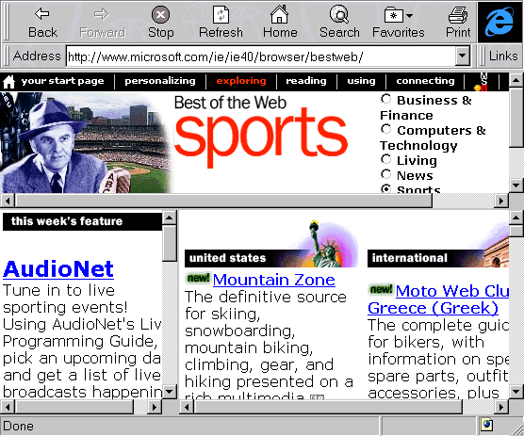
Figure 12 Data Binding

Data Binding
Currently data binding (merged data from database with HTML code) is done on the server. Data binding proposal enables it to be done on the client so that, for example, the output from a search engine can be resorted on the client).
For an example of data binding see http://www.microsoft.com/ie/ie40/browser/bestweb/

Dynamic HTML Multimedia Effects
Uses IE4 control to provide multimedia effects. This will remove the need for animated GIF.
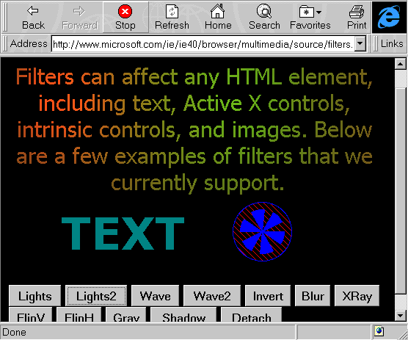
Figure 13 Multimedia Effects
Variety of effects available:
- Transitions, filters, structured graphics, sequencing
- sprite control (scripted animated GIFs)
- Example - e rotating in 3D
An interesting question for Microsoft to address is how will Powerpoint be marketed if control over multimedia effects can be achieved in HTML.

Document Object Model (DOM)
DOM enables every HTML element to be processed as an object (i.e. DOM is an API for accessing HTML elements).
DOM is not a set of tags or a new language (it is language independent).

Standards
It was stated that IE 4.0 conforms to HTML 3.2 and CSS1 and implements new W3C draft proposals (e.g. DOM, forms). In addition the Javascript language is being standardised by ECMA
There is, of course, the question of support for legacy browsers. There are a number of options:
- Don't use the new features
- Use new features in a way so that they degrade gracefully (for example implement a dynamic table of contents which expands when the cursor is positioned over an element, while ensuring that old browsers see the full table of contents).
- Accept that certain new features won't work in legacy browsers (such as the demonstration of a game of Tetris which is implemented as a 10K HTML file, with no ActiveX controls).

Security and Privacy Issues
The development of a richer version of HTML will raise security and privacy concerns. For example dynamic content makes it is possible to change the content of a document which is displayed by a browser and CSS makes it possible to change the visibility of content (e.g. make content disappear). So it would be possible to write a HTML document which uses frames, and the dynamic HTML in one frame changing the content of another frame – such as hiding an advert on Yahoo). There are obviously copyright and privacy implications in this.
In IE4 dynamic HTML can only process HTML documents from within the same domain.

Good Web Design Panel Session
The session on Web design was very popular, with a large audience of well over 100. Panelists included Jakob Neilson (Sun), David Seigel (a leading web designer and of the 1 bit clear GIF used to provide spacing), Cathy Gill (HTML Writer's Guild) and others.
I attended the start and end of this session.
During the discussions strong disagreements emerged between the design community (David Seigel) and the structuralist community (Jakon Neilson).
The panel chair asked the panelists to answer the question “What is Good Design?”. The following responses were given:
Jakob Neilson's responses was “No frames”. He has been a constant critic of the use of Frames - see his paper on 10 top mistakes in web design.
Other panelists and members of the audience made the following comments.
- The design must be related to a user's tasks.
- A well-designed site downloads quickly.
- A good design doesn't break browsers.
- No gratuitous backgrounds or animation.
- Should be internally consistent.
- Should be externally consistent in use of navigation (Jakob Neilson's comments on need for standard navigational aids such as not changing colours of hypertext links)
- Variety in navigational aids (David Siegel's response).
Other comments included:
- "Designers shouldn't be used as shields in the browser wars"
- Web sites need (automated) feedback mechanisms
- There aren't enough good web designers, so we need guidelines
- We need good example of web design (and commentary on the design)
Following the request for examples of web design, David See Seigel mentioned his Highfive site at http://www.highfive.com/. He is also involved with the following sites:
http://www.verso.com/
http://www.killersites.com/
http://www.dsiegel.com/
ACM/Interactions (May/June 97) was also mentioned for a critique of Web design.
There was much disagreement over the Seigel "hack" illustrated.
image4.gif
The trick has been used for a web collection of photographs. The design is based on a roll of film, so that there are 24 (or 36) photographs in the collection. The image for the next page is stored in a 1 pixel by 1 pixel on the current page using the <IMG SRC=imagen+1.gif height=1 width=1> tag for page n. Using this trick the image is downloaded while main image is being examined, so that when moving to the next image it appears to load quickly. David Seigel would regard this as a neat trick. Critics would argue that it is a hack, with no semantics contained in the tag, and that extensive use of the trick would cause future maintenance problems.

Developer’s Day

Transparent Content Negotiation (TCN)
Transparent Content Negotiation is an IETF draft,. It enables:
- Deployment of new data formats and tags
- Tailoring of content for new platforms
- Internationalisation
In TCN spec the server sends list of variants to the client. For example an HTML document containing:
<IMG SRC="logo">
would send the corresponding GET request. The HTTP server would have a variant list of the form:
{logo.gif type image.png}
{logo.png type image.png}
Since the server has a number of formats available, it will send a message back to the client. The client would then transparently chose its preferred format.
For further information see ftp://ftp.ietf.org/internet-drafts/draft-ietf-http-negotiation-01.txt

Feature Negotiation
Feature Negotiation is also an IETF draft. It is part of TCN, addressing extensibility. It will eliminate "Click here from frames, here for tables" buttons. Universal agreement on new features not needed.
See ftp://ftp.ietf.org/internet-drafts/draft-ietf-http-feature-reg-00.txt

Conclusions
There were many good things are WWW 6 . However there were also some failings of WWW 6 which should be borne in mind by members of the WWW 7 organising committee:
There were problems with the local organisation including:
- Catering (lack of coffee in afternoon, lunches were not as good as previous conferences)
- Failure to notify session chairs before conference – a number of session chairs found out they were chairing a session when they read the conference programme!
- Technical support in sessions was patchy. For example in one technical session I attended the sound quality was very poor, and I found it difficult to hear all four speakers.
- The evaluation form was poorly designed.
- No list of delegates was provided.
It was noticeable that numbers of participants was down on last year. I do not know if this was due to a problem in publicity, or the clash with related conferences held in San Francisco the previous week.
Lack of standardisation of presentations (compared with WWW5).
- Presentations not being made available on WWW

Address for Correspondence
Brian Kelly
UK Web Focus
UKOLN
University of Bath
BA2 7AY
Email: B.Kelly@ukoln.ac.uk

