The UK Web Focus Blog


A Guide to the UK Web Focus blog

Background
The briefing document has been produced to support the masterclass on “Using Blogs Effectively Within Your Organisation” held at the Museums and the Web 2008 conference.
This document provides advice on steps you may wish to take once you are in the process of launching a blog.

About The UK Web Focus Blog
The UK Web Focus blog is provided by Brian Kelly, a Web adviser to the UK’s higher and further education community and the cultural heritage sector in England. Brian works for UKOLN, a national centre of expertise in digital information management, located at the University of Bath which is funded by the JISC and the MLA.
The blog is available at the URL <http://ukwebfocus.wordpress.com/>.
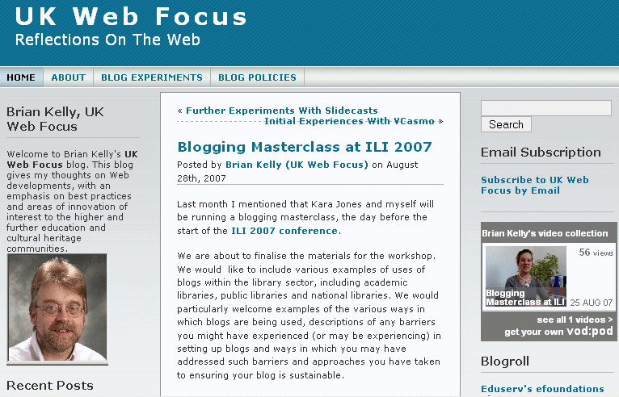
The UK Web Focus Blog

A Guide to the UK Web Focus blog

Background
The briefing document has been produced to support the masterclass on “Using Blogs Effectively Within Your Organisation” held at the Museums and the Web 2008 conference.
This document provides advice on steps you may wish to take once you are in the process of launching a blog.

About The UK Web Focus Blog
The UK Web Focus blog is provided by Brian Kelly, a Web adviser to the UK’s higher and further education community and the cultural heritage sector in England. Brian works for UKOLN, a national centre of expertise in digital information management, located at the University of Bath which is funded by the JISC and the MLA.
The blog is available at the URL <http://ukwebfocus.wordpress.com/>.

Scope Of The Blog
The main audiences of the blog are those involved in the provision of networked information services, with a particular focus on the provision of Web services, within the UK’s higher and further education and the museums, libraries and archives sectors. The blog also seeks to engage with the wider Web and digital library development community.
The contents of the blog cover a range of aspects related to the Web and networked information services. This includes Web standards and best practices, Web accessibility and emerging Web technologies. A particular area of interest is in Web 2.0 technologies and their potential within the library sector.

Aims Of The Blog
The main aims of the blog are:
User engagement: The blog seeks to engage the readers if discussion and debate.
Dissemination: The blog provides a mechanism for disseminating information on UK Web Focus activities.
Experimentation: The blog provides a means of carrying out various experiments, such as approaches to blogging and use of blog widgets.
Thinking out loud: The blog enables the author to air speculative thoughts and ideas and to invite responses.

Reflective Blogging
The experiences gained after launching the UK Web Focus blog in November 2006 have been documented on the blog. The blog therefore provides information which will be of interest to organisations which may be considering establishing a blog or enhancing an existing blog service.

Provider of the UK Web Focus Blog
The UK Web Focus blog has a single author – Brian Kelly – who is responsible for the content of the blog, although there are also occasional invited guest blog posts. The blog supports the author’s work as UK Web Focus at the University of Bath, UK.
The blog’s policy [1] and a description of its purpose [2] are provided on the blog.

References
- Blog Policies, UK Web Focus blog, <http://ukwebfocus.wordpress.com/blog-policies/>
- UK Web Focus blog statistics, UK Web Focus blog, 6 Nov 2007 <http://ukwebfocus.wordpress.com/2006/11/06/scope-rationale-and-policy-for-this-blog/>

Scope Of The Blog
The main audiences of the blog are those involved in the provision of networked information services, with a particular focus on the provision of Web services, within the UK’s higher and further education and the museums, libraries and archives sectors. The blog also seeks to engage with the wider Web and digital library development community.
The contents of the blog cover a range of aspects related to the Web and networked information services. This includes Web standards and best practices, Web accessibility and emerging Web technologies. A particular area of interest is in Web 2.0 technologies and their potential within the library sector.

Aims Of The Blog
The main aims of the blog are:
User engagement: The blog seeks to engage the readers if discussion and debate.
Dissemination: The blog provides a mechanism for disseminating information on UK Web Focus activities.
Experimentation: The blog provides a means of carrying out various experiments, such as approaches to blogging and use of blog widgets.
Thinking out loud: The blog enables the author to air speculative thoughts and ideas and to invite responses.

Reflective Blogging
The experiences gained after launching the UK Web Focus blog in November 2006 have been documented on the blog. The blog therefore provides information which will be of interest to organisations which may be considering establishing a blog or enhancing an existing blog service.

Provider of the UK Web Focus Blog
The UK Web Focus blog has a single author – Brian Kelly – who is responsible for the content of the blog, although there are also occasional invited guest blog posts. The blog supports the author’s work as UK Web Focus at the University of Bath, UK.
The blog’s policy [1] and a description of its purpose [2] are provided on the blog.

References
- Blog Policies, UK Web Focus blog, <http://ukwebfocus.wordpress.com/blog-policies/>
- UK Web Focus blog statistics, UK Web Focus blog, 6 Nov 2007 <http://ukwebfocus.wordpress.com/2006/11/06/scope-rationale-and-policy-for-this-blog/>

