Design Issues

The following points are suggested as aspects of good web design:
- The design must be related to a user's tasks.
- A well-designed site downloads quickly.
- A good design doesn't break browsers.
- No gratuitous backgrounds or animation should be used.
- The design should be internally consistent.
Before designing your web site it may be helpful to prepare a list of web sites similar to yours, and for yourself your colleagues, and potential end users of your service to work through a checklist in order to identify appropriate design features for your web site. This can then be used when preparing a design specification.
The UCISA Web Awards site may be useful for this exercise (see the URL http://www.ucisa.ac.uk/docs/webawa.htm). Analyse the entries submitted for last year’s awards and see if you agree with the judges.

Finding Out More
For further information see the following resources:
URL Of Resource | Description
http://www.yahoo.com/Computers/Internet/  World_Wide_Web/ | Useful general resource about the Web
http://www.yahoo.com/Computers_and_Internet/  Information_and_Documentation/Data_Formats/HTML/ | Resources on HTML and HTML editors
http://www.w3.org/ | Home of the World Wide Web Consortium, which coordinates development of Web standards
http://WWW.Stars.com/Internet/News/index.html | Useful general resource about the Web
http://tips.iworld.com/ | Pointers to various Web products.
http://tips.internet.com/HTML_authoring_products.html | Pointers to various HTML authoring tools.
http://www.webreference.com/ | Resources for web developers.
http://www.stars.com/ | Web Developer's Virtual Library
http://www.webdeveloper.com/ | Wev Developer’s site
http://www.netskills.ac.uk/ | Training resources for Web users.

About This Briefing Document
This briefing document has been produced by UK Web Focus for the LAITG session at LIBTECH97.
UK Web Focus Briefing Document

Providing Information
On the Web

HTML
HTML is the Hypertext Markup Language. It is the native language for the World Wide Web.
HTML is a simple language, as can be seen from the example below.
<TITLE>Hello World</TITLE>  <H1>My First Page</H1>  <IMG SRC="photo.gif">This is my <B>first</B> page on the web.  <P>  It's very easy!  <A HREF="dog.html">Click here</A> to see my pet | 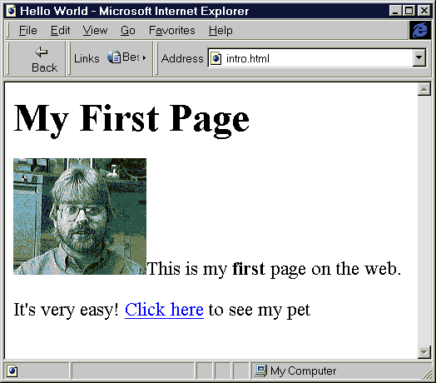
Figure 1 Example of a Simple HTML Document, and How it is Displayed

HTML Authoring Tools
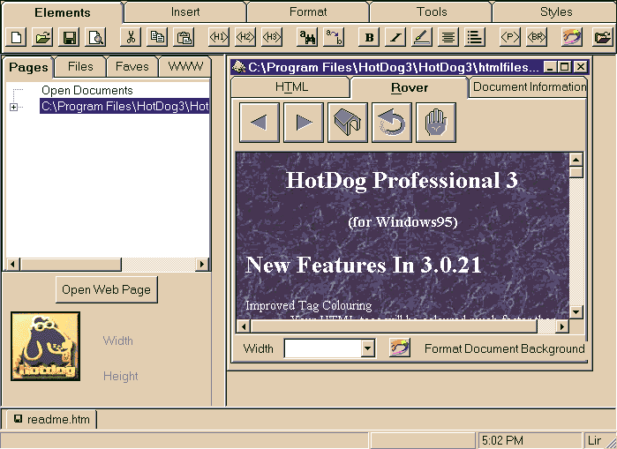
Figure 2 HotDog – A Simple HTML Authoring Tool
Simple HTML documents can be created using a text editor (e.g. Notepad). However an increasing number of HTML authoring tools are available, which can make the creation and maintenance of HTML documents even easier.
Site management tools, such as NetObjects Fusion, can be used to manage the various components of a web site (individual web pages, images, scripts, etc) as a single entity.  This approach makes it much easier to make modifications than using a file-based authoring tool (for example if you wanted to change the background colour, this can be done in a single operation, rather than having to edit each file individually). | 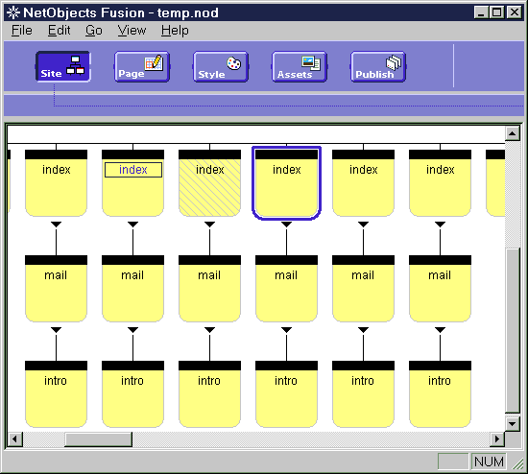  Figure 3 NetObjects Fusion

Web Site Management
Although creating simple individual web pages is relatively easy, management of a large web site can be very time-consuming.
Many well-established web sites suffer from a number of problems:
- Inconsistent design, failing to give coherent image of organisation
- Inconsistent use of navigation aids, causing problems for end users
- Unvalidated HTML, causing errors when accessing a resource
- Out-of-date information
- Inappropriate information
- Poor or inappropriate design
- Inappropriate writing style
- Lack of consistent file and directory naming conventions
- Inappropriate use of underlying directory structure
Attempting to fix these problems can be very time-consuming and expensive.

Interactive Web Pages
Although simple web pages can be produced relatively easily, increasingly web sites are making use of more advanced technologies in order to provide various interactive services. Technologies which can be used include:
- CGI (Common Gateway Interface). Software runs on the web server to create a virtual document. CGI gateways are often used to provide access to search tools.
- Database Integration Tools. A variety of methods can be used to provide access to existing database systems.
- Client-side scripting languages. Scripting languages such as JavaScript and VBasic which run inside the web browser can provide various interactive facilities.
- Java. Java is a powerful programming environment which is being used increasingly on the Web.
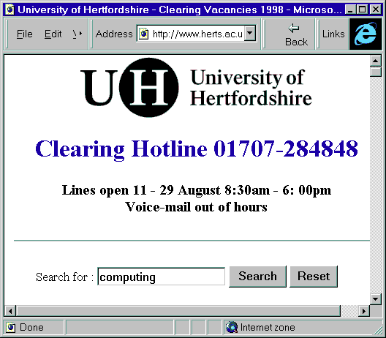 | 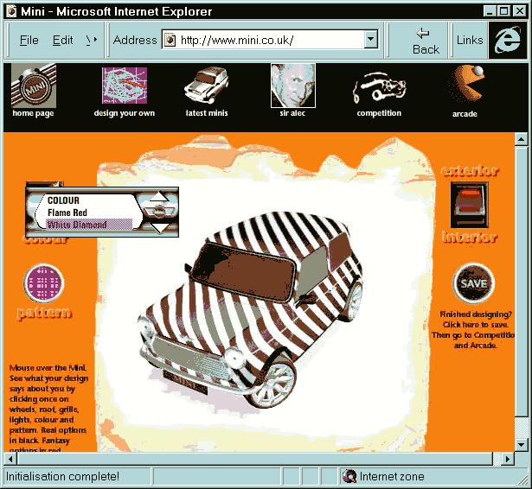
Figure 3a Example of a CGI Gateway Figure 3b Example of a Java Application
Note, however, that use of these technologies will require additional technical expertise, such as programming expertise.

Technological Developments
Anyone setting up a new web site should be aware of a number of recent technological developments.
HTML 4.0 The HTML 4.0 proposal was announced in summer 1997. HTML 4.0, together with a number of related proposals, provides a number of useful features including improved forms support, improved control over printing, etc.
Style Sheets The Cascading Style Sheet (CSS) proposal is the recommended method for providing control over the appearance of HTML document.
HTML 4.0 together with CSS will provide a number of benefits including:
- Ease of maintenance, by separating the document content from the appearance.
- Improved network performance, by minimising the need for images.
- Improved accessibility.
- Enhanced functionality.
However, although there are many benefits in the use of these new technologies, there are also several issues to be aware of:
- The lack of tools which support the new technologies.
- The new proposals have not yet been ratified.
- Old browsers may have problems in accessing the new facilities.
Further information on HTML 4.0 is available at the URL http://www.w3.org/TR/WD-html40-970708/
Further information on style sheets is available at the URL http://www.w3.org/Style/

