

An ecological approach to repository and service interactions

Draft Version 0.9

R. John Robertson (JISCCETIS, University of Strathclyde)
Mahendra Mahey (UKOLN, University of Bath)
Julie Allinson (UKOLN, University of Bath)
June 2007



1 Not the executive summary 1
2 Thinking about repository interactions 2
3 Why technical architectures need help 3
4 An ecological view of repository interaction 4
4.1 What do we mean by ecology? 4
4.2 Ecology and information systems 5
4.2.1 Earlier work on information ecologies 6
5 The core concepts of repository ecology 8
5.1 Introduction 8
5.2 Basic concepts 8
5.2.1 Scale 8
5.2.2 Entity 10
5.2.3 Species 11
5.2.4 Interactions 11
5.2.5 Resource 12
5.2.6 Environmental factor 13
5.2.7 Other relevant features of ecologies 13
5.3 Structured uses of ecological concepts 15
5.3.1 Habitat mapping 15
5.3.2 Resource tracking 17
6 Examples of ecological approaches. 18
6.1 Example 1 An e-Crystallography dataset ecosystem 18
6.1.1 Identifying a scale 18
6.1.2 Dataset Species 19
6.1.3 eBank UK interactions 20
6.1.4 An eBank UK food web 21
6.1.5 Environmental factors in the eBank ecosystem 22
6.1.6 Biodiversity 22
6.1.7 eBank UK: resource tracking 23
6.1.8 Dataset Ecology Diagrams 23
6.2 2
6.3 Example 2: the community of a learning environment 1
7 A bigger picture: how does this approach fit with existing work? 4
7.1 A repository community as a reference, or domain, model 4
7.2 A repository ecosystem and the JISC Information Environment 5
7.3 An ecological approach and the e-Framework 7
7.4 An ecological approach and other work on repository interactions 7
8 Further reading 9
8.1 Related work 9

Not the executive summary
As this is a draft this isn’t the executive summary that will eventually be here, but rather a statement of intent about the development of this approach and what we hope releasing a public draft will accomplish.

This work began with the need to express something of how and why repositories and services interact. As a community we have well understood technical models and architectures that provide mechanisms for interoperability. The actual interactions that occur, however, are not widely understood and knowledge about them is not often shared. This is in part because we tend to share in the abstract through architectures and use cases, articulating interactions or connections requires an engagement with specific details.

We think that constructed systems benefit from being described and understood well and that such understanding allows the possibility of better future development. Within the context of the Information Environment this may mean richer services, more efficient interoperability, or may simply support new connections.

Ecology is the study of systems that are complex, dynamic, and full of interacting entities and processes. Although the nature of these interactions and processes may be highly detailed, a higher level view of them is accessible and intuitive. We think that ecology and the ecosystems it studies may offer a useful analogy to inform the task of understanding and articulating the interactions between users, repositories, and services and the information environments in which they take place. This report outlines some concepts from ecology that may be useful and suggests some definitions for a common conversation about the use of this metaphor.

We hope that this report suggests an additional way to conceptualise and analyse interactions and provide a common vocabulary for an ecological approach. It should as a minimum provoke and support some useful discussions about networks and communities.

As well as all those cited, we would like to acknowledge the contributions that others involved in supporting the Repositories Research Team have made to shaping this report.

your feedback is invited,

John, Mahendra, and Julie
rrt@ukoln.ac.uk

Thinking about repository interactions
The Information Environment is steadily becoming populated with repositories and services that make available or enhance a wide range of digital assets which “support researchers, learners, teachers and administrators in their work and study”. (http://www.jisc.ac.uk/whatwedo/themes/information_environment.aspx).

As these different types of repositories and services develop there is a growing need to consider the interactions between repositories and between repositories and other systems. Planning and articulating these interactions requires a way of thinking that can capture and address the untidy complexity of specific interactions found in the real world as well as supporting the consideration of abstract types of interaction.

In the Digital Repositories Review, Rachel Heery and Sheila Anderson commented that, as the use of repositories matures,

A framework needs to be established for repositories that would encompass:
- relation between repositories
- data flow between repositories
- workflow issues
This would begin to address fundamental questions, such as how institutional repositories relate to thematic, subject repositories? Within institutions, how do repositories relate across the ‘service domains’ of research, learning, administration? A meeting point is required at various levels, both as regards service provision and technical infrastructure. (Heery and Anderson, 2005)

The Repositories Roadmap regarded the development of such a framework as a necessary milestone in moving the organisational viewpoint forward to achieve their 2010 vision for the sector (Heery and Powell, 2006).

This report is a first step in the development of this framework - it introduces the idea of using ecological concepts to describe repository interactions; illustrating its application with specific reference to examples from the UK FE/HE sector, and outlines how this approach fits with other related work. Such a discussion must also make reference to the distributed services that use information made available by repositories and the part they play in a repository ecosystem.

It is anticipated that the report will be of most relevance to the communities of repository and service developers, JISC, and other funding bodies as they plan future developments and as they articulate the current state of the Information Environment.

The term ‘repository’ is used by the report in a similar sense as Heery and Powell use it, that is (following Lynch, 2003) to view a repository as a commitment by a group (typically an institution) to support its members and users by providing set of services. As much of the discussion about repository interactions takes place in the context of distributed services, repositories are sometimes described in terms of their function as a data provider to these distributed services. The term ‘service’ refers to a specific function offered to a user community; most often in this document a ‘service’ exists independently of one or more data providers and interacts with them.

Why technical architectures need help
In its aim “to allow discovery, access and use of resources for research”, the JISC Information Environment (IE) provides an overview of its expected technical architecture. Such technical architectures are required because they:
- allow developers and implementers to gain an overview of the potential components in complex distributed systems.
- specify the component types of information environments and protocols for their technical interoperability.
- consequently support planning for the deployment of such large-scale systems
- provide an abstraction of the participants in an information environment that may assist the identification of missing types of participant (data or service provider) within that environment.

Architectures and architects are needed to plan the way forward and enable the development and construction of great edifices. Other approaches are, however, also needed to help those developments mature, take root, and flourish.

Some suggested reasons why the ongoing growth of an information environment requires that the technical architecture be supplemented with other ‘models’.
- architectures are implicitly static and only address the structures that have been built into them. In particular, technical architectures formalise the technologies they include and the inclusion of a new technology may require the entire architecture to be updated.
- actual implemented practice rarely matches the architectural specification exactly.
- information environment architectures tend to focus on types of technical deployment and interaction. Non-technical interactions or constraints are not often represented.
- architectures deal with abstractions of data or service providers (n, n+1 components) and types of interactions– they do not represent the peculiarities of actual instances of services and their interactions
- architectures aren’t designed to express influences or cultural factors.
- architectures may not be the best way to engage managers and users without a technical background

Managers, developers, and implementers need to be able to do some of the things that an architectural approach can’t articulate. They need to articulate the specific details and conditions of their project and how it will actually relate to other repositories and services. Questions like ‘How will staff in the education faculty want this information presented?’ or ‘If I want to use JHOVE how do the outputted fields map onto our settings?’ or ‘Which members of the university’s senior staff do I need to persuade?’ inevitably arise. We think that ideas and concepts from ecology can complement the architectural view of an information environment and help developers, implementers, and managers articulate their setting.

An ecological view of repository interaction
To supplement abstract architectural approaches and articulate the dynamics of repository and service interactions, an approach that can present and interact with specifics is needed. One source of such an approach is ecology.

What do we mean by ecology?
Ecology may be defined as “the branch of biology dealing with the relations and interactions between organisms and their environment, including other organisms”.

A classic example in ecology is a pond.


Figure 1 photo &copy; Neal Singleton for http://9936.openphoto.net CC:PublicDomain

The ecosystem of a pond has a number of key features:
- it presents a number of different habitats (for example, the surface habitat and the shore habitat).
- it has a clear food chain with different trophic levels (for example, plant life (e.g. algae) sustains a small number of insects, which in turn sustain a smaller number of fish).
- it is clearly influenced by both biotic and abiotic factors (for example the presence of predators or the composition of the surrounding soil).
- it is affected by distinct biological and chemical processes (for example, the relative abundance of nitrogen will directly affect the growth of plant life and the abundance of plant life may have a direct effect on the sunlight present to animal life in habitat at the bottom of the pond.).
- within it all of these processes, species, and environmental factors interact with each other.
- it is a dynamic system that is constantly responding to changes.

Within this example it should be observed that ponds are often managed rather than entirely wild. They are cared for and specific action is taken to promote or hinder the growth and survival of particular components of the ecology.

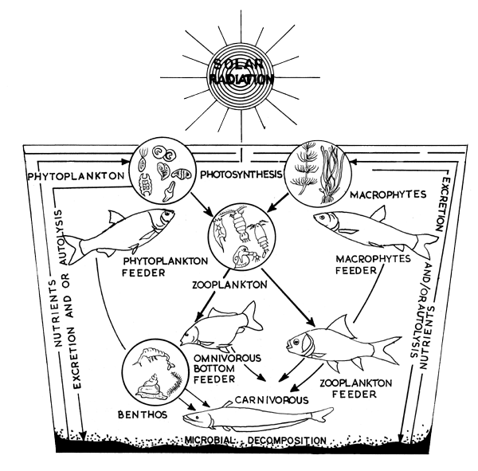Figure 2 A Pond Ecosystem, from D. Kumar (1992) Fish culture in undrainable ponds: A manual for extension, FAO Fisheries Technical Paper No. 325. Rome, FAO http://www.fao.org/docrep/003/T0555E/T0555E00.HTM . Image © Food and Agricultural Organisation of the United Nations used by permission.

Ecology and information systems
In the context of repositories and services there are a number of parallels between information systems and ecologies that make an ecological approach both apt and useful. Specific parallels will be addressed in more detail in section 5 but this section will observe a few general parallels.

Both ecosystems and information systems are complex networks involving many components. They exist in a dynamic changing environment and the interactions of the entities and the processes they create are much more significant than the isolated individual entities could be. A purposive ecosystem, as described in the example of a pond, is a closer parallel to the domain of repositories and services than a wild ecosystem would be.

An ecological approach to repository and service interactions allows a variety of types of information to be expressed. It can take a comprehensive view of repositories’ contexts that addresses cultural, political, and financial influences as well as technical protocols. As an approach, ecology is aware that it is capturing a dynamic system, with continually evolving processes and with this awareness can try to indicate what and where change is occurring.

There is a risk that suggesting a way to use ecology as a metaphor may prove to be too complex and a further risk that, the process of defining the analogy may kill off the intuitive attraction of ecology. The authors are not ecologists; consequently in the development of this report we have developed our ecological view of repositories in dialogue with Chisholm and Schaider’s handouts accompanying “Fundamentals of Ecology, Fall 2003”, Lewis’ “Pond Ecology” and through building on the previous work on information ecologies by Nardi and O’Day and by Davenport.

Earlier work on information ecologies
The idea that ecological concepts might be a useful metaphor in the context of information systems or the interactions between people and ICT is not new.

The application of the idea of an information ecology to the world of corporate ICT use and systems has been examined by Davenport in Information Ecology: Mastering the Information and Knowledge Environment. The interaction of people and ICT has also been explored by Nardi and O’Day in Information Ecologies: using technology with heart.

Ecology as a metaphor or analogy for thinking about how people relate (especially through technology) crops up occasionally as people struggle to express the interactions of a group of people, the dynamics of that group, a location, and the ‘tools’ that enhance that interaction (be they chat software, coffee, or pool tables). A recent example of this intuitive expression is Dave Cormier’s blog post “Building Ecologies - Making room for communities and networks” and various responses to it. As part of that discussion George Siemens commented,
I've stated previously that networks occur within something, that is, our capacity to form networks is influenced by a space or an ecology. Some ecologies are better suited for the formation of learning and knowledge networks than others. For example, certain corporate [settings] are structured to reward holding instead of sharing knowledge...a climate not conducive to the creation of new knowledge. Or, consider what we see occurring today with intellectual property - the climate of ownership of ideas at best only vaguely credible - creates an ecology in which the creation and dissemination of new knowledge is inhibited. Organizations - corporate, academic, or other - should be aware of the attributes of a successful ecology, namely one which allows the greatest probability for network formation. Dave Snowden stated in a presentation (can't remember where) that ecologies can't be engineered. While I don't know the exact scope and context of his statement, my first reaction is one of disagreement. Ecologies can at minimum be fostered (much like networks can be). Consider the economy as an ecology...or IP law...or innovation labs. In each instance, we can certainly influence how they develop and, to varying degrees, how they function. Anyway, the task is to explore what constitutes a desired ecology.

The core concepts of repository ecology

Introduction
Given that an ecological approach may offer some useful insights into or perspectives on how repositories and services interact, the first step in using this approach is to sketch the basic features and methods and suggest some terminology that may be helpful in the conversation that follows.

Some of the basic ecological concepts that may be useful in themselves are defined by Nardi and O’Day and Davenport’s work on information ecologies, others emerge from a further consideration of ecology proper. Most of the use of these ecological concepts by the repository community is likely to be unstructured and different users of the approach are likely to seize upon one or two concepts that help them to express a particular feature of their setting.

Beyond this way of using ecology however, it may be useful to consider some of the methods used in ecology. Two key approaches that will be briefly reviewed are the resource-tracking approach (analysing the movement of energy or nutrients) and the habitat approach (analysing the specific surrounding and community of a particular species or instance).

The following conceptual definitions (scale, entity, species, resource, environmental factor) are provided to support discussion and provide a common frame of reference for the use of an ecological approach. They are not intended to be prescriptive but descriptive of one way of using the metaphor of ecology, to allow further consideration of the idea.

Basic concepts

Scale
A basic principle of ecology is that the scale or the granularity of a discussion needs to be made explicit. Processes or interactions occur at particular granularities. Although processes at one level will obviously affect other levels carefully distinction is required.

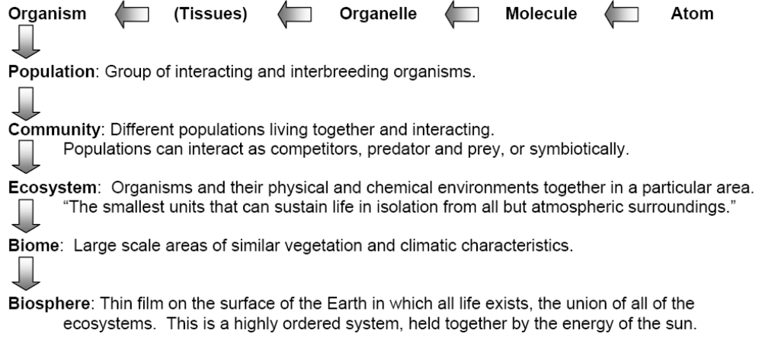
Figure 3 Scales at which ecology can be pursued. Figure adapted from Fundamentals of ecology Fall 2003; lecture 1
http://ocw.mit.edu/OcwWeb/Civil-and-Environmental-Engineering/1-018JFall2003/LectureNotes/index.htm

The above diagram provides a hierarchy of scales (or levels) within an ecological view. Within the context of an ecology of repositories and services we propose that the range ‘Organism’ to ‘Ecosystem’ will be the most useful parallel. Such a parallel may be mapped in different ways but the following (using repositories and people examples) is a suggested view:

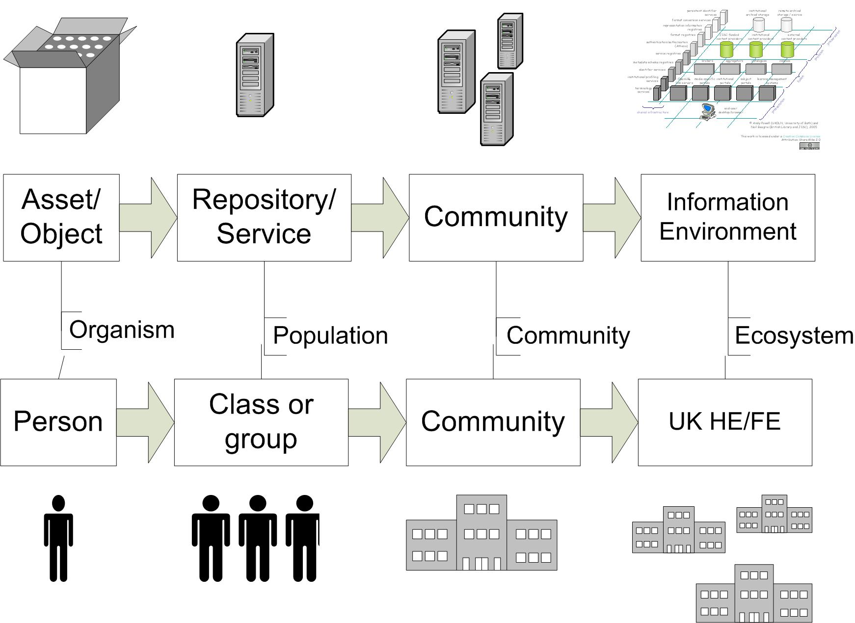
Figure 4 Mapping of the repositories and people to the scales of ecology outlined in figure 3.

Information environment
The existing idea of an information environment may be considered as being roughly parallel to the scale of an ecosystem. A biome may be considered as parallel with larger groupings such as the entire UK ICT sphere or the European HE/FE network.

Although most ecological approaches in the repository and service domain will focus on the community level of granularity (perhaps studying one entity, function, or habitat), it is important to remember that they are a particular localised view of the wider information environment (ecosystem) and will inherit environmental influences from that level.

Entity
An entity is a tangible thing that exists within a repository ecosystem. As mentioned earlier, in the development of an ecological view of repositories and services, repositories and services are regarded as ‘living’ (biotic) and are largely treated in the same as human participants in the ecosystem. The most common types of entities are: users; repositories; services; objects; metadata records.

As suggested in the above consideration of scale entities are generally considered at the population level of granularity. For example repositories and services contain or act on a large or small number of digital objects (organisms) but also have a degree of corporate identity (i.e. it is meaningful to speak of the behaviour of a repository in the same way as one might consider the behaviour of a pack of wolves or herd of sheep). It should be noted that 'environmental factors' affecting entities or the connections between entities are not, in themselves, entities.

Although we will expand this work to include a consideration of the ecological approach at levels of granularity that focuses on objects and metadata records, this initial stage of the development of an ecological approach addresses provides a population-based view of the articulation of a repository and services.

Repository
Within this view a repository is an entity which supports a particular set of functions and meets certain user needs relating to the storage and management of digital assets for a defined group. Many repositories are also services or a bundle of services. For example, an institutional repository may also be an OAI-PMH data provider. A repository does not have to be a formal repository system but can be any other thing that supports this functionality. Examples of repositories include: arXiv; The Depot, Jorum, Daedalus, box.net, flickr; del.icio.us.

Further examples and a typology of repositories are available on the Repositories Research wiki at: http://www.ukoln.ac.uk/repositories/digirep/index/Typology

Service
A service is an entity building on or otherwise interacting with a repository to offer added value to participants in the information environment in which it exists. A service may support technical interactions but it does not need to. Within an ecology-based approach a weekly conversation in a tearoom in which two colleagues consistently talk about good articles they’ve read is as much of a recommender service as a community forum, or an Amazon-style ‘people who bought that..’. Examples of services include: The Information Environment Service Registry (IESR), the Digital Curation Centre, the Ethos service; the Repositories Research wiki; Pilot Engineering Repository Xsearch (PERX).

Species
A species within an ecosystem is a collective name for a particular type of entity. Example species are: institutional repositories, aggregator services, library catalogues, blogs, students, teachers, system administrators.

Although ecological descriptions or representations of repository ecosystems or communities are focused on specific entities, they may contain a combination of entities and species. For example, it may be useful to refer to an interaction with a particular student (a specific entity, an instance of the species), with a defined group of students (a specific group of entities, instances of the species), or with student as generic participants (a species).

When describing entities, the identification of the species allows what is known about the behaviour of the species in general to be used to help understand the particular entity. The observed characteristics of the entity are paramount but more general attributes of the species may illuminate the characteristics of the entity. For example, understanding the uptake in use of Comber University’s repository (the entity) should be seen in the context of what is already known about the uptake of the use of institutional repositories in general (the species).

Interactions
An interaction is a connection, relationship, or link between two or more entities or species in a population, community, or ecosystem. This interaction can have any nature; it may be a machine to machine technical interaction, an interaction between two people, or an interaction between a person/ people and systems. In a few circumstances it may be sufficient to note that there is some form of interaction or interactions between two entities or species that is important for the ecosystem but it will usually be useful to further elaborate on the nature of that interaction.

Defining interactions may simply involve indicating in some way what form of interaction is occurring. For example, interactions can include: harvests; talks to; emails; subscribes to rss feed from; edits objects; selects. Or it may also involve specifying any resources involved in the interactions. For example,

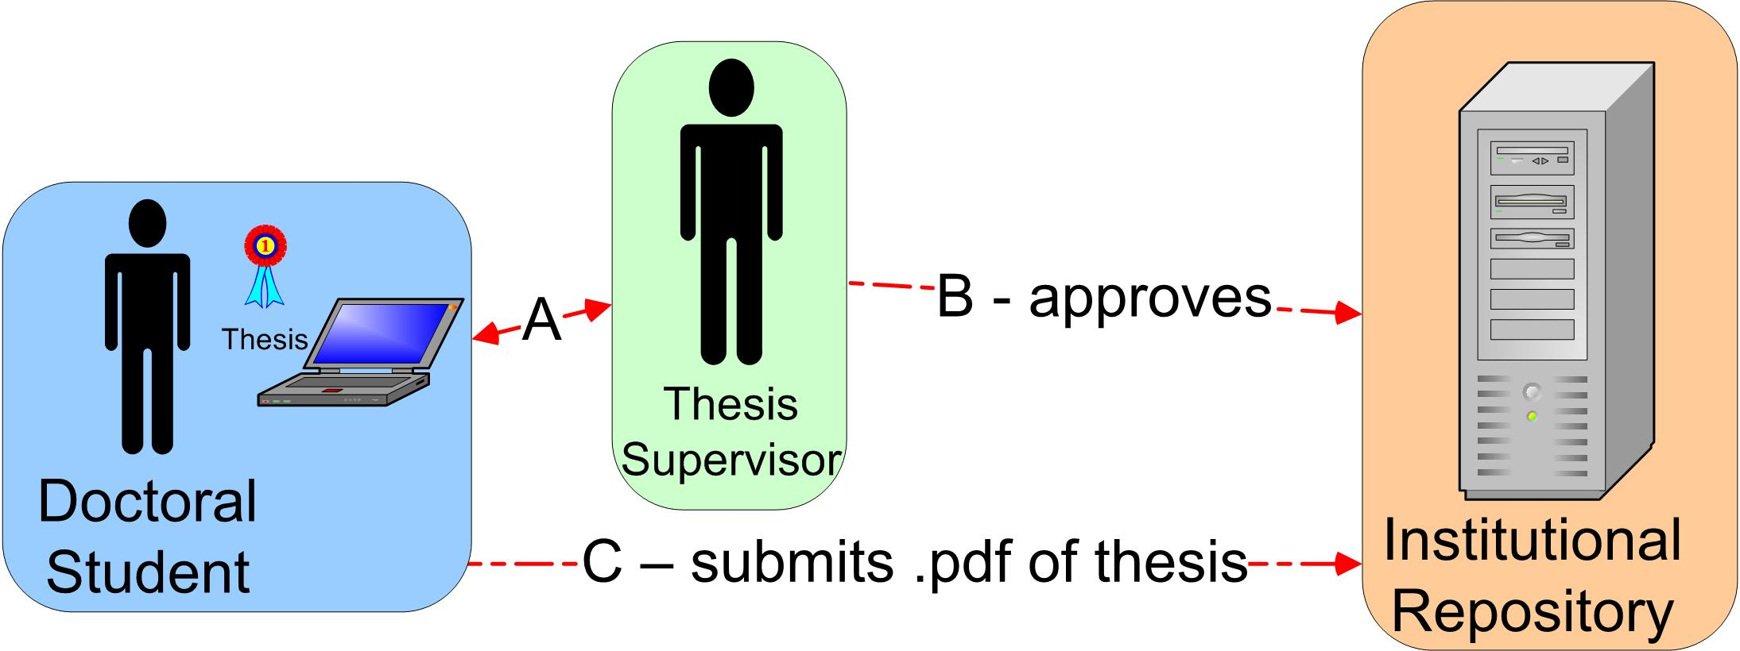
Figure 5 Ethesis interaction example

In the above figure the interactions (A) between the student and supervisor are unspecified (perhaps as they are too numerous to represent on this scale of representation or are secondary to the purposes of the diagram). The interaction B is clarified to show the interaction between the institutional repository and the supervisor (the supervisor approves the student’s thesis deposit). The interaction C has a specified resource as well as an action involved.

Resource
A resource is something that is passed from one entity to another as part of an interaction between them. This will normally be something that is essential to the wellbeing of the receiving entity. A resource may be modeled as an attribute of an interaction or as a nutrient - the choice will depend on the ecological approach chosen (implicitly or explicitly, this is explained in more detail in section 6.3). For example the DCC provides advice to the Edinburgh Research Archive about the sustainability of a mime type. This may be modelled either as:

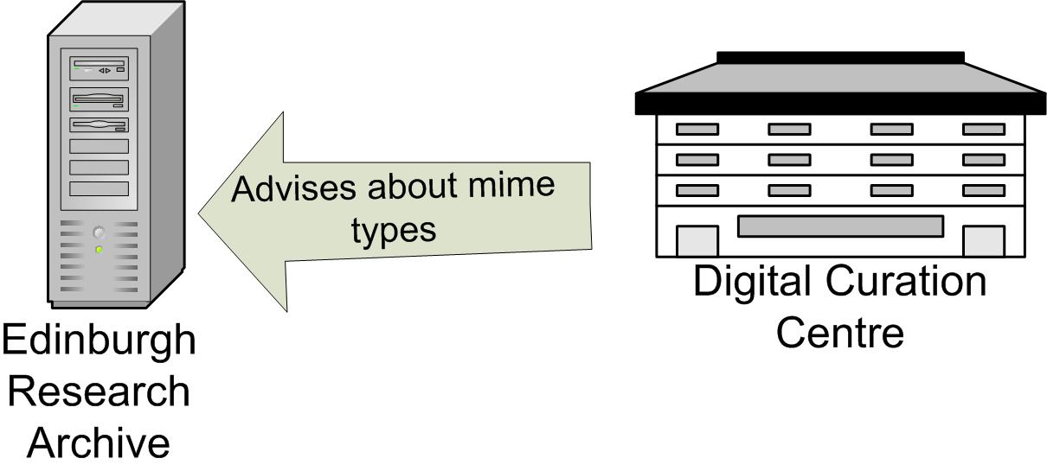
Figure 6 Resources as attributes of an interaction

or as

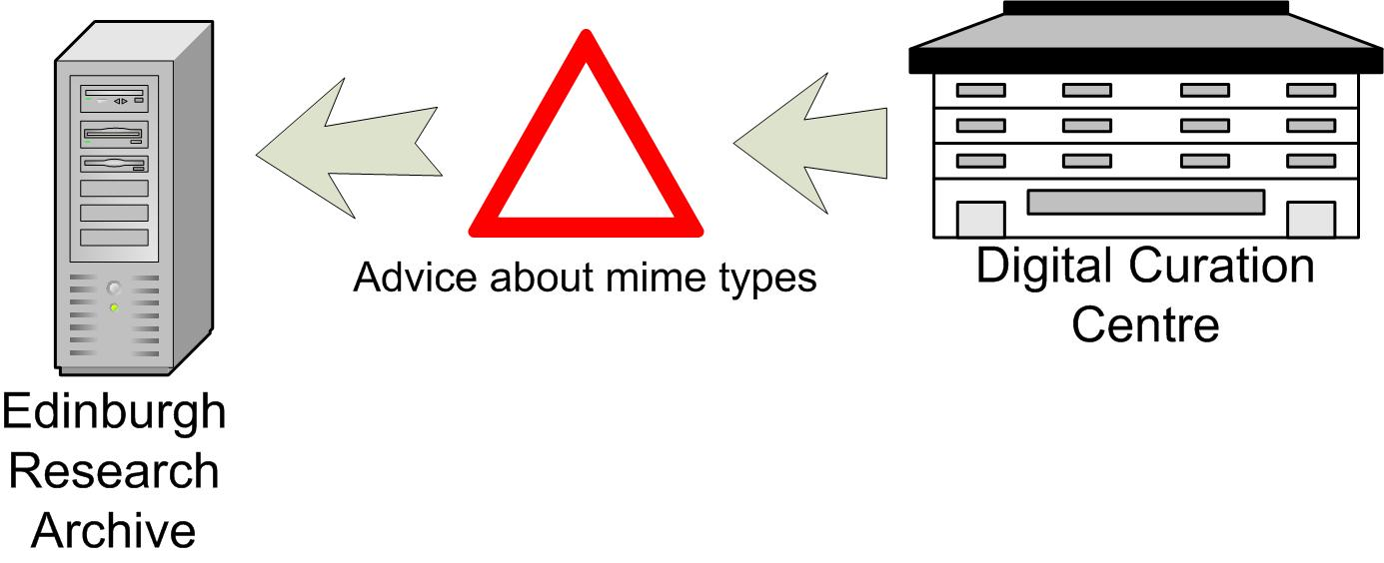
Figure 7 Resources as nutrients

In figure 6 the DCC advises the ERA, and the interaction ‘advises’ has the attribute ‘mime types’ which specifies the nature of the interaction. In figure 7 the same interaction is represented but the advice is represented as a nutrient being transferred rather than as an attribute of the interaction.

Environmental factor
An environmental factor is something that influences an entity, community, or ecosystem but is more general than an interaction between constituent entities. For example, a research council’s mandate for Open Access deposit is likely to affect the number of papers available in that subject area in a given repository community and throughout the ecosystem(s) interacting with that subject area.

It is suggested that environmental factors may usefully be refined as follows:

Biotic factors
Biotic environmental factors are effects on the community or ecosystem caused by other entities or species not represented directly within the particular community or ecosystem being studied (in the pond example, a biotic factor might be migrating predators – birds not directly part of the community being studied but which have an ongoing effect on it). Biotic factors include: competition for resources (e.g. entities can’t develop because available funding has been allocated outside of community) or suppression of competitors by other entities (e.g. political manoeuvring).

Abiotic factors
Abiotic environmental factors are effects on the community or ecosystem not caused by other entities or species (parallel with the weather or geological formations). Abiotic factors include: cultural drivers (e.g. the Research Assessment Exercise); the effect of ideals and concepts (the Open Access movement); the existence of funding (e.g. JISC funding streams), legal constraints (e.g. copyright restrictions).

Other relevant features of ecologies
There are a number of other concepts from ecology that may prove to be of use as well. The following are a selection:

Keystone
Both species and entities may be qualified by the adjective ‘keystone’. This designates a type of entity or particular entity that is essential to the growth or survival of a given community or ecosystem. For example institutional repositories are essential to the vision of an ecosystem set out by the JISC IE or The Depot is an essential component of the maturing IE ecosystem (but not part of the mature one).

Biodiversity
It is inherent in ecological systems that more healthy ecosystems display greater biodiversity – i.e. there is a wider range of species within the system. Within the domain of repositories and services a parallel exists not only in the species or repository or service present but also with respect to the overlap between the species. The benefit of this can be seen in that there is not reliance on one educational institution, one software solution, one search service. Nardi and O’Day comment that “Monoculture –a fake, brittle ecology—gives sensational results for a short time, then completely fails”. One clear example of this within the information environment is if there was a dependency on a single software solution for repositories. Different repositories have different requirements and interfaces, and manage different types of objects. A single solution might allow rapid deployment but would then tie users into only being able to follow that software’s development path.

Evolution
One of the strengths of using an ecology-based approach is that it is understood intuitively that the system is inherently dynamic. Implicit within this idea that a dynamic system is being described is the idea the components of the system change and adapt to their setting. Such adaptation or evolution may not occur at an even rate across the ecosystem in question and it may be appropriate to indicate particular communities or species that are rapidly changing. It should be noted that such change can be an intentional adaptation or a unexpected ‘mutation’ triggered by other species or environmental factors.

A species-based example of evolution was the adaptation of institutional repositories from tools to support open access to also be tools to support RAE submissions – this also resulted in a substantial growth in the occurrence of repositories and the number of papers stored. Another example of a species that may be undergoing evolution is universities’ course information systems – a proportion of the entities in this species are testing the deployment of the XCRI standard; if they are successful that species may change significantly. This implies that when creating a ecological view of part of an ecosystem, the adaptability of the participants and the rate at which a given area is changing should be taken into consideration.

Niche
Related to the above idea of evolution is the idea of a niche - a particular habitat, resource, or set of environmental factors that might exist within a given environment which would allow a particular species (or possibly a particular entity) to thrive. In the example above within some institutions the RAE created a niche for an institutional repository. Asking questions about what a particular set of conditions has made a community or population thrive is a key part of an ecological approach.

Food webs and food chains
Food webs and chains appear to have an immediate parallel with the way processes in an information environment might be represented. The idea that particular species ‘consumes’ another species has a clear comparison with the idea of a data providers and service providers. Further, the numbers of particular consumer species may be dependent on the numbers of species they consume or that consume them. There may be a useful analogy with a trophic pyramid.

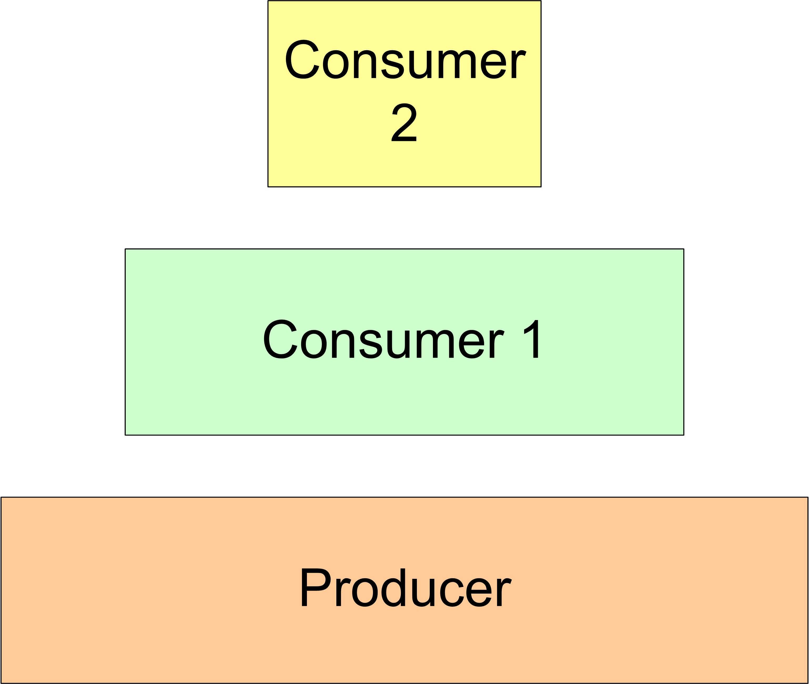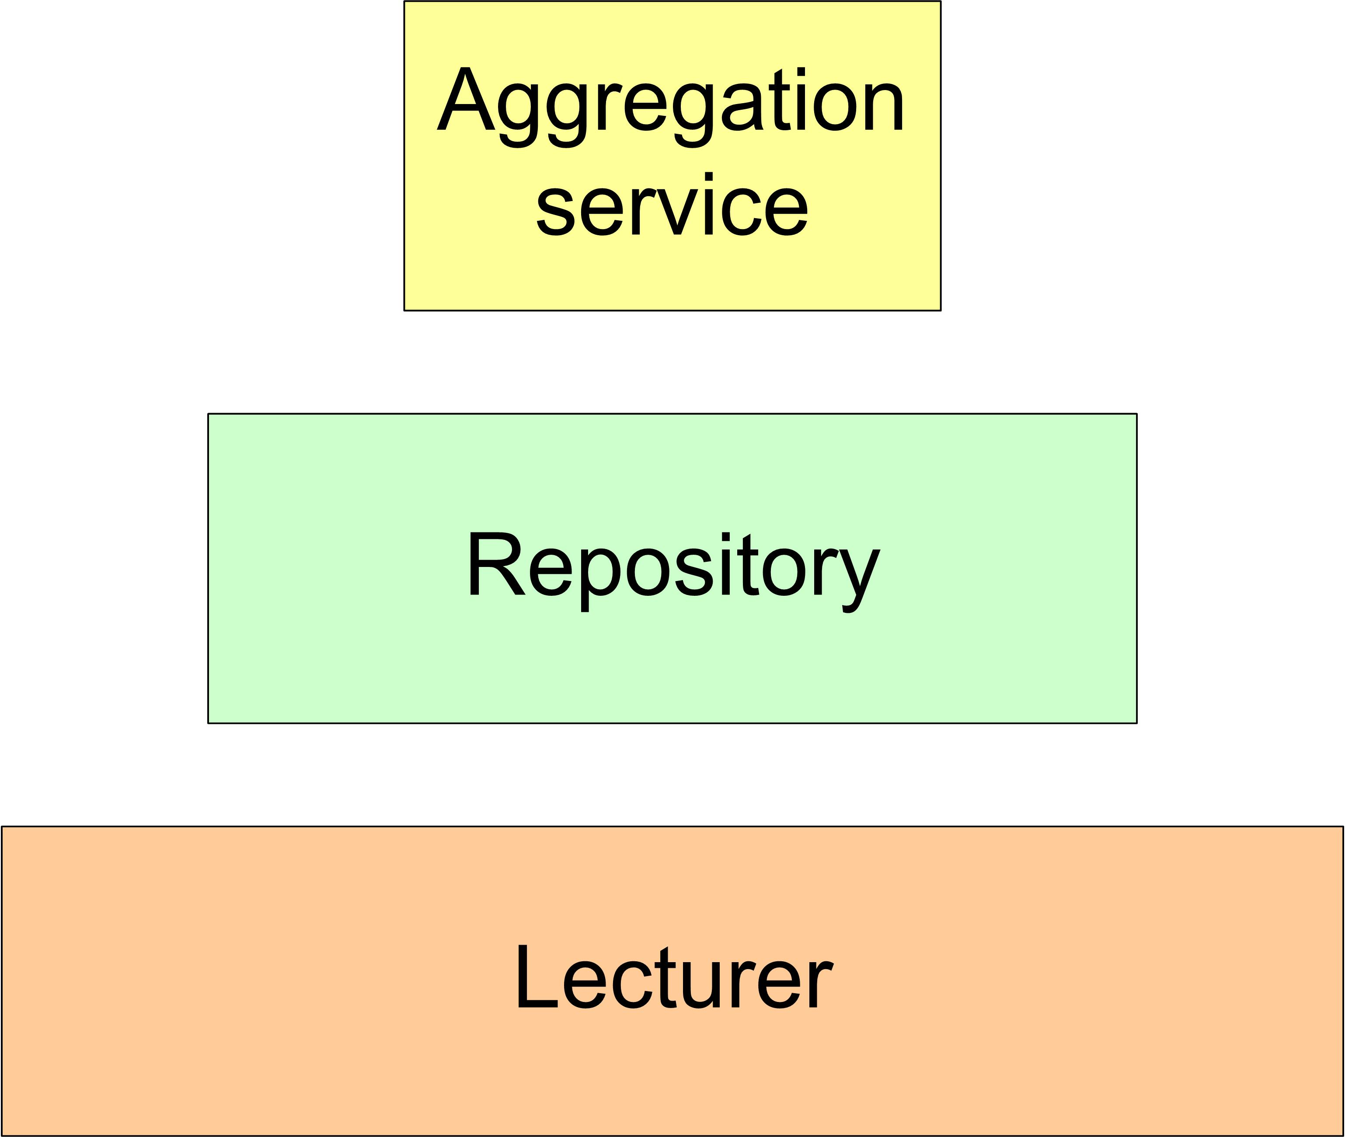
Figure 8 Trophic pyramids

Where the parallel is not quite so direct is in that the data provider is not used up by its consumption. Limits on the growth of one species in an information environment are more likely to come from other members of that species (service A gets funding and B doesn’t) or from unrelated environmental factors (available funding across the environment is decreased). The concept of a food web or chain can usefully illustrate dependencies between entities but the limits of the analogy should be remembered.

Structured uses of ecological concepts
The above are a selection of ecological concepts that resonate and assist with some of the situations participants in the information environment are attempting to describe and articulate. There is however, a further development of ecological concepts that may be of use to the JISC and developers–an approach that uses ecological methods as well as concepts. Two methods in ecology that may be of relevance are resource tracking and habitat mapping. These are very briefly outlined here and each will be the framework of an in-depth case study in future developments of this work.

Habitat mapping
Habitat or population mapping asks questions about where species or entities live. On one level this is a simple articulation of the setting a given entity finds themselves in, what other entities they interact with, what environmental factors they are exposed to, and what resources they have available. Figure 9 (below), illustrates how a food web exists in a particular environmental setting and then locates settings for that population or community at different geographic scales. Within ecology, this approach is not only descriptive but may also have a predictive purpose (the figure is from a paper examining the effect of habitat loss on species).

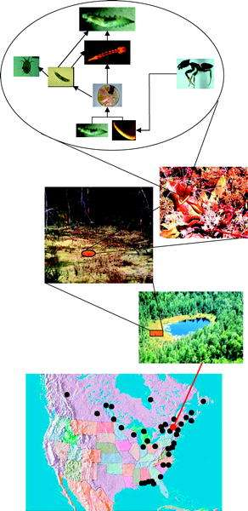
Figure 9 Gotelli NJ, Ellison AM, Food-Web Models Predict Species Abundances in Response to Habitat Change PLoS Biology Vol. 4, No. 10, e324 doi:10.1371/journal.pbio.0040324

Resource tracking
The idea of resource tracking examines energy flow or nutrient flow within the community or ecosystem under consideration. It examines how that particular resource moves around or is consumed. In the context of repositories and services this approach may be of relevance in the consideration of the distribution of expertise, information, or money. The health or the growth of the ecosystem may be reflected by the supply of nutrients to entities within it. Resource tracking will also be directly relevant when the movement of digital objects is being examined. Figure 10 (below) illustrates nitrogen cycling one form of resource tracking.

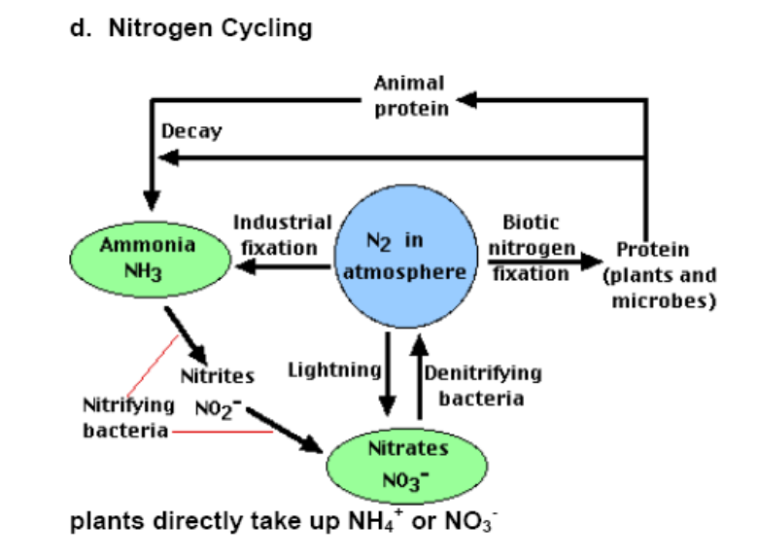
Figure 10 Fundamentals of ecology Fall 2003; lecture 9 http://ocw.mit.edu/OcwWeb/Civil-and-Environmental-Engineering/1-018JFall2003/LectureNotes/index.htm

Examples of ecological approaches.
Although fuller case studies of the use of an ecological approach will be developed, two illustrative examples are included here to suggest how these ecological approaches might be used. Example 1 presents a detailed ecological view of the eBank UK project and example 2 presents a brief ecologically-influenced overview of the DIDET project.

Example 1 An e-Crystallography dataset ecosystem
eBANK UK is a JISC-funded collaborative project between UKOLN, the University of Southampton, Intute and the University of Manchester. It brings together an interdisciplinary team of chemists, digital librarians and computer scientists to explore the potential for integrating crystallography research datasets into digital libraries. It fits well into the scholarly knowledge life cycle by linking data, teaching, and research with publication.

eBANK UK has successfully demonstrated the potential interactions of data-storing institutional repositories with data centres and commercial providers of data, especially in areas relating to the discovery and reuse of data. There are, however, very few examples of institutional repositories which are actually storing subject specific datasets in systematic ways and exposing their contents for discovery and reuse. The project is currently in its third phase:

Phase 3 of the project (2006 – 2007), is the preliminary scoping of a global network of data repositories - an eCrystals federation. This report is particularly interested in investigating what light an ecological perspective can shed on this potential ‘dataset ecosystem’.

Identifying a scale
From an ecological perspective it is worth considering eBANK UK (Phase 3) on at least three different scales: population, community, and ecosystem.

Population: the institutional dataset repository scale
An institution (or a department within it) makes a commitment to create a repository of datasets through the identification of resources (e.g. funding, human resources, equipment). The repository can then be populated through a number of means, e.g. as part of the workflow of an experiment, where the laboratory equipment is directly inputting data into the repository and collecting datasets from previous experiments.

Community: the institutional federation scale.
Institutional repositories containing datasets about crystallography federate their contents (through OAIPMH) and the institutions themselves work together to share resources and collaborate on issues such as training, curation, preservation, and policy development. Each participating institution requires sufficient resources and structures in place to support the population of their repositories with the relevant datasets and associated metadata within institutions. For example, each piece of laboratory equipment deposits data and metadata directly into a repository; this data (or at least the metadata) is then shared between institutions.

Ecosystem: eBank UK – the national scale
The ecosystem of dataset repositories developed in eBANK UK captures the interactions of an institutional crystallography dataset repository federation with publishers and other services such as aggregators and other dataset repositories outside the federation. For example, eBANK UK has successfully demonstrated how the underlying data from an experiment can be made available in or through a publication. Such interactions also indicate that the connections that might exist between a data ecosystem and other ecosystems; for example, those in the print publications world.

Here we can see three scales represented.
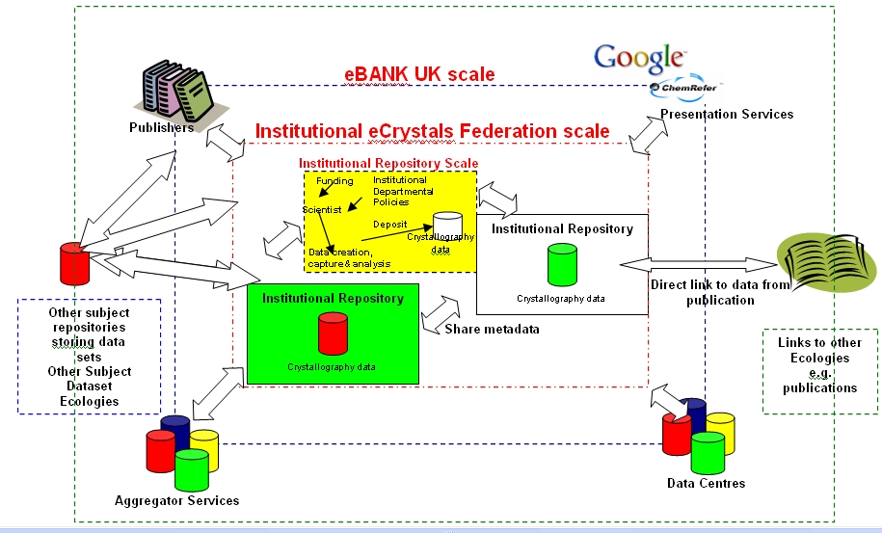
Figure 11 eBANK UK at different ecological scales

Dataset Species
At the Institutional Data Repository level, species are:
- Users | - Scientists | - Institutional Repositories
- Funders | - Metadata | - Datasets (Crystallography)
- Researchers | - Relevant Institutional Stakeholders

At the Institutional Data Repository Federation level, species are;
- Users | - Scientists | - Institutional Repositories
- Funders | - Metadata | - Datasets (Crystallography)
- Researchers | - Policy makers | - Aggregator services

At the eBankUK Model level
- Users | - Scientists | - IR Federations
- Funders | - Datacentrers | - Datasets
- Researchers | - Publishers | - Aggregator services
 |  | - Presentation / Portal services

eBank UK interactions
For each scale within the eBank UK ecosystem, real and potential interactions have been detailed below. It is useful to identify potential interactions to assess how they might help the population, community, or ecosystem flourish. For example, in eBANK UK the symbiotic relationship between institutions holding crystallography datasets and data centres is vital for the success of the ecosystem and needs to recognised and nurtured. The species and interactions of the dataset ecosystem are discussed in detail in the recent report ‘Dealing with Data’..

Interactions at the institutional dataset repository level
Species, | Direction of interaction | Species, | Type of interaction
Lab Machine | ⇨ | Lab Repository | Deposit
Lab Repository | ⇨ | Institutional Data Repository | Deposit and Validation  Data Analysis
Chemistry Blog | ⬄ | Institutional Data Repository | Deposit, Share. collaborate
Scientist and Researcher | ⬄ | Lab Repository, Institutional Data Repository | Deposit, Discover, Re-use, administer
Funder | ⬄ | Scientist | Capture data, make data available
Dataset | ⬄ | Publication | Link

Interactions at the federation level
Species, | Direction of interaction | Species, | Type of interaction
Institutional Data Repository (A) | ⬄ | Institutional Data Repository (B) | Curate, Policy Development, Preserve, Develop Standards, Share Advocacy, Share Training
Institutional Data Repository (A) | ⬄ | Institutional Repository Dataset Federation | Validate, search, Harvest, Expose Records and Metadata
Users | ⇨ | Institutional Repository Dataset Federation | Discovery, Reuse, Linking, Citation
Presentation services (Google Scholar, CiteSeer, ChemRefer) | ⇨ | Institutional Repository Dataset Federation | Discovery, Reuse, Linking, Citation
Funder | ⬄ | Institutional Repository Dataset Federation | Capture data, make data available, make federation possible
Aggregator Service | ⬄ | Presentation Service | Data discovery, linking and citation
Publishers | ⬄ | Aggregator Services | Search and harvest
Subject Repository | ⬄ | Aggregator Services | Search and Harvest
Institutional Repository | ⬄ | Aggregator Services | Validation, search, harvest
Institutional Repository Dataset Federation | ⬄ | Library and Information Services | Harvest, expose, discover, citation
Institutional Repository | ⬄ | Publishers | Citation, Publish, discover

Interactions at the eBANK UK level
Species, | Direction of interaction | Species, | Type of interaction
Institutional Repository Dataset Federation | ⬄ | Library and Information Services | Harvest, expose, discover, citation
Institutional Repository | ⬄ | Publishers | Citation, Publish, discover
Institutional Repository Dataset Federation | ⬄ | Data Centre and Aggregator Services | Harvest, expose records and data
Institutional Repository Dataset Federation | ⬄ | Digital Curation Centre | Advisory

An eBank UK food web
The interactions with an eBank system could be viewed as simple food web.
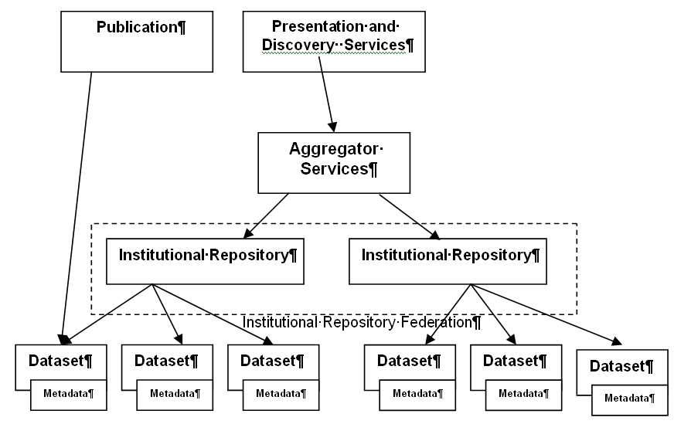
Figure 12 eBank food web

The food web shows how different species are ‘consuming’ others who are acting as nutrients. Although the figure is quite like an architectural representation of harvesting it should be noted that the interactions may also reflect processes other than technical ones (i.e. harvesting). There are also possible ‘chemical’ interactions between nutrients, e.g. data and metadata which could be analysed.

Environmental factors in the eBank ecosystem

Biotic factors
Biotic factors which benefit eBANK UK include:
- ‘Will and motivation’ i.e. agreement amongst community that it should happen (i.e. right conditions)
- Bringing together of multidisciplinary team
- Homogeneity of datasets within the field of crystallography compared to the heterogeneity of datasets in other disciplines (e.g. physiology) which allows the easier implementation of dataset repository
- Funding

Biotic factors potentially hindering the eBank UK ecosystem include:
- Competition for resources from eprint repositories (Resources such as :finance, storage space, infrastructure or expertise).
- Potential institutional immaturity in storing and exposing datasets locally.

Abiotic factors
Abiotic factors benefiting the eBank UK ecology include:
- the Research Assessment Exercise (stating that all publications submitted for the exercise make their underlying data freely available)
- the Open Access movement (arguing that all publications should make their underlying data freely available).
- the Guardian newspaper campaign ‘Free our data’ (arguing that publicly-funded data should be freely available- with particular (but not exclusive) focus on Geospatial data )

Abiotic factors potentially hindering the eBank UK ecosystem include:
- a lack of clarity about dataset ownership within institutions
- copyright restrictions,
- other legal or ethical constraints,
- embargo periods (researchers or others wanting to restrict access to their data for an initial period)

Biodiversity
It could be suggested that eBANK UK represents a monoculture. and, though very successful, might be fragile in the longer term. Consequently an important question, highlighted by an ecological approach is whether the conditions created to make eBank UK successful (e.g. funding, conditions, level and quality of interactions) can be sustained and replicated in other environments with the establishment of other subject specific institutional dataset repositories and federations. Does eBank UK resemble a monoculture because something within the design makes it so, or is it because it is the first such ecosystem to be developed (and is therefore a prototype for future institutional dataset repositories)

eBank UK: resource tracking
There are many resources that are passed between entities at different levels in the eBank UK ecosystem. They include the funding required to set up an institutional dataset repository, user training materials, the datasets themselves, their associated metadata.. If such resources are viewed as nutrients their movement around the ecosystem can be tracked. Such an approach facilitates an understanding of what has been or is needed to help the system thrive, through asking questions like “Has this repository entity benefited from resources provided by others? If so where did the resources come from? Are they available to a other entities in the ecosystem?”

It would be interesting to examine how datasets move and are transformed through an ecosystem, and what effect this may have, for example on their increased use perhaps, again this is something that could be modelled and simulated mathematically e.g.
- does the adding of quality metadata increase discovery and reuse
- is analysed data more used in an ecosystem
- is the way datasets are disseminated important to the way it is discovered

Ecology can perhaps provide a fresh way of looking at existing systems and the interdependencies between entities.

Dataset Ecology Diagrams
The final section of the eBANK UK model presents diagrams before and after an ecological approach has been applied.
















CreateDeposit
Link
Curate Preserve Standards
Scientist
Funder
Collaborate Share
User
Discover Re-use
eCrystals Federation Data Deposit Model
Before Ecological Modelling
Link
Link
Scientist
Policy AdvocacyTraining
Harvest
IR Federation
Publishers
Data centres / aggregator services
Advisory
Slide courtesy of Dr Liz Lyon, UKOLN, taken from the ‘Dealing with Data’ report
CreateDeposit
Link
Standards
Scientist
Funder
Collaborate Share
User
Discover Re-use
eCrystals Federation Data Deposit Model
After Ecological Modelling
Link
Link

Harvest
Publishers
Data centres / aggregator services
Advisory Bodies
Institutional DataSet repository
IR Dataset Ecosystem
Dataset
Funding
Deposit
Scientist
Expose Contents, Metadata
Institutional DataSet repository
Institutional DataSet repository
Organisational DataSet repository
Institutional DataSet repository
Policies
Curate
Preserve
Policy
Advocacy
Advocacy
Training
Web 2.0 technologies
Publications Ecosystem
Open Access, Funding Council Mandates
ABIOTIC FACTORS
Competition for resources
Biotic factors
Other Ecosystems
IR Federation Ecosystem
eBANK UK Ecosystem

Example 2: the community of a learning environment
The DIDET project is a JISC and NSF funded project led by the University of Strathclyde, Stanford University and Olin College. It has developed strategies for collaborative classrooms in design-engineering supported by a software tool based on wiki technology. The classes offered by the participating departments allow “students to participate in global team-based design engineering projects that give them experience of working within multi-cultural contexts and enable them to develop global design team working skills.”

The project approach has been successful and is now integrated into the regular design engineering curriculum of the partners. During the development, however, issues about information literacy, copyright, and the relationship between the formal and informal digital spaces (the workspace and the library) proved unexpectedly complex. The following ecological view of DIDET attempts to capture some of this complexity and to note some questions that emerge from a consideration of this ecology.

As an ecological view, a consideration of a supported design engineering course using the LauLima Learning Environment (LLE) and LauLima Digital Library (LDL) developed by DIDET is probably usefully considered at two different scales: initially as a small community and subsequently as a participant in a wider ecosystem. Its initial analysis at community-level presents a view of how DIDET works and the secondary analysis illustrates how this fits into the wider information environment.

The species within the community are students, lecturers, design coaches, and support staff, repositories with integrated services, and external collaborative services supporting collaboration (such as a video conferencing tool). The basic entities are specific students (A, B, C, D); lecturers (J, K), a coach (F), LauLima support (L), the LLE, the LDL, and other tools for collaboration (Polycom VC, Flashmeeting, etc.). Within this community all the species can be considered as keystone species – early plans to provide the functionality of the LLE and LDL within one system or to use the system without a human review of assets during the migration process between the LLE and LDL had to be revised in light of potential problems with Intellectual Property Rights (IPR) and with the need to enhance user-created metadata.

Some biotic environmental factors present in the DIDET community are: the role of assessment in the collaborative design project (students who are assessed their design process, as presented in the LLE, as well as on their final design will interact with it differently); the support of senior university staff (Lecturers whose online contact time is counted as part of their overall contact time commitments may engage more extensively). Some of the abiotic environmental factors are: the effect of finite project funding (sustainability issues have influenced the design of the community); the cultural differences between the groups of students; the effect of working in different time zones on collaboration, and the effect of IPR legislation on collaboration.
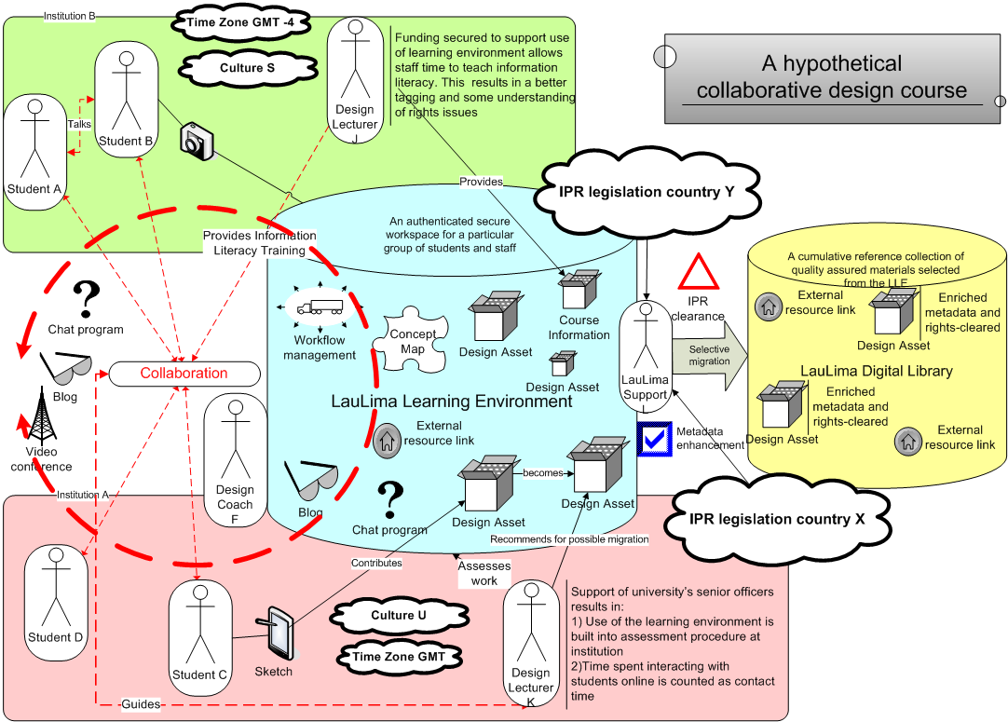
Figure 13 A DIDET community
The DIDET community exhibits a degree of biodiversity in the selection and use of tools for collaboration. Students are free to supplement the LLE as they wish, but resources created externally can then be referenced by or submitted to the LLE or LDL for more permanent use.

If the community developed by DIDET is considered within its wider setting, a number of questions emerge from an ecological model. The below figure considers the effect of IPR factors on the environment of the LLE and LDL and their users.

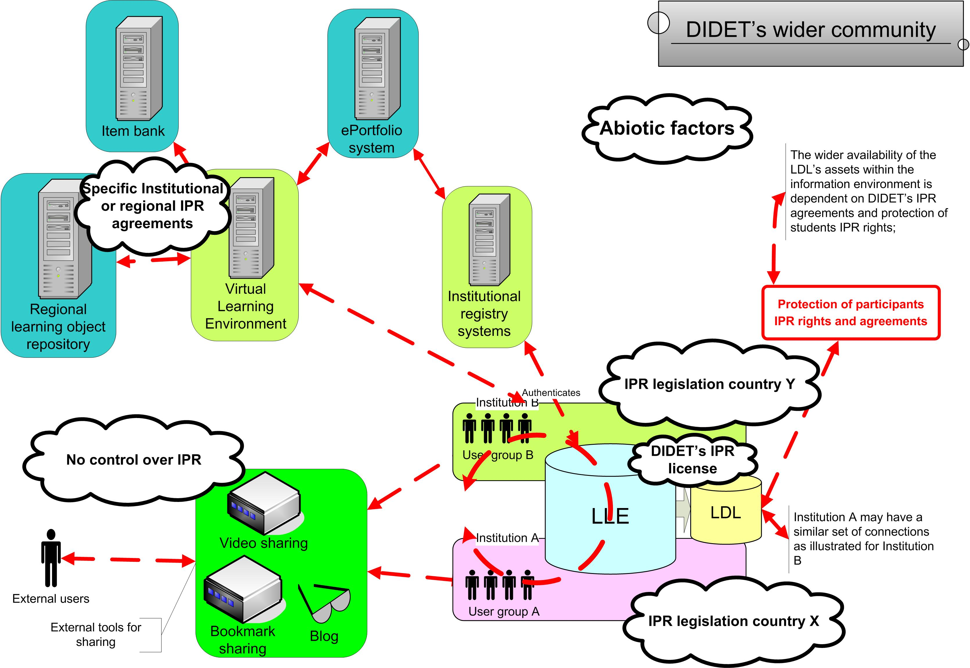
Figure 14 DIDET's wider community

DIDET has very successfully identified a niche and established a mechanism for multi-institutional collaboration within a discipline. Within a least one institution it has been able to integrate the use of local authentication tools – this adaptation to existing components of the one of the host communities makes participation in the LLE more straightforward.

IPR is a key abiotic factor when the exposure of design assets generated in the course is considered. Both when students share them in an uncontrolled manner and when the LDL considers making some of these assets available to either future students within the LLE or to a wider student body. A further consideration of the influences that IPR has on the community might be illustrated by tracking resources (such as an assessment item or a textual excerpt) as they move through influence of the different IPR environments.

An ecological view of DIDET presents the complexity inherent in a collaborative classroom. At a community-level the technological entities, pedagogical processes, and legal factors involved in the classroom are articulated together and when DIDET is considered as part of a wider ecosystem some of the challenges of managing learning materials in the context of a distributed classroom are highlighted.

A bigger picture: how does this approach fit with existing work?
The wealth of existing work within the repository space has created a degree of divergent approaches and terminological confusion in communicating how information and repository systems interact with each other, with other systems, with people, and of how the flow of information resources is managed. Knowledge and use of existing reference models, architectures and frameworks is often either geared towards members of specific communities, e.g. digital preservation, space science, e-learning or e-assessment or focused purely on technical architecture, without reference to the dynamics of a living system.

The ecological metaphor introduces a new set of terminology to this already crowded space. This section of the report aims to explore, briefly, how an ecological approach aligns with existing work and how it might be used to support and enlighten, rather than duplicate.
  - A repository community as a reference, or domain, model
There has been considerable discussion of reference models over the last few years and debate over what a reference model actually is. One well-known example is the Reference Model for an Open Archival System (OAIS), which is aimed at information systems wishing to undertake long-term preservation. It defines a reference model as “A framework for understanding significant relationships among the entities of some environment, and for the development of consistent standards or specifications supporting that environment. A reference model is based on a small number of unifying concepts and may be used as a basis for education and explaining standards to a non-specialist” . The OAIS reference model is very much an abstract framework and communication tool, working at a high level to specify functions and concepts, within the context of long-term preservation. Recent work has shown that its applicability goes wider than that as it identifies an environment containing consumers, producers, repository functions and information flow common to many repositories, whilst bringing with it a heightened awareness of preservation issues. OAIS might prove useful for repositories wishing to communicate or audit their internal functions. Its focus, though, is on the ‘archive’ or ‘repository’ as a single system and it lacks support for defining and understanding the ways in which repositories interface with each other and with other systems. This is a natural point where the repository ecology and OAIS might interface, with the ecology scaling up from the organism to the population and community.

The use of ecological terminology might easily be mapped to many of the concepts within OAIS. Looking ecologically at OAIS, we can already see a clear link between our notion of ‘community’ and the designated community concept in OAIS. The OAIS functional model already specifies a range of interactions within, and potentially between, systems and it is easy to see that issues like a mime type ceasing to be supported might be considered as an environmental factor.

Recent work within the e-Framework has embraced the notion of domain models or maps. This work takes a much wider view than the OAIS definition of a reference model, extending the high-level informative abstractions, through process-oriented and human elements to low-level normative detail. Bill Olivier defines a domain as “a coherent area of practice” and outlines various identifies the following elements of a domain model:

0 Boundaries of the domain
1 Related domains (context)
2 Domain stakeholders
3 Domain roles
4 Domain aims/purpose
5 Domain top level functions
6 Domain scenarios (human)
7 Domain practices and processes models (bridge)
8 Use cases (interaction with ICT)
9 Domain information models
10 Domain ICT System models

An ecological approach provides a complementary mechanism for considering and framing many of these elements. Community or ecosystem diagrams can act as informal maps of the domain whilst concepts such as ‘species’ and ‘entities’ are useful when classifying and identifying both the human stakeholders, user agents and services within different systems. Relationships, workflows and service interoperability can also be usefully explored as interactions through the repository ecology.
  - A repository ecosystem and the JISC Information Environment
This report has already discussed why the architectural models set out as part of the development of information environments can benefit from supplementary models or approaches. This section reviews how an ecological approach can interact with the JISC Information Environment (IE).

An Information Environment is a mechanism for identifying and bringing together individuals, organisations and systems that ingest, store and disseminate information, along with the information resources themselves. For JISC, its own IE is identified as a core theme, aiming to “allow discovery, access and use of resources for research and learning [in the context of UK Higher and Further Education] irrespective of their location.”

The JISC Strategy for 2007-2009 outlines three principles for technology development: community engagement, open standards and modularity. The IE supports these three principles by providing an abstract architectural view of the wider information landscape in which we are working, helping to frame discussions, service development, funding, to engage the community, to provide a common view and to guide on the use of technical standards. Demonstrating a commitment to enhancing the user’s experience of networked information in an educational context, the IE is best illustrated by the diagram produced by Powell and Beagrie (figure 13).

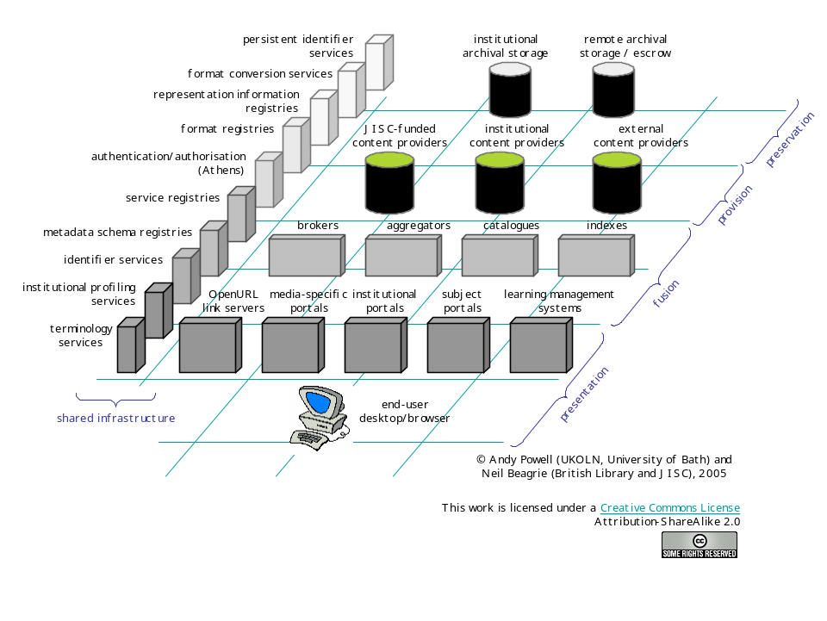
Figure 15 The JISC Information Environment
From this diagram it is clear that the IE is awash with ‘species’, species that are gradually being realised as ‘entities’ as identified earlier (the IESR, the Depot and so on). It is suggested that considering an ecological view at the levels of population, community, and ecosystem can help conceptualise the IE for repositories and services and also help us navigate and understand this complex, unpredictable and changing landscape using well-defined ecological concepts. Although the terminology may differ, the advice ecology can offer is easy to see:
the provision of as extensive a system of varied habitats, each with its complex food-web in as many locations as possible, is increasingly being considered desirable in a nation's environment provision. In this way, a wide variety of species numbers (biodiversity) is maintained, habitats are more attractive and species of potential use to mankind are preserved. In addition, a society that bequeaths its natural habitats and ecosystems to future generations in an acceptable varied, useful, and pleasant condition, is contributing to the sustainable development of that nation.
  - An ecological approach and the e-Framework
Movement towards service-oriented approaches (soa) has impacted on the JISC strategy and IE and the increased awareness of the need to modularise service delivery and to integrate disparate systems and specifications has led to the development of the e-Framework for Education and Research. A joint initiative of the UK’s Joint Information Systems Committee (JISC) and Australia’s Department of Education, Science and Training (DEST), the primary goal of the e-Framework is “to facilitate technical interoperability within and across education and research through improved strategic planning and implementation processes” . In this context, ‘service’ refers to technical services that are used to build true interoperability between systems, rather than the looser concept of a service used by the IE. Service Usage Models, a core element of the e-Framework and can be succinctly described as a model of how services meet business needs.

The ecological view of repositories and services could be seen to sit between the IE and the e-Framework, offering a kind of extended Service Usage Model, drawing together many additional user-focussed elements that might be drawn together in the domain map or model envisioned by Bill Olivier. It can offer a concrete example of both IE and e-Framework services in active use and could similarly be used to identify areas where services are lacking or where opportunistic species are damaging the ecology. Again, using ecological concepts offers a useful impartial set of terms for describing services and a mechanism for generating cross-domain empathy.
  - An ecological approach and other work on repository interactions
Ecology offers a neutral metaphor for examining the complex interactions between people and systems. It can be used by repository managers, implementers, developers, funding agencies and users for communication and understanding. If it proves useful it might be applied to other aspects of the JISC Information Environment and beyond. There is, though, other activity which is working within a similar realm. There is not space in this report to cover these in detail. Indeed, the detailed sections above provide only a glimpse of the complexity and effort involved in developing architectures and models. But it is worth pointing to existing and ongoing work, as a placeholder for further effort to draw connections between these and an ecology-based approach.

Kerry Blinco’s ‘Wheel of fortune’ is one example of a successful visual aid for communicating the types and interlinking factors within a repository ecosystem that are combined within each individual repository. Work on repository typology in Heery and Anderson’s ‘Digital Repositories Review’ and since then within the Repositories Research Team has attempted to further document these types and parameters, each of which could be viewed as ‘environmental factors’ or as the beginnings of a sub-set of typed ecologies.

Work on architectures like CORDRA and aDORE could be envisioned in ecological terms, acting as elements of an overall ecosystem. Other reference models, such as the DELOS manifesto for digital libraries provide additional frameworks for repository development and could impact on the structure of our ecosystem. The OAI-ORE project, funded by the Mellon Foundation in the U.S., is looking at developing specifications to support the exchange and re-use of compound information objects across systems. This offers a good example of an entity whose resulting outputs may have significant impact on objects and interactions within a repository ecosystem, just as OAI-PMH has had on the exchange of metadata between repository and other systems.

Ecology is not a new concept. As a metaphor it has the benefits of being instantly recognisable to everyone – our own environment and the ecologies within that are all around us. Its usefulness for the repositories space is in helping to make connections, to link technical complexity with non-technical complexity and offer a more neutral platform for understanding and communication. We believe it is a natural partner for the Information Environment and offers a neat bridge between the IE and the service-oriented approaches of the e-Framework, drawing together, along the way, on a set disparate resources - scenarios, use cases, documented workflows and more - that together can help document and develop repository provision across the world.

Further reading
  - Bonnie A. Nardi, & Vicki L O’Day, First Monday Vol 4 No 5 May 3, 1999. Information ecologies: using technology with heart. Chapter Four: Information ecologies. http://www.firstmonday.org/issues/issue4_5/nardi_chapter4.html
  - Thomas H. Davenport, Information ecology, OUP, 1997
  - R. Heery & A. Powell, Digital Repositories Roadmap: looking forward http://www.ukoln.ac.uk/repositories/publications/roadmap-200604/
  - Rachel Heery and Sheila Anderson, Digital Repositories Review, UKOLN and AHDS, 2005 (Final version)
http://www.jisc.ac.uk/uploaded_documents/digital-repositories-review-2005.pdf
  - Kerry Blinco & Neil McLean, “A 'Cosmic' View of the Repositories Space (Wheel of Fortune)”, 2004, http://www.rubric.edu.au/extrafiles/wheel/main.swf
  - Paul Miller "Interoperability. What is it and Why should I want it?" Ariadne Issue 24, 2000: http://www.ariadne.ac.uk/issue24/interoperability/intro.html
  - R. John Robertson, Anthony Troman, Paul Needham and Susan Copeland, “Repository Ecology: EThOS, the new UK e-theses service, national and institutional repository interaction”, Presentation at JISC Conference, 13th March 2007, http://www.jisc.ac.uk/events/2007/03/event_conf_0307/abstract_ethos.aspx
  - R. John Robertson, “Repository ecologies” Presentation at OAI 5, April 2007, http://indico.cern.ch/materialDisplay.py?contribId=11&amp;sessionId=10&amp;materialId=slides&amp;confId=5710

Related work

  - J. Barton & R.J. Robertson, “Developing a metadata lifecycle model” Workshop at CoLIS 5, June 2005, http://mwi.cdlr.strath.ac.uk/Colisworkshop.htm
  - Anoush Margaryan, Sarah Currier, Allison Littlejohn, & David Nicol, Report on Learning Communities and Repositories, Community Dimensions of Learning Object Repositories, 2006, http://www.ic-learning.dundee.ac.uk/projects/CD-LOR/CDLORdeliverable1_learningcommunitiesreport.doc
  - R. J. Robertson & J. Barton, "Optimising Metadata Workflows in a Distributed Information Environment", Digital Repositories: Interoperability and Common Services, The Foundation for Research and Technology, 11-13 May 2005 , Hellas (FORTH), Heraklion, Crete, 2005, http://delos-wp5.ukoln.ac.uk/forums/dig-rep-workshop/robertsonbarton.pdf

This work is licenced under the Creative Commons Attribution-Non-Commercial-Share Alike 2.5 UK: Scotland License. To view a copy of this licence, visit http://creativecommons.org/licenses/by-nc-sa/2.5/scotland/ or send a letter to Creative Commons, 171 Second Street, Suite 300, San Francisco, California 94105, USA..
http://www.jisc.ac.uk/whatwedo/themes/information_environment.aspx
This section of the draft report presents a case why an architectural model is not, on its own, enough, a fuller version of this section will present a similar case with respect to a service oriented approach or domain modelling approach (as instanced in the eFramework, http://www.e-framework.org/ )
ecology. (n.d.). Dictionary.com Unabridged (v 1.1). Retrieved June 08, 2007, from Dictionary.com website: http://dictionary.reference.com/browse/ecology
Joe Lewis (n.d.) , Pond Ecology, Yale-New Haven Teachers Institute Curriculum Unit 92.05.07 http://www.yale.edu/ynhti/curriculum/units/1992/5/92.05.07.x.html
“Relating to the feeding habits of different organisms in a food chain or web” trophic. (n.d.). The American Heritage® Science Dictionary. Retrieved June 28, 2007, from Dictionary.com website: http://dictionary.reference.com/browse/trophic
“2. Associated with or derived from living organisms. The biotic factors in an environment include the organisms themselves as well as such items as predation, competition for food resources, and symbiotic relationships.” biotic. (n.d.). The American Heritage® Science Dictionary. Retrieved June 28, 2007, from Dictionary.com website: http://dictionary.reference.com/browse/biotic ; “Not associated with or derived from living organisms” abiotic. (n.d.). The American Heritage® Science Dictionary. Retrieved June 28, 2007, from Dictionary.com website: http://dictionary.reference.com/browse/abiotic
Chisholm and Schaider, (2003) “Fundamentals of Ecology, Fall 2003”, Cambridge, MA: MIT, http://ocw.mit.edu/OcwWeb/Civil-and-Environmental-Engineering/1-018JFall2003/CourseHome/index.htm
Davenport, T., & Prusak, L. (1997). Information Ecology. Oxford: Oxford University Press.
Nardi, B., & O'Day, V. (2000). Information Ecologies. Cambridge: The MIT Press.
Dave Cormier (2007) “Building Ecologies - Making room for communities and networks” Dave’s Educational Blog http://davecormier.com/edblog/?p=107
George Siemens (2007) elearnspace http://www.elearnspace.org/blog/archives/002930.html
It should be noted that in taking an ecological view of repositories and services they are regarded as ‘living’ entities within the ecosystem (more detail in the Entities section (5.2.2)
An entity is therefore more narrowly defined than a W3C resource:, defined as “anything that has identity” to include abstract concepts that might capture these factors (http://www.w3.org/TR/2002/WD-webarch-20021115/#glossary-resource ).
The utility of each of these ways of modelling resources will be refined by further case studies (ongoing over the summer). It is as yet unclear if both are necessary. A related issue, being investigated in parallel with these further studies is whether or not resources are entities.
The Depot (http://depot.edina.ac.uk/ ) provides an interim repository service for ePrints. It serves UK academics whose institutions do not yet have a repository and a redirection service for those whose do but are unaware of it. Once the information environment matures an interim repository should not be required.
See also Nardi and O’Day, 53-4
Ibid, 51. Note: as yet this contention that monocultures are unhealthy is not proven in the context of repositories and services.
See also Ibid, 51-2
Initial XCRI programme: http://www.jisc.ac.uk/whatwedo/programmes/elearning_framework/elfref_mmu.aspx ; Ongoing XCRI implementation and development work http://www.xcri.org/
Food-Web Models Predict Species Abundances in Response to Habitat Change Gotelli NJ, Ellison AM PLoS Biology Vol. 4, No. 10, e324 doi:10.1371/journal.pbio.0040324; One of the possible future benefits of examining ecosystems is the potential to generate some forms of mathematical models and simulations. Attempting to capture the rules and properties which determine the way species behave and interact with one each other, how they respond to nutrients, how they are effected by abiotic and biotic factors, what environmental impact they have on the ecosystem etc. Such mathematical models and simulations could enable developers or funders to generate predications of what might happen to the ecosystem in response to changes in the properties of organisms, species, populations and communities and their interactions. This area of modelling and simulating changes is a key area of ecology proper and it may have some application in the repository environment.
http://www.ukoln.ac.uk/projects/ebank-uk/
Lyon, L. eBANK UK: Building the links between research data, scholarly communication and learning. Ariadne July 2003, http://www.ariadne.ac.uk/issue36/lyon/
There are, of course, other scales at which dataset repositories could be considered.
Liz Lyon (2007) Dealing with Data http://www.jisc.ac.uk/media/documents/programmes/digital_repositories/dealing_with_data_report-final.pdf
http://www.freeourdata.org.uk/
http://www.didet.ac.uk/
It should be noted that this section is the authors’ perspective on DIDET and does not represent DIDET’s view.
Consultative Committee for Space Data Systems (2002). Reference Model for an Open Archival Information System (OAIS). Blue Book, January 2002. Retrieved 2005-04-20, from: http://ssdoo.gsfc.nasa.gov/nost/wwwclassic/documents/pdf/CCSDS-650.0-B-1.pdf
For further information refer to Allinson, Julie, OAIS as a reference model for repositories : an evaluation, UKOLN, November 2006 http://www.ukoln.ac.uk/repositories/publications/oais-evaluation-200607/
Olivier, Bill, ‘Domain, Process and Service Usage Models’, JISC e-Learning Focus, February 2007 http://www.elearning.ac.uk/resources/Domain%20Process%20and%20Service%20Models.doc/file_view
ibid
JISC Information Environment http://www.jisc.ac.uk/ie
JISC Strategy 2007-2009 http://www.jisc.ac.uk/media/documents/about_us/strategy/jisc_strategy_2007-2009.pdf
Adams, C.R., Bamford, K.M. and Early, M.P. Principles of Horticulture. Butterworth-Heinemann, 2002, p.5
The e-Framework for education and research http://www.e-framework.org/
Blinko, Kerry and McLean, Neil. 'A 'Cosmic' View of the Repositories Space (Wheel of Fortune)', 2004 http://www.rubric.edu.au/extrafiles/wheel/main.swf
Anderson, Sheila and Heery, Rachel, Digital Repositories Review, AHDS and UKOLN, February 2005 http://www.ukoln.ac.uk/repositories/publications/review-200502/
Repositories Research Team wiki (digirep) http://www.ukoln.ac.uk/repositories/digirep/

