Quality Assurance Handbook:
Part 2: Quality Assurance For Standards
This handbook provides advice and support for projects funded by JISC’s digital library programmes. The handbook provides advice for projects in their choice of standards, best practices and implementation architectures. The handbook provides a quality assurance methodology which will help to ensure that projects funded by JISC’s digital library programmes are interoperable and widely accessible.
This handbook addresses the issue of standards.



Authors QA Focus team at UKOLN and AHDS
Publication date: 16 August 2004

Updated 27 April 2006
Version: 1.1
Changes Briefing document 96 added

Table Of Contents

1 Introduction 1
Background 1
About QA Focus 1
Scope Of QA Focus 1
The QA Focus Team 2
2 About This Handbook 3
Licence For Use Of Content Of The Handbook 3
3 Standards Briefing Papers 4
What Are Open Standards? 5
Matrix for Selection of Standards 7
Open Standards For JISC Development Programmes 9
5 Standards Case Studies 12
Standards And Accessibility Compliance In The FAILTE Project Web Site 13
Standards For e-learning: The e-MapScholar Experience 16
Standards and Accessibility Compliance for the DEMOS Project Web Site 20
6 Standards Toolkit 28
Standards Toolkit 28
7 Further Information 31
CETIS 31
UKOLN 31
Acknowledgements 32

1 Introduction

Background
Welcome to QA Focus’s “Quality Assurance For Standards” Handbook. This handbook has been published by the JISC-funded QA Focus project. The handbook provides advice on compliance with the standards and best practices in the area of metadata.

About QA Focus
QA Focus has funded by the JISC to help develop quality assurance methodology which projects funded by JISC’s digital library programmes should seek to implement in order to ensure that project deliverables comply with appropriate standards and best practices which. This will help to ensure that project deliverables and widely accessible and interoperable and to facilitate the deployment of deliverables into a service environment.
The approach taken by QA Focus has been developmental: rather than seeking to impose requirements on projects, which are being undertaken by many institutions across the country, with differing backgrounds and levels of funding and resources, we have sought to raise an awareness of JISC’s commitment to use of open standards, to describe various technical frameworks which can help in deploying open standards and to outline ways of ensuring that selected standards and used in a compliance fashion.
We do, however, recognise the difficulties which projects may experience in implementing open standards (such as, for example, the immaturity of standards or the poor support for standards by tool vendors; the resource implications in implementing some of the standards; etc.). We have sought to address such concerns by developing a matrix framework to assist in the selection of standards which are appropriate for use by standards, in the light of available funding, available expertise, maturity of standard, etc.
We hope that the wide range of advice provided in this handbook will be valuable to projects. However the most important aspect of this handbook is the quality assurance QA methodology which is outlined in the handbook. The QA methodology has been developed with an awareness of the constraints faced by projects. We have sought to develop a light-weight QA methodology which can be easily implemented and which should provide immediate benefits to projects during the development of their deliverables as well as ensuring interoperability and ease of deployment into service which will help to ensure the maximum effectiveness of JISC’s overall digital library development work.

Scope Of QA Focus
QA Focus seeks to ensure technical interoperability and maximum accessibility of project deliverables. QA Focus therefore has a focus on the technical aspects of project’s work.
Our remit covers the following technical aspects:
Digitisation: The digitisation of resources, including text, image, moving image and sound resources.
Access: Access to resources, with particular references to access using the Web.
Metadata: The use of metadata, such as resource discovery metadata.
Software development: The development and deployment of software applications.
Service deployment: Deployment of project deliverables into a service environment.
In addition to these core technical areas we also address:
Standards: The selection and deployment of standards for use by projects.
Quality assurance: The development of quality assurance procedures by projects.
QA Focus’s was originally funded to support JISC’s 5/99 programme. However during 2003 our remit was extended to support JISC’s FAIR and X4L in addition to 5/99.

The QA Focus Team
QA Focus began its work on 1 January 2002. Initially the service was provided by UKOLN and ILRT, University of Bristol. However, following ILRT’s decision to re-focus on their core activities they left QA Focus and were replaced by the AHDS on 1 January 2003. The project officially finished in June 2004. Since the the documents produced bythe project have been made more widely available to support JISC’s development programme and for wider use.
This handbook has been developed by members of the QA Focus team: Brian Kelly, UKOLN (QA Focus project leader), Amanda Closier, UKOLN, Marieke Guy, UKOL, Hamish James, AHDS and Gareth Knight, AHDS.

2 About This Handbook
This handbook provides advice on best practices for use of standards.
The handbook forms part of a series of Quality Assurance handbooks, which cover the areas which have been addressed by QA Focus work:
Part 1: About Quality assurance: The development of quality assurance procedures by projects.
Part 2: Quality Assurance For Standards: The selection and deployment of standards for use by projects.
Part 3: Quality Assurance For Digitisation: The digitisation of resources, including text, image, moving image and sound resources.
Part 4: Quality Assurance For Web/Access: Access to resources, especially access using the Web.
Part 5: Quality Assurance For Metadata: The use of metadata, such as resource discovery metadata.
Part 6: Quality Assurance For Software: Development and deployment of software applications.
Part 7: Quality Assurance For Service Deployment: Deployment of project deliverables into a service environment.
Part 8: Quality Assurance For Other Areas: Quality assurance in areas not covered elsewhere.
The handbook consists of three main sections:
Briefing Documents: Brief, focussed advice on best practices.
Case studies: Descriptions of the approaches taken by projects to the deployment of best practices.
Toolkit: Self-assessment checklists which can help ensure that projects have addressed the key areas.

Licence For Use Of Content Of The Handbook
This handbook contains access to QA Focus briefing document on the topic of digitisation. The majority of the briefing documents have a Creative Commons Attribution-NonCommercial-ShareAlike License which grants permission for third parties to copy, distribute and display the document and to make derivative works provided:
- The authors are given due credit. We suggest the following:
"This document is based on an original document produced by the JISC-funded QA Focus project provided by UKOLN and AHDS."
- You may not use this work for commercial purposes.
- If you alter, transform, or build upon this work, you may distribute the resulting work only under a licence identical to this one.
Briefing documents for which the licence is application are shown with the illustrated Creative Commons logo.

3 Standards Briefing Papers
Background
Open standards can help provide:
- Platform and application-independence
- Wide accessibility
- Long term preservation for resource
- Interoperability
However there can be confusions over the term ‘open standards’ and use of open standards may not always be easy.
The briefing documents seek to provide advice and describe best practices in this area.
Briefing Documents
The following briefing documents which address the area of standards have been produced:
- What Are Open Standards? (briefing-11)
- Matrix for Selection of Standards (briefing-31)
Advisory documents which cover specific technical areas are available within the section on the appropriate technical area.

What Are Open Standards?
About This Document
This briefing document gives an overview of the key characteristics of open standards.
Citation Details
What Are Open Standards?, QA Focus, UKOLN,
<http://www.ukoln.ac.uk/qa-focus/documents/briefings/briefing-11/>
Keywords: standards, open, open standards, platform independence, briefing
Background
The Standards and Guidelines to Build a National Resource document (see <http://www.jisc.ac.uk/index.cfm?name=projman_standards>) lists many of the standards which projects funded by the JISC 5/99 and related programmes are expected to use.
The development programme for the Internet Environment (as the DNER is now known) is based on use of open standards. This raises two questions: “Why open standards?” and “What are open standards?”.
Why Open Standards?
Open standards are required for several reasons:
- Application Independence:
To ensure that access to resources is not dependent on a single application.
- Platform Independence:
To ensure that access to resources is not restricted to particular hardware platforms.
- Long-term Access:
To ensure that quality scholarly resources can be preserved and accessed over a long time frame.
- Accessibility:
To ensure that resources can be accessed by people regardless of disabilities.
- Architectural Integrity:
To ensure that the architectural framework for the Information Environment is robust and can be developed in the future.
What Are Open Standards?
The term “open standards” is somewhat ambiguous. Open standards can mean:
- An open standards-making process
- Documentation freely available on the Web
- Use of the standard is uninhibited by licensing or patenting issues
- Standard ratified by recognised standards body
Some examples of recognised open standards bodies are given in Table 1.
Organisation | Comments
W3C | World Wide Web Consortium (W3C). Responsible for development of Web standards (known as Recommendations). See W3C Recommendations at <http://www.w3.org/TR/>. Standards include HTML, XML, CSS, SVG, etc.
IETF | Internet Engineering Task Force (IETF). Responsible for the development of Internet standards (known as IETF RFCs). See list of IETF RFCs at <http://www.ietf.org/rfc.html>. Standards include HTTP, MIME, etc.
ISO | International Organisation For Standardization (ISO). See <http://www.iso.org/iso/en/stdsdevelopment/whowhenhow/how.html>.
NISO | National Information Standards Organization (NISO).  See <http://www.niso.org/>. Relevant standards include Z39.50.
IEEE | Institute of Electrical and Electronics Engineers (IEEE).  See <http://www.ieee.org/>.
ECMA | ECMA International. Association responsible for the standardisation of Information and Communication Technology Systems (such as JavaScript). See <http://www.ecma-international.org/>.
Table 1: Examples Of Independent Standards Organisations
Other Types Of Standards
The term proprietary refers to formats which are owned by an organisation, group, etc. Unfortunately since this term has negative connotations, the term industry standard is often used to refer to a widely used proprietary standard. For example, the proprietary Microsoft Excel format is sometimes referred to as an industry standard for spreadsheets. To make matters even more confusing, the prefix is sometime omitted and MS Excel can be referred to as a standard.
To further confuse matters, companies which own proprietary formats may choose to make the specification freely available. Alternatively third parties may reverse engineer the specification and publish the specification. In addition tools which can view or create proprietary formats may be available on multiple platforms or as open source.
In all these cases, although there may appear to be no obvious barriers to use of the proprietary format, such formats should not be classed as open standards as they have not been approved by a neutral standards body. The organisation owning the format may chose to change the format or the usage conditions at any time. File formats in this category include Microsoft Office formats, Adobe’s PDF, Macromedia Flash and Java.
Matrix for Selection of Standards
About This Document
This briefing document provides advice on a matrix approach to the selection of standards.
Citation Details
Matrix for Selection of Standards, QA Focus, UKOLN,
<http://www.ukoln.ac.uk/qa-focus/documents/briefings/briefing-31/>
Keywords: standards, matrix, deployment, briefing
Background
JISC and the JISC advisory services provide advice on a wide range of standards and best practices which seek to ensure that project deliverables are platform and application-independent, accessibility, interoperable and are suitable for re-purposing.
The standards and best practices which JISC advisory service recommend have been developed with these aims in mind.
Challenges
Although use of recommended standards and best practices is encouraged, there may be occasions when this is not possible:
Building on existing systems:
Projects may be based on development of existing systems, which do not use appropriate standards.
Standards immature:
Some standards may be new, and there is a lack of experience in their use. Although some organisations may relish the opportunity to be early adopters of new standards, others may prefer to wait until the benefits of the new standards have been established and many teething problems resolved.
Functionality of the standard:
Does the new standard provide functionality which is required for the service to be provided?
Limited support for standards:
There may be limited support for the new standards. For example, there may be a limited range of tools for creating resources based on the new standards or for viewing the resources.
Limited expertise:
There may be limited expertise for developing services based on new standards or there may be limited assistance to call on in case of problems.
Limited timescales:
There may be insufficient time to gain an understanding of new standards and gain experience in use of tools.
In many cases standards will be mature and expertise readily available. The selection of the standards to be deployed can be easily made. What should be done when this isn’t the case?
A Matrix Approach
In light of the challenges which may be faced when wishing to make use of recommended standards and best practices it is suggested that projects use a matrix approach to resolving these issues.
Area | Your Comments
Standard
How mature is the standard?
Does the standard provide required functionality?
Implementation
Are authoring tools which support the standard readily available?
Are viewing tools which support the standard readily available?
Organisation
Is the organisation culture suitable for deployment of new standards?
Are there strategies in place to continue development in case of staffing changes?
Individual projects will need to formulate their own matrix which covers issues relevant to their particular project, funding, organisation, etc.
Implementation
This matrix approach is not intended to provide a definitive solution to the selection of standards. Rather it is intended as a tool which can assist projects when they go through the process of choosing the standards they intend to use. It is envisaged that projects will document their comments on issues such as those listed above. These comments should inform a discussion within the project team, and possibly with the project’s advisory or steering group. Once a decision has been made the rationale for the decision should be documented. This will help to ensure that the reasonings are still available if project teams members leave.
For examples of how projects have addressed the selection of standards see:
- ESDS Web Standards Policy, QA Focus case study,
<http://www.ukoln.ac.uk/qa-focus/documents/case-studies/case-study-16/>
- Standards for e-learning: The e-MapScholar Experience, QA Focus case study, <http://www.ukoln.ac.uk/qa-focus/documents/case-studies/case-study-05/>.
Open Standards For JISC Development Programmes
About This Document
This QA Focus briefing document outlines the importance of open standards for JISC Development Programmes.
Citation Details
Open Standards For JISC Development Programmes, QA Focus, UKOLN,
<http://www.ukoln.ac.uk/qa-focus/documents/briefings/briefing-96/>
Keywords: standards, JISC, briefing
The Importance of Open Standards
Open standards play an important role in JISC’s development programmes in order to help ensure:
- Device-independence
- Application independence
- Avoidance of patented technologies
- Architectural integrity
- Ease interoperability across products from multiple suppliers
- Ease of curation and long term preservation of digital resources
Open standards are of particular importance in a JISC development environment, in order to enable developments in one institution to be reused in another, and to support the diversity of the UK’s higher and further education environment.
Open Standards and JISC’s Development Programmes
JISC funds a range of development programmes. Various procedures and policies may be developed for the different programme calls. This briefing document outlines some of the key principles related to the selection and use of open standards for project teams (a) preparing proposals and (b) developing project deliverables, once a proposal has been accepted.
The key areas for projects are:
- Ensuring that you have knowledge of open standards relevant to your proposal, including advice provided by JISC and JISC advisory services.
- Ensuring that you have an understanding of potential difficulties and limitations of relevant open standards, and are able to address such concerns.
- Ensuring that you can provide documentation of the section of open standards.
- Ensuring that you have quality assurance procedures in place to ensure you make use of open standards in an appropriate fashion.
Programme-Specific Advice and Procedures
Please note that projects should consult with Programme Managers and appropriate documentation for specific information related to individual programme calls.
Preparing Your Proposal
When preparing a proposal it is important that you are familiar with standards which are relevant to your proposal and to the particular programme you are involved with. You should ensure that you read relevant resources such as resources documented in the programme call, QA Focus advisory resources [1], JISC services such as UKOLN [2], CETIS [3], etc.
Your proposal should demonstrate that you have an understanding of appropriate open standards and that you will use, implement or work towards developing relevant open standards, or can provide valid reasons why you will not.
Implementing Your Proposal
If your proposal is accepted you will need to address the issue of the selection and deployment of standards in more detail. For example, you may have a work package on the selection of standards and the technical architecture used to create, manage and use the standards.
It is important that you have appropriate quality assurance processes in place in order to ensure that you are making use of open standards in an appropriate way. Further advice on quality assurance is provided on the QA Focus Web site [4].
Sharing Your Experiences
Since projects may be involved in developing innovative applications and services, making use of standards in innovative ways, making use of emerging standards or prototyping new standards, it is important that feedback is provided on the experiences gained. The feedback may be provided in various ways: on project reports; by producing case studies; by providing feedback on emailing lists, on Wikis, etc.
Where possible it is desirable that the feedback is provided in an open way, allowing other projects, programmes and the wider community to benefits form such experiences. JISC Programmes may put in place structures to support such feedback.
References
- Briefing documents, QA Focus,
<http://www.ukoln.ac.uk/qa-focus/documents/briefings/>

- UKOLN, <http://www.ukoln.ac.uk/>
- CETIS, <http://www.cetis.ac.uk//>
- Quality Assurance, QA Focus briefing documents, <http://www.ukoln.ac.uk/qa-focus/documents/briefings/#qa>
About This Document
This document was produced to support JISC’s development programmes. We are grateful to JISC for their feedback on the document.

5 Standards Case Studies
Case Studies
The following case studies which address the area of metadata have been produced:
- Standards And Accessibility Compliance In The FAILTE Project Web Site (case-study-02)
- Standards For e-learning: The e-MapScholar Experience (case-study-05)
- Standards and Accessibility Compliance for the DEMOS Project Web Site (case-study-10)
Please note that case studies 5 and 10 are also included in the QA For Web Handbook.
Standards And Accessibility Compliance
In The FAILTE Project Web Site
About This Document
This case study describes the approaches taken in choosing and deploying standards in the FAILTE project.
Citation Details
Standards And Accessibility Compliance In The FAILTE Project Web Site, QA Focus, UKOLN, <http://www.ukoln.ac.uk/qa-focus/documents/case-studies/case-study-02/>
Keywords: standards, Web, accessibility, compliance, CSS< XHTML, FAILTE, case study
Background
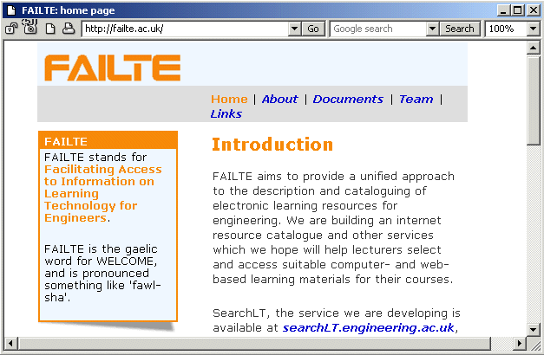Figure 1: The FAILTE home page
The FAILTE project [1] was funded by JISC to provide a service which engineering lecturers in higher education could use to identify and locate electronic learning resources for use in their teaching. The project started in August 2000. One of the first tasks was to set up a project Web site describing the aims, progress and findings of the project and the people involved.
Problem Being Addressed
As an experienced Web author I decided to use this opportunity to experiment with two specifications which at that time were relatively new, namely cascading style sheets (CSS) and HTML. At the same time I also wanted to create pages which looked reasonably attractive on the Web browsers in common use (including Netscape 4.7 which has poor support for CSS) and which would at least display intelligible text no matter what browser was used.
Why Use XHTML and CSS?
Here is not the place for a detailed discussion of the merits of separating logical content markup from formatting, but I will say that I think that, since this is how HTML was envisaged by its creators, it works best when used in this way. Some of the immediate reasons at the time of starting the Web site were:
- I had recently been through the tedious experience of adjusting the appearance of a Web site which had the formatting information held in each page, and having one file which held the formatting information for the entire site seemed an attractive proposition.
- I wanted to increase the accessibility of the Web site by not using tables to control the layout of the pages
- At that time several of my colleagues were telling me that CSS "just didn't work". I wanted to produce an example which showed to what extent it was possible to rely CSS alone for styling.
- It has been my experience that avoiding browser-specific "enhancements" to HTML reduces the long-term maintenance requirements for Web sites.
The Approach Taken
A quick investigation of the Web server log files from a related server which dealt with the same user community as our project targeted lead us to the decision that we should worry about how the Web site looked on Netscape 4.7, but not browsers with poorer support of XHTML and CSS (e.g. Netscape 4.5 and Internet Explorer 3).
The Web site was a small one, and there would be one contributor: me. This meant that I did not have to worry about the lack of authoring tools for XHTML at the time of setting up the Web site. I used HomeSite version 4.5, a text editor for raw HTML code, mainly because I was familiar with it. Divisions (<div> tags) were used in place of tables to create areas on the page (a banner at the top, a side bar for providing a summary of the page content), graphics were used sparingly, and colour was used to create a consistent and recognisable look across the site. It is also worth noting that I approached the design of the Web site with the attitude that it I could not assume that it would be possible to control layout down to the nearest point.
While writing the pages I tested primarily against Netscape 4.7, since this had the poorest support of XHTML and CSS of the browsers which we wanted to make a good job of rendering the Web design. I also made heavy use of the W3C XHMTL and CSS validation service [2], and against Bobby [3] to check for accessibility issues. Once the code validated and achieved the desired effect in Netscape 4.7 I checked the pages against a variety of browser platforms.
While it was never my aim to comply with a particular accessibility level, the Bobby feedback allowed me to enhance accessibility while building the pages.
Problems Experienced
Most of the problems stemmed from the need to support Netscape 4.7, which only partially implements the CSS specification. This cost time while I tried approaches which didn't work and then looked for work-around solutions to achieve the desired effect. For example, Netscape 4.7 would render pages with text from adjacent columns overlapping unless the divisions which defined the columns had borders. Thus the <div> tags have styles which specify borders with border-style: none; which creates a border but doesn't display it.
The key problem here is the partial support which this version of Netscape has for CSS: older versions have no support, and so the style sheet has no effect on the layout, and it is relatively easy to ensure that the HTML without the style sheet makes sense.
Another problem was limiting the amount of white space around headings. On one page in particular there were lots of headings and only short paragraphs of text. Using the HTML <h1>, <h2>, <h3>, etc. tags left a lot of gaps and led to a page which was difficult to interpret. What I wanted to do was to have a vertical space above the headings but not below. I found no satisfactory way of achieving this using the standard heading tags which worked in Netscape 4.7 and didn't cause problems in other browsers. In the end, I created class styles which could be applied to a <span> to give the effect I wanted e.g.:
<p><span class="h2">Subheading</span><br />
Short paragraph</p>
This was not entirely satisfactory since any indication that the text was a heading is lost if the browser does not support CSS.
Pleasant Surprises
The Web site is now two years old and in that time I have started using two new browsers. I now use Mozilla as my main browser and was pleasantly surprised that the site looks better on that than on the browsers which I used while designing it. The second browser is an off-line Web page viewer which can be used to view pages on a PDA, and which makes a reasonable job rendering the FAILTE Web site - a direct result of the accessibility of the pages, notably the decision not to use a table to control the layout of the page. This is the first time that the exhortation to write Web sites which are device-independent has been anything other than a theoretical possibility for me (remember WebTV?)
Things I Would Do Differently
I think that it is now much easier to use XHTML and CSS since the support offered by authoring tools is now better. I would also reconsider whether Netscape 4.7 was still a major browser: my feeling is that while it still needs supporting in the sense that pages should be readable using it, I do not think that it is necessary to go to the effort of making pages look attractive. In particular I would not create styles which imitated <Hn> in order to modify the appearance of headings. I look forward to the time when it is possible to write a page using standard HTML repertoire of tags without any styling so that it makes sense as formatted text, with clear headings, bullet lists etc., and then to use a style sheet to achieve the graphical effect which was desired.
References
1 FAILTE, <http://failte.ac.uk/>
2 W3C HTML Validation Service, W3C, <http://validator.w3.org/>
3 Bobby, WatchFire, <http://bobby.watchfire.com/bobby/>
Contact Details
Phil Barker, ICBL, MACS, Heriot-Watt University, Edinburgh
Email: philb@icbl.hw.ac.uk URL: http://www.icbl.hw.ac.uk/~philb/
Standards For e-learning:
The e-MapScholar Experience
About This Document
This case study describes the approaches to choosing and deploying standards for e-learning in the e-MapScholar project.
Citation Details
Standards For e-learning: The e-MapScholar Experience, QA Focus, UKOLN,
<http://www.ukoln.ac.uk/qa-focus/documents/case-studies/case-study-05/>
Keywords: standards, Javascript, browser, e-Map-Scholar, case study
Background
The e-MapScholar project [1] aims to develop tools and learning and teaching materials to enhance and support the use of geo-spatial data currently available within tertiary education in learning and teaching, including digital map data available from the EDINA Digimap service [2]. These tools and learning materials will be delivered over the Web and will be accessed from a repository of materials branded the "Learning Resource Centre".
The project is funded by the JISC [3] to form part of the DNER, now called the Information Environment [4] and works closely with other projects funded under the same programme.
The Need For Standards
From the outset of the e-MapScholar Project it was apparent that various standards needed to be agreed upon and conformed to. The two core issues were:
- Material and software would be developed at a number of different sites, but needed to be integrated together as part of the software engineering process.
- The solution should work on a variety of different platforms, yet be reliable and predictable in its behaviour.
In reaching a broad community of users, a compromise needed to be found between delivery of service to 'low spec' PCs and high-end functionality that would support interactive tools. A range of technical discussions at the outset of the project discussed these implications in the context of choice of standards and technical evaluation criteria.
The Approach Taken
The various technical elements and their respective standards were specified at the start of the project. These included the use of Java 1.1 for the interactive applets (see Figure 1), and Javascript 1.2 and HTML 4.01 for the user interface. All learning material content would be stored in XML files which would be transformed using XSLT and Java. Similarly, authors of learning materials would also be provided with a set of guidelines for producing the content.
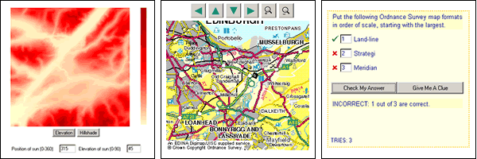Figure 1: Screen shots of interactive tools produced by e-MapScholar

Java 1.1
All software components were written in Java 1.1. All code has and remains fully compliant with this version. Though Java 1.1 does not have as much functionality as later versions e.g. 1.2 and 1.3, it makes the service compliant with a broader choice of browsers and operating systems. Java code was also written to control the conversion of XML into HTML.

JavaScript 1.2 and HTML 4.0.1
HTML 4.01 is used for the layout of the learning resource centre pages. Using HTML standards ensure that the site is more accessible to a wider range of browsers, and is transformed more quickly and easily. The use of client-side JavaScript has been kept to a minimum and only used for pop-up window items such as the help menu and map legends. These are all written in JavaScript 1.2. Using this version of JavaScript again reflected a compromise between control of graphics and levels of interaction, and compatibility with browsers and operating systems.
Author Guidelines
Authors providing content to the learning units have been issued with a document containing guidance notes. This document aims to standardise the content of the learning units, by providing procedures on how various elements of the units should be written. These elements include guidelines on the structuring of a unit, wording of learning objectives and quiz tools, and the acceptable formats for images and photographs. Complying with these guidelines will ensure the pedagogical aspect of the units meet teaching requirements and are suitable for students across a range of abilities.
The imposition of all of the above standards increased the chances of interoperability between the various units and modules comprising the service.
Problems Experienced
The use of Java 1.1 should ensure that users do not have to download the plug-in as the majority of browsers come packaged with this version of Java Virtual Machine installed (or higher). However, last year Microsoft launched their latest version of Internet Explorer (6.0) without a Java VM. This means that users of IE 6 will have to download a Java plug-in to run any Java applets, regardless of what version of Java the applets have been created with.
Web statistics [5] (illustrated in Figure 2) show that Internet Explorer is the most widely used Web browser, with IE 6 already accounting for a considerable portion of this usage. This means that 48% of Internet users will have to download the Java plug-in order to run any Java applets.
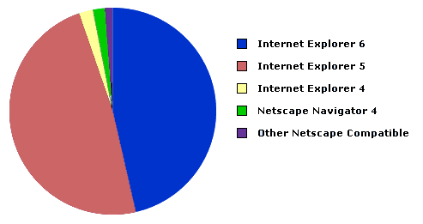
Figure 2: Pie chart of browser statistics generated using data from [6]
With many users upgrading to the new service in the future, one might question the point in using Java 1.1 when the majority of Internet users will still have to download the plug-in? Ideally, standards should be employed with the majority of users in mind.
Things We Would Do Differently
At the outset we chose Java 1.1 since it was incorporated in Internet Explorer and the majority of other browsers, and would not involve users having to download the plug-in. It is estimated that 48% of web users are using IE6, all of whom will need to download the Java plug-in. Our ambition of 'use without plug-in' has somewhat evaporated, and an argument could now be made that we could ask users to download other plug-ins, notably 'Flash'. Ironically IE6 users would not need to download Flash player as it comes ready packaged in IE6.
If Flash were used (in conjunction with Java 1.1) it would allow greater levels of interaction with the user, and easier development of visualisation tools. However, this would have required access to Flash developers which the project does not have at this stage. Currently no decision has been made on whether it is worth taking advantage of the additional functionality afforded by Flash player, but it does open a door, which was previously thought to be firmly closed.
On the whole, throughout the project, various software engineering problems have arisen. But broad agreement on the use of standards coupled with clarification of system requirements, and requirement specifications has helped to keep the project manageable from a software engineering prospective.
References
1 e-MapScholar Web site, EDINA, <http://edina.ac.uk/projects/mapscholar/>
2 Digimap Web site, EDINA, <http://edina.ac.uk/digimap/>
3 JISC Web site, <http://www.jisc.ac.uk/>
4 Information Environment, JISC, <http://www.jisc.ac.uk/index.cfm?name=about_info_env>
5 Browser News Web Statistics, <http://www.upsdell.com/BrowserNews/stat.htm>
6 W3C Schools Browser Statistics, <http://www.w3schools.com/browsers/browsers_stats.asp>
Contact Details
Lynne Robertson
Geography
School of Earth, Environmental and Geographical Sciences
The University of Edinburgh
Drummond Street
Edinburgh EH8 9XP
Email: lr@geo.ed.ac.uk
Standards and Accessibility Compliance
for the DEMOS Project Web Site
About This Document
This case study describes the approaches taken to use of standards and accessible Web design by the DEMOS project.
Citation Details
Standards and Accessibility Compliance for the DEMOS Project Web Site QA Focus, UKOLN, <http://www.ukoln.ac.uk/qa-focus/documents/case-studies/case-study-10/>
Related Documents
See also the Compliance With HTML Standards (briefing-01) briefing document.
Note
This case study is also included in the QA For Web Handbook.
Keywords: standards, Web, matrix, accessibility, compliance, DEMOS, case study
Background
Funded by the Higher Education Funding Council for England under strand three of the initiative 'Improving Provision for Students with Disabilities', the aim of the DEMOS Project [1] was to develop an online learning package aimed at academic staff and to examine the issues faced by disabled students in higher education. The project was a collaboration between the four universities in the Manchester area - the University of Salford [2], the University of Manchester [3], the Manchester Metropolitan University [4] and UMIST [5].
The Web Site
At the start of the project the purpose of the Web site was still unclear, which made it difficult to plan the information structure of the site. Of course, it would serve as a medium to disseminate the project findings, research reports, case studies... but for months the design and the information architecture of this site seemed to be in a never-ending state of change.
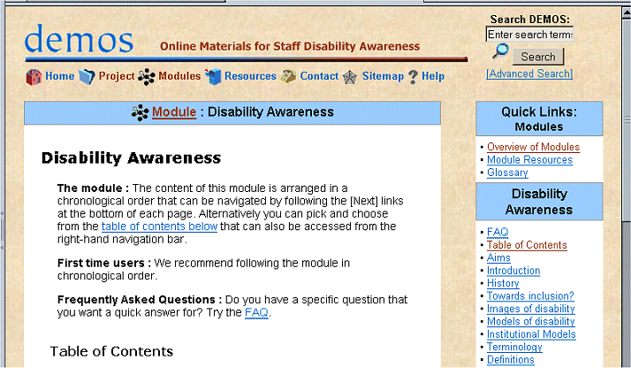
Figure 1: The Demos Web Site
In the early stage of the project virtual learning environments, such as WebCT, were tested and deemed unsuitable for delivering the course material, due to the fact that they did not satisfy the requirements for accessibility.
At this point it was decided that the Web site should carry the course modules. This changed the focus of the site from delivering information about the progress of the project to delivering the online course material.
In the end we envisioned a publicly accessible resource that people can use in their own time and at their own pace. They can work through the modules in the linear fashion they were written in or they can skip through via the table of contents available on every page. There are also FAQ pages, which point to specific chapters.
Many academic institutions have already added links to the DEMOS materials on their own disability or staff development pages.
Problem Being Addressed
To ignore accessibility would have been a strange choice for a site that wants to teach people about disability. Accessibility was therefore the main criteria in the selection of a Web developer.
I have been a Web designer since 1998 and specialised in accessibility from the very beginning. For me it is a matter of ethics. Now it is also the law.
The challenge here was to recreate, at least partially, the feeling of a learning environment with its linear structure and incorporating interactivity in form of quizzes and other learning activities without the use of inaccessible techniques for the creation of dynamic content.
The Approach Taken
Accessibility techniques were applied from the beginning. But the site also represents an evolution in my own development as a Web designer, it always reflected my own state of knowledge. Where in the beginning accessibility meant eradicating the font tag, it now means standard-compliant code and tableless CSS layout.

Valid and Accessible Design and Code
This site was designed in compliance with the latest standards developed by the World Wide Web Consortium (W3C) [6] and using the latest accessibility techniques [7] as recommended by the Web Accessibility Initiative (WAI) [8].
In December 2001 the code base of the site was switched over to XHTML 1.0 Transitional. In November 2002 the site was further improved by changing it to a CSS layout, which is used to position elements on the page without the use of tables. The only layout table left is the one holding the header: logo, search box and top navigation icons.
Stylesheets are also used for all presentational markup and a separate print stylesheet has been supplied.
The code was validated using the W3C Validation Service [9].

Standards = Accessibility
With the advent of standard-compliant (version 6 and 7) browsers, the Web developer community started pushing for the adoption of the W3C guidelines as standard practise by all Web designer. Now that version 3 and 4 browsers with all their proprietary mark-up were about to be consigned to the scrap heap of tech history, it was finally possible to apply all the techniques the W3C was recommending. Finally the makers of user agents had started listening to the W3C too and were making browsers that rendered pages designed according to standards correctly. (It turns out things weren't all that rosy but that's the topic for another essay.)
Standards are about accessibility, or, as the W3C phrases it, 'universal design'. They ensure that universal access is possible, i.e. that the information contained on a Web page can be accessed using:
- a modern standard-compliant browser on an up-to-date high spec PC
- an old browser on a slow connection and legacy hardware
- a text-only browser (often used as a basis for screen readers)
- assistive technology (screen readers, foot pedals, braille printers, etc.)
- a small device (PDA, mobile phone)

User Control
The most important reason for designing according to standards is that it gives the user control over how a Web page is presented. The user should be able to increase font sizes, apply preferred colours, change the layout, view headers in a logical structure, etc.
This control can be provided by the Web designer by:
- using correct structural markup
- using stylesheets to specify presentational styles (such as fonts and colours)
- using CSS layout (instead of table layout)
- applying accessibility techniques
On the DEMOS site, all presentational styles are specified in stylesheets. The site 'transforms gracefully' when stylesheets are ignored by the user agent, which means that the contents of a page linearises logically. The user has control over background and link colours via the browser preferences and can increase or decrease font sizes.
The DEMOS Guide to Accessible Web Design contains a chapter on User Control [10], which describes how these changes can be applied in various browsers.

Accessibility Techniques
(The links below lead to pages on the DEMOS site, more precisely: the DEMOS Guide to Accessible Web Design [11])
Some of the techniques used:
- A mechanism to skip to the main content was provided.
- Access keys were defined.
- Alternative descriptions were provided for all images. Purely decorative images contain an empty ALT attribute.
- Links are separated with printable characters.
- Stylesheets are used to allow user control.
- All acronyms and abbreviations are labelled.
- Icons and colours are used in a consistent manner to improve accessibility for users with cognitive or learning disabilities.
- The site can be navigated via the keyboard.
- Tables are only used for data, not for layout (except for the header table).
- Frames and dynamic content are avoided.
- Accessible interactivity was provided using PHP.
- Text is kept scannable, language clear and jargon is explained in glossaries.
- Language changes are declared for the benefit of screen readers.
More information and details: Accessibility techniques used on the DEMOS site [12] (listed by WAI checkpoints).

Inclusive Design
Web developers sometimes believe that accessibility means providing a separate text-only or low-graphics version for the blind. First of all: I have always been on that side of the camp that believes that there should be only one version of a site and that it should be accessible.
"Don't design an alternative text-only version of the site: disabled people are not second class citizens..." (Antonio Volpon, evolt.org [13]).
Secondly, accessibility benefits not only blind people [14]. To be truly inclusive we have to consider people with a variety of disabilities, people with a range of visual, auditory, physical or cognitive disabilities, people with learning disabilities, not to forget colour blindness, senior citizens, speakers of foreign languages, etc.
Surely not all of them are part of the target audience, but you never know, and applying all available accessibility techniques consistently does not take that much more effort.
We tried to provide a satisfactory experience for everyone, providing user control, keyboard access, icons and colour to loosen things up, whitespace and headers to break up text in digestable chunks. And we encourage people to provide feedback, especially if they experience any problems.

Accessibility Testing
To ensure accessibility the site was tested across a variety of user agents and on different platforms. A number of screenshots from these tests [15] can be found at the DEMOS site. The site has also been tested using the Bobby [16] and Wave [17] accessibility checkers. It is AAA compliant, which means that it meets all three levels of accessibility.

Accessible Interactivity
One of the last things we finally solved to our satisfaction was the problem of creating interactive quizzes and learning activities for the course modules without the use of inaccessible techniques. Many of the techniques for the creation of dynamic and multimedia content (JavaScript, Java, Flash...) are not accessible.
Eventually we discovered that PHP, a scripting language, was perfect for the job. PHP is processed server-side and delivers simple HTML pages to the browser without the need for plug-ins or JavaScript being enabled.
Problems Encountered

Information Architecture and Navigation
As mentioned before, the Web site started without a clear focus and without a clear structure. Therefore there wasn't much planning and structured development. In the first months content was added as it was created (in the beginning mainly information about the project) and the site structure grew organically. This caused some problems later when main sections had to be renamed and content restructured. From the Web development point of view this site has been a lesson in building expandability into early versions of Web site architecture.
Since there was so much uncertainty about the information architecture in the beginning, the navigation system is not the best it could be. The site grew organically and navigations items were added as needed. The right-hand navigation was added much later when the site had grown and required more detailed navigation - more detailed than the main section navigation at the top of the page underneath the logo and strapline.
But the right-hand navigation is mainly sub-navigation, section navigation, which might be confusing at times. At the same time, however, it always presents a handy table of contents to the section the visitor is in. This was especially useful in the course modules.
The breadcrumb navigation at the top of the main content was also added at a later date to make it easier for the visitor to know where they are in the subsections of the site.

Netscape 4
Already mentioned in Phil Barker's report on the FAILTE Web site [18], Netscape 4 was also my biggest problem.
Netscape 4 users still represent a consistent 12% of visitors in the UK academic environment (or at least of the two academic sites I am responsible for). Since this is the target audience for the DEMOS site, Netscape 4 quirks (i.e. its lack of support for standards) had to be taken into account.
Netscape understands just enough CSS to make a real mess of it. Older browsers (e.g. version 3 browsers) simply ignore stylesheets and display pages in a simpler fashion with presentational extras stripped, while standard-compliant browsers (version 6 and 7) display pages coded according to standards correctly. Netscape 4 is stuck right between those two scenarios, which is the reason why the DEMOS site used tables for layout for a long time.
Tables are not really a huge accessibility problem if used sparingly and wisely. Jeffrey Zeldman wrote in August 2002 in 'Table Layout, Revisited' [19]:
Table layouts are harder to maintain and somewhat less forward compatible than CSS layouts. But the combination of simple tables, sophisticated CSS for modern browsers, and basic CSS for old ones has enabled us to produce marketable work that validates - work that is accessible in every sense of the word.
Tables might be accessible these days because screenreader software has become more intelligent but standard-compliance was my aim and layout tables are not part of that.
Luckily techniques have emerged that allow us to deal with the Netscape 4 quirks.
One option is to prevent Netscape 4 from detecting the stylesheet, which means it would deliver the contents in the same way as a text-only browser, linearised: header, navigation, content, footer following each other. No columns, colours, font specifications. But an audience of 12% is too large to show a site to that has lost its 'looks'. The site still had to look good in Netscape 4.
The other option is to use a trick to get Netscape 4 to ignore some of the CSS instructions [20] . Deliver a basic stylesheet to Netscape 4 and an additional stylesheet with extra instructions to modern browsers. This required a lot of tweaking and actually consumed an enormous amount of time but only because I was new to CSS layout. I have converted a number of other sites to CSS layout in the meantime, getting better at it every time.
The DEMOS site now looks good in modern browsers, looks OK but not terrific in Netscape 4, and simply linearises logically in browsers older than that and in text-only browsers.
To Do
There are still a few issues that need looking at, e.g. the accessibility of input forms needs improving (something I'm currently working on) and the structural mark-up needs improving so that headers are used in logical order starting with <h1>
There are also a few clashes of forms with the CSS layout. All forms used on the DEMOS site are still in the old table layout. I haven't had the time to figure out what the problem is.
Eventually I also plan to move the code to XHTML Strict and get rid of the remains of deprecated markup [21], which XHTML Transitional, the DOCTYPE [22] used at the moment, still forgives.
The Site's Future
Of course it is important to keep the materials produced over the last two and a half years accessible to the public after the funding has run out. This will happen at the end of March 2003. This site will then become part of the Access Summit Web site (at time of writing still under construction). Access Summit is the Joint Universities Disability Resource Centre that was set up in 1997 to develop provision for and support students with disabilities in higher education in Manchester and Salford.
We currently don't know whether we will be able to keep the domain name, so keep in mind that the URL of the DEMOS site might change. I will do my best to make it possible to find the site easily.
Further Information
DEMOS Web site, <http://www.demos.ac.uk/>
Jarmin.com Guide to Accessible Web Design, <http://jarmin.com/accessibility/>
A collation of tips, guidelines and resources by the author of this case study. Focuses on techniques but includes chapters on barriers to access, evaluation, legislation, usability, writing for the Web and more. Includes a huge resources section <http://jarmin.com/accessibility/resources/> where you can find links to W3C guidelines, accessibility and usability articles, disability statistics, browser resources, validation tools, etc. This section also contains resources that helped me understand the power of stylesheets <http://jarmin.com/accessibility/resources/css_layout.html>.
DEMOS Accessibility Guide, <http://jarmin.com/demos/access/>
Consists of the Techniques section from the Guide to Accessible Web Design <http://jarmin.com/accessibility/>, plus extra information on accessibility techniques used on the DEMOS site <http://jarmin.com/demos/access/demos.html> (listed by WAI checkpoints) and a number of demonstrations <http://jarmin.com/demos/access/
demos06.html> on how the site looks under a variety of circumstances.
References
- The DEMOS Project, <http://jarmin.com/demos/>
- University of Salford, <http://www.salford.ac.uk/>
- University of Manchester, <http://www.man.ac.uk/>
- Manchester Metropolitan University, <http://www.mmu.ac.uk/>
- UMIST, <http://www.umist.ac.uk/>
- World Wide Web Consortium (W3C), <http://www.w3.org/>
- Guide to Accessible Web Design, Iris Manhold, <http://jarmin.com/accessibility/>
- Web Accessibility Initiative (WAI), W3C, <http://www.w3.org/wai/>
- Validation Service, W3C, <http://validator.w3.org/>
- DEMOS Accessibility Guide: User Control, Iris Manhold, <http://jarmin.com/demos/access/control.html>
- DEMOS Accessibility Guide, Iris Manhold, <http://jarmin.com/demos/access/>
- Accessibility Techniques Used On The DEMOS Site, <http://jarmin.com/demos/access/demos.html>
- The Lifecycle of Web Accessibility, Antonio Volpon, evolt.org, <http://evolt.org/article/The_Lifecycle_of_Web_Accessibility/20/50376/>
- Benefits Of Accessibility, Iris Manhold, <http://jarmin.com/accessibility/access/index.html>
- The DEMOS site Tested, <http://jarmin.com/demos/access/demos06.html>
- Bobby Accessibility Checker, <http://bobby.watchfire.com/bobby/html/en/index.jsp>
- Wave Accessibility Checker, <http://www.wave.webaim.org/>
- Standards and Accessibility Compliance for the FAILTE Project Web Site, QA Focus, Phil Barker, <http://www.ukoln.ac.uk/qa-focus/documents/case-studies/case-study-02/>
- Table Layout, Revisited, Jeffrey Zeldman, A List Apart, 17 August 2001, <http://www.zeldman.com/daily/0802d.html#livedandlovedlikefrank>
- Tricking Browsers And Hiding Styles, Eric A. Meyer, <http://www.ericmeyeroncss.com/bonus/trick-hide.html>
- Deprecated markup, <http://jarmin.com/demos/access/deprecat.html>
- Doctype, <http://jarmin.com/demos/access/doctype.html>
Contact Details
Iris Manhold
Manchester Metropolitan University
Manchester

6 Standards Toolkit

Standards Toolkit
The metadata toolkit provides a checklist which is intended to ensure that projects address key areas when planning the deployment of metadata.
Note that an online version of this toolkit is available at
<http://www.ukoln.ac.uk/qa-focus/toolkit/>.
The online version provides links to relevant QA Focus resources.
1. Ownership of Standard
Is the standard you are considering using:
- owned by an acknowledged open standards body?
- owned by a neutral body, but not (yet) formally adopted as an open standard (e.g. Dublin Core)?
- owned by a company (i.e. a proprietary standard)
2. Openness of Proprietary Format
If the standard is proprietary:
- Is there an open development process (e.g. Sun's Java Community Programme)?
- Is the specification is published openly (e.g. Microsoft's RTF)?
- Is the specification has been published by third parties reverse-engineering the specification (e.g. Microsoft's Word)?
Has the specification not been published?
3. Availability of Viewers
Are viewers for the format:
- Available free of charge?
- Available on multiple platforms?
- Available as open source?

4. Availability of Authoring Tools
Are authoring tools for the format:
- Available free of charge?
- Available on multiple platforms?
- Available as open source?

5. Functionality of the Standard
Does the standard provide:
- Rich functionality?
- Basic functionality?

6. User Requirements
Does the standard:
- Largely provide the functionality required by end users of the service?
- Adequately provide the functionality required by end users of the service?
- Insufficiently provide the functionality required by end users of the service?
- Largely fail to provide the functionality required by end users of the service?
7. Fitness for Purpose
Is the standard:
- Ideal for the purpose envisaged?
- Appropriate for the purpose envisaged?
- Not particularly appropriate for the purpose envisaged?

8. Resource Implications
Will use of the standard:
- Have significant staffing implications for development and maintenance?
- Have relatively few staffing implications for development and maintenance?
- Have significant financial implications for development and maintenance?
- Have relatively few financial implications for development and maintenance?
9. Preservation
Is the format:
- Easy to preservation?
- Difficult to preserve?
- You are unsure of the ease of preservation?

10. Migration
If it becomes necessary to migrate to an alternative format will it be:
- Easy to migrate to alternative formats?
- Difficult to migrate to alternative formats?

11. Stability of Standard
If it becomes necessary to migrate to an alternative format will it be:
- Easy to migrate to alternative formats?
- Difficult to migrate to alternative formats?

12. Cultural Factors
As well as the various technical issues addressed above, there is also a need to consider the organisational culture of the developers. For example is your organisation:
- Keen to make use of innovative developments?
- Keen to make use of mature solutions?

Use Of This Toolkit
It is envisaged that this toolkit will be used to support the planning processes at the early stages of the development of a digital library service.
The issues covered in the toolkit are intended to help in the technical and managerial discussions which projects will be involved in.
Projects will probably find it helpful if the answers to the issues raised are documented, and possibly included in reports to the funders or as part of the project’s internal documentation.

7 Further Information
We hope that the QA For Standards Handbook provides useful advice to projects and services which are engaged in digital library development work.
In addition to this handbook there are other sources of information funded by the JISC which provide useful advice.

CETIS
CETIS is a JISC-funded advisory service which provides advice on educational metadata for the further and higher education communities.
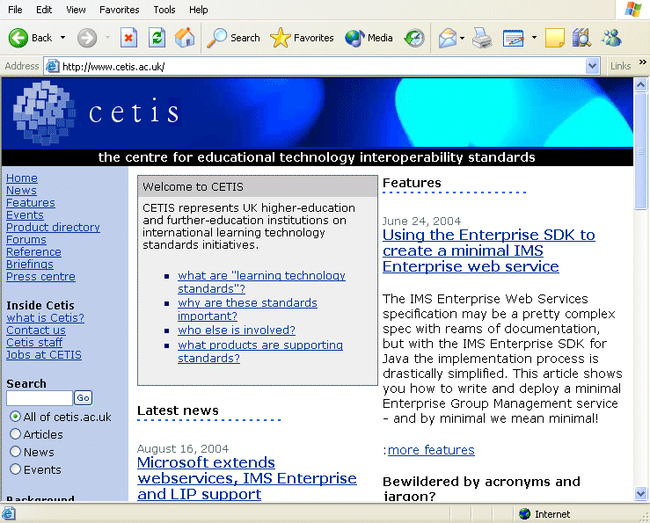
The CETIS Web Site
Further information on CETIS is available on the Web site which is available at <http://www.cetis.ac.uk/>.
The CETIS Web site is illustrated.

UKOLN
UKOLN is funded by the JISC and the MLA (Museums, Libraries and Archives Council) to provide advice and support on digital management issues to the further and higher education and cultural heritage communities.
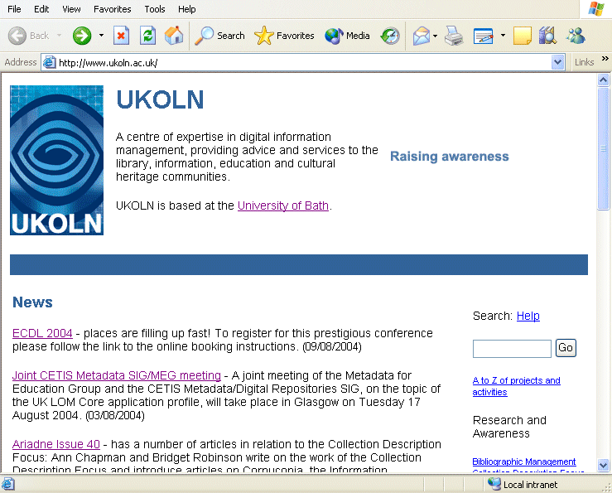
The UKOLN Web Site
Further information on UKOLN is available on the Web site which is available at <http://www.ukoln.ac.uk/>.
The UKOLN Web site is illustrated.

Acknowledgements
We are grateful to the following for contributing to the work of the QA Focus project:
Members of the JISC including Caroline Ingram our initial point of contact in JISC and Rachel Bruce and Balviar Notay, who provided valuable advice and support to the QA Focus team following Caroline’s departure from JISC.
The contributors to the briefing papers and case studies included in the handbook: Lynne Robertson (e-MapScholar project, University Of Edinburgh), Iris Manhold, (DEMOS project, Manchester Metropolitan University) and Phil Barker, (FAILTE project, Heriot Watt University).
Colleagues at UKOLN and the AHDS who provided valuable input to the work of the QA Focus project.
Karla Youngs and Ed Bremner, TASI, for their contributions to the work of QA Focus in its early days.
Others involved in JISC and related work who, knowingly or unknowingly, contributed to our work.

